NAME…………………………………......………………ADM. NO…………....……CLASS………

BIOLOGY
FORM 1
END TERM 1 2024
TIME: 2 HRS 15 MINUTES
Instructions: Answer all question in the spaces provided.

- a) Define biology. (1mk)

b) State and explain the three main branches of biology. (3mks)

- a) state three importances of studying biology. (3mks)

b) Name 3 careers that require biology. (3mks)

- List three environmental problems solved by studying biology. (3mks)

- Complete the table below about sub divisions of biology. (11mks)
Branch | Definition
Entomology
Genetics
 | Study of cells
 | Study of birds
 | Study of fish
Anatomy
Ecology
 | Study of external structure.
Physiology
 | Study of tissues;
 | Study of viruses;

- a) State eight characteristics that make an organism be called a living organism. (8mks)

- How does nutrition differ in plants and animals? (2mks)

- A car/ Aeroplane is able to move from one place to another and give out exhaust gases but it is snot classified as a living organism. List other characteristics of living things that do NOT occur in motor vehicles. (3mks)

- State the characteristic illustrated by the photos below. (2mks)
Photo | Characteristics.

- Name the most suitable apparatus used to collect the following specimens for study in the laboratory.
(5mks)
Organism | Apparatus.
Grasshopper.
Rat.
Fish.
Ants.
Stinging nettle.

- Below is an apparatus used to trap specimen.
- Identify the apparatus. (1mk)

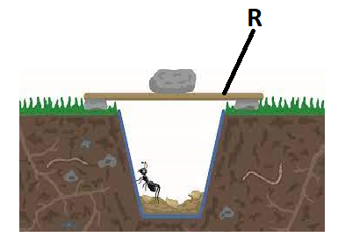
- State the purpose of the part labelled R. (1mk)

- What is a specimen. (1mk)

- List three precautions made during collection and observation of specimen. (3mks)

- Below is a drawing of an apparatus used during the study of biology.
- Identify the apparatus. (1mk)

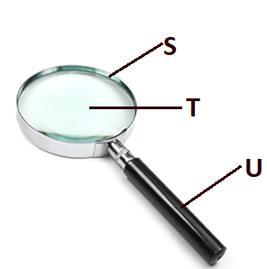
- Name the parts labelled S, T, and U. (3mks)
S –
T -
U –

- State the function of the apparatus. (1mk)

- A student observing a head of an insect using a hand lens.
- Write the formular used to calculate magnification of a specimen using a hand lens.(1mk)

- She made a drawing of the head whose length was 3 cm. If the magnification was X2, calculate the actual length of the drawing. (3mks)

- State three main differences between plants and animals. (3mks)
Animals | Plants

- Define the following terms.
    - Taxon. (1mk)

    - Species. (1mk)

- State two reasons that make scientific names to be written in Latin language. (2mks)

- State three importances of classification of living organisms. (3mks)

- State all the taxonomic units in descending order. (7mks)

- Apart from Plantae and animalia, name the three other kingdoms of classification and give an example for each. (6mks)
Kingdom | Example

- a) what is binomial nomenclature. (1mk)

b) State three rules of binomial nomenclature. (3mks)

- The scientific name of paw paw is carica Papaya.
- Which taxonomic unit is represented by the name carica. (1mk)

- State two mistakes made in writing the name. (2mks)

- Write the name correctly. (1mk)

- The scientific name of a tiger is Panthera tigris and that of Jaguar is Panthera onca. State a reason why a tiger and Jaguar cannot interbreed yet they belong to the same genus. (1mk)

- Study the light microscope below and answer the questions that follows.
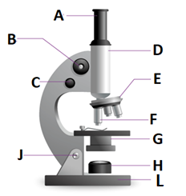
- Name the parts labelled A – L. (10mks)
A –
B –
C –
D –
E –
F –
G –
H –
L –

