NAME…………………………………......………………ADM. NO…………....……CLASS………

BIOLOGY
FORM 1
END TERM 1 2024
TIME: 2 HRS 15 MINUTES
MARKING SCHEME
Instructions: Answer all question in the spaces provided.

- a) Define biology. (1mk)
The study of life/living things
b) State and explain the three main branches of biology. (3mks)
Botany – study of plants;
Zoology – study of animals;
Microbiology – study of microscopic organisms;

- a) state three importances of studying biology. (3mks)
- Helps to solve environmental problems;( such as pollution)
- Helps to acquire scientific skills such data collecting used in everyday living;
- For entry into other professions/careers such as teaching;
- Knowledge gained can be used to enhance international cooperation;
- Understand developmental stages in the human body;

b) Name 3 careers that require biology. (3mks)
  - Medicine;
  - Teaching;
  - Horticulture (AVP)
- List three environmental problems solved by studying biology. (3mks)
- Pollution;
- Food shortage;
- Drought;
- Poor health;
- Conservation of natural resources;

- Complete the table below about sub divisions of biology. (11mks)
Branch | Definition
Entomology | Study of insects;
Genetics | Study of inheritance and variation;
Cytology; | Study of cells
Ornithology; | Study of birds
Ichthyology; | Study of fish
Anatomy | Study of internal structures of living organisms;
Ecology | Study of living organisms in their surroundings;
Morphology; | Study of external structure.
Physiology | Study of body functions;
Histology | Study of tissues;
Virology | Study of viruses;

- a) State eight characteristics that make an organism be called a living organism. (8mks)
  - Nutrition
  - Growth and development
  - Respiration
  - sensitivity/irritability
  - Excretion
  - Movement/locomotion
  - Reproduction
  - Gaseous exchange;

- How does nutrition differ in plants and animals? (2mks)
Plants manufacture their own food/ are autotrphic while animals do not manufacture their own food/ are heterotrophic;
- A car/ Aeroplane is able to move from one place to another and give out exhaust gases but it is snot classified as a living organism. List other characteristics of living things that do NOT occur in motor vehicles. (3mks)
    - Growth and development;
    - Irritability;
    - Reproduction;

- State the characteristic illustrated by the photos below. (2mks)
Photo | Characteristics.
 | Nutrition;
 | Movement/locomotion;

- Name the most suitable apparatus used to collect the following specimens for study in the laboratory.
(5mks)
Organism | Apparatus.
Grasshopper. | Sweep net;
Rat. | Bait trap;
Fish. | Fish net;
Ants. | Pooter/ pitfall trap;
Stinging nettle. | Pair of forceps;

- Below is an apparatus used to trap specimen.
- Identify the apparatus. (1mk)
Pitfall trap;
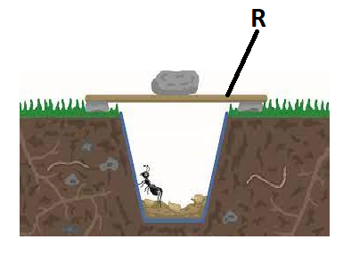
- State the purpose of the part labelled R. (1mk)
Prevent entry of rain water or sun rays;
- What is a specimen. (1mk)
A whole or a part of an organism being studied or examined;
- List three precautions made during collection and observation of specimen. (3mks)
- Collect only the number of specimens you need;
- Do not harm specimens during the capture(collection);
- Do not destroy the natural habitat of the specimen;
- After use return any live specimens back to their habitat whenever possible;
- Dangerous/ injurious specimens should be handled with a lot of care such include stinging plants or insects make use of forceps and hand gloves in such cases;
- For highly mobile animals they should be immobilized;

- Below is a drawing of an apparatus used during the study of biology.
- Identify the apparatus. (1mk)
Magnifying lens/ hand lens;
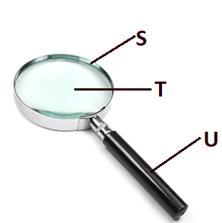
- Name the parts labelled S, T, and U. (3mks)
S – Frame;
T – (convex) lens;
U – Handle;

- State the function of the apparatus. (1mk)
Make small objects to appear larger/ enlarge specimen/ magnify specimen;
- A student observing a head of an insect using a hand lens.
- Write the formular used to calculate magnification of a specimen using a hand lens.(1mk)
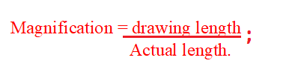
- She made a drawing of the head whose length was 3 cm. If the magnification was X2, calculate the actual length of the drawing. (3mks)

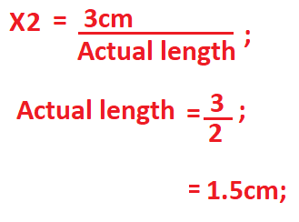
- State three main differences between plants and animals. (3mks)
Animals | Plants
Has Specialized complex excretory organs | Has simple excretory organs
Respond quickly to stimulus | respond to stimulus slowly
Has definite growth | Have indefinite growth
Move around to look for food | Stationery
Heterotrophic | Autotrophic
Cells have no cell walls | Cells have cell wall made of cellulose
Cells lack chlorophyll | Cells has chlorophyll

- Define the following terms.
    - Taxon. (1mk)
Group of organisms with similar characteristics;
    - Species. (1mk)
A group of organisms that can naturally interbreed to give rise to fertile offspring;
- State two reasons that make scientific names to be written in Latin language. (2mks)
  - Does not change;
  - Was widely spoken/ used by scientists during Linnaeus time;
- State three importances of classification of living organisms. (3mks)
  - Place organisms in their right group for reference;
  - Put together organisms with similar characteristic and separate those with different characteristic;
  - Organize information about living organisms in an orderly manner to avoid chaos that may arise if it was done arbitrarily;
  - Understand evolutionary relationship between organisms;

- State all the taxonomic units in descending order. (7mks)
Kingdom;
Phyla/division;
Class;
Order;
Family;
Genus;
Species;

- Apart from Plantae and animalia, name the three other kingdoms of classification and give an example for each. (6mks)
Kingdom | Example
Fungi | Mushroom;
Protoctista | Amoeba;
Monera; | Bacteria; acc a good example;

- a) what is binomial nomenclature. (1mk)
Assigning of two scientific names to living organisms;
b)State three rules of binomial nomenclature. (3mks)
  - The genus name should start followed by scientific name;
  - The name should be underlined separately when handwritten;
  - The specific name is sometimes written with the name of the person who first described the organism adequately;

- The scientific name of paw paw is carica Papaya.
- Which taxonomic unit is represented by the name carica. (1mk)
Genus;
- State two mistakes made in writing the name. (2mks)
- Starting the genus name with a small letter;
- Starting the species name with a capital letter;
- Write the name correctly. (1mk)
Carica papaya;

- The scientific name of a tiger is Panthera tigris and that of Jaguar is Panthera onca. State a reason why a tiger and Jaguar cannot interbreed yet they belong to the same genus. (1mk)
They belong to different species;

- Study the light microscope below and answer the questions that follows.
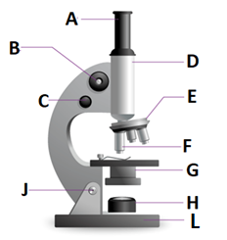
- Name the parts labelled A – L. (10mks)
A – Eye piece;
B – Coarse adjustment knob;
C –Fine adjustment knob;
D –Body tube;
E –Revolving nose piece;
F –High power objective lens; acc objective lens alone
G –Condenser;
H – Mirror;
L – Base;

