NAME:……………………………………………………………………ADM NO……………….
DATE: ………………….
443
AGRICULTURE
FORM THREE
TIME : 2 HOURS

END OF TERM ONE 2024 EXAMINATION

INSTRUCTIONS TO CANDIDATES:
- This paper consists of three sections; A, B and C
- Answer ALL the questions in sections A, B and C
- All answers to be written in English

FOR OFFICIAL USE ONLY
SECTION | QUESTION | MAX. SCORE | CANDIDATE SCORE
A | 1 – 20 | 40
B | 21 – 24 | 20
C | 25 – 26 | 40
 | TOTAL | 100

SECTION A (40 MARKS)
ANSWER ALL THE QUESTIONS IN THIS SECTION
- State four characteristics of shifting cultivation. (2 mks)
…………………………………………………………………………………………………………………………………………………………………………………………………………………………………………………………………………………………………………………………………………………………………………………………………………………………………………………………………………

2.List six effects of temperature on crop production (3 mks) …………………………………………………………………………………………………………………………………………………………………………………………………………………………………………………………………………………………………………………………………………………………………………………………………………………………………………………………………………
3.Give three soil factors that influence soil productivity ( 1 ½ mks) …………………………………………………………………………………………………………………………………………………………………………………………………………………………………………………………………………………………………………………………………………………………………………………………………………………………………………………………………………

4. Name four categories of livestock farming (2 mks) …………………………………………………………………………………………………………………………………………………………………………………………………………………………………………………………………………………………………………………………………………………………………………………………………………………………………………………………………………
5.Give four factors that influence the number of secondary cultivation in seedbed preparation. (2 mks) …………………………………………………………………………………………………………………………………………………………………………………………………………………………………………………………………………………………………………………………………………………………………………………………………………………………………………………………………………
6.State four farming practices that ensure minimum tillage. (2 mks) …………………………………………………………………………………………………………………………………………………………………………………………………………………………………………………………………………………………………………………………………………………………………………………………………………………………………………………………………………
7. State four reasons for treating water for use on a farm. (2 mks) …………………………………………………………………………………………………………………………………………………………………………………………………………………………………………………………………………………………………………………………………………………………………………………………………………………………………………………………………………
8. State four factors that influence the quality of farmyard manure. (2 mks) …………………………………………………………………………………………………………………………………………………………………………………………………………………………………………………………………………………………………………………………………………………………………………………………………………………………………………………………………………
9. Name four rabbit breeds reared in Kenya. (2 mks) …………………………………………………………………………………………………………………………………………………………………………………………………………………………………………………………………………………………………………………………………………………………………………………………………………………………………………………………………………
10. State four functions of calcium in plant growth and development. (2 mks) …………………………………………………………………………………………………………………………………………………………………………………………………………………………………………………………………………………………………………………………………………………………………………………………………………………………………………………………………………
11. Give four advantages of timely planting in maize production. (2 mks) …………………………………………………………………………………………………………………………………………………………………………………………………………………………………………………………………………………………………………………………………………………………………………………………………………………………………………………………………………

12. State three methods of controlling insect pest in a crop nursery. (1 ½ mks) ………………………………………………………………………………………………………………………………………………………………………………………………………………………………………………………………………………………………………………………………………………………
13. Give four reasons of pruning coffee. (2 mks) …………………………………………………………………………………………………………………………………………………………………………………………………………………………………………………………………………………………………………………………………………………………………………………………………………………………………………………………………………
14. Give four ways in which disease causing organism can gain access into a newly born calf. (2 mks) …………………………………………………………………………………………………………………………………………………………………………………………………………………………………………………………………………………………………………………………………………………………………………………………………………………………………………………………………………
15. State four ways by which a farmer can identify an animal suffering from worm infestations. (2 mks) …………………………………………………………………………………………………………………………………………………………………………………………………………………………………………………………………………………………………………………………………………………………………………………………………………………………………………………………………………
16. List four factors that determine amount of feed an animal consumes. (2 mks) …………………………………………………………………………………………………………………………………………………………………………………………………………………………………………………………………………………………………………………………………………………………………………………………………………………………………………………………………………
17. State four characteristics of a good breeding stock. (2 mks) …………………………………………………………………………………………………………………………………………………………………………………………………………………………………………………………………………………………………………………………………………………………………………………………………………………………………………………………………………
18. State four functions of the worker bees in a bee colony. (2 mks) …………………………………………………………………………………………………………………………………………………………………………………………………………………………………………………………………………………………………………………………………………………………………………………………………………………………………………………………………………
19. List four materials that can be used in constructing a Kenya Top Bar Hive (KTBH) (2 mks) …………………………………………………………………………………………………………………………………………………………………………………………………………………………………………………………………………………………………………………………………………………………………………………………………………………………………………………………………………
20. State four disadvantages of communal land tenure system. (2 mks) …………………………………………………………………………………………………………………………………………………………………………………………………………………………………………………………………………………………………………………………………………………………………………………………………………………………………………………………………………

SECTION B (20 MARKS)
Answer ALL the questions in section
- The diagram below illustrates the general shape of a cattle breed. Study it carefully and answer the questions that follow.
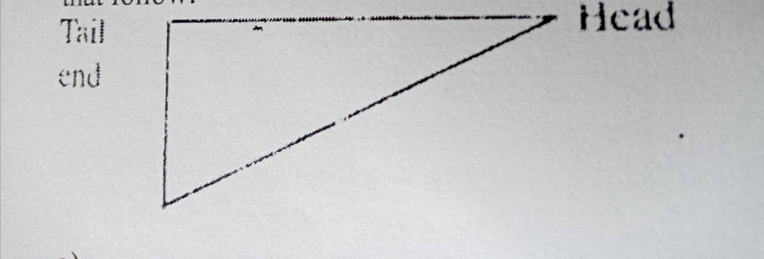

a). Identify the type of breed illustrated by the above shape. ( ½ mk)
…………………………………………………………………………………………………………………
b). Give an example of a breed in (a) above ( ½ mk)
…………………………………………………………………………………………………………………

c). State four physical characteristics of the type of breed identified in (a) above. (4 mks)
…………………………………………………………………………………………………………………………………………………………………………………………………………………………………………………………………………………………………………………………………………………………………………………………………………………………………………………………………………
22.a). Distinguish between straight and compound fertilizers. (1 mk)
……………………………………………………………………………………………………………………………………………………………………………………………………………………………………
b). A farmer applied 250 kgs of urea (46% N) per hectare on his six hectares maize crop. Calculate the amount of nitrogen the farmer applied on his crop. Show your working. (4 mks)

23.The table below shows a farm record for Ufanisi Farm.
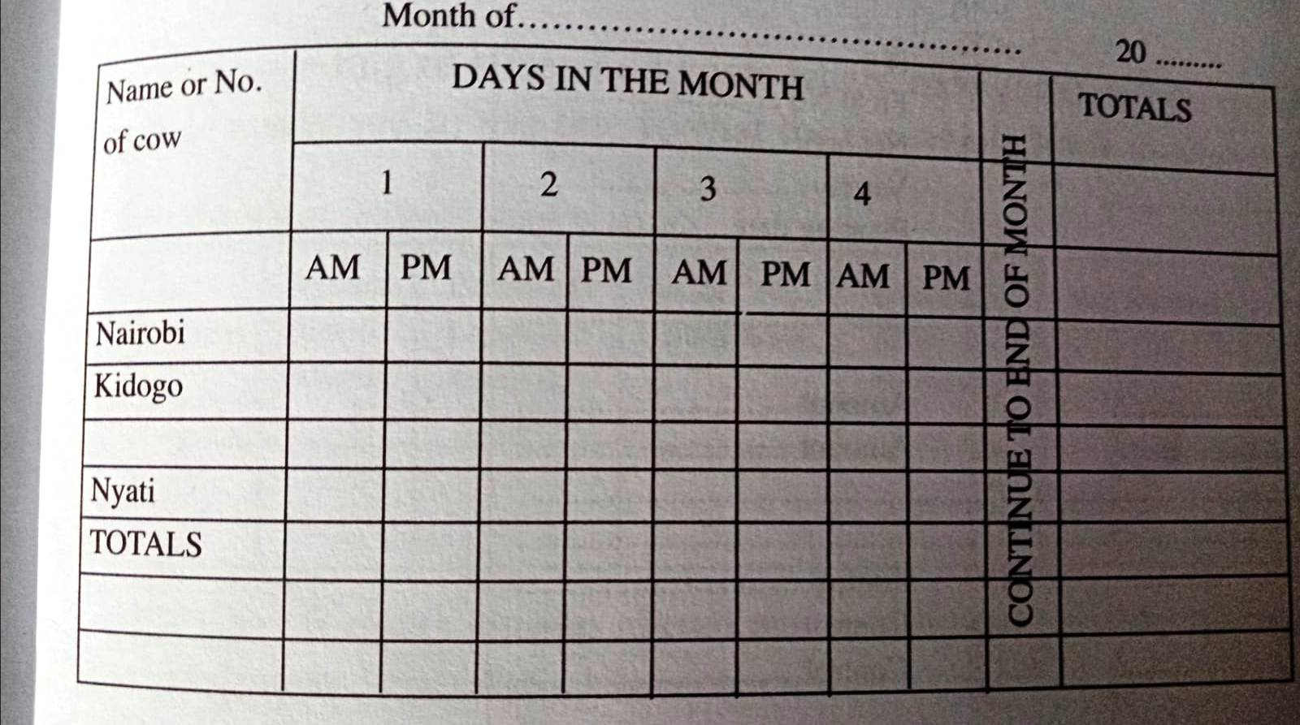
- Name the farm record illustrated above (1 mk)
…………………………………………………………………………………………………………………
- State two uses of the farm record shown above. (2 mks)
……………………………………………………………………………………………………………………………………………………………………………………………………………………………………
- Name two other records kept by the Ufanisi farm (2 mks)
……………………………………………………………………………………………………………………………………………………………………………………………………………………………………

24.a). The diagram below illustrates a method of identification in livestock production. Study the diagram and answer the questions that follow.
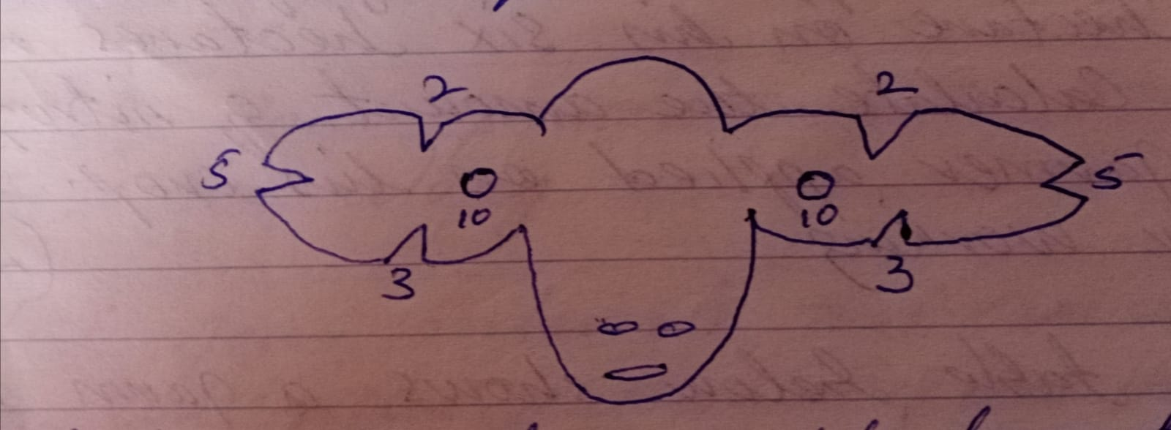

i). Name the type of identification illustrated above. (1 mk)
…………………………………………………………………………………………………………………
ii). Give the identification number of the animal illustrated in the diagram above. (1 mk)

iii). Using diagrams, illustrate how you can identify animals No. 24 and 36 using the above method. (2 mks)

b). If a sow was successfully served on 27th September 2023, state the date she is likely to have furrowed. (2 mks)

SECTION C (40 MARKS)
Answer ALL the questions in section
25.a). Describe the production of onions under the following sub – headings.
i). Seed bed preparation (3 mks) ……………………………………………………………………………………………………………………………………………………………………………………………………………………………………………………………………………………………………………………………………………………………………………………………………………………………………………………………………………………………………………………………………………………………………………………………………………………………………………………………………………………………………………………………………………………………………………………………………………………………………………………………………………………………………………………………………………………
ii). Field management (4 mks) …………………………………………………………………………………………………………………………………………………………………………………………………………………………………………………………………………………………………………………………………………………………………………………………………………………………………………………………………………
…………………………………………………………………………………………………………………………………………………………………………………………………………………………………………………………………………………………………………………………………………………………………………………………………………………………………………………………………………
iii). Harvesting (3 mks) …………………………………………………………………………………………………………………………………………………………………………………………………………………………………………………………………………………………………………………………………………………………………………………………………………………………………………………………………………
…………………………………………………………………………………………………………………………………………………………………………………………………………………………………………………………………………………………………………………………………………………………………………………………………………………………………………………………………………

b). Explain five advantages of mulching in crop production (10 mks) …………………………………………………………………………………………………………………………………………………………………………………………………………………………………………………………………………………………………………………………………………………………………………………………………………………………………………………………………………
…………………………………………………………………………………………………………………………………………………………………………………………………………………………………………………………………………………………………………………………………………………………………………………………………………………………………………………………………………
…………………………………………………………………………………………………………………………………………………………………………………………………………………………………………………………………………………………………………………………………………………………………………………………………………………………………………………………………………
…………………………………………………………………………………………………………………………………………………………………………………………………………………………………………………………………………………………………………………………………………………………………………………………………………………………………………………………………………
26.a). Explain five factors that a farmer should consider when siting a bee hive to prevent swarming of bees. (10 mks)
…………………………………………………………………………………………………………………………………………………………………………………………………………………………………………………………………………………………………………………………………………………………………………………………………………………………………………………………………………
…………………………………………………………………………………………………………………………………………………………………………………………………………………………………………………………………………………………………………………………………………………………………………………………………………………………………………………………………………
…………………………………………………………………………………………………………………………………………………………………………………………………………………………………………………………………………………………………………………………………………………………………………………………………………………………………………………………………………

b). Describe the process of digestion in the following sections in the alimentary canal of a non – ruminant animal
i). Mouth (1 mk) ……………………………………………………………………………………………………………………………………………………………………………………………………………………………………

ii). Stomach (3 mks)
…………………………………………………………………………………………………………………………………………………………………………………………………………………………………………………………………………………………………………………………………………………………………………………………………………………………………………………………………………
……………………………………………………………………………………………………………………………………………………………………………………………………………………………………………………………………………………………………………………………………………………………………………………………………………………………………………………………………………………………………………………………………………………………………………………………
…………………………………………………………………………………………………………………………………………………………………………………………………………………………………………………………………………………………………………………………………………………………………………………………………………………………………………………………………………
iii). Small intestines (6 mks) …………………………………………………………………………………………………………………………………………………………………………………………………………………………………………………………………………………………………………………………………………………………………………………………………………………………………………………………………………
………………………………………………………………………………………………………………………………………………………………………………………………………………………………………………………………………………………………………………………………………………………………………………………………………………………………………………………………………………………………………………………………………………………………………………………………………………………………………………………………………………………………………………

