AGRICULTURE FORM THREE
SECTION A 40 MARKS
ANSWER ALL THE QUESTIONS IN THIS SECTION
- State four characteristics of shifting cultivation. (2 mks)
- Practised where land is plenty
- Practised with annual crops; not perennial
- Movement when soil loses fertility
- Agricultural output is low
- Inputs such as pesticides, fungicides are rarely used
- Simple hand tools are used
- Land is communally owned
- Population is sparse
- Low number of livestock per area

- List six effects of temperature on crop production (3 mks)
Low temperature
- Slow growth rate of crops as the process of photosynthesis is slowed
- High incidences of disease infection to crops
- Improve quality of certain crops e.g. tea, pyrethrum
High temperature
- Increasing the rate of evaporation
- Hastens / increases the rate of growth
- Improve quality of certain crops
- Increases incidences of disease infection and pest attack

- Give three soil factors that influence soil productivity ( 1 ½ mks)
- Good depth
- Good drainage
- Good supply of plant nutrients
- Abundance of useful soil micro – organisms
- Good supply of oxygen
- Adequate water retention
- Freedom from plant pest and disease causing agents
- Name four categories of livestock farming (2 mks)
- Pastoralism / mammalian livestock farming
- Fish farming / pisciculture / aquaculture
- Bee keeping / apiculture
- Poultry rearing

- Give four factors that influence the number of secondary cultivation in seedbed preparation. (2 mks)
- Type of crop to be established / size of seed
- Moisture content of soil
- Type of soil
- Condition of the land after primary cultivation
- Implement used during primary cultivation
- Amount of organic matter on the surface
- Vulnerability to soil erosion / slope of the land

- State four farming practices that ensure minimum tillage. (2 mks)
- Application of herbicides
- Mulching
- Timing cultivation
- Restricted cultivation to planting areas
- Cover cropping
- Uprooting / slashing

- State four reasons for treating water for use on a farm. (2 mks)
- Remove chemical impurities
- Kill disease causing organisms
- Remove bad smell and taste
- Remove impurities of solid particles

- State four factors that influence the quality of farmyard manure. (2 mks)
- Type of animal used
- Type of feed matter eaten by the animal
- Type of litter used
- The method of storage
- Age of farmyard manure
- The species of the animal

- Name four rabbit breeds reared in Kenya. (2 mks)
- New Zealand white / Kenya white
- Flemish giant
- Chinchilla
- California white
- Earlops
- Rex
- Angora

- State four functions of calcium in plant growth and development. (2 mks)
- Strengthen plant cell wall
- Help in protein formation
- Helps in formation of the middle lamella
- Used in cell division
- Elongation of root and shoot

- Give four advantages of timely planting in maize production. (2 mks)
- Enable the crop to withstand competition from weeds
- Enable the crop to escape attack by pests and diseases
- To better utilization of nutrients in the soil
- To get good market
- To reduce competition for labour
- To time harvesting to occur during appropriate weather conditions

- State three methods of controlling insect pest in a crop nursery. (1 ½ mks)
- Physically destroying the insect pest
- Spraying seedlings with appropriate insecticides
- Rogueing / uprooting affected seedlings
- Fumigating the nursery before planting
- Seed dressing / use of certified seeds

- Give four reasons of pruning coffee. (2 mks)
- Allow adequate light penetration into the plant
- Improve quality of the fruits / berries
- Reduces incidences of pests and diseases attack
- Enable effective use of chemical sprays
- Facilitates easy harvesting

- Give four ways in which disease causing organism can gain access into a newly born calf. (2 mks)
- Contaminated air / food
- Direct contact with sick animal
- Poor handling by stockmen or the farmer
- By use of contaminated beddings in the calf’s pen
- By use of dirty equipment for drinking milk / water

- State four ways by which a farmer can identify an animal suffering from worm infestations. (2 mks)
- Presence of eggs
- Swollen stomach
- Staring coat / hair
- Health status / condition
- Appetite

- List four factors that determine amount of feed an animal consumes. (2 mks)
- Physiological condition of an animal
- Body size / weight
- Age
- Animal activity
- Level of production

- State four characteristics of a good breeding stock. (2 mks)
- Young
- Prolific
- Free from physical deformities
- Proper body conformation
- Good mothering ability
- Good temperament / behaviour
- Healthy
- High performers / yielders
- Fertile
- Adapted to local conditions
- Good quality products

- State four functions of the worker bees in a bee colony. (2 mks)
- Kill the drones after mating the queen
- Feed the queen, drones and brood
- Protect the hive from intruders / security
- Collect nectar, pollen, tree resins / propolis
- Build combs
- Seal cracks / crevices on the hives
- Clean the hive
- Make honey and bees wax
- Scouts / search for new swarming area

- List four materials that can be used in constructing a Kenya Top Bar Hive (KTBH) (2 mks)
- Timber
- Plain wire
- Nails
- Iron sheets

- State four disadvantages of communal land tenure system. (2 mks)
- Encourage soil erosion
- Results in overgrazing / overstocking
- Difficult to control breeding
- No individual security on land ownership
- Difficult to acquire loans for agricultural development
- Lacks incentives for permanent / long term development projects
- Difficult to carry out sound farm planning
- Encourage spread of diseases and parasites
- Encourage disputes among the community members.

SECTION B (20 MARKS)
- The diagram below illustrates the general shape of a cattle breed. Study it carefully and answer the questions that follow.

a). Identify the type of breed illustrated by the above shape. ( ½ mk)
- Dairy breed / dairy cattle
b). Give an example of a breed in (a) above ( ½ mk)
- Fresian / Guernsey / Ayrshire / Jersey
c). State four physical characteristics of the type of breed identified in (a) above. (4 mks)
- Wedge / triangular shaped
- Prominent milk veins
- Prominent / visible pin bone
- Large and well – developed udder and teats
- Small head and long neck
- Straight top line
- Large stomach
- Lean bodies / thinly freshly bodies
- a). Distinguish between straight and compound fertilizers. (1 mk)
- Straight fertilizers supply only one of the fertilizer elements e.g. N, P or K, while compound fertilizers supply two or the three fertilizer elements.
b). A farmer applied 250 kgs of urea (46% N) per hectare on his six hectares maize crop. Calculate the amount of nitrogen the farmer applied on his crop. Show your working. (4 mks)
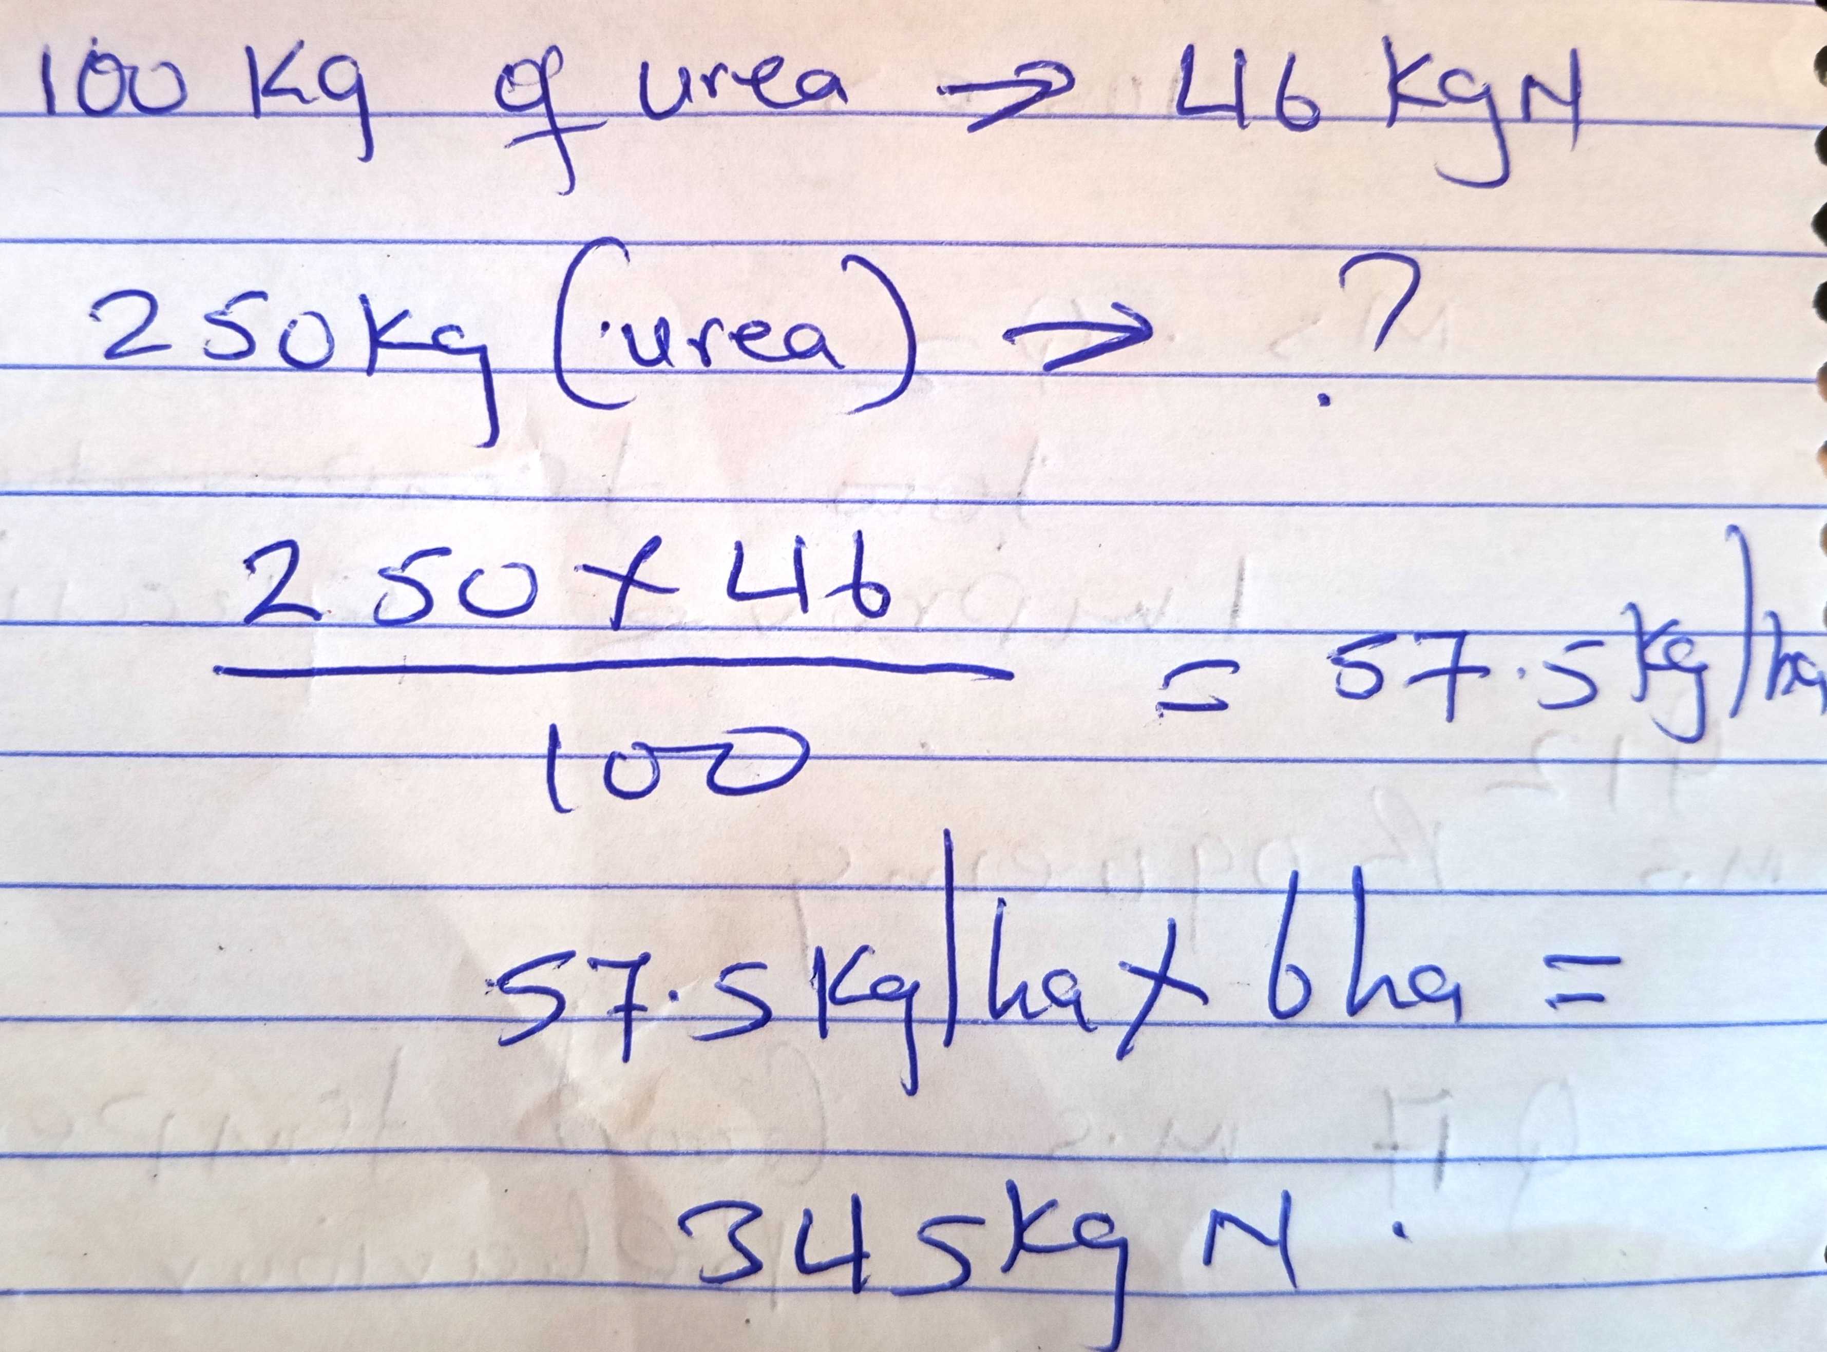

- The table below shows a farm record for Ufanisi Farm.

- Name the farm record illustrated above (1 mk)
- Production records

- State two uses of the farm record shown above. (2 mks)
- Show total yield
- Show yield per unit of each enterprise

- Name two records kept by the Ufanisi farm (2 mks)
- Field operation record
- Consumable goods inventory
- Permanent goods inventory
- Breeding records
- Feeding records
- Health records
- Marketing records
- Labour records
- Master roll records
- Labour utilization analysis

- a). The diagram below illustrates a method of identification in livestock production. Study the diagram and answer the questions that follow.

i). Name the type of identification illustrated above. (1 mk)
- Ear notching
ii). Give the identification number of the animal illustrated in the diagram above.
- 40 (1 mk)
iii). Using diagrams, illustrate how you can identify animals No. 24 and 36 using the above method.(2 mks)
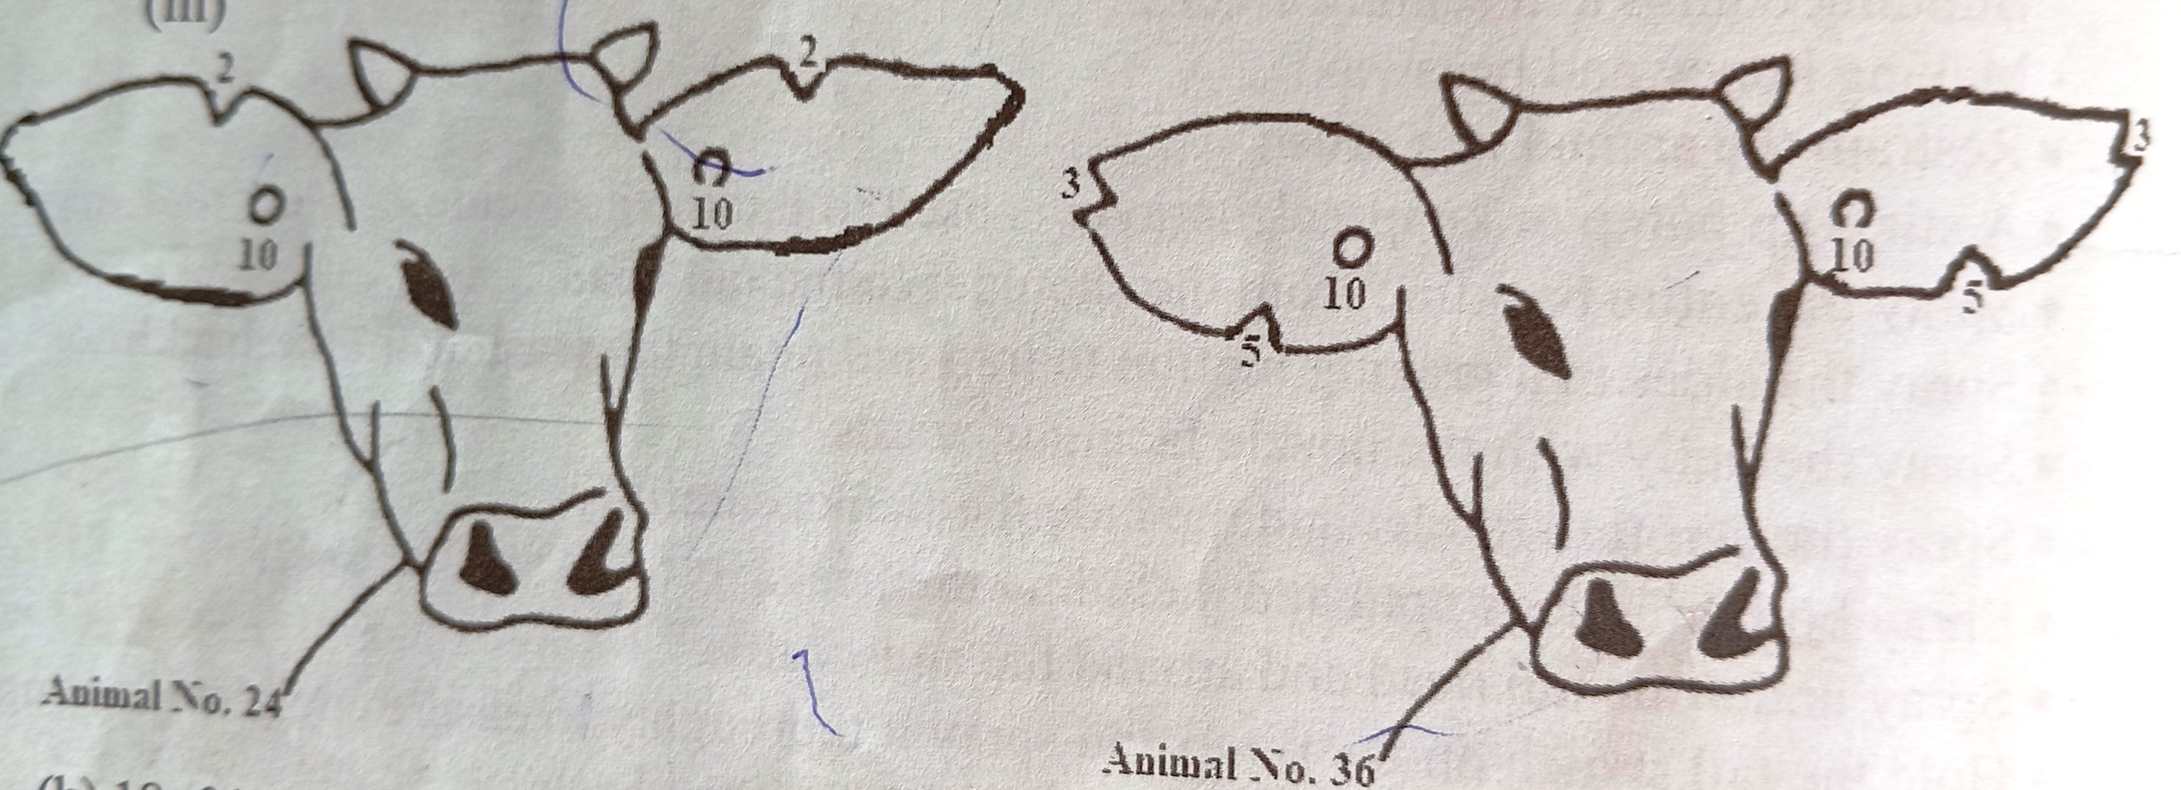
b). If a sow was successfully served on 27th September 2023, state the date she is likely to have furrowed. (2 mks)
- 18 – 01 – 2023 to 20 – 01 – 2023

SECTION C (40 MARKS)
- a). Describe the production of onions under the following sub – headings.
i). Seed bed preparation (3 mks)
- Clear the land – removal of vegetation
- Prepare land early
- Plough / dig deeply and eradicate all weeds
- Harrow to a moderate tilth / fine tilth
ii). Field management (4 mks)
- Thinning in directly planted crops to reduce competition
- Weeding should be done carefully so as not to damage shallow roots
- Remove excess soil from the root region
- Do not compact soil around the bulb
- Top dress with nitrogenous fertilizer / CAN at a rate of 250 kg per Hectre three months after planting.
- Spray with appropriate pesticides to control pests
- Spray with fungicides to control fungal diseases
- Watering during dry spell

iii). Harvesting (3 mks)
- Harvest after 4 – 5 months
- Harvest when leaves start drying
- Dig up the bulbs / lift to dry under a shade
- Turn daily to ensure uniform drying
- Store in slated boxes / nets

b). Explain five advantages of mulching in crop production (10 mks)
- Prevent water evaporation thus maintaining moisture in the soil for crop use
- Acts as an insulation thus modifies or regulates the soil temperature
- Control soil erosion by reducing speed of running water
- Control the weeds by suppressing their growth
- Organic materials are decomposed by soil micro – organisms resulting in to humus that improves soil structure
- Organic materials improve soil fertility

- a). Explain five factors that a farmer should consider when sitting a bee hive to prevent swarming of bees. (10 mks)
- Availability of water – where water is not available in a 3 km, sugar solution is provided
- Availability of flowers
- A sheltered place – beehives should be protected from strong sun and wind
- A place which is free from noise and other disturbances
- Away from human beings and livestock – the apiary should be sited away from homesteads, pastures and busy roads

b). Describe the process of digestion in the following sections in the alimentary canal of a non – ruminant animal
i). Mouth (1 mk)
- Food is chewed into small pieces
- Food is mixed with saliva which lubricates the food
- Salivary amylase – ptyalin converts starch to maltose
ii). Stomach (3 mks)
- Food is mixed with gastric juice / HCL
- HCL provides optimum pH for enzymes / rennin / pepsin activities and kill micro – organisms ingested with food. / HCL activates pepsinogen to pepsin
- Pepsin breaks down proteins to proteases and peptones / peptides
- Rennin coagulates milk to increase the surface for enzyme / pepsin action
iii). Small intestines (6 mks)
- In the duodenum, food is mixed with bile and pancreatic juice (pancreatic amylase, lipase and trypsin)
- Bile emulsifies fat to increase the surface area for enzyme action / it has salts that neutralizes acids
- Pancreatic amylase converts starch to maltose
- Pancreatic lipase converts starch to maltose
- Trypsin converts proteins to peptones and peptides
- In the rest of small intestines, food is mixed with intestinal juice / erepsin / peptidase, maltose, sucrose / invertase and lactase enzymes
- Erepsin / peptidase convert peptodes and peptides to amino acids
- Maltase converts maltose to glucose
- Sucrase (invertase) converts sucrose to glucose and galactose
- Digested food materials are absorbed in the ileum
- Undigested and indigested food materials then move to the large intestines for further digestion

