NAME:……………………………………………………………ADM NO……………….
DATE: ………………….
443
AGRICULTURE
FORM TWO
TIME: 2 HOURS

END OF TERM ONE 2024 EXAMINATION

INSTRUCTIONS TO CANDIDATES:
- This paper consists of three sections; A, B and C
- Answer ALL the questions in sections A, B and C
- All answers to be written in English

FOR OFFICIAL USE ONLY
SECTION | QUESTION | MAX. SCORE | CANDIDATE SCORE
A | 1 – 10 | 40
B | 11 – 14 | 20
C | 15 – 16 | 40
 | TOTAL | 100

SECTION A (40 MARKS)
Answer ALL the questions in section
- Name three forms of horticulture practiced in Kenya (3 mks)
………………………………………………………………………………………………………………………………………………………………………………………………………………………………………………………………………………………………………………………………………………………………………………………………………………………………………………………………………………………………
2.List four problems associated with nomadic pastoralism in Kenya (4 mks) ………………………………………………………………………………………………………………………………………………………………………………………………………………………………………………………………………………………………………………………………………………………………………………………………………………………………………………………………………………………………
3. Give four biotic factors that influence agriculture negatively. (4 mks) ………………………………………………………………………………………………………………………………………………………………………………………………………………………………………………………………………………………………………………………………………………………………………………………………………………………………………………………………………………………………
4. List four reasons why use of fire should be discouraged during land clearing. (4 mks) ………………………………………………………………………………………………………………………………………………………………………………………………………………………………………………………………………………………………………………………………………………………………………………………………………………………………………………………………………………………………
5. a). What is minimum tillage? (1 mk) ………………………………………………………………………………………………………………………………………………………………………………………………………………………………………………
b). Give four reasons for practicing minimum tillage. (4 mks) ………………………………………………………………………………………………………………………………………………………………………………………………………………………………………………………………………………………………………………………………………………………………………………………………………………………………………………………………………………………………
6. List four methods used to drain farm land. (4 mks) ………………………………………………………………………………………………………………………………………………………………………………………………………………………………………………………………………………………………………………………………………………………………………………………………………………………………………………………………………………………………
7. State four roles of organic matter in sandy soil. (4 mks) ………………………………………………………………………………………………………………………………………………………………………………………………………………………………………………………………………………………………………………………………………………………………………………………………………………………………………………………………………………………………
8. State four physical characteristics of beef cattle. (4 mks) ………………………………………………………………………………………………………………………………………………………………………………………………………………………………………………………………………………………………………………………………………………………………………………………………………………………………………………………………………………………………
9. Give four characteristics of nitrogenous fertilizers (4 mks) ………………………………………………………………………………………………………………………………………………………………………………………………………………………………………………………………………………………………………………………………………………………………………………………………………………………………………………………………………………………………
10. State four benefits of nursery bed in cabbage production. (4 mks) ………………………………………………………………………………………………………………………………………………………………………………………………………………………………………………………………………………………………………………………………………………………………………………………………………………………………………………………………………………………………

SECTION B (20 MARKS)
Answer ALL the questions in section
11. The table below shows a format of a farm record.
Date | Amount sold | Price per unit (KShs) | Total value (KShs) | Where sold | Remarks
a). Name the farm record illustrated above. (1 mk) ………………………………………………………………………………………………………………………

b). Give two uses of the farm record shown above (2 mks) ………………………………………………………………………………………………………………………………………………………………………………………………………………………………………………
c). Name any other two farm records kept by the farmer (2 mks) ………………………………………………………………………………………………………………………………………………………………………………………………………………………………………………
12. The diagram below shows a soil sampling method
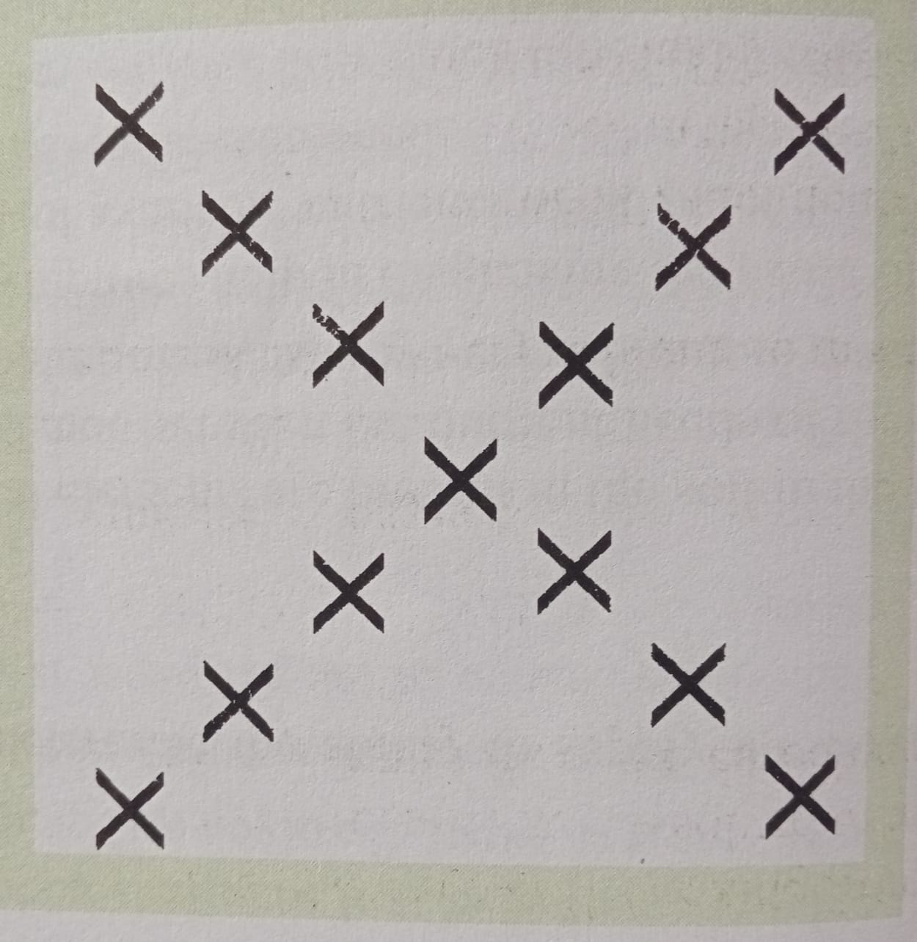

a). Identify the method (1 mk) ………………………………………………………………………………………………………………………
b). State two activities that are carried out during sampling in the field. (2 mks) ………………………………………………………………………………………………………………………
………………………………………………………………………………………………………………………
c). What information should the sample have before being taken to the laboratory? (2 mks) ………………………………………………………………………………………………………………………
………………………………………………………………………………………………………………………
13. Money maker variety of tomatoes are spaced at 100cm X 60cm. Calculate the number of plants which would be accommodated in a 0.5 Ha plot. (5 mks)

14. K, N and M are diagrams of farm tools. Study them and answer the questions that follow.
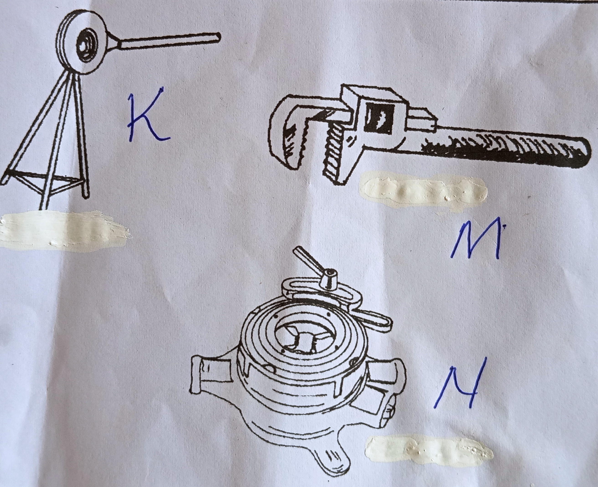
a). Identify the farm tools K, N and M. (3 mks)
K –
N –
M –
b). State the uses of M and N (2 mks)
M –
N –

SECTION C (40 MARKS)
Answer ALL the questions in section
15. a). State and explain five factors that influence spacing of crops. (10 mks) ………………………………………………………………………………………………………………………………………………………………………………………………………………………………………………………………………………………………………………………………………………………………………………………………………………………………………………………………………………………………
………………………………………………………………………………………………………………………………………………………………………………………………………………………………………………………………………………………………………………………………………………………………………………………………………………………………………………………………………………………………
………………………………………………………………………………………………………………………………………………………………………………………………………………………………………………………………………………………………………………………………………………………………………………………………………………………………………………………………………………………………
………………………………………………………………………………………………………………………………………………………………………………………………………………………………………………………………………………………………………………………………………………………………………………………………………………………………………………………………………………………………

b). Describe the process of chemical water treatment. (10 mks) ………………………………………………………………………………………………………………………………………………………………………………………………………………………………………………………………………………………………………………………………………………………………………………………………………………………………………………………………………………………………
………………………………………………………………………………………………………………………………………………………………………………………………………………………………………………………………………………………………………………………………………………………………………………………………………………………………………………………………………………………………
………………………………………………………………………………………………………………………………………………………………………………………………………………………………………………………………………………………………………………………………………………………………………………………………………………………………………………………………………………………………
………………………………………………………………………………………………………………………………………………………………………………………………………………………………………………………………………………………………………………………………………………………………………………………………………………………………………………………………………………………………

16. a). Explain five importance of keeping livestock in Kenya. (10 mks) ………………………………………………………………………………………………………………………………………………………………………………………………………………………………………………………………………………………………………………………………………………………………………………………………………………………………………………………………………………………………
………………………………………………………………………………………………………………………………………………………………………………………………………………………………………………………………………………………………………………………………………………………………………………………………………………………………………………………………………………………………
………………………………………………………………………………………………………………………………………………………………………………………………………………………………………………………………………………………………………………………………………………………………………………………………………………………………………………………………………………………………
………………………………………………………………………………………………………………………………………………………………………………………………………………………………………………………………………………………………………………………………………………………………………………………………………………………………………………………………………………………………

b). Describe the use of various hand tools used by a carpenter. (10 mks) ………………………………………………………………………………………………………………………………………………………………………………………………………………………………………………………………………………………………………………………………………………………………………………………………………………………………………………………………………………………………
………………………………………………………………………………………………………………………………………………………………………………………………………………………………………………………………………………………………………………………………………………………………………………………………………………………………………………………………………………………………
………………………………………………………………………………………………………………………………………………………………………………………………………………………………………………………………………………………………………………………………………………………………………………………………………………………………………………………………………………………………
………………………………………………………………………………………………………………………………………………………………………………………………………………………………………………………………………………………………………………………………………………………………………………………………………………………………………………………………………………………………
………………………………………………………………………………………………………………………………………………………………………………………………………………………………………………………………………………………………………………………………………………………………………………………………………………………………………………………………………………………………
………………………………………………………………………………………………………………………………………………………………………………………………………………………………………………………………………………………………………………………………………………………………………………………………………………………………………………………………………………………………

