FORM 2
AGRICULTURE
SECTION A (40 MARKS)
- Name three forms of horticulture practiced in Kenya (3 mks)
- Floriculture
- Olericulture
- Pomoculture

- List four problems associated with nomadic pastoralism in Kenya (4 mks)
- Draught / aridity
- Diseases and parasites
- Attack by wild animals
- Soil erosion due to overstocking
- Poor pasture species
- Inadequate land
- Give four biotic factors that influence agriculture negatively. (4 mks)
- Pests
- Parasites
- Pathogens
- Predators

- List four reasons why use of fire should be discouraged during land clearing. (4 mks)
- Destroys organic matter
- Kills micro – organisms
- Destroys plant nutrients
- Leads to loss of moisture
- Destroys soil structure
- Destroys plant nutrients
- Causes mineral imbalances
- Leads to soil erosion

- a). What is minimum tillage? (1 mk)
- Application of a combination of farming practices aimed at least disturbance of the soil

b). Give four reasons for practicing minimum tillage. (4 mks)
- Reduces the cost of cultivation
- Controls soil erosion
- Maintain soil structure
- Conserve moisture
- Prevent disturbance of roots and underground structures
- Prevent exposure of humus

6. List four methods used to drain farm land. (4 mks)
- Open ditches
- Underground drain pipes
- French drains
- Cambered beds
- Pumping
- Planting trees

7. State four roles of organic matter in sandy soil. (4 mks)
- Increases water holding capacity
- Improves soil structure
- Reduces leaching
- Increases microbial activity
- Improves nutrients status
- Moderates soil temperature
- Buffers the soil pH

8. State four physical characteristics of beef cattle. (4 mks)
- Blocky in shape
- Deep well fleshed
- Short strong legs
- Grow fast leading to early maturity
- Short thick neck
- Good foragers
- Breed regularly

9. Give four characteristics of nitrogenous fertilizers. (4 mks)
- Highly soluble
- Easily leached
- Short residual effect
- Scorching / burning effect
- Highly volatile
- Hygroscopic
- Highly corrosive

10. State four benefits of nursery bed in cabbage production. (4 mks)
- Production of many seedlings
- Ensures transplanting of healthy and vigorously growing
- Mature fast
- Source of income

SECTION B (20 MARKS)
11. The table below shows a format of a farm record.
Date | Amount sold | Price per unit (KShs) | Total value (KShs) | Where sold | Remarks
a). Name the farm record illustrated above. (1 mk)
- Marketing record

b). Give two uses of the farm record shown above (2 mks)
- Compare performance
- Show history
- Planning and budgeting
- Detect losses / theft
- Assessment of income tax
- Value of farm
- Easy to share profits and losses
- Settling disputes
- Shows whether is making profits or losses
- Supporting insurance claims
- Provide labor information

c). Name any other two farm records kept by the farmer (2 mks)
- Production
- Field operations
- Breeding
- Feeding
- Health
- Labour

12. The diagram below shows a soil sampling method

a). Identify the method (1 mk)
- Traverse
b). State two activities that are carried out during sampling in the field. (2 mks)
- Clearing vegetation and vertical cut 15 – 25cm crop and 5cm pasture
- Take a slice using spade / soil auger
- Put in clean container / polythene bag
- Repeat in several points
- Mix, dry and crush
- Take sub – sample and send to laboratory
c). What information should the sample have before being taken to the laboratory? (2 mks)
- Name and address of farmer
- Field number
- Date of sampling
13. Money maker variety of tomatoes are spaced at 100cm X 60cm. Calculate the number of plants which would be accommodated in a 0.5 Ha plot. (5 mks)
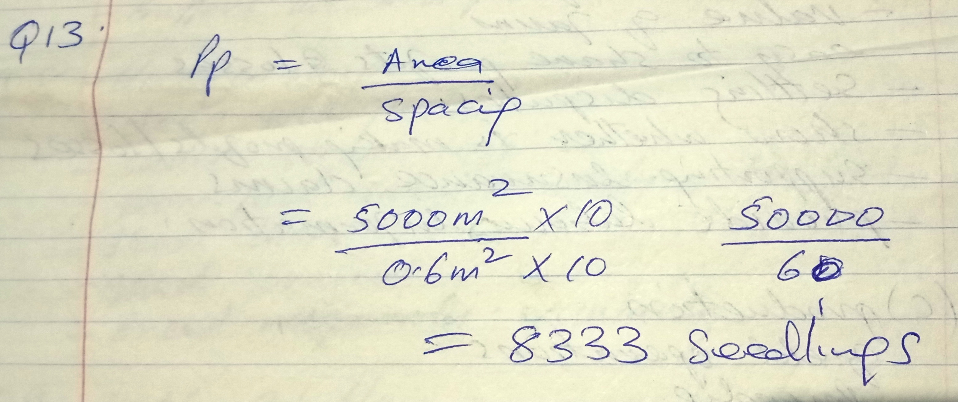
14. K, N and M are diagrams of farm tools. Study them and answer the questions that follow.
a). Identify the farm tools K, N and M. (3 mks)
K – pipe cutter
N – Pipe wrench
M – stock and die
b). State the uses of M and N (2 mks)
M – holding, tightening and loosening metallic pipes
N – for cutting threads on pipes

SECTION C (40 MARKS)
15. a). State and explain five factors that influence spacing of crops. (10 mks)
- Growth habit – crops that tiller, spread, creep, tall require wider space
- Intended use – maize for silage is planted closer spacing than maize for grain
- Type of machinery to use – space required to allow passage
- Soil fertility – fertile soil requires closer spacing
- Moisture content – high moisture allow closer spacing
- Inter – planted crops – require wider spacing
- Pests control – properly space crop make difficult for pest to move i.e. aphids
- Disease control – wider spacing control certain fungal diseases
- Number of seeds planted per hole – more than one seed / plant per hole require wider spacing
b). Describe the process of chemical water treatment. (10 mks)
- Stage 1: Filtration at intake. Water passes through series of sieves trapping / huge particles
- Stage 2: Softening of water: Circulate in tank mixing chamber where it is mixed with soda ash to soften it.
- Stage 3: Coagulation and sedimentation: Alum added to facilitate sedimentation and coagulation, stays for 36 hours
- Stage 4: Filtration: Passes into filtration tank where solid particles are removed
- Stage 5: Chlorination: Enters chlorination tank where small amount of chlorine is added to kill disease agents
- Stage 6: Storage: Stored before entering distribution channels for use.
16. a). Explain five importance of keeping livestock in Kenya. (10 mks)
- Source of food / food supply i.e. meat, eggs, honey
- Source of income / capital – sold to earn income to farmer
- Source of raw materials for industry i.e. skin and hides, wool
- Source of employment – dairy farmers, veterinary officers
- Source of market for industrial goods i.e. acaricides, insecticides, feeds, drugs
- Source of power i.e. draught / pulling animals
- Source of foreign exchange – exported to earn foreign exchange
- Cultural uses – pay dowry, sacrifices, recreation, social ceremonies

b). Describe the use of various hand tools used by a carpenter. (10 mks)
- Saws
- Tape measure
- Wood chisel
- Jack plane
- Wood / rasp file
- Try square
- Brace – bit
- Hand drill
- G – Clamp
- Sash / T – clamp
- Claw hammer
- Mallet
- Screw drivers

