NAME:……………………………………………………………………ADM NO……………….
DATE: ………………….
443
AGRICULTURE
FORM ONE
TIME: 2 HOURS

END OF TERM ONE 2024 EXAMINATION

INSTRUCTIONS TO CANDIDATES:
- This paper consists of three sections; A, B and C
- Answer ALL the questions in sections A, B and C
- All answers to be written in English

FOR OFFICIAL USE ONLY
SECTION | QUESTION | MAX. SCORE | CANDIDATE SCORE
A | 1 – 12 | 50
B | 13 – 15 | 20
C | 16 – 17 | 30
 | TOTAL | 100

SECTION A (50 MARKS)
Answer ALL the questions in section
1.a). Define agriculture (1 mk)
………………………………………………………………………………………………………………………………………………………………………………………………………………………………………………………………………………..……………………………………………………………………………………………
………………………………………………………………………………………………………………………………………………………………………………………………………………………………………………………………………………………………………………………………………………………………………………
b). Give four areas of study that make agriculture a science (4 mks)
………………………………………………………………………………………………………………………………………………………………………………………………………………………………………………………………………………..……………………………………………………………………………………………
………………………………………………………………………………………………………………………………………………………………………………………………………………………………………………………………………………………………………………………………………………………………………………
2. Name four branches of agriculture (4 mks)
………………………………………………………………………………………………………………………………………………………………………………………………………………………………………………………………………………..……………………………………………………………………………………………
………………………………………………………………………………………………………………………………………………………………………………………………………………………………………………………………………………………………………………………………………………………………………………
3. State four methods of farming. (4 mks)
………………………………………………………………………………………………………………………………………………………………………………………………………………………………………………………………………………..……………………………………………………………………………………………
………………………………………………………………………………………………………………………………………………………………………………………………………………………………………………………………………………………………………………………………………………………………………………
4. Give five reasons why agriculture is important in Kenya. (5 mks)
………………………………………………………………………………………………………………………………………………………………………………………………………………………………………………………………………………..……………………………………………………………………………………………
………………………………………………………………………………………………………………………………………………………………………………………………………………………………………………………………………………………………………………………………………………………………………………
5. Give four effects of rainfall in agricultural production. (4 mks)
………………………………………………………………………………………………………………………………………………………………………………………………………………………………………………………………………………..……………………………………………………………………………………………
………………………………………………………………………………………………………………………………………………………………………………………………………………………………………………………………………………………………………………………………………………………………………………

6. Give four advantages of organic farming. (4 mks)
………………………………………………………………………………………………………………………………………………………………………………………………………………………………………………………………………………..……………………………………………………………………………………………
………………………………………………………………………………………………………………………………………………………………………………………………………………………………………………………………………………………………………………………………………………………………………………

7. Differentiate between the following terms
a). Apiculture and aquaculture (2 mks)
……………………………………………………………………………………………………………………………………………………………………………………………………………………………………
b). Olericulture and Pomoculture (2 mks)
……………………………………………………………………………………………………………………………………………………………………………………………………………………………………
8. Identify four farming systems practiced in Kenya (4 mks)
………………………………………………………………………………………………………………………………………………………………………………………………………………………………………………………………………………..……………………………………………………………………………………………
………………………………………………………………………………………………………………………………………………………………………………………………………………………………………………………………………………………………………………………………………………………………………………
9. State four effects of HIV/AIDS and other illnesses on agricultural production (4 mks) ………………………………………………………………………………………………………………………………………………………………………………………………………………………………………………………………………………..……………………………………………………………………………………………
………………………………………………………………………………………………………………………………………………………………………………………………………………………………………………………………………………………………………………………………………………………………………………

10. Give five biotic factors that influence agricultural production (5 mks) ………………………………………………………………………………………………………………………………………………………………………………………………………………………………………………………………………………..……………………………………………………………………………………………
………………………………………………………………………………………………………………………………………………………………………………………………………………………………………………………………………………………………………………………………………………………………………………

11. Outline four ways in which high temperatures affect agriculture in Kenya (4 mks) ………………………………………………………………………………………………………………………………………………………………………………………………………………………………………………………………………………..……………………………………………………………………………………………
………………………………………………………………………………………………………………………………………………………………………………………………………………………………………………………………………………………………………………………………………………………………………………

12. List three aspects of light that influence agricultural production (3 mks) ………………………………………………………………………………………………………………………………………………………………………………………………………………………………………………………………………………..……………………………………………………………………………………………
………………………………………………………………………………………………………………………………………………………………………………………………………………………………………………………………………………………………………………………………………………………………………………

SECTION B (20 MARKS)
Answer ALL the questions in section
13. Study the photograph below and answer the questions that follow
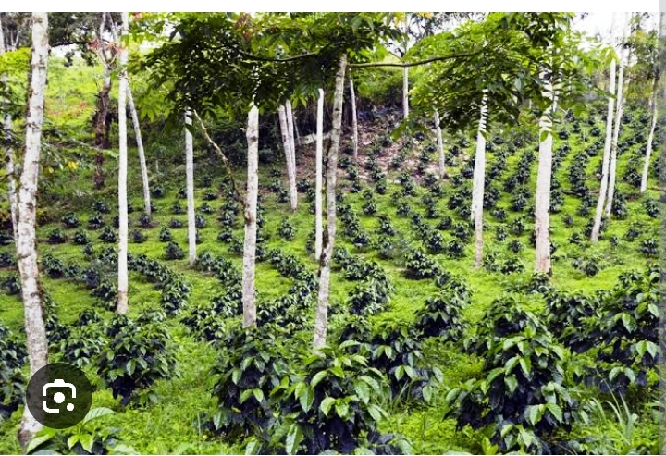

a). Identify the method of farming shown above (1 mk)
………………………………………………………………………………………………………………
b). State four advantages of the above practice (4 mks) ……………………………………………………………………………………………………………………………………………………………………………………………………………………………………………………………………………………………………………………………………
……………………………………………………………………………………………………………………………………………………………………………………………………………………………………………………………………………………………………………………………………

14. The diagram below shows two climatic aspects affecting agricultural production.


A B
a). Identify the aspects labeled A (1 mk)
………………………………………………………………………………………………………………………………………………………………….
b). Give four ways through which aspect A affect crop production (4 mks)
……………………………………………………………………………………………………………………………………………………………………………………………………………………………………………………………………………………………………………………………………
……………………………………………………………………………………………………………………………………………………………………………………………………………………………………………………………………………………………………………………………………
c). Identify four aspects represented by image B. (4 mks) ……………………………………………………………………………………………………………………………………………………………………………………………………………………………………………………………………………………………………………………………………
……………………………………………………………………………………………………………………………………………………………………………………………………………………………………………………………………………………………………………………………………
15. The diagram below shows a feature observed after digging the soil several metres deep. Study it and answer the questions that follow.
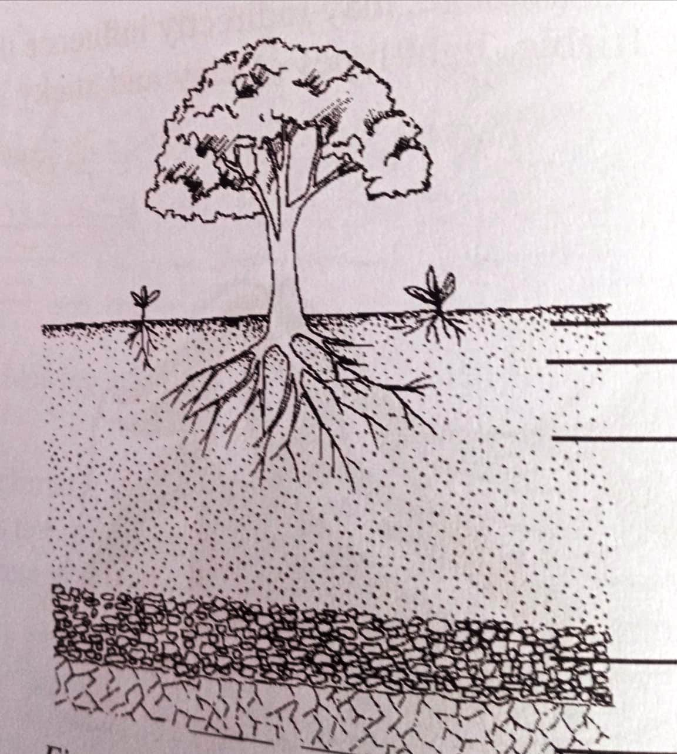
A
B
C

a). Identify the feature (1 mk)
…………………………………………………………………………………………………………………

b). Name the parts of the diagram labeled A, B and C (3 mks)
A
B
C
c). State two importance of soil in crop production (2 mks)
……………………………………………………………………………………………………………………………………………………………………………………………………………………………………………………………………………………………………………………………………

SECTION C (30 MKS)
Answer ALL the questions in section
16. a). Give five advantages of mixed farming. (10 mks) ………………………………………………………………………………………………………………………………………………………………………………………
………………………………………………………………………………………………………………………………………………………………………………………
………………………………………………………………………………………………………………………………………………………………………………………
………………………………………………………………………………………………………………………………………………………………………………………
………………………………………………………………………………………………………………………………………………………………………………………
………………………………………………………………………………………………………………………………………………………………………………………
………………………………………………………………………………………………………………………………………………………………………………………
………………………………………………………………………………………………………………………………………………………………………………………
………………………………………………………………………………………………………………………………………………………………………………………
………………………………………………………………………………………………………………………………………………………………………………………
………………………………………………………………………………………………………………………………………………………………………………………
………………………………………………………………………………………………………………………………………………………………………………………………………………………………………………………………………………………………………………………………………………………………………………

b). i. What is a pest? (1 mk)
………………………………………………………………………………………………………………………………………………………………………………………
ii. Give two examples of pests (2 mks)
………………………………………………………………………………………………………………………………………………………………………………………………………………………………………………………………………………………………………………………………………………………………………………

iii. Give five effects of pests to crop production. (10 mks) ………………………………………………………………………………………………………………………………………………………………………………………
………………………………………………………………………………………………………………………………………………………………………………………
………………………………………………………………………………………………………………………………………………………………………………………
………………………………………………………………………………………………………………………………………………………………………………………
………………………………………………………………………………………………………………………………………………………………………………………
………………………………………………………………………………………………………………………………………………………………………………………
………………………………………………………………………………………………………………………………………………………………………………………
………………………………………………………………………………………………………………………………………………………………………………………
………………………………………………………………………………………………………………………………………………………………………………………
………………………………………………………………………………………………………………………………………………………………………………………
………………………………………………………………………………………………………………………………………………………………………………………
………………………………………………………………………………………………………………………………………………………………………………………………………………………………………………………………………………………………………………………………………………………………………………
………………………………………………………………………………………………………………………………………………………………………………………

17. a). Differentiate between monocropping and intercropping (2 mks) ………………………………………………………………………………………………………………………………………………………………………………………
………………………………………………………………………………………………………………………………………………………………………………………
b). Mention five field crops. (5 mks)
………………………………………………………………………………………………………………………………………………………………………………………
………………………………………………………………………………………………………………………………………………………………………………………………………………………………………………………………………………………………………………………………………………………………………………
………………………………………………………………………………………………………………………………………………………………………………………………………………………………………………………………………………………………………………………………………………………………………………
………………………………………………………………………………………………………………...…………………………………………………………………

