COMPETENCE BASED CURRICULUM
7
2024
JUNIOR SCHOOL
SOCIAL STUDIES Question paper
TIME
2 HRS 15 MINS
SCHOOL: …………………….………………………………………………..…
NAME: …………………………….…………….…..………………………...…
ASSESSMENT NO: ………….……. SIGN: …..……..... DATE: ………..….
RUBRICS (for official use)
MARK SCORE RANGE | Below 40 | 40-59 | 60-79 | 80-100
PERFORMANCE LEVEL | Below expectation | Approaching expectations | Meeting expectations | Exceeding expectations

OUT OF | 100%
LEARNERS SCORE
PERCENTAGE SCORE
PERFORMANCE LEVEL

FOR FACILITATOR’S USE ONLY

INSTRUCTIONS TO CANDIDATES
- Answer all the questions in the spaces provided.
- Ensure your work is neat.

- State three components of social studies? (3 mks)
- ………………………………………
- ………………………………………
- ……………………………………….

- Study the diagram on structure of the earth (internal and external) below and answer the questions that follow.

A
C

D.
B

- Name the regions marked A,B,C and D. (4 mks)
- Write two effects of rotation and revolution of the earth. (4 mks)
Rotation of the Earth | Revolution of the Earth

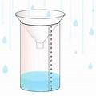
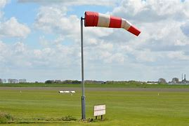
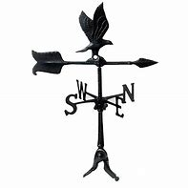
- Identify the following weather measuring instruments. (3 mks)

- Give one example of Communities in each of the groups below. (5 mks)
Bantu | Nilotes | Cushites | Europeans | Asians
- The total number of people living in an area if referred to as ……………………………. (1 mk)

- Name the places in Kenya where the following minerals are mined ;(3 mks)
Mineral | Place mined
Soda ash
Fluorspar
Diatomite

- State two factors to consider when siting a weather station.(2 mks)
- …………………………………………………………………………..
- ………………………………………………………………………….
- An area with high population is said to be …………………..populated whereas an area with low population is said to be ……………populated. (2 mks)
- The way of life and doing thing in a community is known as ………………………… (1 mk)
- List two aspects of culture in most of our communities; (2 mks)
- ……………………………………………………………..
- ……………………………………………………………….
- List four elements of weather; (4 mks)
- …………………………………………..
- …………………………………………..
- …………………………………………..
- ………………………………………….
- Monuments, museums, historic buildings and cultural centres are referred to as……………..………………………………. (1 mk)
- Large carvings and models that remind us of our past heroes like Jomo Kenyatta are known as …………………………………… (1 mk)
- Name the capital cities of the following African countries.(2 mks)
- Burundi …………………………..………….
- Morocco …………………………………….

- Write the meaning of the following road signs.(3 mks)
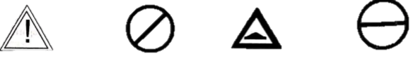

- Name any two facts about planet earth.(2 mks)
- ……………………………………………………………………….
- ………………………………………………………………………..
- The sun is overhead the equator on dates. (2 mks)
- ……………………………………………..
- ……………………………………………..
- The atmosphere consists of? (3 mks)
- …………………………………..
- ………………………………….
- ………………………………….
- The growing of fruits and vegetables is called ………………….(1 mk)
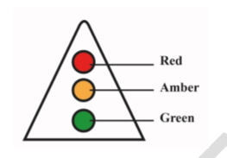
- Timothy came across the road sign below at a junction. The sign turned red. What action should he take?(1 mk)
………………………………………

- Name the important lines of latitude in Africa. (3 mks)

- ………………………………………..
- ……………………………………….
- ………………………………………..

A plane took off in Freetown 15⁰ W at 7am local time. What is the local time in Cape Town, 18⁰ E (5mks)

- State three importance of maps in day to day lives. ( 3 mks)

- …………………………………………………………………………
- …………………………………………………………………………
- …………………………………………………………………………

- Identify the following maps. (3 mks)
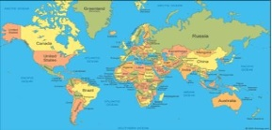
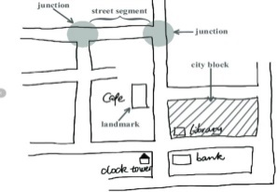
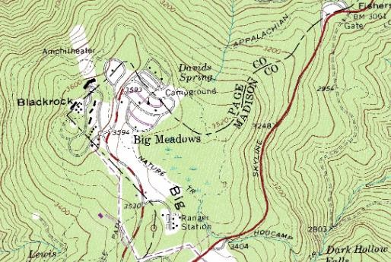

- State three components of the solar system. (3 mks)
- ………………………………………..
- ………………………………………..
- ………………………………………..
- Identify the following planets. ( 8mks)
    - Evening star-………………………………….
    - Red planet-……………………………………
    - Giant planet-…………………………………..
    - Life’s planet-………………………………….
    - Smallest planet-……………………………….
    - Ringed planet-………………………………..
    - Bellied planet-…………………………….
    - Coldest planet-…………………………….

- Name any two theories explaining the origin of the earth.( 2 mks)
- …………………………………………………………………….
- …………………………………………………………………….
- Discuss the origin of the solar system under any of the theories you have listed above,( 5 mks)
………………………………………………………………………………………………………………………………………………………………………………………………………………………………………………………………………………………………………………………………………………………………………………………………………………………………………………………………………………………………………………………….……………..

- State three names that describes the shape of the earth. ( 3 mks)
- ……….…………………………
- ………………………………….
- ………………………………….
- List down three proofs that the earth is spherical ( 3 mks)
- …………………………………………………………………..
- ………………………………………………………………….
- …………………………………………………………………
- State four Effects of Rotation of the Earth (4 mks)
- …………………………………………………………………
- …………………………………………………………………
- …………………………………………………………………
- …………………………………………………………………

State three ways the Rotation of the Earth affects human activities. (3mks)
Effects of Rotation | How rotation affects human activities

THIS IS THE LAST PRINTED PAGE
……………….Every learner counts …………

