COMPETENCE BASED CURRICULUM
7
2024
JUNIOR SCHOOL
SOCIAL STUDIES
MARKING SCHEME

Please Note:
Facilitators are advised to go through the marking scheme as answers given could not be exhaustive.
- State two components of social studies? (3 mks)
- History
- Geography
- Citizenship
- Life skills
- Study the diagram on structure of the earth (internal and external) below and answer the questions that follow.

A Core
C Crust

D. Atmosphere
B Mantle

- Name the regions marked A,B,C and D. (4 mks)

- Write two effects of rotation and revolution of the earth. (4 mks)
Rotation of the Earth | Revolution of the Earth
Causes day and night | Causes seasons
Causes winds and ocean currents to change direction | Causes varying lengths of days and nights
Causes rising and falling of ocean tides | Causes changes in position of the midday sun

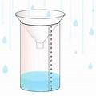
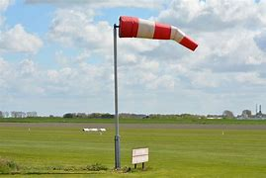
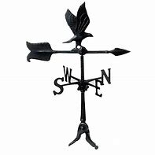
- Identify the following weather measuring instruments. (3 mks)

Windsock
Raingauge
Windvane

- Give one example of Communities in each of the groups below. (5 mks)
Bantu | Nilotes | Cushites | Europeans | Asians
Kikuyu | Maasai | Somali | Americans | Indians
Ameru | Kipsigis | Borana | British | Chinese
Abagusii etc | Jemps etc | Rendile etc | Italians etc | Arabs etc
- The total number of people living in an area if referred to as Population (1 mk)

- Name the places in Kenya where the following minerals are mined ;(3 mks)
Mineral | Place mined
Soda ash | Lake Magadi in Magadi
Fluorspar | Kimwarer In Kerio Valley
Diatomite | Kariandusi Near Gilgil

- State two factors to consider when siting a weather station.(2 mks)
- The area should be flat and away from tall buildings and trees.
- The area should be accessible
- The area should have good security etc
- An area with high population is said to be densely populated whereas an area with low population is said to be sparsely populated. (2 mks)
- The way of life and doing thing in a community is known as Culture. (1 mk)
- List two aspects of culture in most of our communities; (2 mks)
- Greeting
- Food
- Dressing
- House
- Gender Roles
- Economic Activity
- Animals kept Etc
- List four elements of weather; (4 mks)
- Sunshine
- C. Wind
- Temperature
- Rainfall/Precipitation Any Other Correct
- Monuments, museums, historic buildings and cultural centres are referred to as
Historic Built Environments (1 mk)
- Large carvings and models that remind us of our past heroes like Jomo Kenyatta are known as Monuments/statutes (1 mk)
- Name the capital cities of the following African countries.(2 mks)
- Burundi Bujumbura
- Morocco Rabat

- Write the meaning of the following road signs.(3 mks)

Proceed with caution
Danger ahead
No entry
Bumps ahead

- Name any two facts about planet earth.(2 mks)
- It supports life, it the only planet with people and vegetation
- It’s a blue planet has liquid water, has oxygen, takes 24 hr to make a complete rotation
- It is the third planet from the sun, takes approximately 149m km from sun
- It is an inner/ terrestrial planet, takes 3661/4 days to make a complete revolution
- The sun is overhead the equator on dates. (2 mks)
- 21st March
- 23rd September
- The atmosphere consists of? (3 mks)
- Water vapour
- Gases
- Dust particles
- Clouds smoke particles
- The growing of fruits and vegetables is called horticulture(1 mk)
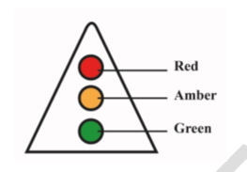
- Timothy came across the road sign below at a junction. The sign turned red. What action should he take?(1 mk)
Stop where he is and wait

- Name the important lines of latitude in Africa. (3 mks)

- Tropic of cancer
- Equator
- Tropic of Capricorn

A plane took off in Freetown 15⁰ W at 7am local time. What is the local time in Cape Town, 18⁰ E (5mks)

Calculate the number of degrees between Freetown and Cape Town. 150 + 180 =330.

Calculate the time difference between the two cities. If 3600 = 24 hrs.

Then 330 =?

33x24÷ 360

=2 hrs. 12 minutes.

Since Cape Town is to the east of the Greenwich meridian, it means the city is a head of Freetown.

Therefore, to get time in Cape town, add the time difference to Freetown local time.

7.00 am + 2hrs 12 minutes= 9.12 am (Cape Town local time)

- State three importance of maps in day to day lives. ( 3 mks)

- Sketch maps are used to summarize information for easy reference.
- Used for locating other countries.
- Used for comparing sizes of countries.
- For locating climatic regions of different parts of the world.
- Give information on distribution of geographical phenomena e.g. vegetation on the earth’s surface.
- Help travellers to find their way.
- Used to calculate distance of a certain place.
- Used to locate physical features like landforms.

- Identify the following maps. (3 mks)
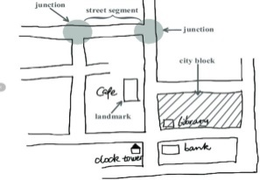
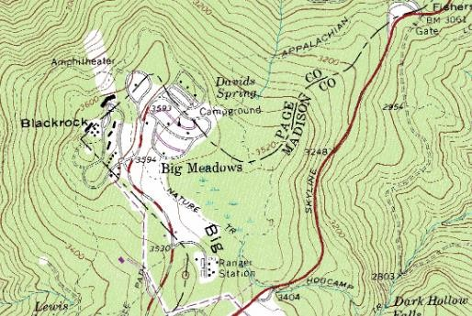
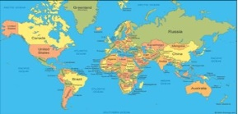

Topographical map Atlas map A sketch map.
- State three components of the solar system. (3 mks)
- 8 planets
- Dwarf planets
- Moons
- Asteroids
- Comets
- Meteors
- Meteorites
- Sun

- Identify the following planets. ( 8mks)
    - Evening star-Venus
    - Red planet-Mars
    - Giant planet-Jupiter
    - Life’s planet-Earth
    - Smallest planet-Mercury
    - Ringed planet-Saturn
    - Bellied planet-Uranus
    - Coldest planet-Neptune

- Name any two theories explaining the origin of the earth.( 2 mks)
- Passing star theory
- Nebula cloud theory
- Big bang theory
- Supernova theory
- Discuss the origin of the solar system under any of the theories you have listed above,( 5 mks)
The passing star theory
- A star with a greater gravitational pull passed near the sun
- It attracted large quantities of gaseous materials from the sun
- The materials split, cooled and condensed to form planets
- The planets were set in orbit by the passing star

The nebula cloud theory
- There was a slowly rotating cloud of dust and gas called Nebula. This caused high concentration of materials at the center that formed the sun.
- Rotation speed increased and successive rings of gaseous materials were formed.
- The rings condensed to form planets.
- The materials grew in size enough to exert their own gravitational pull.
- The central gaseous material remained as the sun

- State three names that describes the shape of the earth. ( 3 mks)
- Geoid
- Ovoid
- Oblate-spheroid
- List down three proofs that the earth is spherical ( 3 mks)
- circumnavigation
- Approaching ship
- earth rotates from west to East
- Eclipse of the moon
- Earth curved horizon
- All other planets are round
- State four Effects of Rotation of the Earth (4 mks)
- Creates day and night because at any one time one side of the earth faces the sun (day) and the other remains in darkness (night).
- Causes deflection of winds and ocean currents in the N hemisphere to the left and in the S hemisphere to the right.
- It causes rising and falling of ocean tides.
- Causes time difference between longitudes.
- Lowest altitude during solstices.
- Causes lunar eclipse due to revolution bringing the earth in line with the sun and the moon.

State three ways the Rotation of the Earth affects human activities. (3mks)
Effects of Rotation | How rotation affects human activities
Day and night | Planning day and night activities
High and low tides | Helps in fishing activities Sea transport –
Deflection of winds and ocean currents | Triggering of cyclones, hurricanes and tornadoes for example the deflection cause pressure changes which affect ocean currents and movement of wind Growing of crops Aviation or sea transport Causes flooding
Time difference | Travelling Education Sports

THIS IS THE LAST PRINTED PAGE
……………….Every learner counts …………

