COMPETENCE BASED CURRICULUM
7
2024
JUNIOR SCHOOL
PRETECHNICAL STUDIES Question paper
TIME
2 HRS 15 MINS
SCHOOL: …………………….……….………………………………………..…
NAME: …………………………….…………………………..…………………..
ASSESSMENT NO: ………….……. SIGN: …..……..... DATE: ………..….
RUBRICS (for official use)
MARK SCORE RANGE | Below 40 | 40-59 | 60-79 | 80-100
PERFORMANCE LEVEL | Below expectation | Approaching expectations | Meeting expectations | Exceeding expectations

OUT OF | 100%
LEARNERS SCORE
PERCENTAGE SCORE
PERFORMANCE LEVEL

FOR FACILITATOR’S USE ONLY

INSTRUCTIONS TO CANDIDATES
- Answer all the questions in the spaces provided.
- Ensure your work is neat.

- Give two examples of Metals. (2 mks)
- …………………………………
- …………………………………
- Name three examples of Non-metals. (3 mks)
- ……………………
- ……………………
- ……………………
- Distinguish between metallic and Non-metallic materials.( 8 mks)

Metallic materials | Non-metallic materials

- Describe Physical properties of materials.(6 mks)
  - ………………………………………………………………………………
  - ………………………………………………………………………………
  - ………………………………………………………………………………
  - ………………………………………………………………………………
  - ………………………………………………………………………………
  - ………………………………………………………………………………

- State three Careers related to materials in the locality. ( 3 mks)
- ……………………………………….
- ………………………………………
- ……………………………………..

- State four importance of different materials found in the locality?(4 mks)
- …………………………………………………………………..
- ……………………………………………….…………………..
- ……………………………………………………………………
- ……………………………………………………………………
- State two physical properties of ferrous metals include?( 2 mks)
- ………………………………………………………………………………..
- ………………………………………………………………………………..

- Identify two physical properties of non-ferrous materials include? (2 mks)
- ……………………………………………………………………………………
- ……………………………………………………………………………………

- State two Careers related to use of metals. ( 2 mks)
- …………………………………………
- …………………………………………..

- Distinguish between synthetic and natural non-metallic materials. ( 6 mks)

 | Natural non-metallic materials | Synthetic non-metallic materials
1
2
3
- State the Careers related to the Processing and use of non-metallic materials.( 5 mks)
- ……………………………………………………………
- …………………………………………………………..
- …………………………………………………………..
- …………………………………………………………..
- …………………………………………………………

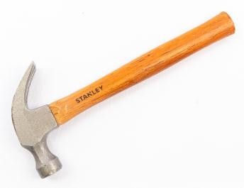
- Identify the following household tools. ( 7 mks)
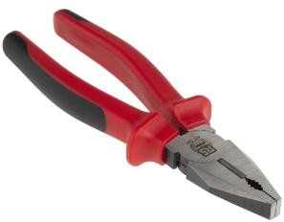
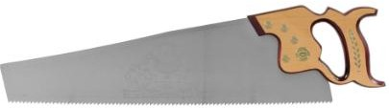
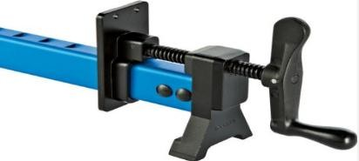
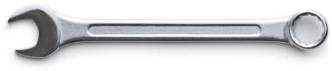

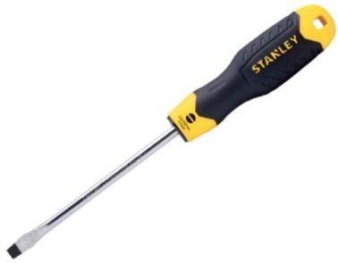

- What is the Importance of entrepreneurship to the Kenyan economy? Mention five. (6 mks)
- ……………………………………………………………..…………
- ……………………………………………………………..…………
- ……………………………………………………………..…………
- ………………………………………………………………………..
- ………………………………………………………………………..
- ………………………………………………………………………..
- What are Personal goals? (2mks)
…………………………………………………………………………………………………………………………………………………………
- State three Importance of setting personal goals for self-development. (4mks)
- ..........................................................................................................
- …………………………………………………………….………..
- ………………………………………………………………………

- State five factors to consider when setting personal goals for self-development. (5mks)
- ………………………………………………………………………
- ………………………………………………………………………
- ………………………………………………………………………
- ………………………………………………………………………
- ………………………………………………………………………

- Define Talents and abilities. (2mks)
…………………………………………………………………………………………………………………………………………………………

- Distinguish between talents and abilities of learners in school
Give at least four Differences. (4mks)

Talent | Ability

- State five Ways of nurturing talents and abilities. (5 mks)
- ………………………………………………..……………………..
- ………………………………………………………………………
- ………………………………………………………………………
- ………………………………………………………………………
- ………………………………………………………………………

- State four Ethical issues related to the use of talents and abilities in business. (4mks)
- ………………………………………………………………………
- ………………………………………………………………………
- ………………………………………………………………………
- ………………………………………………………………………
- Define :Business environment (2 mks)
……………………………………………………………………………………………………………………………………………………
- Distinguish Needs and wants as used in business studies (6mks)

Needs | Wants

- State 5 Characteristics of an entrepreneur. (5 mks)
- …………………………………………………………………….….
- ………………………………………………………………………..
- ……………………………………………………………………….
- ……………………………………………………………………….
- ……………………………………………………………………….

- Mention five Sources of Business Ideas. (5 mks)
- ………………………………………………………………………
- …………………………………………………………………….
- ……………………………………………………………………..
- …………………………………………………………………….
- ………………………………………………………………………

- Explain the procedure for Shutting down a computer. (4 mks)
- ……………………………………………………………………….
- ……………………………………………………………………….
- ……………………………………………………………………….
- ……………………………..………………………………………...

Identify three facilities that will ensure proper ventilation in a room. (3 mks)

……………………………………………………………………………

………………………………………………………………………..…

……………………………………………………………………….…

- State three Safety precautions and practise in the computer user environment. (3 mks)
- ……………………………………………………………………………
- ……………………………………………………..…………………..…
- ……………………………………………………………………………

Why must foods and beverages be kept out of the computer room? (2 mks)

……………………………………………………………………

…………………………………………………………………..
- Why would it not be good to install Powder or Water – based fire extinguishers in the computer room? (2 mks)
  - ………………………………………………………………………….
  - ………………………………………………………………………….

State two reasons why a computer needs to be connected to a stable power supply (2 mks)

……………………………………………………………………………..…

………………………………………………………………………………..

List down four functions of the uninterruptible Power Supply (UPS) (4 mks)

…………………………………………..…….………………………………

…………………………………………….…………………………….……

………………………………………………………………………..………

……………………………………………………………………………...…

Mention three things that are likely to cause strain- in the computer room. (3 mks)

…………………………………………………………………………….…

………………………………………………………………………………

……………………………………………………………………………..

Identify three proper sitting postures while using the computer. (3 mks)

…………………………………………………………………….………

……………………………………………………………………………

…………………………………………………………………….……..
- State two Characteristics of the 3rd generation computers. (2 mks)
- ………………………………………………………………………….
- ………………………………………………………………………….
- Name one Example of the 3rd generation computers. (1 mk)
- ……………………………..……………
- …………………..………………….…..

- Name three resources that are used for setting up a computer user environment. (3 mks)
- ……………………………………………………………..………………
- ………………………………………………………………………………
- ……………………………………………………………………………..

- Name the following keys of a computer keyboard. (4 mks)

State two methods of minimizing dust in a computer laboratory. (2 mks)

………………………………………………………………………………

…………………………………………………………………………..….

Name three main causes of fire in the computer laboratory and give the precautions that should be taken to guard against them. (3 mks)

…………………………………………………………….…………………

………………………….…………………………………………………..…

…………………………………………………………………………….….
- Name two Examples of computers. (2mks)
- ……………………………………………………………………………
- ……………………………………………………………………………

THIS IS THE LAST PRINTED PAGE
……………….Every learner counts …………

