COMPETENCE BASED CURRICULUM
7
2024
JUNIOR SCHOOL
PRETECHNICAL STUDIES
MARKING SCHEME

Please Note:
Facilitators are advised to go through the marking scheme as answers given could not be
exhaustive.

- Give two examples of Metals. (2 mks)
- Copper.
- Iron.
- Aluminum.
- Steel.
- Silver among others.
- Name three examples of Non-metals. (3 mks)
- Wood.
- Stones.
- Textile.
- Soil.
- Glass.
- Leather.
- Plastic.
- Rubber.
- Water.
- Air

- Distinguish between metallic and Non-metallic materials.( 8 mks)

Metallic materials | Non-metallic materials
Some rust | They do not rust.
They have definite shape. | Liquids and air do not have a definite shape  but solids have a definite shape.
They produce a sharp loud sound on  knocking. | They produce a dull sound on knocking.
They are more reflective. | They are less reflective, except glasses.
They are generally smooth. | They are generally more rough when not  polished.
They heat up faster when put under the sun. | They heat up slowly.
They are hotter than non-metals when under  the sun. | They are cooler than metals when put under  a shade.
They cool faster when put under a shade. | They cool slowly when put under a shade.
They are colder than non-metals under cold  weather. | They are warmer than metals under cold  weather.
They are not easy to break. | They are easier to break than metals.

- Describe Physical properties of materials.(6 mks)
  - Shape
Solid material such as stones and metals have definite shape.
Liquids and gaseous materials do not have a definite shape of their own. They take any shape of the container in which they are stored in.
  - Appearance
Material have different colours, texture and reflection. For example, materials such as wood, stone and soil are rough.
  - Feel
Some materials have surface that feel smooth such as metals and glasses while other like wool is tenderer than sand and glasses are smooth and shiny.
  - Hardness
The ability of a material to resist scratching. Some materials are harder than others. For example, a stone is harder than timber.
  - Fire resistance
Some materials like metals, stones and clay do not burn. Other materials like those from plants and animals burn.

- State three Careers related to materials in the locality. ( 3 mks)
- Making of items from different such as a potter, weaver and blacksmith.
- Extraction and production of materials such as mining, quarrying, concrete production etc.
- Preparation of materials as cotton ginnery, tanning of hides and skin etc.
- Marketing and selling of materials such as hardware shop, textile shops and products outlets etc.

- State four importance of different materials found in the locality?(4 mks)
- Materials are used to produce parts, components and products.
- They are also used to build infrastructure, buildings and landscapes.
- Materials can also be used as raw materials in farming and other manufacturing process.
- Materials are consumed as food.
- Materials create job opportunities and careers.

- State two physical properties of ferrous metals include?( 2 mks)
- Magnetism-ferrous metals are highly attracted to a magnet.
- Heat conductivity- ferrous metals are better conductors of heat than non-ferrous materials.
- Appearance-ferrous metals have a silvery colour.
- Electricity conductivity – ferrous metals are poor conductors of electricity than non-ferrous metals.

- Identify two physical properties of non-ferrous materials include? (2 mks)
- Magnetism-non-ferrous metals are not magnetic.
- Heat conductivity- non-ferrous metals are poor conductors of heat than ferrous metals.
- Appearance- non-ferrous metals like gold have a more colorful appearance than ferrous metals.
- Electricity conductivity- non-ferrous metals like copper are better conductors of electricity than ferrous metals.

- State two Careers related to use of metals. ( 2 mks)
- Making of items from different metals such as a welding, fabrications and blacksmith, among others.
- Extraction of metals such as mining.
- Processing of metals such as metal smelting.
- Marketing and selling metals and metal products such as hardware among others.

- Distinguish between synthetic and natural non-metallic materials. ( 6 mks)

 | Natural non-metallic materials | Synthetic non-metallic materials
1 | Natural materials like skin or bark depends on the length and size of the  animal or plant form which it is taken. | The length or size of synthetic material can be adjusted according to the needs.
2 | The shape of a natural material is similar to the shape of the source from  which it is got. | The shape of synthetic material can be adjusted to the needs.
3 | Items made from natural fiber such as  wool and cotton are soft and very comfortable to wear. | Items made from synthetic fibre are less comfortable.
4 | Natural materials are in their original  colour and they do not fade easily. | Synthetic materials are dyed to change their  colours as desired and they easily fade.
5 | Most of materials are not easily  damaged by water. | Most synthetic materials are easily damaged  by water.
- State the Careers related to the Processing and use of non-metallic materials.( 5 mks)
- Making of items from different non-metallic materials such as curving, pottery, moulding and shoe making among others.
- Extraction of non-metallic materials such as quarrying.
- Processing of non-metallic materials such as tanning of skins and baking of bricks.
- Merchandising in non-metallic materials such as boutique and timber yard.
- Rope making. Rope makers harvest sisal fibres, dry and use them to make ropes
- Building and constructions. Builders use timber, grass, clay and other materials to construct houses.
- Brick making. Brick makers make bricks from clay soil.
- Logging. Loggers are authorised to cut trees selectively from a given area to get logs.
- Saw milling. Saw millers cut the logs into timber or shapes them into boards.
- Carpentry. Carpenters use timber and boards to make furniture and other useful items.
- Pottery. Potters make pots and other earthen items. Some potters may also use of cement or concrete to make flower pots and flower vases
- Weaving. Weavers make baskets, mats brooms, and other items from grasses and reeds. Plastic straws can also be made in weaving
- Farming. Crop farmers cultivate the soil using hand tools or farm machinery and plants crops into it.
- Glass smithing. This is a career where people are involved in making objects out of glass
- Shoe making. Shoe makers make shoes from non-metallic materials like leather, rubber and plastic.

- Identify the following household tools. ( 7 mks)
 | House hold tool | photograph
1 | Screwdriver. | 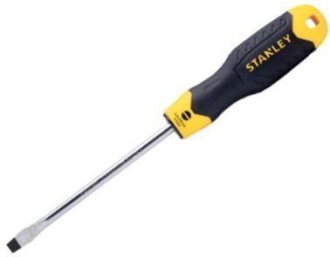
2 | Tape measure. | 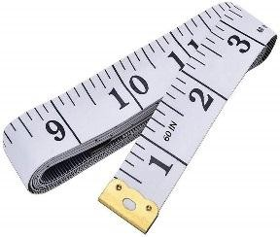
4 | Pliers | 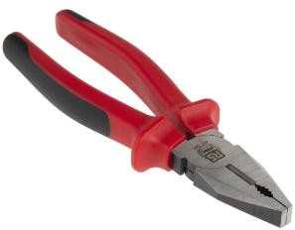
5 | Hand saw. | 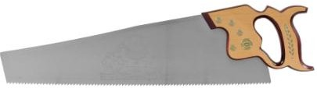
6 | Hammer. | 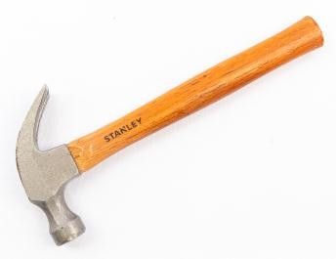
7 | Spanner | 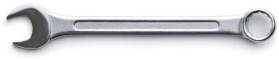
8 | Clamp | 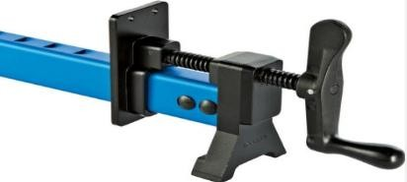

- What is the Importance of entrepreneurship to the Kenyan economy? Mention five. (6 mks)
- Creation of employment-Through entrepreneurship, jobs are created which help in absorbing people who would otherwise have been jobless e.g. people employed in the jua kali sector.
- Formation of capital-Profit earned by entrepreneurs may be used to expand the business or even to start other businesses. Wages and salaries paid to the employees is a source of capital to them.
- Raising standards of living-Entrepreneurs pay wages and salaries to their employees which enable them to acquire goods and services they need to live comfortable lives. Entrepreneurs also provide a wide variety of goods and services to consumers hence leading to improved living standards.
- Encourages the use of local resources-Entrepreneurship makes it possible to use/exploit local resources. Idle resources such as scrap metal may be used to make jikos.
- Improving infrastructure-The existence of businesses in the economy makes the government establish or improve infrastructure such as roads, communication facilities and water. At other times, entrepreneurs may combine forces to improve infrastructure in their area of operation.
- Savings on imports-Local entrepreneurs are able to produce goods and services that are a substitute to imports. This helps the country to reduce the amount of money required to pay for such imports.
- Reducing foreign dominance of the economy-Participation of local entrepreneurs in various business activities helps in reducing investments by foreigners in the particular area.
- Promotion of technology/promotion of innovation, research and development-Entrepreneurs are creative and they come up with new and better ways of accomplishing tasks. Most of the inventions and innovations in our society have been developed by entrepreneurs.
- Promotion of entrepreneurial culture/helps in the creation of role models- Successful entrepreneurs/entrepreneurial ventures encourage other members of society to initiate their own businesses and hence act as role models in the business world.
- It contributes to government revenue-Taxes and fees paid by entrepreneurial ventures constitute part of government revenue / income that helps it to facilitate its operations.
- It promotes economic growth-Entrepreneurs produce goods and services. This increases the volume of goods and services in the economy leading to expansion of the economy.
- It may promote self-actualization and esteem-By initiating businesses in which they are their own bosses, entrepreneurs pride is boosted and this may promote the overall productivity of the economy.

- What are Personal goals? (2mks)
A goal is an aim that someone tries to achieve through hard work and planning.
A personal goal is an aim that is meant to motivate a person to achieve what they want in life.
They can be short term or long term.
- State three Importance of setting personal goals for self-development. (4mks)
- Provides a clear path to success.
When one sets goals, they give him or her steps to follow so that tasks are completed according to importance.
- Helps improve time management and organisation skills.
If one knows exactly what he or she wants to achieve and knows the steps required to achieve it, there isles room for delaying or postponing.
- Increase motivation
When we achieve one short term goal after the other, we become motivated and work even harder.
- Measures progress.
Setting clear goals makes it easier for one to track his or her progress.
- Gives focus and purposes
Setting goals determines a clear pathway to success, allowing one to focus on what needs to get done.
- Boost self-confidence.
When one starts making progress towards achieving his or her goals, one starts to believe in themselves and become more confident.

- State five factors to consider when setting personal goals for self-development. (5mks)
- Specific
The goal should be very precise with no room for misinterpretation.
- Measurable
The progress of the goal set should be easy to track
- Achievable
The goal should be attainable. Set goals that can actually be done.
- Relevant
The short term goal should contribute to your broader goal.
- Realistic
Goals should relate to your personal strengths and abilities
- Time bound
The goal should have a defined start and end date
NB
SMART

- Define Talents and abilities. (2mks)
A talent is an inborn or natural ability to be good at something especially without being taught.
It is something you are naturally good at and you enjoy doing like drawing, singing, dancing
Ability is the skill to do a particular task that is acquire through learning training or practise.

- Distinguish between talents and abilities of learners in school
Give at least four Differences. (4mks)
- Talent is an inborn special skill while ability is a skill acquired by a person through training and experience.
- Talent is God given gift while ability is a skill in which you put your effort and time to develop.
- Talent is often possessed by a few people while ability can be acquired by any person who is interested.
- Talent require coaching while ability require training.
- Talent is hidden and needs recognition while ability requires development
- State five Ways of nurturing talents and abilities. (5 mks)
- Nurturing talent and abilities involves offering ways to promote and encourage people to develop their skills and demonstrate their talents.
- Everyone has a talent. However it is important to be in environments that help us discover them early as possible.
- Once we have identified our talents and abilities, we should demonstrate and improve them as much as possible. Skills need to be practised and improved for them to be helpful in our lives.
- We can nature skills by engaging in activities like talent shows, creating clubs like drama, music and journalism among others. Sports teams can also help in nurturing sports skills.
- In a business environment, employees can encourage the workers to be creative and share their skills and ideas. They can also provide skills development programs that help the employees to improve and acquire more skills.
- Nurturing talents and abilities in a business motivates and encourages people to be more productive. This can improve different areas of the business and make it profitable.
- State four Ethical issues related to the use of talents and abilities in business. (4mks)
Ethics is a set of beliefs about what is morally right and wrong
The following are some of the ethical issues relating to use of talents and abilities in business.
- Discrimination
In a business environment, people should not be advantaged or disadvantaged according to the talents and abilities they do or do not have.
- Harassment.
We should not use talents and abilities to treat people who do not share talents and abilities unfairly.
- Unethical accounting.
We should not use our talents and abilities to mislead or give false information
- Nepotism and favouritism
Nepotism is when someone is given advantage for being a family member.
Favouritism occurs when a person is treated better than others because of one reason or the other.

- Define
Business environment (2 mks)
– These are the business surroundings which may be internal or external
- Distinguish Needs and wants as used in business studies (6mks)

Needs.
- Is a good or a service that a person must have to live.
- They include basic needs like shelter, food and clothing
- Without this needs, we can fall sick, causing us to require products like medicine and services like healthcare
- Needs remain the same, doesn’t keep on changing.
- Lack of basic needs may lead to death
Wants
- Is a good or a service that a person would like to have but not for survival. Therefore we can live without wants
- Wants are unlimited. This means that human beings get enough of their wants.
- Wants keep on changing and increasing as we progress in life

- State 5 Characteristics of an entrepreneur. (5 mks)
A good entrepreneur should have the following characteristics:
- Desire to achieve-An entrepreneur is a person who wishes to excel and has the drive to succeed while competing with others. He/she always tries to accomplish something new.
- Ability to solve problems-An entrepreneur is expected to struggle with determination to get solutions even under difficult situation so that the business can succeed.
- Risk taker-Entrepreneurs take viable business ventures even when they are not sure of the returns. They assess situations and take calculated risks.
- Initiative –An entrepreneur should be aggressive in implementing ideas well ahead of other businesses so that he/she can be ahead of them.
- Time consciousness-An entrepreneur should be able to use time wisely and avoid wasting it. A wise and quickly implemented decision may mean success in business whereas time lost may mean failure.
- Creativity and innovation-An entrepreneur should be able to generate new ideas as well as think of the best ways of putting them into practice.
- Independence and self-confidence-Entrepreneurs are their own bosses and should believe in their ability to do things and succeed.
- Persistence and patience-An entrepreneur should not give up when challenges arise. Sometimes, he/she takes time and make a repeated action or adopts a different course of action in order to overcome such challenges so as to reach the target
- Decisive-Entrepreneurs have strong problem, solving and decision making skills. The business environment is such that decision has to be made quickly to respond to any situation that may arise.
- Persuasive-Convincing people to believe in their ideas and buy their products keeps entrepreneurs in business
- Goal-oriented-Entrepreneurs are achievers who work towards set goals. They continually monitor progress to determine whether they are achieving the goals they have set and where improvements need to be made.
- Seek information-Entrepreneurs use various methods to get the relevant information that is necessary for the success of the business.
- Concern for high quality products-An entrepreneur should strive to cope or beat the existing standards of quality. This will enable him/her succeed in a competitive market.
- Commitment to work-An entrepreneur places priority on getting tasks accomplished. To achieve this he/she may make extra ordinary personal sacrifice e.g. working until very late.
- Concern for customer satisfaction-An entrepreneur should ensure that customers are satisfied so as to continue being/remain loyal to the business.
- Desire to feedback-An entrepreneur should be interested in knowing how the business is performing.

- Mention five Sources of Business Ideas. (5 mks)
- Newspapers-Local newspapers like the Daily Nation, East African etc. especially in the business and advertising sections have a lot of information about commercial opportunities as well as personal services.
- Shows and exhibition-Visiting shows and exhibitions organized by manufactures and distributors and asking questions from the sales persons. Entrepreneurs can also get business ideas from products displayed in such shows.
iii. Magazines and journals-Reading magazines and journals with business information may equip an entrepreneur with new business ideas.
iv. Hobbies and talents –These are activities pursued for pleasure but they can also serve as a source of business ideas e.g. photography.
v. Vocational training and experience-A business idea may be developed from one’s own area of training or experience e.g. a teacher may use ideas from his/her training to start a private school.
vi. Surveys and market research-This involves conducting an investigation to gather information from consumers on what products they require.
vii. Recycling/using waste products-Some waste products could be converted into useful products e.g. scrap metal for making jikos,old tyres for making sandals e.t.c
viii. Listening to what people say-By listening keenly to what people say, one can identify unsatisfied needs e.g. complaints about goods and services in the market. These complaints may form a basis of a business idea for an entrepreneur.
ix. Identifying a market gap (niche)-An entrepreneur may try to identify/spot the needs of consumers which are not being met by the existing goods and services.
x. Brain storming-An entrepreneur can engage other people in a discussion on how best to develop businesses.
xi. Listing attributes of a product-By listing the attributes of a product that is already existing in the market, one can find new use for the product.
xii. Copying/improving an existing business-This involves identifying the weaknesses of a business and trying to come up with solutions.

- Explain the procedure for Shutting down a computer. (4 mks)
- Close all the programs that may still be running
- Click on the start button and select the power button
- Click the power button. A window showing power option will appear
- Click shut down for the computer to undergo the shutdown process

Identify three facilities that will ensure proper ventilation in a room. (3 mks)

Large & enough windows and doors

Installing fans

Installing air conditioning system

Avoid overcrowding of either machines or people in the room

- State three Safety precautions and practise in the computer user environment. (3 mks)
- Do not eat or drink in a computer user environment
- Do not touch naked wires
- Only allow authorised people. Avoid welcoming strangers
- Organise your desks before leaving
- Enter and exit quietly from the computer user environment
- Do not rush or push each other
- Avoid carrying pointed objects near computers
- Remove shoes entry to minimise dust
- Always follow the proper procedure for starring and shutting down the computer to avoid loss of data

Why must foods and beverages be kept out of the computer room? (2 mks)

Food particles may fall into the moving parts of the computer and damage them.

Liquids may spill into the computer parts causing rusting or electrical faults

Why would it not be good to install Powder or Water – based fire extinguishers in the computer room? (2 mks)

Powder particles settle on storage devices and may scratch them during read/ write operation

Water causes rustling of metallic parts and short – circuits if used

State two reasons why a computer needs to be connected to a stable power supply (2 mks)

To prevent damage to the computer’s secondary storage media

To avoid damage and loss of important data or information such as application software stored on the media

Prevent loss of data/ information that had not been saved before the failure

List down four functions of the uninterruptible Power Supply (UPS) (4 mks)

It prevents sudden power surges that might destroy the computer

It supplies power to the Computer during blackouts and brownouts

It provides stable (clean) power supply

Alerts the user of power loss (by beeping)

Allows the user to save his/ her work, and switch off the system using the correct procedure

Mention three things that are likely to cause strain- in the computer room. (3 mks)

Poor lighting of the room

Bright monitors

Flickering monitors

Very bright wall paints reflect too much light

Identify three proper sitting postures while using the computer. (3 mks)

Adopt relaxed and straight back position to avoid bending forward or learning far backwards

The feet should be firmly placed flat on the floor

The seat must be high enough allowing the eyes to be the same level with the top of the Screen

The seat must have a straight backrest that allows someone to sit upright. This prevents muscle pains & backaches caused by poor sitting posture

The height of the chair or working surface must be high enough such that your forearms are parallel with the floor and your wrists are straight.

The seat must be high enough relative to the table to enable the user use the hands on the peripheral devices comfortably.
- State two Characteristics of the 3rd generation computers. (2 mks)
- Had faster processing speed than the previous generation
- Consumed less power and emitted less heat as compared to the other generation
- Became relatively cheaper and therefore available for commercial use
- Were smaller in size than the second generation
- Had larger storage for data
- Used a mouse and keyboard to enter data
- Were more accurate
- Name one Example of the 3rd generation computers. (1 mk)
- IB 360 SERIES
- PDP
- IBM 370 SERIES

- Name four resources that are used for setting up a computer user environment. (3 mks)
- Desks and chairs
- Computer system
- Extension cards and electrical cables
- Good lighting
- Printers
- Scanner
- Projector
- UPS

- Name the following keys of a computer keyboard. (4 mks)

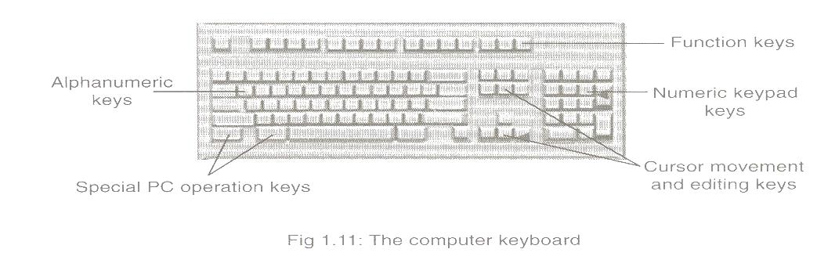

State two methods of minimizing dust in a computer laboratory. (2 mks)

Fit the computer room with special curtains to reduce entry of dust particles

Cover the floor with carpets in order to absorb dust

Regular cleaning of the laboratory

Cover the computer devices with dust covers when cleaning the room

Name three main causes of fire in the computer laboratory and give the precautions that should be taken to guard against them. (3 mks)

Inflammable chemical such as those used to clean the computer equipment Keep the chemicals away in store after use

Open wires/ cables

Ensure that all electrical wires are properly insulated

Ensure that the computer room has a gaseous fire extinguisher containing carbon dioxide in case of any accidents

Smocking
- Name two Examples of computers. (2mks)
- Notebooks
- Smartphones
- MacBook
- PDA
- Desktop computer
- Laptop
- Ipad
- Tablet
- Smart watch etc.

THIS IS THE LAST PRINTED PAGE
……………….Every learner counts …………

