END OF YEAR EXAMINATIONS, 2023
FORM 2
PHYSICS
Name …………………………………………… Index Number ………………………………..
Candidate’s Signature ………………………... Date …………………………………………...
Time Allowed: 2 ½ hours

INSTRUCTIONS TO CANDIDATES
- Write your name and admission number in the spaces provided at the top of the page.
- Write the date of the examination in the spaces provided above.
- Answer all the questions in the spaces provided.
- The paper consists of 9 printed pages.
- Students should check the question paper to ascertain that all the pages are printed as indicated and that no questions are missing.

1. A student used the measuring instrument shown below to measure the thickness of a cylindrical wire, If the wire is 10cm long, find the volume of the wire. (3mks)
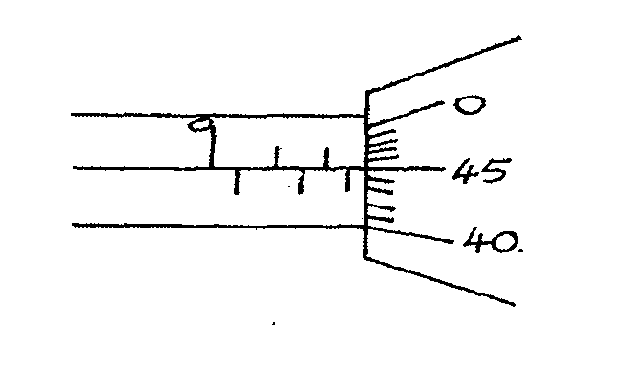
………………………………………………………………………………………………………………………………………………………………………………………………………………………………………………………………………………………………………………………………………………………………………

- The load carried by a truck loader was measured to be 65,000 grams. Convert the mass of the load into milligrams and express the answer in standard form. (2 Marks)
…………………………………………………………………………………………………………………………………………………………………………………………………………………………………………………………………………………………………………………………………………………………………………………………………………………………………………………………………………………………….

- A form one girl observed that when mercury is put into a glass it does not wet the glass. Explain the observations made by the girl. (2 Marks)
- ………………………………………………………………………………………………………………………………………………………………………………………………………………………………………………………………………………………………………………………………………………………………………………………………………………………………………………………………
- In using the lift pump to raise water from a bore hole. It is observed that practically the height the water is raised cannot be 10m and more. Give two reasons for this observation. (2 Marks)

…………………………………………………………………………………………………………………………………………………………………………………………………………………………………………………………………………………………………………………………………………………………………………………………………………………………………………………………………………………………….
- When a mass of 2kg is hang from a single spring, the spring extends by a distance x. Determine the total extension in the set up below. (2 marks)

2 Kg

6. (a) State what is meant by streamline flow (1 Mark)
………………………………………………………………………………………………………………………………………………………………………………………………………………………………………………………………………………………………………………………………………………………………………………………………………………………………………………………………
(b) The figure shows the cross section of an aeroplane wing, with the aeroplane moving in the direction shown by the arrow.

Sketch streamlines to show how air flows past the wing as the aeroplane moves (1 Mark)

……………………………………………………………………………………………………………………………………………………………………………………………………………………………………………………………………………………………………………………………………………………………………………………………………………………………………………………………………………………………..

(c) The diagram below shows two horizontal pipes, A and B. Tube A contains liquid at rest while tube B contains liquid in motion.
A
B

(a) Liquid at rest (b) Liquid at motion

(i) Sketch graphs for (a) and (b) to show variation in pressure (2 Marks)

……………………………………………………………………………………………………………………………………………………………………………………………………………………………………………………………………………………………………………………………………………………………………………………………………………………………………………………………………………………………..

7, Explain why ethylated spirit at room temperature when dropped at the back of the palm makes the palm to feel very cold. (2 Marks)
……………………………………………………………………………………………………………………………………………………………………………………………………………………………………………………………………………………………………………………………………………………………………………………………………………………………………………………………………………………………..

- A block measuring 20cm by 10cm by 4 cm rests on a flat surface. The block has a weight of 6.0N. Determine:
(a) The minimum pressure it exerts on the surface. (2 Marks)

……………………………………………………………………………………………………………………………………………………………………………………………………………………………………………………………………………………………………………………………………………………………………………………………………………………………………………………………………………………………..

(b) The density of the block in kg/m³. (2 Marks)
Take (g = 1N/kg)
……………………………………………………………………………………………………………………………………………………………………………………………………………………………………………………………………………………………………………………………………………………………………………………………………………………………………………………………………………………………..

- (a) State the kinetic theory of matter. (1 Mark)
……………………………………………………………………………………………………………………………………………………………………………………………………………………………………………………………………………………………………………………………………………………………………………………………………………………………………………………………………………………………..
(b) Why is smoke preferred for use in the smoke cell experiment? (2 marks)
……………………………………………………………………………………………………………………………………………………………………………………………………………………………………………………………………………………………………………………………………………………………………………………………………………………………………………………………………………………………..
(c). Explain the cause of random motion of smoke particles as observed in Brown Motion experiment using a smoke cell (3mks)
……………………………………………………………………………………………………………………………………………………………………………………………………………………………………………………………………………………………………………………………………………………………………………………………………………………………………………………………………………………………..
……………………………………………………………………………………………………………………………………………………………………………………………………………………………………………………………………………………………………………………………………………………………………………………………………………………………………………………………………………………………..
- In the figure 2 below shows a uniform bar of length 1.0M pivoted near one end. The bar is kept in equilibrium by a spring balance shown.
Figure 2
Spring
balance

20cm

10cm

Given that the weight of the metre bar is 1.4N, determine the reading of the spring balance. (3 Marks)
……………………………………………………………………………………………………………………………………………………………………………………………………………………………………………………………………………………………………………………………………………………………………………………………………………………………………………………………………………………………..
……………………………………………………………………………………………………………………………………………………………………………………………………………………………………………………………………………………………………………………………………………………………………………………………………………………………………………………………………………………………..
11 .State the property of light associated with formation of shadows (1mk)
……………………………………………………………………………………………………………………………………………………………………………………………………………………………………………………………………………………………………………………………………………………………………………………………………………………………………………………………………………………………..
12. .Explain why soft iron keepers are suitable for storing magnets (2mks)
……………………………………………………………………………………………………………………………………………………………………………………………………………………………………………………………………………………………………………………………………………………………………………………………………………………………………………………………………………………………..
13.Fig 1 below shows a conductor carrying current placed in the magnetic field of two magnets. Complete the diagram by showing the field pattern and the direction of force F that acts on the conductor (2mks)

Figure 2
Figure 1
14.State two quantities that are used to determine whether accumulator require recharging or not (2mks)
……………………………………………………………………………………………………………………………………………………………………………………………………………………………………………………………………………………………………………………………………………………………………………………………………………………………………………………………………………………………..
15.The figure 2 below shows the image I, formed in a convex mirror. Complete the ray diagram to show the position of the object. (2mks)
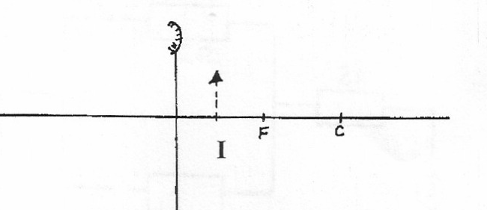

……………………………………………………………………………………………………………………………………………………………………………………………………………………………………………………………………………………………………………………………………………………………………………………………………………………………………………………………………………………………..
16. The figure below shows a displacement –time graph for a wave with a period of 0.5 seconds
Figure 3
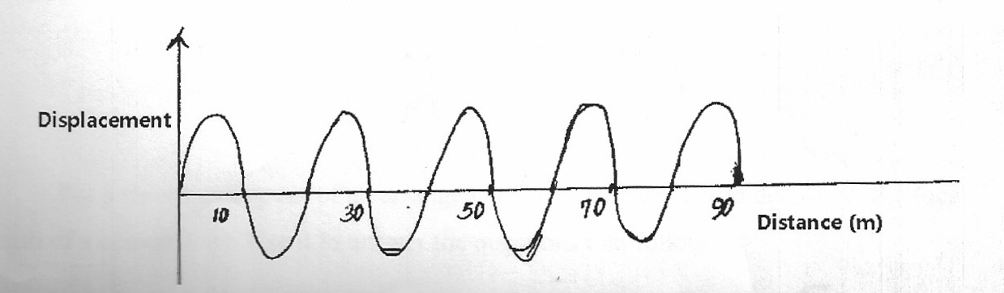
Figure 4
Displacement

Calculate the velocity of the wave (2mks)
……………………………………………………………………………………………………………………………………………………………………………………………………………………………………………………………………………………………………………………………………………………………………………………………………………………………………………………………………………………………..
- The figure below shows part of a burette scale after 200 drops of olive oil were run out.
The initial reading of the volume was 15.5ml
- Determine the volume of 200 drops. (3 marks)
……………………………………………………………………………………………………………………………………………………………………………………………………………………………………………………………………………………………………………………………………………………………………………………………………………………………………………………………………………………………..

- When a single drop was allowed to spread on a careful prepared water surface it made a circular patch of diameter 31.0cm Use this information to determine;
- The area of the patch.(3 marks)
……………………………………………………………………………………………………………………………………………………………………………………………………………………………………………………………………………………………………………………………………………………………………………………………………………………………………………………………………………………………..

- An estimate for the length of the olive oil molecules to three significant figures.(3 marks)
……………………………………………………………………………………………………………………………………………………………………………………………………………………………………………………………………………………………………………………………………………………………………………………………………………………………………………………………………………………………..

- State one necessary assumption for the calculation in b(ii) above. (1 mark)
……………………………………………………………………………………………………………………………………………………………………………………………………………………………………………………………………………………………………………………………………………………………………………………………………………………………………………………………………………………………..

- State any two differences between image formed by plane mirror and pinhole camera
(2 marks)
……………………………………………………………………………………………………………………………………………………………………………………………………………………………………………………………………………………………………………………………………………………………………………………………………………………………………………………………………………………………..

- The diagram below shows a positively charged rod brought close to two metal spheres on
insulating stands.
Describe how you would use the rod to charge the two spheres differently. (2 marks)
……………………………………………………………………………………………………………………………………………………………………………………………………………………………………………………………………………………………………………………………………………………………………………………………………………………………………………………………………………………………..

- State two defects of a simple cell and how each can be corrected. (2 marks)
……………………………………………………………………………………………………………………………………………………………………………………………………………………………………………………………………………………………………………………………………………………………………………………………………………………………………………………………………………………………..

- Figure 2 below shows two bar magnets holding steel pins and placed side by side.
Identify the polarities of: (2 marks)
A ……………………………………………………..
P ……………………………………………………..
22. .(a) One the axis provided, sketch a graph of volume against temperature of water from 0º to 20ºC. (2mks)
Temperature (ºC)
Volume (cm³)

(b)During anomalous expansion of water, heat transfer is limited to conduction and radiation only explain (1mk)

- A student stands at a distance 400m from a wall and claps two pieces of wood. After the first clap, the student claps whenever an echo is heard from the wall. Another student starts a stopwatch at the first clap and stops it after the twentieth clap. The stopwatch records a time of 50 seconds. Find the speed of sound. (3mks)

……………………………………………………………………………………………………………………………………………………………………………………………………………………………………………………………………………………………………………………………………………………………………………………………………………………………………………………………………………………………..
……………………………………………………………………………………………………………………………………………………………………………………………………………………………………………………………………………………………………………………………………………………………………………………………………………………………………………………………………………………………..

- A lawn sprinkler has 40 holes , each of cross-section area 2.0*10⁻² cm².It is connected to a hose-pipe lof cross-section area 1.6 cm².If the speed of the water in the hose-pipe is 1.2 ms⁻¹,calculate:

- The flow rate in the hose-pipe (2 mks)
……………………………………………………………………………………………………………………………………………………………………………………………………………………………………………………………………………………………………………………………………………………………………………………………………………………………………………………………………………………………..
……………………………………………………………………………………………………………………………………………………………………………………………………………………………………………………………………………………………………………………………………………………………………………………………………………………………………………………………………………………………..
- The speed at which water emerges from the holes.(3 mks)
……………………………………………………………………………………………………………………………………………………………………………………………………………………………………………………………………………………………………………………………………………………………………………………………………………………………………………………………………………………………..
……………………………………………………………………………………………………………………………………………………………………………………………………………………………………………………………………………………………………………………………………………………………………………………………………………………………………………………………………………………………..

THIS IS THE LAST PRINTED PAGE.

