END OF YEAR EXAMINATIONS, 2023
FORM 2
MARKING SCHEME

1. 2.50+0.45=2.95mm Reading 1
1

- 65,000g x 1000
65,00,000mg Either step
  - x 107mg (A.O Accept without units)
- The weak adhesive force between mercury and glass makes mercury not wet the glass while strong adhesive force between water and glass makes water wet the glass.
Accept argument interms of cohesive forces.
- – Low atmospheric pressure in places high sea
- Leakages at the valves and pistons of the lift pump
- $\frac{1}{2}$x + x + x = $\frac{5}{2}$x = (2.5x)
- (a) A flow in which every particle of liquid passing a point follows the path of the preceeding particle.
The velocity of the particles passing a certain point is the same and in one direction.
(b)

- Bottom- the streamlines must be closer
- Top - the streamlines must be spaced
Distance
Pressure
Distance
Pressure
(c) (i) (a)
1 Mark 1 Mark

7. .Ethylated spirit is highly volatile. It evaporates easily taking away latent heat of vaporation.
8. . (a) P_{max} = $\frac{f}{A_{max}}$ = $\frac{6.0N}{{200 x 10}^{-4}m^{2}}$
= 300N/m²
(b) P = $\frac{Mv}{V}$ = $\frac{0.6kg}{80 x {10}^{-6}m^{3}}$
= 750kg/m³
9. . Matter is made up of small particles which are in constant random motion.
b – Smoke has the same density with air hence forms a suspension in air.
- Smoke particles become bright when illuminated and therefore can easily be seen.
c). . They move in continuous random movement because of uneven bombardment by the invisible particles or molecules of the air.

10. Clockwise moments = Anticlockwise
f x 0.7m = 1.4N x 0.3N
f = 0.6N
11. Recline property/light travels in a straight line;
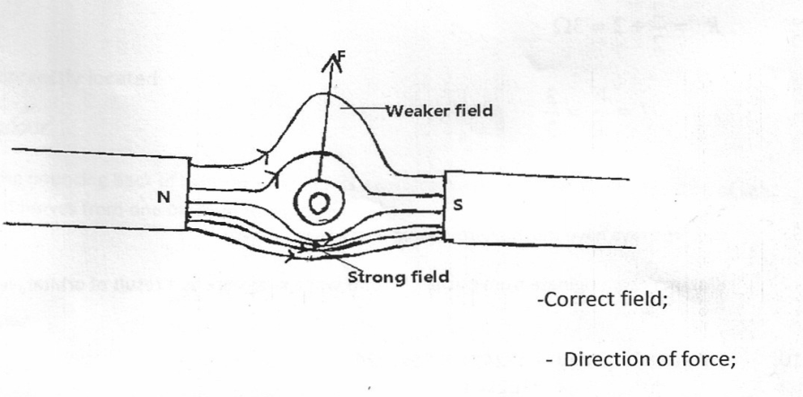
12. Magnetism is easily induced in them. The dipoles of the keepers form a closed loop with those in the magnets hence protecting the magnets from being demagnetized;

13

14. Relative density of the acid;
The voltage output;
15.
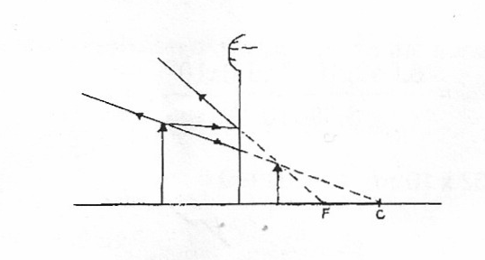

16. But f=
∴V=2.0x20

- Final volume = 15.6
Volume of 200 drops = 15.6 – 15.5
= 0.1cm³
- i) Area of patch = $π$r²
= $π × {\left(\frac{31.0}{2}\right)}^{2}$
= 754.77 cm²
ii) Volume of molecule = $\frac{Vol of drop}{Area of patch}$
= $\frac{0.0005}{754.77}$
= 6.62 x 10⁻⁷ cm
- The oil patch is one molecule deep

Plane mirror | Pinhole camera
Image is;  - Virtual 1  - Upright 1  - Same size as object1 | Image is;  - Real 1  - Inverted 1  - Size varies depending on distance 1
Any correct 2 @ 1 mark
Total 2 marks
- I will bring the rod close to but not touching the spheres. The charges will be separated as shown
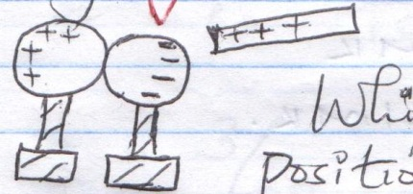

1
While the rod is still in position, I will separate the spheres and then remove the rod 1

Defect | Correction
- Polarisation  - Local action | By depolarizer (potassium dichromate)1  Amalgamation of Zinc plate1

- A South 1
B North 1

- 5a)On the axis provided , sketch a graph of volume against temperature of water from Oº C to 20⁰ C 2mks

Volume (cm³)

Temperature (0⁰C)

b) During anomalous expansion of water , heat transfer is limited to conduction and radiation only explain (1mk)
water is a poor conductor of heat
- Speed = 2d t = 500 = 2.5s
t 20
Speed = 2 x 400 = 320m/s
2.5
24. a) Flow rate = cross-section area * speed
= 1.6*10⁻⁴*1.2 ms⁻¹
=1.92*10⁻⁴ m³s⁻¹
b) The flow rate is constant
Volume efflux (Volume of water coming out) =v*2.0*10⁻²*10⁻⁴*40
= 8*10⁻⁵ v m³s⁻¹
Volume influx = Volume efflux
8*10⁻⁵v =1.92*10⁻⁴
V = 2.4 ms⁻¹

