**NAME: ______________________________________ ADM NO: ____________CLASS:__________**

**DATE: ______________________________ SIGN: _______________________**

MARKS HERE

**PHYSICS**

**FORM 1**

**TERM 3, 2023**

**INSTRUCTIONS: (Answer all the questions in the spaces provided) TIME: (1 h 30 min)**

1. Give two career opportunities in physics (2mks)
2. State one factor that determines the choice of an instrument used in measuring length (1mk)
3. State three properties of a liquid that is suitable for use in a thermometer (3mks)
4. The density of a material is 22.5gcm-3. Express this in SI units. (3mks)
5. The mass of an empty density bottle is 20g. Its mass when filled with water is 40g and 50g when filled with liquid X. Calculate the density of liquid X in SI units if density of water is 1000kg/m3. (4 mks)
6. State 3 effects of anomalous expansion of water (3mks)
7. A man wants to fit a brass ring tightly onto a steel rod of diameter equal to the inner diameter of the ring. Explain how this can be achieved. (2 mks)
8. Brownian motion of smoke particles can be studied by using the apparatus shown below. To observe the motion, some smoke is enclosed in the smoke cell and then observed through the microscope.

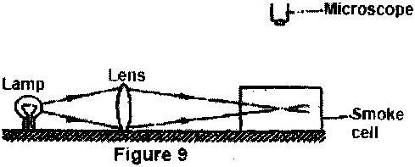

1. Explain the role of the lamp, lens and microscope in the experiment (3mks)
2. State and explain the nature of the observed motion of the smoke particles (2 mks)

(c) State what will be observed about the motion of the smoke particles if the temperature surrounding the smoke cell is slightly raised. (2 mark)

1. The experiment below was done by form 1 students.

**Ball and ring experiment**



Procedure

-Obtain a ball and ring apparatus bigger than the size of the ball.

-Pass the ball through the ring at room temperature.

-Heat the ball using a Bunsen burner for one minute.

-Try to pass the ball through the ring and observe what happens.

-Let it cool for some time and try passing the ball again.

(i) What was the purpose of experiment? (1 mk)

(ii) What happens when you try to pass the ball through the ring before heating it? (1 mk)

(iii) What happens to the ball when heated? (1 mk)

(iv) What happens when you try to pass the ball just after heating it? Explain. (2 mks)

(v) What is observed when you try to pass the cooled ball through the ring (1mk)

1. a) Giving an example in each, state the difference between scalar and vector quantity. (4mks)

b) A concrete slab of mass 20g is held by a steel cable of a crane as shown below. Name and show the forces acting on the slab (2mks)

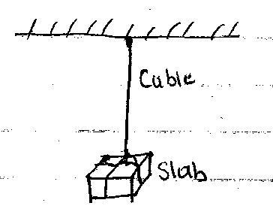

1. State any two examples of contact forces (2mks)
2. State any **three** effects of a force on a body (3mks)

11 The diagram below shows a simple hydraulic lift

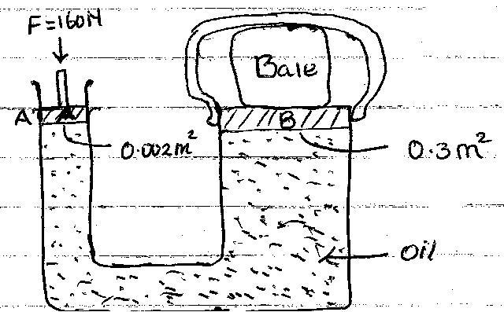

If a force of 160N is applied on the small piston. Determine:

1. The pressure at the side of small piston A.(2mks)
2. Pressure experienced by the oil (1mk)

1. Force produced on large piston B to compress the bale (3mks)
2. State **two** factors that affect pressure other than depth. (2mk)