**NAME ……………………………..................................................ADM. NO……………CLASS:...........**

**232/2**

**PHYSICS**

**PAPER 2**

**FORM THREE**

**TIME: 2 HOURS**

**END TERM TWO EXAMINATION - 2024**

***INSTRUCTIONS***

1. Write your **name, admission number** and **class** in the spaces provided
2. This paper consists of **TWO** sections: section **A** and **B**
3. Answer **ALL** question in the both section A and B in the spaces provided
4. Mathematical tables and Non programmable silent electronic calculators may be used
5. All working **MUST** be clearly shown.
6. This paper consists of 8 printed pages.
7. Candidates should answer the questions in English.

**For Examiners Use Only**

|  |  |  |  |
| --- | --- | --- | --- |
| **Section** | **Question** | **Maximum Score** | **Candidate’s Score** |
| **A** | **1 – 9** | **25** |  |
| **B** | **10** | **6** |  |
| **11** | **10** |  |
| **12** | **12** |  |
| **13** | **11** |  |
| **14** | **16** |  |
| **TOTAL** | | **80** |  |

***SECTION A (25 MARKS)***

*Answer all the questions in this section in the spaces provided*

1. State two characteristics of image formed by plane mirrors. (2mks)
2. An object is 25m tall is at a point 8m from the pin hole camera. If the image is 8.6m from the pin hole. Calculate the size of the image. (3mks)
3. State three factors that affects the speed of sound air. (3mks)
4. A curve at the bottom of a jar glycerin appears to be 13.2cm below the surface glycerin. Calculate the height of the Column of glycerin in the jar. (The refractive index of glycerin is 1.47). (3mks)
5. State the law of electrostatics. (1mk)
6. A gun is fired and an echo heard at the same place 0.6s later. Determine the distance between the barrier which reflected the sound and the gun (speed of sound in air is 330m/s.) (3mks)
7. i) Sketch rays to show the image formed by the object in the following. (2mks)

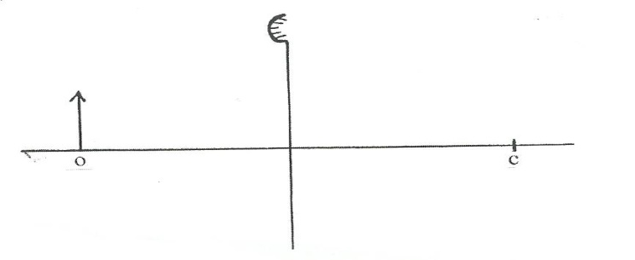

F

ii) State two characteristics of the image formed in (i) above (2mks)

1. State two defects of a simple cell, and state one way of minimizing each. (3mks)
2. K.B.C radio broadcasts on a wavelength of 1.5km. Determine its frequency if the velocity of radio waves is 3.0×108m/s. (3mks)

***SECTION B (55 MARKS)***

*Answer all the questions in this section in the spaces provided*

1. i) State two ways of charging a gold leaf electroscope (2mks)
2. The figure below shows two identical electroscopes. The one on the right is charged but the one on the left is not.

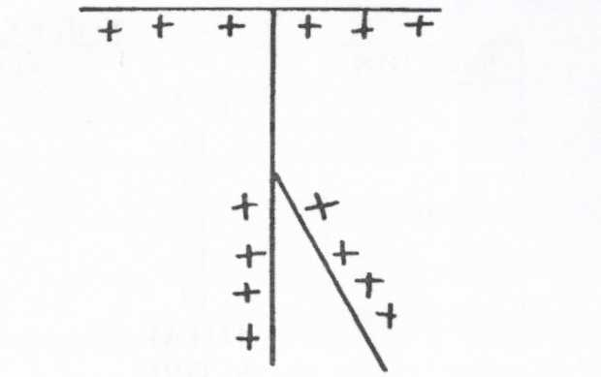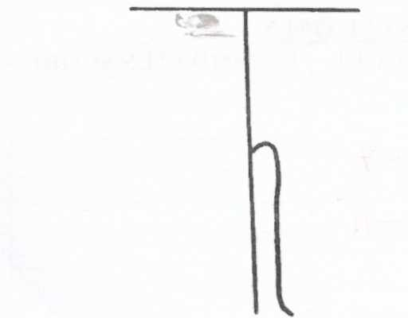

Show, using a sketch, the charge distribution after the caps of the two electroscopes are connected by a thin conducting wire (2mks)

1. Give two uses of a gold leaf electroscope. (2mks)
2. a) State Snells’ law of refraction (1mk)

1. State two necessary and sufficient conditions for total internal reflection to occur. (2mks)
2. The figure below shows white light incident on a rain drop.

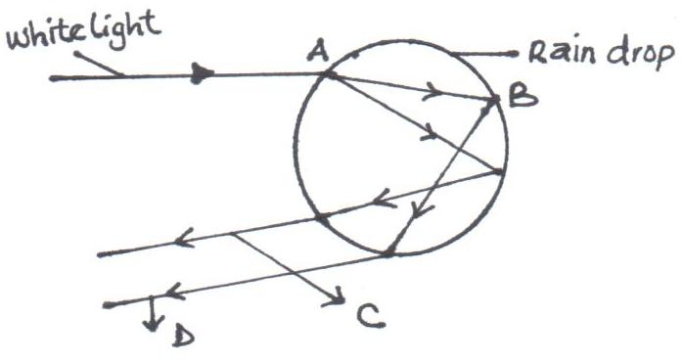

1. State what happens at :

2mks

A …………………………..

B…………………………….

(ii) State the colour of rays C and D. (2mks)

C…………………..

D…………………

1. The figure below shows the path of light passing through a rectangular block of Perspex, placed in air.

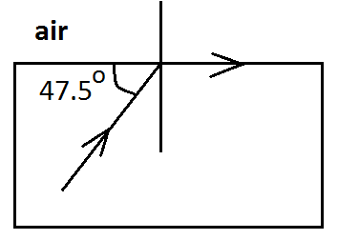

Calculate the refractive index of the Perspex. (3mks)

1. a) Draw magnetic field pattern between the following poles. (2mks)

N N

b) Using domain theory, explain why it is not possible to magnetize a magnetic material beyond a certain limit. (2mks)

1. The figure below shows an electromagnet connected to a battery.

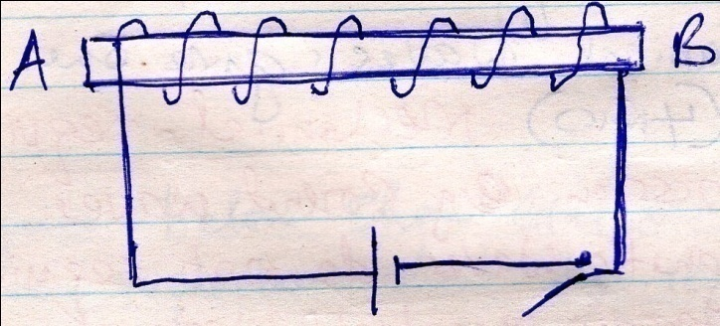

1. On the same diagram indicate the direction of the flow of current when the switch is closed. (1mk)
2. State polarities A and B. (2mks)
3. State three ways of increasing the strength of the electromagnet. (3mks)
4. State two uses of electromagnets (2mks)
5. a)Define the following terms
6. Amplitude (1mk)
7. Frequency (1mk)

b) Distinguish between electromagnetic and mechanical waves and give one example in each. (3mks)

1. The wave shown in the figure below has a velocity of 200mls.

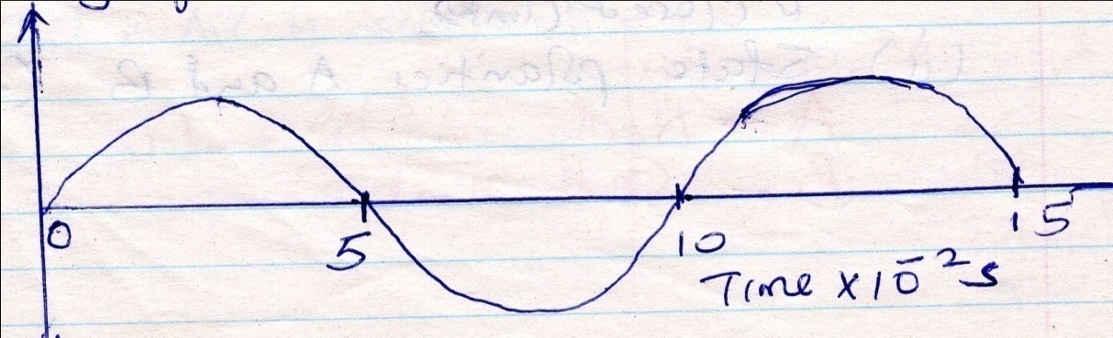

Determine

1. The period of the wave. (1mk)
2. The frequency of the wave. (2mks)
3. The wavelength of the wave, (3mks)
4. a) State Ohms’ law. (1mk)

b) Differentiate between potential difference (pd) and electromotive force (Emf) (2mks)

c) A cell drives a current of 2.0A through a 0.6Ω resistor. When the same cell is connected to a 0.952Ω resistor the current that flows is 1.5A. Find:

i) The internal resistance of the cell. (3mks)

ii)The electromotive force (Emf) of the cell. (1mks)

1. State two factors that affect the resistance of a metallic conductor. (2mks)
2. The figure below shows resistor network.

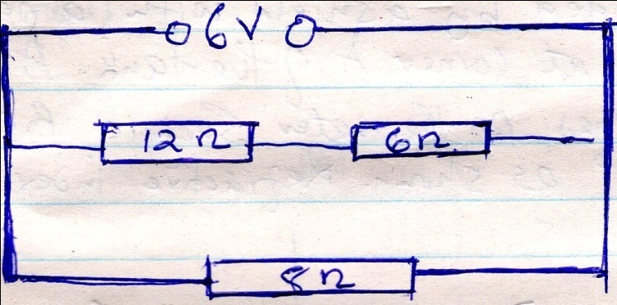

From the figure determine the:

1. Total resistance. (3mks)
2. Total current. (2mks)
3. Voltage across the 8Ω resistor (2mks)