**232/2**

**MARKING SCHEME**

**PHYSICS**

**PAPER 2**

**FORM THREE**

**TIME: 2 HOURS**

**END TERM TWO EXAMINATION - 2024**

***INSTRUCTIONS***

1. Write your **name, admission number** and **class** in the spaces provided
2. This paper consists of **TWO** sections: section **A** and **B**
3. Answer **ALL** question in the both section A and B in the spaces provided
4. Mathematical tables and Non programmable silent electronic calculators may be used
5. All working **MUST** be clearly shown.
6. This paper consists of 8 printed pages.
7. Candidates should answer the questions in English.

**For Examiners Use Only**

|  |  |  |  |
| --- | --- | --- | --- |
| **Section** | **Question** | **Maximum Score** | **Candidate’s Score** |
| **A** | **1 – 9** | **25** |  |
| **B** | **10** | **6** |  |
| **11** | **10** |  |
| **12** | **12** |  |
| **13** | **11** |  |
| **14** | **16** |  |
| **TOTAL** | | **80** |  |

***SECTION A (25 MARKS)***

*Answer all the questions in this section in the spaces provided*

1. State two characteristics of image formed by plane mirrors. (2mks)

* **Upright**
* **Virtual**
* **Same size as the object**

1. An object is 25m tall is at a point 8m from the pin hole camera. If the image is 8.6m from the pin hole. Calculate the size of the image. (3mks)

**v = hi**

**u ho**

**8.6 =hi**

**8 2.5**

**Hi = 8.6 x 2.5**

**8**

**= 21.5**

**8**

**= 2.89m**

1. State three factors that affects the speed of sound air. (3mks)

* **Wind**
* **Humidity**
* **Temperature**

1. A curve at the bottom of a jar glycerin appears to be 13.2cm below the surface glycerin. Calculate the height of the Column of glycerin in the jar. (The refractive index of glycerin is 1.47). (3mks)

**n= Real depth**

**Apparent depth**

**1.47 = Real**

**13.2**

**Real depth = 1.47 x 13.2**

**= 19.40cm**

1. State the law of electrostatics. (1mk)

**Like charges repel while unlike charges attract.**

1. A gun is fired and an echo heard at the same place 0.6s later. Determine the distance between the barrier which reflected the sound and the gun (speed of sound in air is 330m/s.) (3mks)

**2d = s × t**

**2d = 330 × 0.6**

**d = $\frac{198}{2}$**

**= 99 m**

1. i) Sketch rays to show the image formed by the object in the following. (2mks)

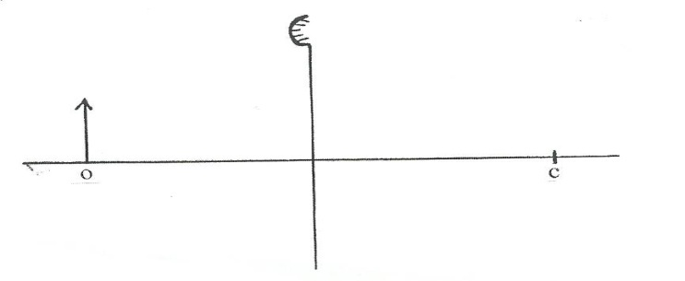

F

ii) State two characteristics of the image formed in (i) above (2mks)

* **It is upright**
* **It is virtual**
* **It is diminished**
* **It is formed behind the mirror**

1. State two defects of a simple cell, and state one way of minimizing each. (3mks)

* **Polarization – adding a depolarizer eg Manganese (IV) Oxide**
* **Local action – using pure zinc**

1. K.B.C radio broadcasts on a wavelength of 1.5km. Determine its frequency if the velocity of radio waves is 3.0×108m/s. (3mks)

**F=**

**=**

**=2.0 × 105 Hz or 200,000 Hz**

***SECTION B (55 MARKS)***

*Answer all the questions in this section in the spaces provided*

1. i) State two ways of charging a gold leaf electroscope (2mks)

* **Induction method**
* **Contact method**

1. The figure below shows two identical electroscopes. The one on the right is charged but the one on the left is not.

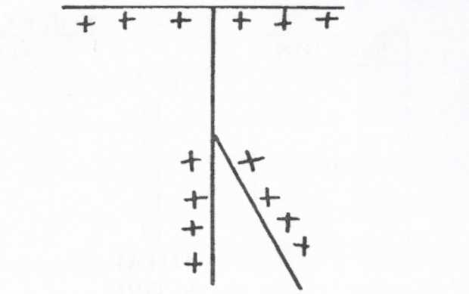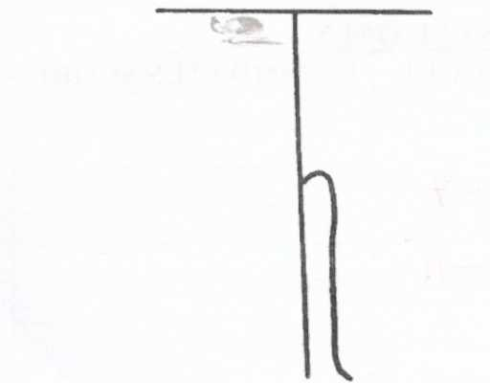

Show, using a sketch, the charge distribution after the caps of the two electroscopes are connected by a thin conducting wire (2mks)

**The deflection of the leaf will be the same for both electroscopes**

1. Give two uses of a gold leaf electroscope. (2mks)

* **Determine the quantity of charge in a body**
* **Test for insulating property of a material**
* **Detect the sing of charge in a body**

1. a) State Snells’ law of refraction (1mk)

**The ratio of the sine of angle of incidence to the sine of the angle of refraction is a constant**

1. State two necessary and sufficient conditions for total internal reflection to occur. (2mks)

* **Light must be travelling from an optically denser medium to a less optically dense medium.**
* **The angle of incidence must exceed the critical angle.**

1. The figure below shows white light incident on a rain drop.

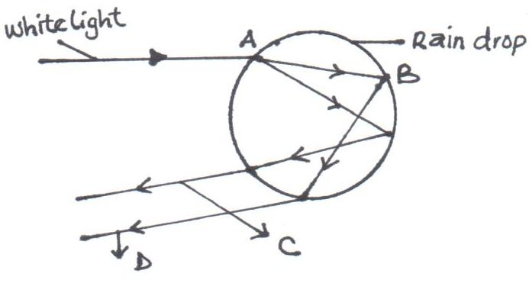

1. State what happens at :

2mks

**Refraction**

A …………………………..

**Total internal reflection**

B…………………………….

(ii) State the colour of rays C and D. (2mks)

**Violet**

**C…………………..**

**Red**

D…………………

1. The figure below shows the path of light passing through a rectangular block of Perspex, placed in air.

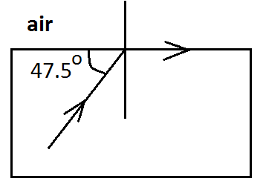

Calculate the refractive index of the Perspex. (3mks)

**n=**

**c = 900 – 47.50 = 42.50**

**n=**

**= 1.480**

1. a) Draw magnetic field pattern between the following poles. (2mks)

**Repulsion; with field lines moving away from the North pole**

N N

b) Using domain theory, explain why it is not possible to magnetize a magnetic material beyond a certain limit. (2mks)

**During magnetization the dipoles and the domains align themselves in one direction such that when all the domains and dipoles are in one direction the material is said to be magnetically saturated**.

1. The figure below shows an electromagnet connected to a battery.

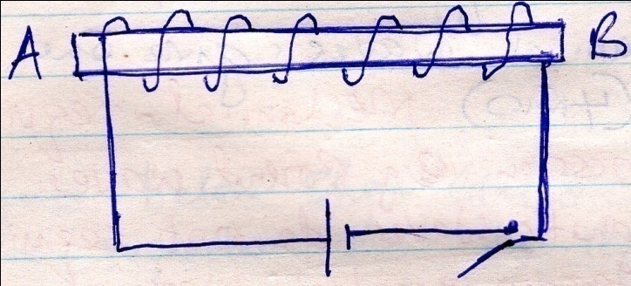

1. On the same diagram indicate the direction of the flow of current when the switch is closed. (1mk)
2. State polarities A and B. (2mks)

**A – North**

**B - South**

1. State three ways of increasing the strength of the electromagnet. (3mks)

* **Increasing the number of turns**
* **Increasing the magnitude of current**
* **Using a u – shaped core**

1. State two uses of electromagnets (2mks)

* **Used in electric bells**
* **Used in electric motors**
* **Used in loudspeakers**

1. a)Define the following terms
2. Amplitude (1mk)

**Maximum displacement on either side of the wave**

1. Frequency (1mk)

**No of oscillations made per second**

b) Distinguish between electromagnetic and mechanical waves and give one example in each. (3mks)

**Mechanical require medium for transmission eg sound waves while electromagnetic waves do not require medium for transmission eg light waves**

1. The wave shown in the figure below has a velocity of 200mls.

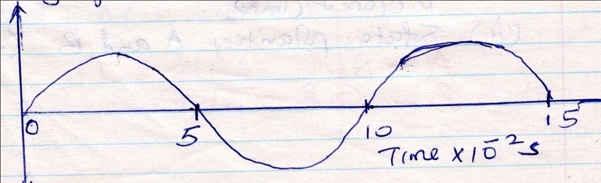

Determine

1. The period of the wave. (1mk)

**T = 10 x 10-2**

**= 0.10 s**

1. The frequency of the wave. (2mks)

**F = 1/t**

**=1/0.1**

**= 10Hz**

1. The wavelength of the wave, (3mks)

**λ = v/f**

**= 200/10**

**= 20m**

1. a) State Ohms’ law. (1mk)

**Current through a conductor is directly proportional to potential difference across the end of a conductor provided temperature and other physical conditions one kept constant**

b) Differentiate between potential difference (pd) and electromotive force (Emf) (2mks)

**Potential difference is the voltage across the ends of a conductor in a closed circuit while electromotive force is the voltage across the terminals of a cell in an open circuit.**

c) A cell drives a current of 2.0A through a 0.6Ω resistor. When the same cell is connected to a 0.952Ω resistor the current that flows is 1.5A. Find:

i) The internal resistance of the cell. (3mks)

**E = IR + IV**

**E = (2 x 0.6) + 2r**

**E = 1.2 + 2r……………..eqn1**

**E = (1.5 x 0.9) + 1.5r**

**E = 1.35 + 1.5r ………..Eqn2**

**1.2 + 2r = 1.35 + 1.5 v**

**0.5r = 0.15**

**r= 0.3Ω**

ii)The electromotive force (Emf) of the cell. (1mks)

**E = 1.2 + 2r**

**= 1.2 + 0.3 x2**

**= 1.2 + 0.6**

**= 1.8V**

1. State two factors that affect the resistance of a metallic conductor. (2mks)

* **Length of conductor**
* **Cross – section area of the conductor**

1. The figure below shows resistor network.

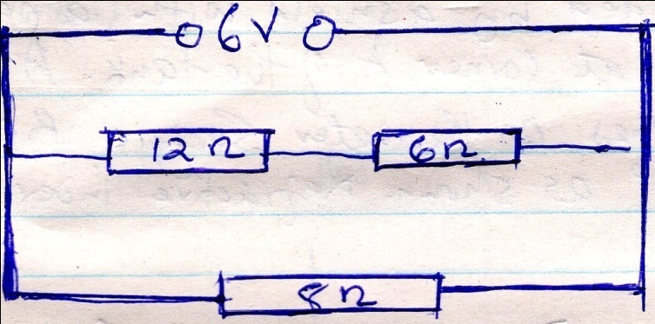

From the figure determine the:

1. Total resistance. (3mks)

**RT = 18 x 8 =144 = 5.538Ω**

**18 + 8 26**

1. Total current. (2mks)

**I= $\frac{V}{R}$**

**= $\frac{6}{5.538}$**

**= 1.083A**

1. Current across the 8Ω resistor (2mks)

**I = $\frac{V}{R}$**

**= $\frac{6}{8}$**

**= 0.75A**