NAME ________________________________ ADM. NO.____________ CLASS__________
232/1
PHYSICS
FORM THREE
(THEORY)
END OF TERM TWO - 2024
TIME: 2 HOURS

INSTRUCTIONS
- Write your name, index no, signature and date in the spaces provided above.
- The paper consists of two sections, Section A and B.
- Answer ALL the questions in section A and B in the spaces provided.
- ALL answers and working MUST be clearly shown.
- Mathematical tables and electronic calculators may be used.

SECTION A (25 MARKS)
Answer ALL the questions in this section in the spaces provided.

1.Thermodynamics is one of the branches of physics. What does it entail? (1mk)

2.(a) What is the reading in the following; (1mk)

0 45

40

(b) If the reading above was the diameter of a spherical ball; find its volume. (2mks)

3. State two factors which affect the spring constant. (2mks)

4. State the relationship between mass and weight. (1mk)

5. (a)State how the pressure in a moving fluid varies with speed of the fluid. (1 mks)

(b)Water flows along a horizontal pipe of cross sectional area 60 cm² which has a constriction of cross sectional area 24 cm² at one place. If the speed of water at the constriction is 5 m/s, calculate the speed in the wider section. (2 mks)

6.Explain why brakes fail in a hydraulic braking system when air gets into the system. (2mks)

7.(i) State the principle of moments ( 1mk)

(ii)The figure below shows a non-uniform log of mass 1000g balanced on the pivot by a 20N weight as shown.
20N
35cm

pivot

Determine the position of the centre of gravity from the pivot ( 2mks).

8.It is observed that a drop of milk carefully put into a cup of water turns the water white after sometime. Explain this observation (1mk)

9.A bullet hits a stationary block at the edge of a cliff 100m high and moves with a common velocity of 200 m/s. Determine the maximum horizontal distance covered. (take g=10 m/s²) (3 marks)

10.The figure below shows a beam balance made out of concrete and reinforced with steel
Concrete
Steel

Use a diagram to explain the behaviour of the shape of the beam when heated up (2mks)

11. When a Bunsen burner is lit below a wire gauze, it is observed that the flame initially burns below the gauze shown in figure (i). After sometime, the flame burns below as well as above the gauze as shown in figure (ii).
Gauze
(i)
(ii)

State the reason for this observation. (1 mk)

12. a) State Newton’s 2nd Law of Motion (1mk)

b) A car of mass 1200kg moving at 90km/h is brought to rest over a distance of 20m. Calculate the braking force . (2 mks)

SECTION II (55mks)
Attempt ALL the questions in this section in the spaces provided.
13. (a) Define the term velocity ratio as used in machines (1mk)

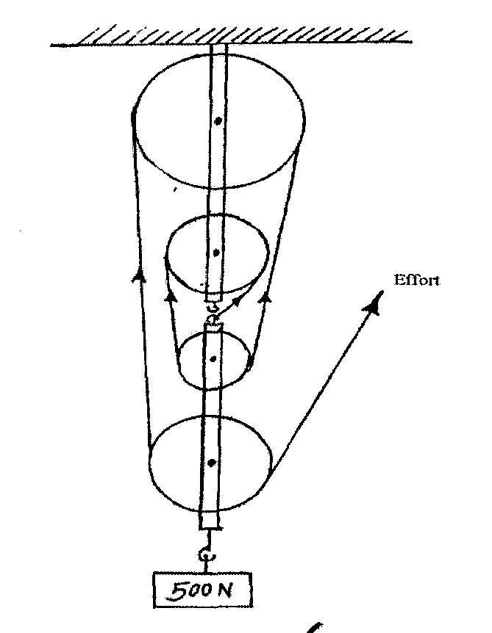
(b) Figure below shows a block and tackle pulley system lifting a load of 500N

(i) Determine the velocity ration of the machine (1mk)

(ii)If an effort of 120N is required to lift the load using the machines determine the efficiency of the pulley system (3mks)

(iii) In the space provided below, sketch a graph of efficiency against load for the system. (2mks)

14. A car of mass 2000kg travelling at 5m/s collides with a minibus of mass 5000kg travelling in the opposite direction at 7m/s, the vehicles stick and move together after collision. If the collision lasts 0.1 seconds
(a) Determine the velocity of the system after collision to 3 decimal places (3mks)

(b) Calculate the impulsive force on the minibus (3mks)

(c) Calculate the change in kinetic energy of the system to 5 significant figures (3mks)

15. the figure below shows a windlass. An effort is applied on the handle which is turned on a radius of 60 cm. As the handle turns, a rope is wound around the drum of diameter 24 cm, thus raising a bucket of water out of the well
Handle
24cm
60cm

a) If an effort of 20N is needed to lift a bucket full of water of mass 8kg, Calculate:
(i) the energy gained by the mass when the drum turns through one revolution (3mks)

(ii) The work done by the effort during this revolution. (3mks)

b) Suggest a reason why the two quantities in a(i) and (ii) are not equal (1mk)

c) Calculate:
(i) the velocity ratio of the machine (2mks)

(ii) the efficiency of the windlass (2mks)

16. a) Differentiate Between streamline flow and turbulent flow (2 mks)

b) Water flows along a horizontal pipe of uniform cross-sectional area 30cm². The speed of water is 8m/s but this increases to 10m/s in a constriction in the Pipe. What is the cross-sectional area of this narrow part of the pipe. (3 mks)

c) A liquid flows through a pipe with a velocity of 4.5 m/s on the wider side and 1.8 m/s on the narrow side. Determine the radius of the wider part if the narrow side has a diameter of 4cm. (3 mks)

d) In the figure below show the liquid that is in streamline motion. Calculate the speed of water in the narrow part of the tube if the speed of water in the larger pipe is 3m/s. The narrow sides diameter is 3cm (3 marks)

diameter (12cm) 3m/s

17. a) A girl standing 150 M away from a high wall claps her hands at a steady rate so that each echo coincides with the echo of the one before. If she walks 60 claps in 1 minute, calculate the speed of sound in air. (3 marks)

b) A miner stands between two vertical cliffs 400m from the nearest cliff. The cliffs were Xm apart. Every time he strikes the rock over he hears echoes. The first echo after 2.5 sec while the second follows 2 seconds. Determine;
a) Speed of sound in air. (2 mks)

b) Value of X. (2 mrk)

18. a)State Hooke’s law (1 mk)

b)Determine the total extension below given the spring constant of the spring in 50 n/m. The springs are identical and has a mass of 10g and the supporting bar is of mass 20g. (3mks)

19. a) Define the term Density (1 mrk)

b) An empty density bottle of mass 12g weighs 70g when full of water and 100g when full of liquid
X. Given that the density of water is 1000kg/m3, determine the density of liquid X (3 mks)

c) A wooden block of mass 200g is 4.0cm long, 3.0cm thick and 6.0cm in width. Determine its density
in kg/m3 (2 mrks)

