PHYSICS FORM ONE
END-TERM TWO 2024 EXAM
NAME…………………..…………….………..…CLASS………..…....ADM NO…………
Instructions:
Answer all questions in the spaces provided
1. Define physics (1 marks)

2. Give two benefits of studying physics as a subject. (2 marks)

3. The water volume in a burette is 30cm³. If 55 drops of water falls from the burette and the average volume of one drop is 0.12cm³, what is the final water in the burette? 3mks

4. Give three basic laboratory rules. (3mks)

5. State with a reason what will happen to the diagram if side A is broken with a needle, and draw the final diagram (3mks)

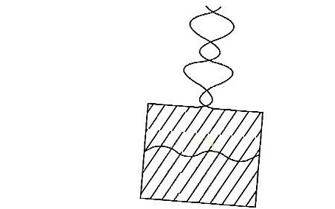

6. In a hydraulic press, a force of 200N is applied to master piston of area 25cm². If the area of the slave piston is 2500cm², determine the force generated on the slave piston. (4mks)

7. State three properties of a liquid that can be used as a brake fluid. (3mks)

8. What are vector quantities? 2mks

9. A thin wire was wound 40 times closely over a boiling tube. The total length of the wire was found to be 352 cm. Calculate the radius of the boiling tube in cm. (Take π = $\frac{22}{7}$) (3 marks)
40 turns

10. a) Define mass and state its SI units (2 marks)

b) Name the instrument used to measure mass. (1 mark

10. The diagram below shows a sketch of the map of Kenya, which is not drawn to scale.

If the area of one small square is2.0 cm², calculate the area of the map. (3 marks)

12. Name four types of forces. (4mks)

13. The figure below shows the shapes formed when drops of water and mercury are placed on the surface of a clean glass plate
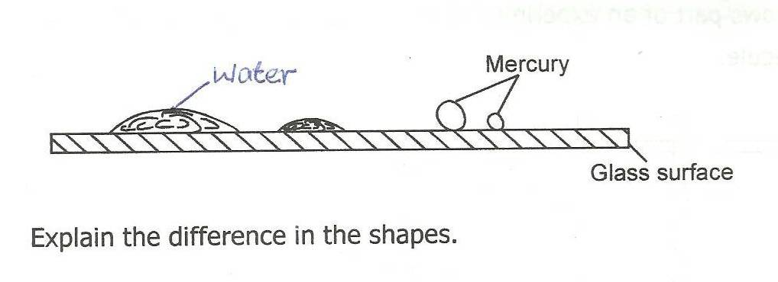
Explain the difference in the shapes. (2mks)

13. Two liquids X and Y have densities 1.25g/cm³ and 2.7g/cm³ respectively. Calculate the density of the mixture containing 30% by mass of liquid X and 70% by mass of liquid Y, if 100g mass of the mixture was used. (4mks)

14. Name the type of force used to do the work below: (3mks)

a) Mosquito larvae float on water surface

b) Water rising a narrow tube.

c) Separate a mixture of iron fillings and sand.

15. A tin containing 5000cm³ of paint has a mass of 70kg. If the mass of the empty tin, including the lid, is 0.5kg, calculate the density of the paint. (3 marks)

16. The two factors to be considered when measuring the volume of an irregular solid using displacement method. (2 marks)

17. A brick 20cm long,10cm wide and 5cm thick has a mass of 500g. Determine the (Take g=10Nkg⁻¹)
(a) greatest pressure that can be exerted by the brick on a flat surface. (2mks)

(b) Least pressure that can be exerted by the brick on a flat surface. (2mks)

18. Give two differences between mass and weight. 2mks
 | mass | Weight
19. Calculate the weight of each of the following (take g = 10 N/Kg): 4mks
- A cat of mass 1.5kg

- A pencil of mass 5.0g

20. Find the total pressure acting on a diver who is working 10m below the surface of water of density 1030kg/m³, given that the atmospheric pressure is 103360Pascals and g=10N/kg. 3mks

21. Give a reason why trucks which carry heavy loads have many wheels 2mks

22. Indicate on the diagram below, the level of mercury in the tubes X and Y (2mks)
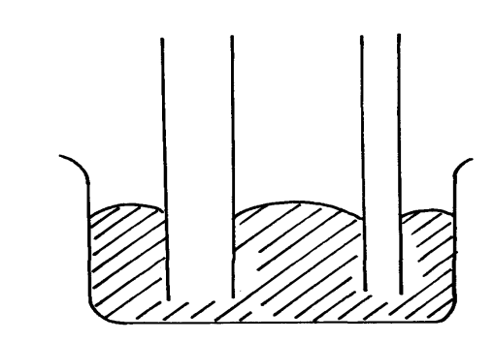
Mercury
X
Y

23. Determine the resultant force in the following case. (2mks)

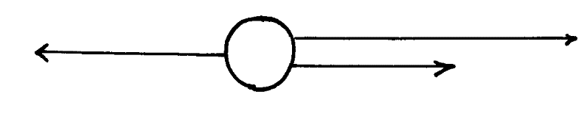
2N
3N
4N

