COMPETENCE BASED CURRICULUM

7

2024

JUNIOR SCHOOL

**MATHEMATICS**  MARKING SCHEME

1. The interior angles of a triangle are as shown below.



Find the value of x. (2mk)

Solution

Angles in a triangle adds up to 3600

(x+5)0 +(x+25) o+ (2x-10)0=3600

Open brackets and collect like terms

$$X + x+ 2 x +25+5 -10=3600$$

Crossing the whole numbers over the other side of the equal sign and changing their signs

$X + x+ 2x=360-25-5 +10$

4x=160

Dividing both sides by 4

X=400

1. Find the area of the circle drawn (take = 𝜋 =22/7 **(2mk)**



Solution

Area of a circle is given by AREA=Πr2

Area= 22/7*14cm*14cm

Area= 616cm2

1. A cube has a volume of 3.6m3. What is the volume of the cube in cubic centimetres? **(1mk)**

1m=100cm

1m2=100cm*100cm

1m3=100cm*100cm*100cm

1m3=1000000cm3

If 1m3=1000000cm3

3.6m3 =? cm3

= **3,600,000cm3**

1. Convert 72000m2 into hectares. **(2mk)**

1ha=10,000m2

?ha=72,000m2

**=72ha**

1. Express **80** as a product of its **prime factors** using a factor tree.(2 marks)

Ans **2X2X2X2X5**

1. What is the sum of the **GCD** and the **LCM** of **6, 12 and 18**? (3 marks) Ans **42**
2. A trader stored milk in three containers of **24 litres, 30 litres and 60 litres**. The milk in each container was then repacked into smaller containers. The amount of milk in each of the small container was the same. What was the capacity of the largest container used to repack the milk? (3 marks) Ans **6 L**
3. Maria bought $6\frac{2}{3}$ metres of white cloth material and $2 ¾$ metres of yellow cloth material to be used in a home science project. How many metres of material did she buy altogether? (3 marks)

Ans $9\frac{5}{12}$

1. Work out the following .
   1. $33\frac{7}{12}+40\frac{2}{3}$ (2 marks)

Ans

* 1. (3 marks)

Ans $7\frac{29}{40}$

1. Work out the following.

$5\frac{5}{8}×24$ (2 marks)

Ans **135**

1. Find the area of the figure below. (2 marks)

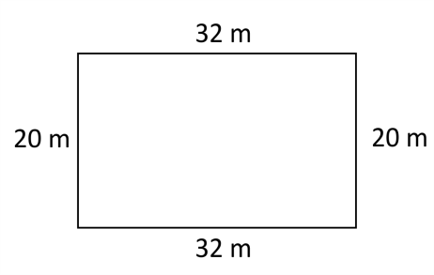Ans **640CM2**

1. Name the angle shown below. (1 mark)

Ans **obtuse ANGLE**

1. What is 25% written as a fraction in its simplest form? (1 mark)

Ans **¼**

1. What is the volume of the cuboid below? (2 marks)

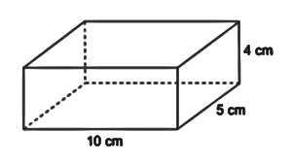 Ans **200CM3**

1. How many days are there in total in the months of November, December and January? (1 mark)

Ans **92 DAYS**

1. Simplify the following expression. ( 2 mks)

(5(x+4) + 4(2x+5)

Ans 13x+40

1. The perimeter of the figure below is 100cm. what is the length of the longest side?( 2mks)

(3x+10) cm

(2x-5) cm

Ans 42cm

1. The diagonal of a square measures 44cm.Calculate the perimeter of the square. (3mrks)

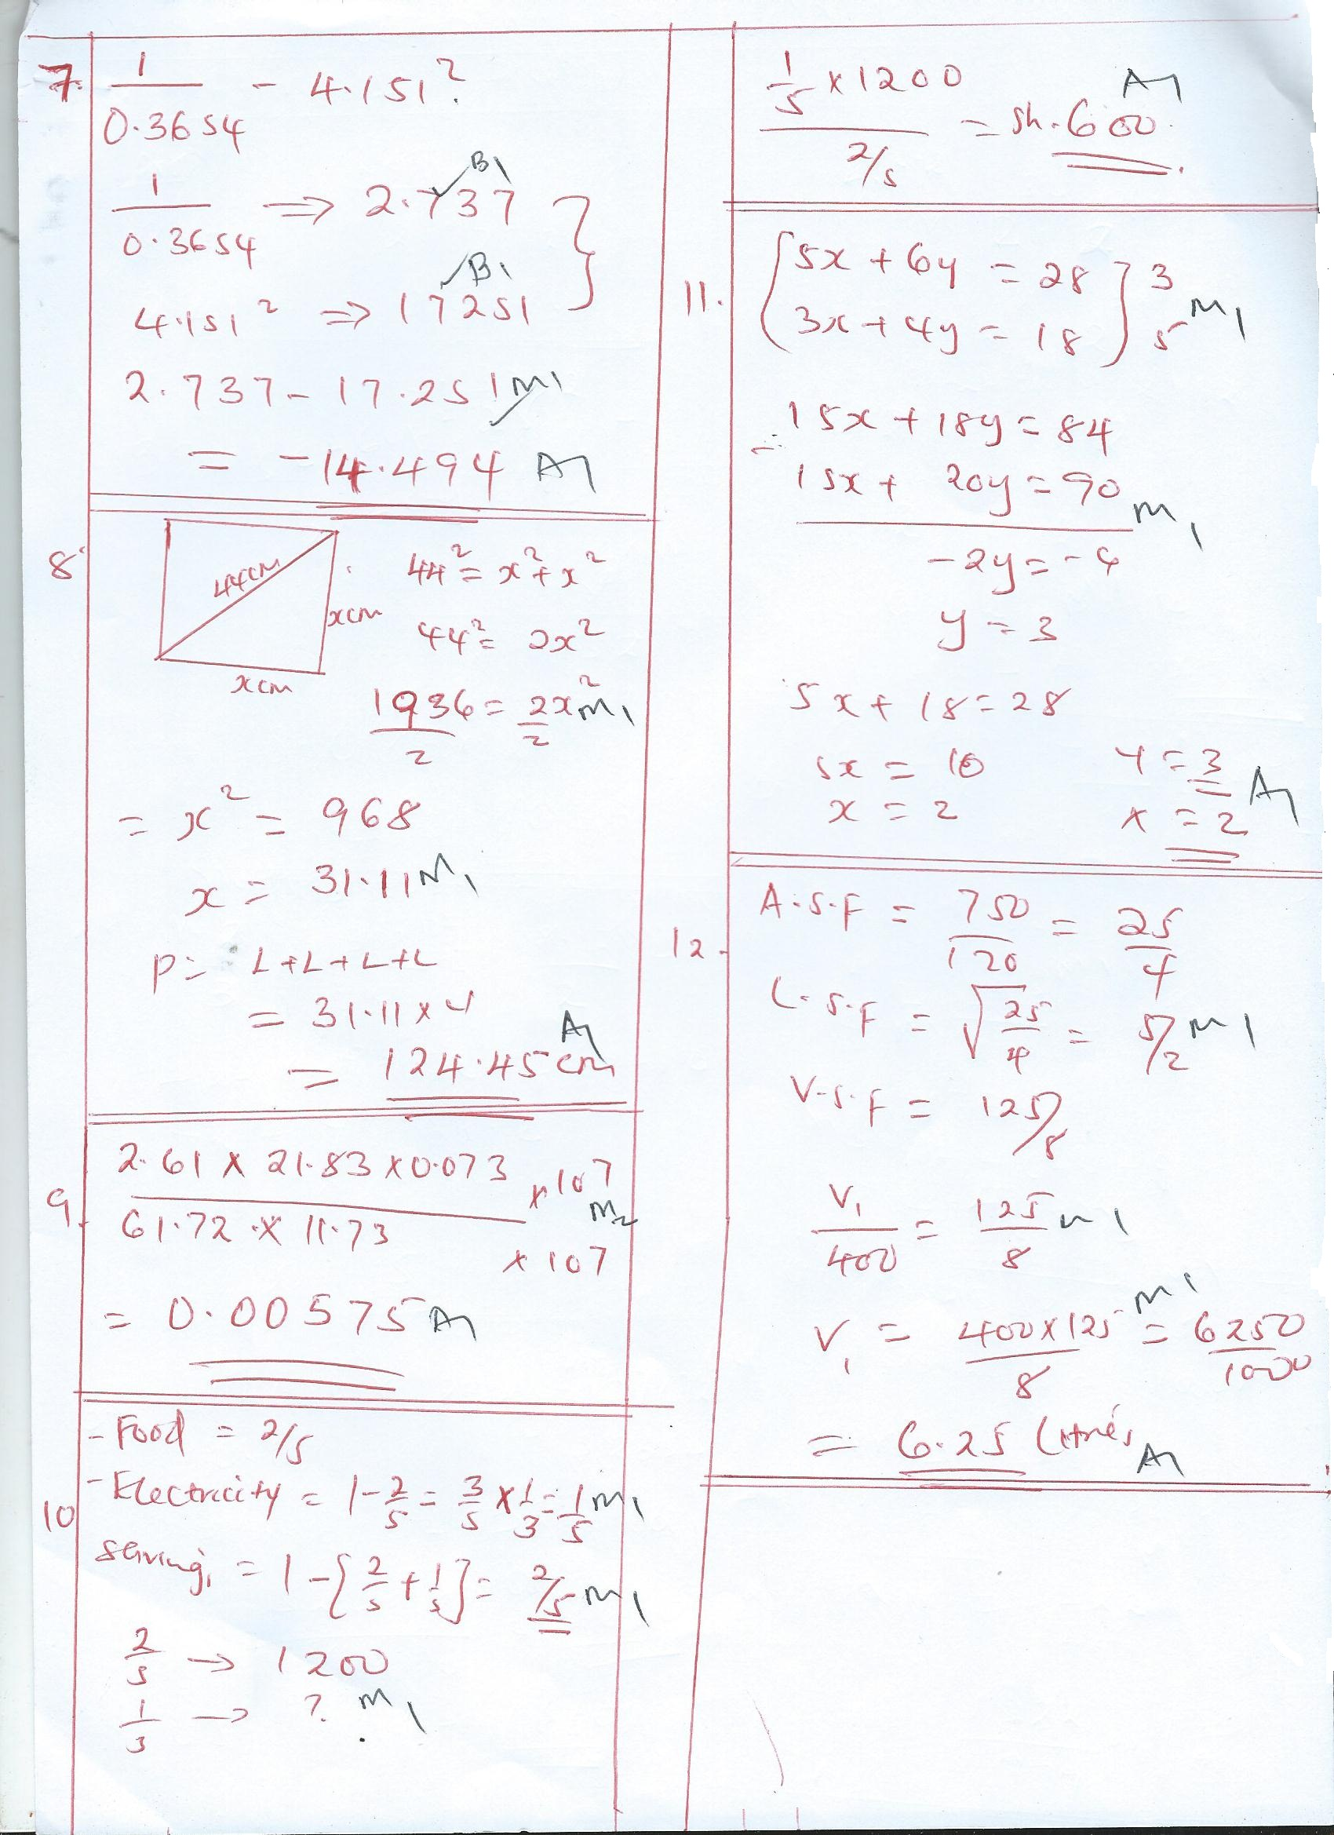

1. Calculate; (3 mks)

2.61 x 21.83 x 0.073

61.72 x 11.73



1. Patrick spent 2/5 of his salary on food, 1/3 of the remainder on electricity and saved the rest.

(a). What fraction of his salary did he save? (2mrks).



(b). If he spent Sh. 1,200 on food, how much did he spend on electricity? (2Mks)



1. A farmer has three containers of capacity 12L, 15L and 21L, calculate the capacity of:
2. The smallest container which can be filled by each one of them an exact number of times (2 Mrks).

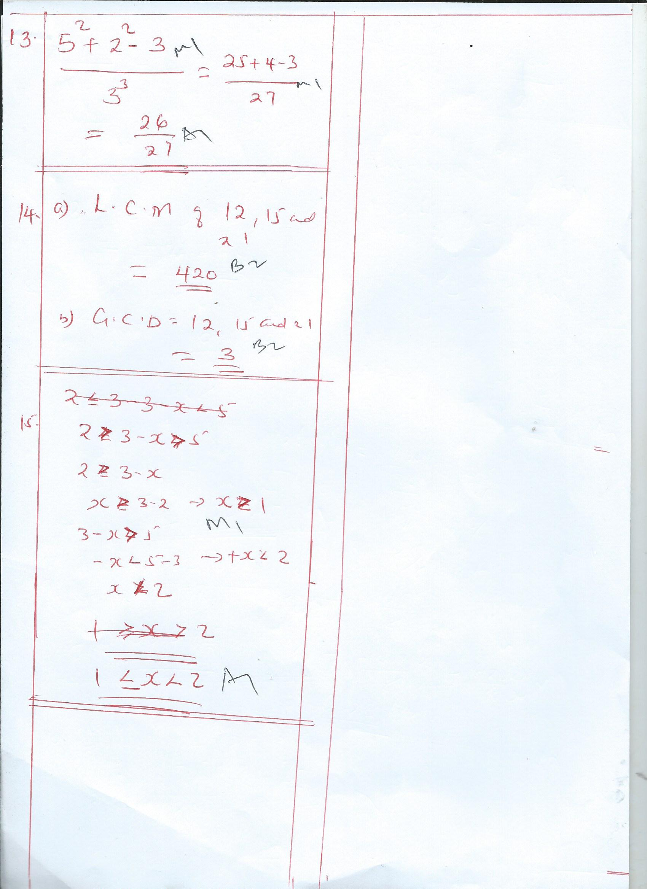

1. (b). The largest container which can fill each one of them an exact number of time.(2 Mks)

**THIS IS THE LAST PRINTED PAGE**

***……………….Every learner counts …………***