NAME: ______________________________________ ADM NO: ____________CLASS:__________
DATE: ______________________________ SIGN: _______________________
MARKS HERE
MATHEMATICS FORM 2
TERM 3, 2023

INSTRUCTIONS: (Answer all the question in Section A & any two in section B)
TIME: (1H 30 Min)
SECTION A
- Without using a mathematical table or calculator solve the following. (3mks)

3√0.729 x 409.6
0.1728

- Three bells are programmed to ring after an interval of 15 minutes, 25 minutes and 50 minutes. If they all rang together at 6:45am, when will they next ring together? (3mks)

- Solve 28x = 512 (2mks)

- Solve the inequality and represent the solution on a number line
4 - 5x $≥$ -11 (2mks)

- Find the equation of a line passing through point (2,3) and is perpendicular to (y=3x-1) (3mks)

- In the figure below, lines AB AND LM are parallel. Find angle X, Y and Z. (3mks)
Y
Z
83^{O}
X
130⁰

- Solve the following quadratic equation. (2mks)
5x2 – 21x + 4

- Calculate surface area of the rectangular based pyramid below. (4mks)
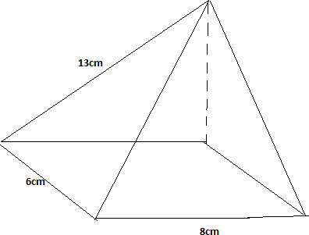

- From a window 25m above a street, the angle of elevation of the top of a wall on the opposite side is 15⁰. If the angle of depression of the base of the wall from the window is 35⁰ find:
- The width of the street. (2mks)

- The height of the wall on the opposite side. (2mks)

- a) Solve the inequalities 2x-5>11 and 3+2x$≤$13, giving the answer as combined inequality (3mks)

- List the integral values of x that satisfy the combined inequality in (a) above (1mk)

SECTION B
- Three towns P,Q and R are such that, P is on a bearing of 120⁰ and 20km from Q. Town R is on a bearing of 220⁰ and 12km from P.
  - Using a scale of 1cm to 2km, draw and locate the position of the three towns (3mks)

  - Measure;
    - The distance between Q and R in Kilometres. (2mk)

    - The bearing of P from R. (1mk)

    - The bearing of R from Q. (1mk)

    - Calculate the area bounded by PQR. (3mks)

- Makau made a journey of 700km partly by train and partly by bus. He started his journey at 8:00 am by train which travelled at 50km/h. After alighting from the train which travelled 50km/h. After alighting from the train, he took a lunch break of 30 minutes. He then continued his journey by bus which travelled at 75km/h. The whole journey took 11¼ hours.
a) Determine;
- The distance travelled by bus (4mks)

- The time Makau started travelling by bus (3mks)

b) The bus developed a puncture after travelling 187.5km. It took him 15 minutes to replace the wheel. Find the timed taken to complete the remaining part of the journey (3mks)

- A Rhombus has its vertices as PQRS. The co-ordinates of the vertex P and Q of the rhombus are P(-1, 3) and Q(2, 4). The diagonal QS and PR meet at point M. Given that the equation of the line PR is y = x + 4.
- Find the equation of the diagonal QS. (1 mark)

- Find the co-ordinates of the mid-point M of QS. (2 marks)

- Find the co-ordinates of the points R and S. (4 marks)

d) Calculate the length of diagonal PR. (3 marks)

