**MATHEMATICS**

**FORM FOUR PAPER 2**

**MARKING SCHEME**

|  |  |  |
| --- | --- | --- |
| **No** | **Working** | **Marks** |
| 1 | |  |  |  | | --- | --- | --- | | No | Standard form | Log | | 415.3 |  |  | |  |  |  | |  |  |  | | B1 for all logs  B1 for correct addition  M1  A1 |
| 2 | Maximum area  Minimum area  Absolute error = | M1  M1  A1 |
| 3 |  | B1  M1  A1 |
| 4 | Centre (2,-3) | B1  M1  A1 |
| 5 | hrs | B1  M1  A1 |
| 6 |  | M1  A1  A1 |
| 7 |  | M1  A1  M1  A1 |
| 8 |  | M1  M1  A1 |
| 9 | When P = 11 | M1  M1  A1 |
| 10 |  | M1  M1  A1 |
| 11 |  | M1  M1  A1 |
| 12 | Let  When , values of  , values of | M1  M1  A1 for the two expression |
| 13 | Cost of mixture =  Profit made =  Percentage profit = | M1  M1  A1 |
| 14 |  | B1  M1  A1 |
| 15 |  | M1  A1  A1 |
| 16 |  | B1  M1  A1 |
| 17 | C:\Users\user\Desktop\ML EXAMS\T2 2023\P2 Q17.jpg   1. (i)   (ii)  (iii)  (iv)  = | B1  B1  M1 A1  M1 A1  M1 A1 |
| 18 | 1. (i)     (ii)    Comparing the coefficients | M1  A1  B1  M1  M1  M1  M1  M1  A1  M1 A1 |
| 19 | 1. Taxable income      1. Tax due   1st band  2nd band  3rd band  4th band  5th band  6th band  Total tax due =    Net tax =  Net monthly tax =  Net salary = | M1  A1  M1  M1  M1  M1  A1  M1  M1 A1 |
| 20 | |  |  |  |  |  |  |  | | --- | --- | --- | --- | --- | --- | --- | | Marks |  |  |  |  |  | c.f | | 0-9 | 3 | 4.5 |  |  | 4800 | 3 | | 10-19 | 6 | 14.5 |  |  | 5400 | 9 | | 20-29 | 10 | 24.5 |  |  | 4000 | 19 | | 30-39 | 12 | 34.5 |  |  | 1200 | 31 | | 40-49 | 9 | 44.5 | 0 | 0 | 0 | 40 | | 50-59 | 5 | 54.5 | 10 | 50 | 500 | 45 | | 60-69 | 3 | 64.5 | 20 | 60 | 1200 | 48 | | 70-79 | 2 | 74.5 | 30 | 60 | 1800 | 50 | |  | 50 |  |  |  | 18900 |  |  1. Actual mean = 2. Standard deviation = 3. Lower quartile =   Upper quartile =    Quartile deviation | B1 for ∑ -450  B1 for ∑18900  M1 A1  M1 M1 A1  B1 for c. freq  M1 for lower & upper quartile  A1 |
| 21 |  |  |

|  |  |  |  |  |  |  |  |  |  |  |
| --- | --- | --- | --- | --- | --- | --- | --- | --- | --- | --- |
|  |  |  |  |  |  |  |  |  |  |  |
|  | 0 | 1.29 | 1.97 | 1.73 | 0.68 |  |  |  |  | 0 |
|  | 2.12 | 1.27 | 0.26 |  |  |  |  |  |  |  |



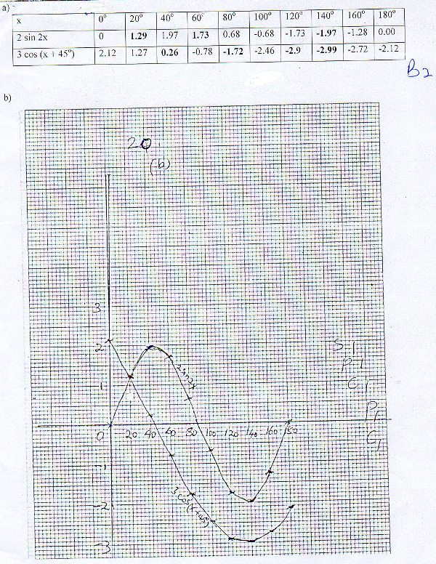

1. Amplitude

d)

|  |  |  |
| --- | --- | --- |
| 22 | 1. Using sine rule | B1  M1 for 3.464  A1  M1 A1  M1 M1 A1  M1 A1 |
| 23 | 1. Shown on the graph 2. Maximum number of animals = 6 goats and 14 sheep = 20 animals | B1  B1  B1  B1 |

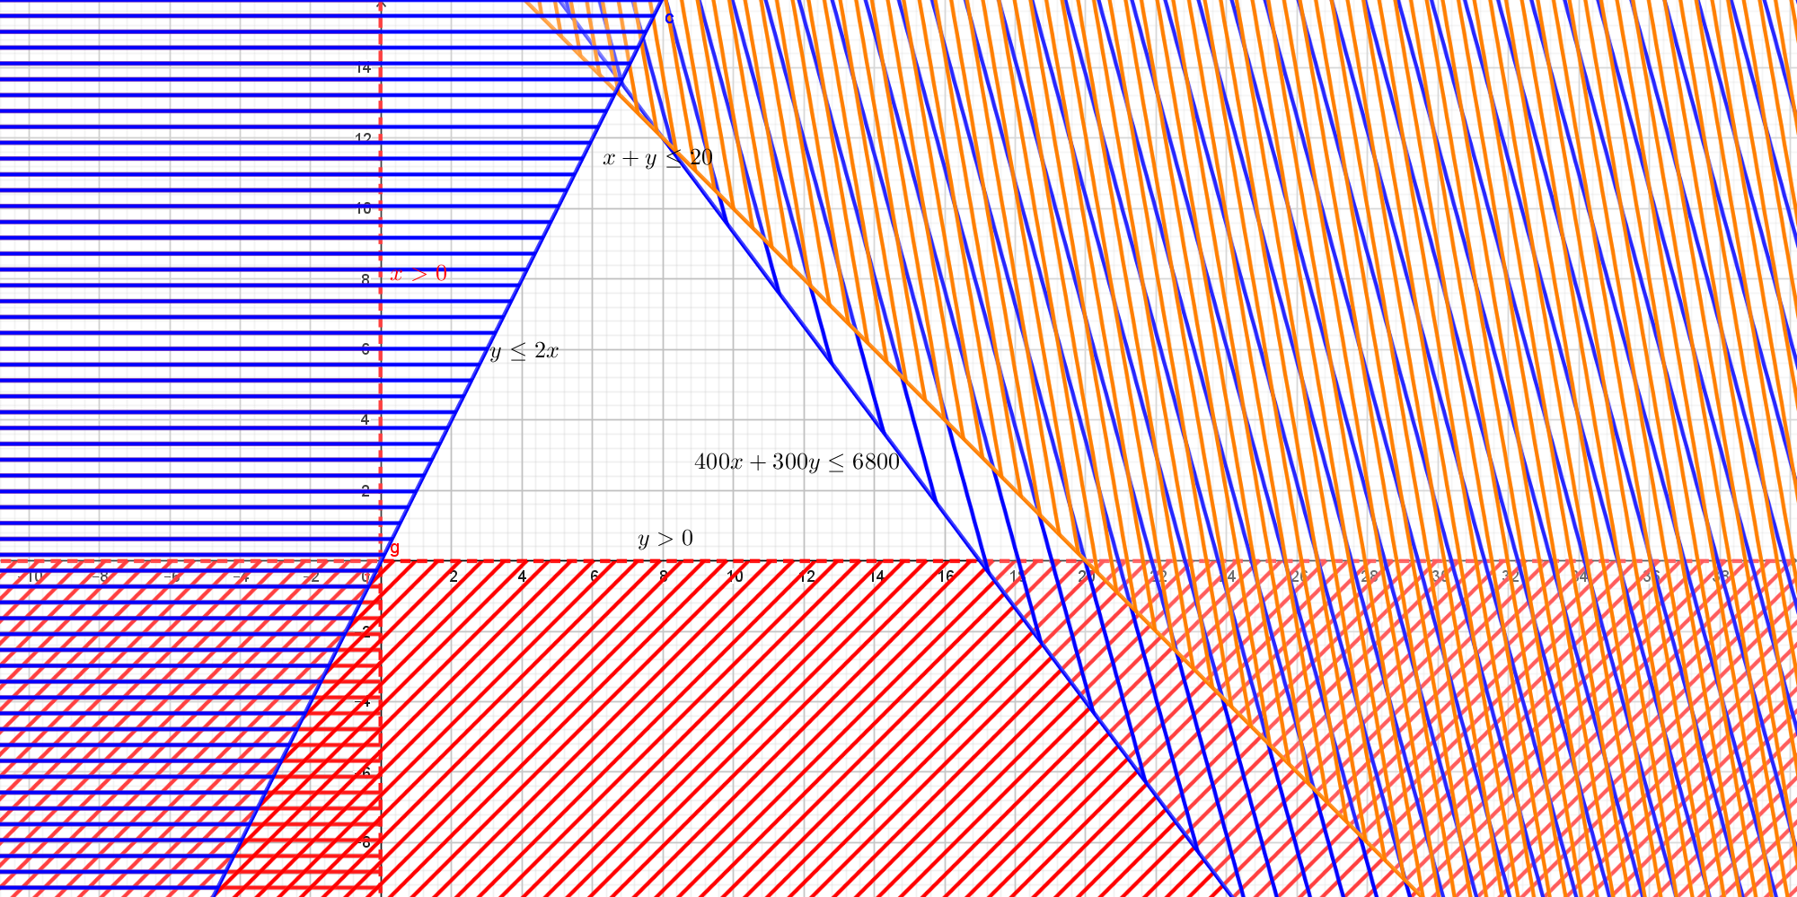

|  |  |  |
| --- | --- | --- |
| 24 | 1. At maximum height, Velocity is zero     m   1. m/s | M1 A1  M1  M1  A1 for  M1 for differentiation  M1  A1  M1 A1 |