NAME ……………………………………….…… ADM NO……….… DATE …….………
SCHOOL…………………………………………...……… SIGNATURE …………...……….
121
MATHEMATICS
FORM 4 PAPER 1
JULY 2024
TIME: 2 ½ HOURS
END OF TERM TWO EXAMINATION
Kenya Certificate of Secondary Education 2024

INSTRUCTIONS TO CANDIDATES
- Write your name and admission number in the spaces provided at the top of this page.
- This paper consists of two sections: Section I and Section II.
- Answer all questions in section I and any five questions in Section II.
- Show all the steps in your calculations, giving your answers at each stage in the spaces below each question.
- Marks may be given for correct working even if the answer is wrong.
- KNEC Mathematical tables may be used.

For Examiner’s Use Only

1 | 2 | 3 | 4 | 5 | 6 | 7 | 8 | 9 | 10 | 11 | 12 | 13 | 14 | 15 | 16 | Total

17 | 18 | 19 | 20 | 21 | 22 | 23 | 24
Grand
Total

SECTION 1 (50 Marks)
Answer all questions in this section.
- Evaluate the following; (3 marks)
$$\frac{\left(8\frac{1}{2}-6\frac{2}{3}\right) ÷\frac{4}{9}}{\frac{2}{5} of 6\frac{1}{4}+1\frac{1}{4}}$$

- Simplify; (3 marks)
$${\left(\frac{27}{125}\right)}^{-\frac{2}{3}}×{\left(\frac{16}{81}\right)}^{\frac{1}{4}}$$

- In a covid-19 vaccination centre, teachers may receive their jabs from either of the two doctors stationed at the two tents. On an average, one doctor takes 2 minutes while the other doctor takes 3 minutes to serve one teacher. If the two doctors start to serve the teachers at the same time, find the shortest time it takes to vaccinate a total of 300 teachers. (3 marks)

- Simplify the expression; (3 marks)
$$\frac{6a^{2}+ab-2b^{2}}{4a^{2}-b^{2}}$$

- Solve for $ϑ$ if $\sin\left(2ϑ-50°\right)=\cos\left(ϑ+10°\right)$. (3 marks)

- The velocity $V m/s$ of a particle projected into space is given by the formula $V={5t}^{2}-2t+9$ where $t$ is the time in seconds elapsed since projection. Determine the acceleration of the particle when $t=4$ seconds. (3 marks)

- The interior angles of a heptagon are$\left(2y+35\right)°, 100°, 135°, 150°, 125$,$\left(3y+25\right)°$, and $\left(2y-20\right)°$. Find the value of y. (3 marks)

- Two similar cylinders have diameter of 14 cm and 42 cm. If the larger cylinder has a volume of $12 474 cm^{3},$find the volume of the smaller cylinder. (3 marks)

- The figure below shows a circle centre O, PQRS is a cyclic quadrilateral and QOS is a straight line. Angle PRQ is 70°.

Giving reasons for your answers, find the size of
- Angle POQ (1 mark)

- Angle PRS. (2 marks)

- Solve for x and state the integral values. (4 marks)
$23-2x>x+2≥-\frac{1}{4}x-3$

- Given that $\tilde{a}=3i-2j+3k$ and $\tilde{b}=2i-4j-3k$ where $i, j and k$ are unit vectors. Find $\left|2a+2b\right|$ (3 marks)

- Use the exchange rates below to answer this question
 | Buying (Kshs) | Selling (Kshs)
1 US dollar ($) | 105.00 | 105.40
1 UK Sterling Pound (£) | 145.20 | 145.75
A tourist arrived in Kenya from Britain with 7,800 UK£. He converted the whole amount of money to Kenya Shillings. While in Kenya, he spent 70% of this money and changed the rest to US $. Calculate the amount of money to the nearest dollar that he received. (3 marks)

- Construct triangle ABC in which BC = 6 cm, AB = 4.5 cm and angle $ABC = 135°$.Drop a perpendicular from point B to line AC and determine the shortest distance from point B to line AC. (4 marks)

- Use tables of cubes, cube roots and reciprocals to find the value of; (3 marks)
$$\frac{4}{{\left(8.63\right)}^{3}}+{\left(\frac{5}{34.46}\right)}^{\frac{1}{3}}$$

- A juice seller blends three types of juices P, Q and R in the ratios $P:Q = 3:4$ and $Q:R = 1: 2.$ The blend contains 16.8 litres of R
- Find the ratio P: Q: R (1 mark)

- Find the required capacity of P in the blend (3 marks)

- A hawker bought 1948 sweets on the first day and sold 570 sweets on the same day. On the second day he sold 204 sweets more than the first day. On the third day he added 650 sweets to his stock. He sold all the sweets on the same day at the price of Sh. 5 each. Calculate the amount of money he received on the third day. (3 marks)

SECTION II (50 Marks)
Instruction: Attempt any Five questions only in this section in the spaces provided.
- (a) A triangle with vertices $A(-4,2)$ $B(-6,6)$ and $C(-6,2)$ is enlarged by a scale factor $-1$ and center $(-2,6)$ to produce triangle $A^{'}B^{'}C^{'}$. Draw triangle ABC and $A^{'}B^{'}C^{'}$and state its coordinates. (4 marks)
(b) Triangle$A^{'}B^{'}C^{'}$ is then reflected in the line $y=x$ to give triangle $A''B^{''}C^{''}$. Draw $A''B^{''}C^{''}$ and state its coordinates . (3 marks)

(c) If triangle $A''B^{''}C^{''}$ is mapped on to $A'''B^{'''}C^{'''}$ whose coordinates are $A^{'''}(0,-2)$, $B^{'''}(4,-4)$, and $C^{'''}(0, -4)$ by a rotation. Find the center and angle of rotation. (3 marks)

- The table below shows heights of 50 students.

Height (cm) | $$150-154$$ | $$155-159$$ | $$160-164$$ | $$165-169$$ | $$170-174$$ | $$175-179$$
Number of students | 5 | 13 | 12 | $$x$$ | $$7$$ | $$3$$

- Determine the value of X. (1 mark)

- Calculate the mean height (4 marks)

- (i) On the grid provided, draw a histogram to represent the above information. Use a scale of 1 cm to represent 5 students and 2 cm to represent 5 cm. (2 marks)
(ii) On the histogram, draw a vertical line to show where the median mark lies. (3 marks)

- The figure below shows a test tube used to store laboratory reagents during a research study.
One of the study reagents was filled into the test tube up to 80% full.
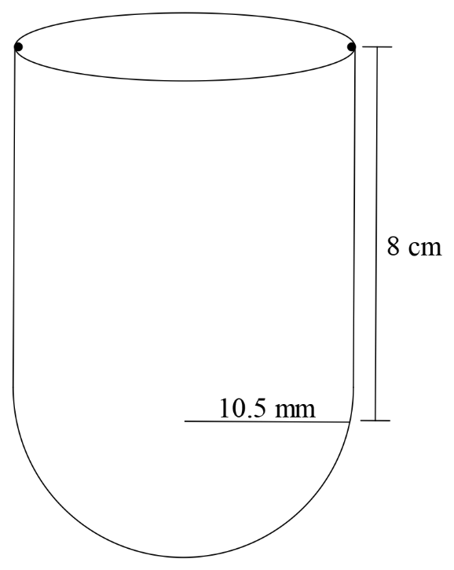
Calculate:
- The volume of the reagent in the test tube. (3 marks)

- The height of the reagent in the test tube. (3 marks)

- The total surface area of the tube in contact with the reagent. (4 marks)

- A bus left Mombasa and travelled towards Nairobi at an average speed of 60km/hr. After 2hrs and 30 minutes, a car left Mombasa to Nairobi and travelled along the same road at an average speed of 100km/hr. If the distance between Mombasa and Nairobi is 500km.
- Determine
- The distance of the bus from Nairobi when the car took off. (2 marks)

- The distance the car traveled to catch up with the bus. (4 marks)

- Immediately the car caught with the bus the car stopped for 25 minutes. Find the new average speed at which the car traveled in order to reach Nairobi at the same time as the bus (4 marks)

- The velocity of a particle after t seconds is given by $V=t^{2}-2t+4$.
- Use the mid ordinate rule with six strips to estimate the displacement of the particle between t = 1 and t = 13 (3 marks)

(b) Determine;
- The exact area of the particle between t = 1 and t = 13. (3 marks)

- Acceleration of the particle at t = 4 (2 marks)

(c) Calculate the percentage error arising from the estimated area in (a) above. (2 marks)

- A shopkeeper planned to buy some fridges from a sum of 1.8 million shillings. Before she could buy the fridges, the price per unit was reduced by Sh. 4 000. As a result she was able to buy five more fridges using the same amount of money as originally planned.
- Determine the number of fridges that the shopkeeper bought. (6 marks)

- If two of the fridges purchased got damaged while in store and the rest were sold making a profit of 20 %, calculate her profit per fridge. (4 marks)

- The equation of a line $L_{1}$ is $3y-2x=10$
- Find in form of $y=mx+c$ where m and c are constants,
- The equation of line $L_{2}$ passing through point N (-5,2) and parallel to $L_{1}.$ (2 marks)

- The equation of $L_{3}$ perpendicular to $L_{2}$ at M $(1,-8)$. (3 marks)

- Find the angle of inclination of the line $L_{2}$ with the horizontal (2 marks)

- Find the magnitude of MN (3 marks)

- The diagram below shows a garden in the shape of a quadrilateral PQRS in which $PQ=SR=120m$, $QR=45 m$, $PQR=SPQ=90°$ and $QRS = 135°$
- Calculate to 1 decimal place:
- The size of angle QPR. (3 marks)

- The length PS (4 marks)

- Calculate the area of the garden in hectares, correct to 3 decimal places. (3 marks)

