**MATHEMATICS**

**FORM FOUR PAPER ONE**

**MARKING SCHEME**

|  |  |  |
| --- | --- | --- |
| No | Working | Marks |
| 1 |  | M1  M1  A1 |
| 2 |  | M1  M1  A1 |
| 3 | Doctor A will give jabs to 3 teachers in 6 minutes  Doctor B will give jabs to 2 teachers in 6 minutes  minutes | MI  M1  A1 |
| 4 |  | M1  M1  A1 |
| 5 |  | M1  M1  A1 |
| 6 | Acc = | M1  M1 A1 |
| 7 | Heptagon  Sum of interior angles = | M1  M1  A1 |
| 8 | L.S.F =  V.S.F =  Volume of smaller cylinder = | M1  M1  A1 |
| 9 |  | B1  B1  B1 |
| 10 | Integral values area | M1  M1  A1  B1 |
| 11 |  | M1  M1  A1 |
| 12 | Balance after spending =  Amount US dollars = | M1  M1  A1 |
| 13 | C:\Users\user\Desktop\ML EXAMS\T2 2023\img20230706_18274721.jpg  – complete  Lines  Angle ABC  Shortest distance BX | B1  B1  B1  B1 |
| 14 | (4 s.f) | M1  M1  A1 |
| 15 | 1. Total capacity =   Capacity of P = | B1  M1  M1 A1 |
| 16 | First day  Second day  Third day =  Amount received = | M1  M1  A1 |
| 17 |  |  |

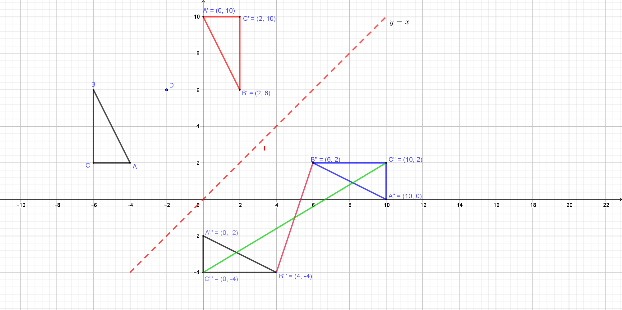

|  |  |  |  |  |  |  |  |  |  |  |  |  |  |  |  |  |  |  |  |  |  |  |  |  |  |  |  |  |  |  |  |  |  |  |
| --- | --- | --- | --- | --- | --- | --- | --- | --- | --- | --- | --- | --- | --- | --- | --- | --- | --- | --- | --- | --- | --- | --- | --- | --- | --- | --- | --- | --- | --- | --- | --- | --- | --- | --- |
| 18 | |  |  |  |  | | --- | --- | --- | --- | | Class |  |  |  | |  | 152 | 5 | 760 | |  | 157 | 13 | 2041 | |  | 162 | 12 | 1944 | |  | 167 | 10 | 1670 | |  | 172 | 7 | 1204 | |  | 177 | 3 | 531 | |  |  | **50** | **8 150** | | B1  B1 – column  B1 – column  M1  A1 |

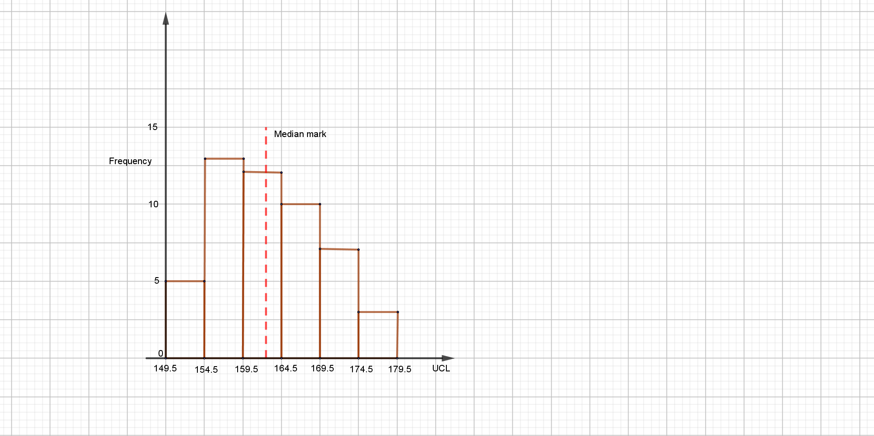

|  |  |  |
| --- | --- | --- |
| 19 | 1. Volume of hemisphere =   Volume of cylinder =  Volume of reagent =   1. Volume of reagent in cylindrical part =     height =   1. Hemisphere   Cylindrical part =  Total Surface Area = | M1  M1  A1  M1  M1  A1  M1  M1  M1 A1 |
| 20 | 1. (i) Distance moved by bus in 2.5 hours =   Distance from Nairobi =  (ii) Relative speed =  Time taken  Distance =   1. Remaining distance =   Time taken by bus =  Time taken by car =  Speed of the car = | M1  A1  M1  A1  M1 A1  M1  M1  M1 A1 |
| 21 | |  |  |  |  |  |  |  | | --- | --- | --- | --- | --- | --- | --- | | t | 2 | 4 | 6 | 8 | 10 | 12 | | V | 4 | 12 | 28 | 52 | 84 | 124 |     Displacement =   1. (i)         (ii) Acceleration       1. Percentage error = | B1  M1 A1  M1  M1  A1  M1  A1  M1  A1 |
| 22 | 1. Initial price =   New price =  Number of fridges bought   1. Selling price of a fridge =   Buying price of a fridge =  Profit made = | M1  M1  M1  M1  A1  B1  M1  M1  M1 A1 |
| 23 | 1. (i)   (ii) | M1  A1  M1  M1  A1  M1  A1  M1  M1 A1 |
| 24 | 1. (i)     (ii)     1. Area = 2. Area in hectares = | M1  M1 A1  M1  M1  M1 A1  M1  M1 A1 |