COMPETENCE BASED CURRICULUM
7
2024
JUNIOR SCHOOL
INTEGRATED SCIENCE Question paper
2 HOURS
SCHOOL: …………………….……….……………………………………..…
NAME: …………………………….………………………….………………...…
ASSESSMENT NO: ………….……. SIGN: …..……..... DATE: ………..….
RUBRICS (for official use)
MARK SCORE RANGE | Below 40 | 40-59 | 60-79 | 80-100
PERFORMANCE LEVEL | Below expectation | Approaching expectations | Meeting expectations | Exceeding expectations

OUT OF | 100%
LEARNERS SCORE
PERCENTAGE SCORE
PERFORMANCE LEVEL

FOR FACILITATOR’S USE ONLY

INSTRUCTIONS TO CANDIDATES
- Answer all the questions in the spaces provided.
- Ensure your work is neat.

QUESTIONS
      - Name two laboratory apparatus used for measuring mass of substances.( 2 mks)
  - ………………………………………..
  - ………………………………………..
      - What is the meaning of the following sign?( 3 mks)

      - Name two careers related to integrated science.(2mks)
- ………………………….
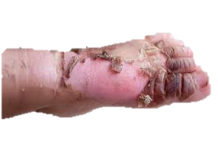
- …………………………..
      - Identify the common lab injury below. ( 1mk)

      - Calculate the area of the following object.( 3 mks)
15cm

10cm

12cm

Mention two rules you must observe when in the laboratory. (2 mks)
- ……………………………………………………………………………………………..…..
- …………………………………………………………………………………………………

      - Name two heat instruments used in the lab for heating purposes.(2 mks)
- …………………………………….
- …………………………….………
      - State two ways of reducing frictional force between two surfaces.( 2mks)
- ………………………………………….
- …………………………………………..
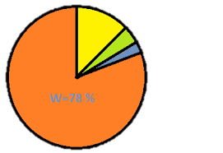
      - The chart drawn below shows the composition of air in the atmosphere. Use it to answer quiz (a) and (b)
- Identify the gases labeled(4 mks)
W …………………..………. W X Y Z
X ………………….………….
Y ……………….…………….
Z ……………………………..

b. Write two uses of gas X. (2 mks)
- ………………………………………………………………………..
- ……………………………………………………………………….
      - State the functions of the following parts of a Bunsen burner.( 5mks)

Part | Function
Collar
Air hole
Base
Gas hose
Gas inlet
      - Name two types of blood groups. ( 2mks)
- ………………………………..
- ………………………………..
      - Identify the following parts of the human skeleton. (4 mks)
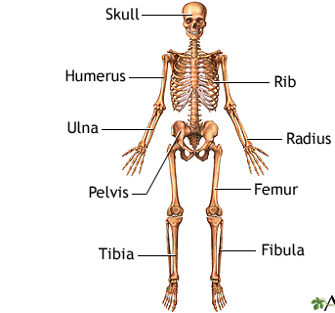
Tibia
Radius
Skull
Pelvis
Rib
Femur
Humerus

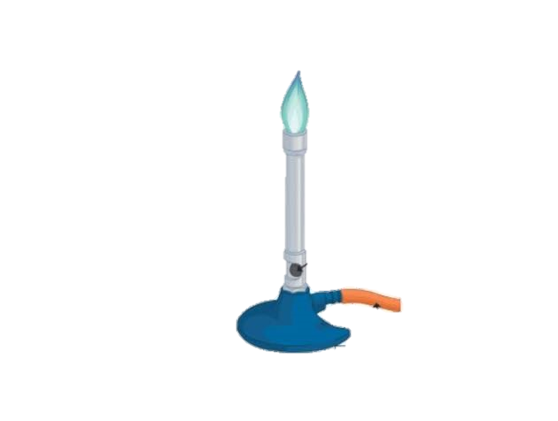
      - Identify the following parts of a Bunsen burner. (3 mks)

      - To identify whether a substance is either acidic or basic, we use
……………………………………………………. ( 1mk)

State two ways of handling a light microscope. ( 2mks)
- ……………………………………………………………………….
- ……………………………………………………………………….
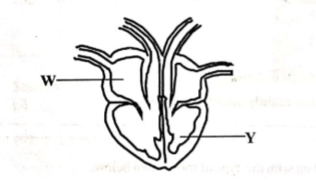
      - The diagram below shows the human heart. Name the parts(2 mks)

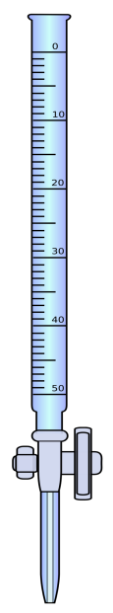
W ……………………………………
Y ……………………………………..

      - Identify the following lab apparatus. (3 mks)
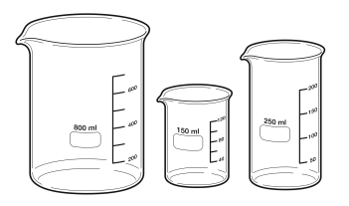

Name two components of a first aid kit (2 mks)
  - …………………………………………………………………
  - ………………………………………………………………..
- The volume of 2355g of glass was found to be 50cm³.Calculate the density of mercury ( 2 mks)

- Draw in the meniscus the following readings.(1 mk)
8cm³

THIS IS THE LAST PRINTED PAGE

