INTEGRATED SCIENCE
GRADE 7
CBC JUNIOR SECONDARY
STRAND ONE
SCIENTIFIC INVESTIGATION
NOTE: Integrated science is taught through inquiry-based learning approaches with an emphasis on the 5Es: engagement, exploration, explanation, elaboration and evaluation.
Integrated Science: What is integrated science?
Integrated Science is an interdisciplinary approach to science education that seeks to connect and integrate concepts and ideas from different branches of science, such as biology, chemistry, physics, and earth science.
Components of Integrated science
The components of Integrated Science may vary depending on the curriculum and educational approach, but typically include:
- Basic scientific concepts: students learn about fundamental scientific principles and theories, such as the nature of matter and energy, the structure of the universe, and the process of evolution.
- Laboratory experiences: hands-on experiments and investigations provide students with opportunities to apply scientific concepts and methodologies.
- Problem solving and inquiry: students learn to use scientific reasoning and inquiry to design experiments, analyze data, and make informed conclusions.
- Scientific literacy: students learn to critically evaluate scientific information, understand the impact of science and technology on society, and appreciate the ethical considerations involved in scientific research.
- Integration of scientific concepts: the curriculum emphasizes connections between different branches of science and the interplay between science, technology, and society.
Pathways related to integrated Science
The provision of pathways at senior school is based on the aspiration that all learners can be successful in life. These pathways are contained in one-word STEM (Science, Technology, Engineering and Mathematics)

Subjects in the STEM pathway include
- Pure Science
Students in this track shall be expected to join a university or other middle level college to pursue careers in area such as education, medicine, pharmacy, science (BSc), industrial science and actuarial science. Some will be able to join the world of work under experienced persons and later undergo further training and apprenticeships to advance their skills.
- Applied Sciences
The Applied science track provides a specialization opportunity for learners who have demonstrated the interest, abilities and aptitude to pursue a career in applied sciences. The track builds on the competencies acquired at lower secondary in the areas of mathematics and integrated science. It equips learners with the knowledge, skills and attitudes necessary for advanced careers in applied sciences offered in middle level colleges and universities
Students graduating from this track shall be expected to join middle level colleges or universities to pursue careers in areas such as agricultural engineering, computer engineering, foods science and technology, business and hospitality and home economics. They shall also be able to join the world of work where they shall work under the guidance of a specialist as they advance their skills on the job, through apprenticeships or further training.
The pure and applied sciences curriculum shall prepare learners to graduate with a senior school national certificate that will open the following career opportunities for them:
- Enroll directly into a university for a degree in science related subjects.
- Enroll into middle level colleges for a diploma in science related fields.
- Join the world of work to work under skilled personnel
- Technical and Engineering
The schools shall prepare learners with foundational skills in applied sciences and modern
technology. Emphasis shall be on the understanding and practical application of basic principles of science and mathematics in various fields such as engineering, design, agriculture, business, computers and data processing, environmental and resource management and health.
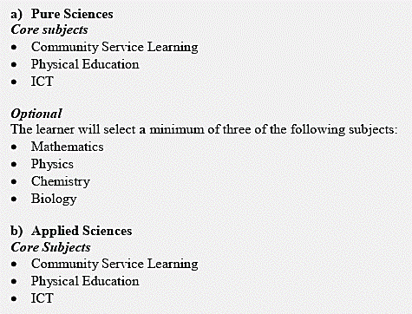
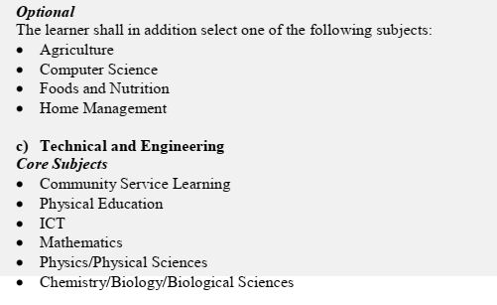
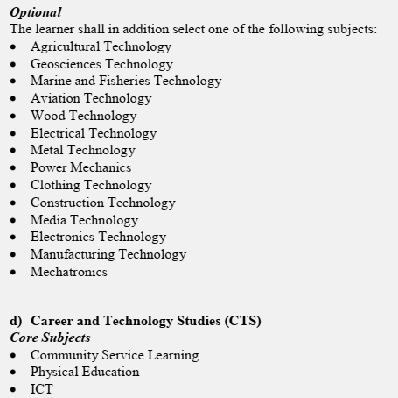
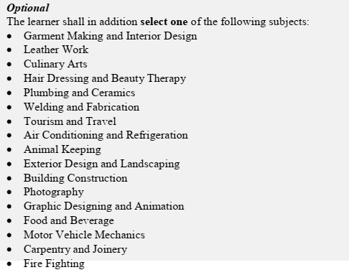
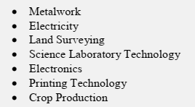
Career opportunities related to Integrated Science
- Environmental manager
- Forensic laboratory technician
- Health education specialist
- Laboratory technician
- Public health advisor/analyst
- Research assistant
- Scientific journalist
- Software Developer
- Dentist
- Doctor
- Forensic scientist
- Geneticist
- Lawyer
- Marine biologist
- Neuroscientist
- Nurse
- Nutritionist
- Optometrist
- Pharmacist
- Physiotherapist
- Psychiatrist
- Urban planner
- Teacher/Professor
- Veterinarian
- Virologist
Importance of Integrated Science
Learning in the 21st century should have context, be linked to community life, be student centered and be collaborative.
Learning has context mean that the content of learning material must be associated with the real world. In this way, the material discussed in the school is close to the daily life of the students.
In learning process, students more involved actively to construct their competences. Construction of competencies in learning is done collaboratively. Hence, these four principles of learning are the essence of the 21st century learning.
- Integrated science learning is a good way to apply the essence of learning in the 21st century.
- In integrated science learning students are encouraged to connect the learning materials content to real-world contexts. Students are involved actively in exploring the real-world contexts which relevant to the learning material, conducting the collaborative investigation, and communicating the results of the investigation. Thus, the learning can be implemented holistically, authentically, meaningfully and actively.
- aims to improve students’ understanding on the environment

Importance of Scientific Knowledge
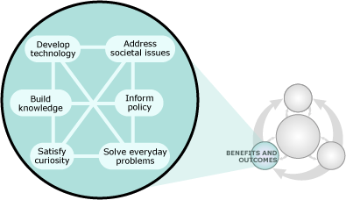
And that knowledge is useful for all sorts of things:
- designing bridges,
- slowing climate change, and
- prompting frequent hand washing during flu season.
- Scientific knowledge allows us to develop new technologies,
- solve practical problems, and
- make informed decisions — both individually and collectively.
Laboratory safety
A place equipped for experimental study in a science or for testing and analysis. a research laboratory. broadly: a place providing opportunity for experimentation, observation, or practice in a field of study.
Common hazards and their symbols
Hazard pictograms alert us to the presence of a hazardous chemical. The pictograms help us to know that the chemicals we are using might cause harm to people or the environment. Here are a few of them.
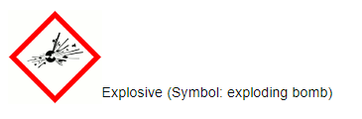
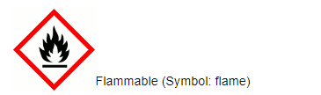
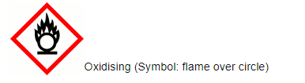
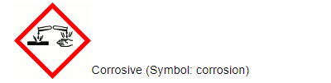
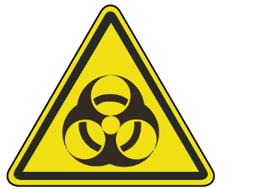 Biohazard – It provides warning on lab equipment that may contain biohazardous materials like blood samples.
Causes of accidents in the laboratory
1. CHEMICALS
If you handle chemicals, you need to wear protective gloves. Treat chemicals with the necessary caution, measure chemicals carefully, contain potentially irritating or hazardous chemicals and use only approved containers when you’re transferring chemicals.
Chemical burns should be treated by flushing the affected area with a large amount of cool, running water for at least 15 minutes. If the burn area is large or if the affected person is dizzy or weak, call 911.
If you work in a chemistry lab, ensure you are taking the proper steps to be safe around the chemicals in your workplace.
2. HEAT
Exercise caution when handling hot items. Hastily or improperly handling these items without the correct tools can cause serious burns. Workers should be properly using water baths, tongs and cooling equipment. Be careful not to touch hot surfaces with your bare hand.
If you suffer a heat burn in the lab, run the burned area under cool water for five minutes.
3. CUTS AND SCRAPES
Using sharp tools in the laboratory setting can cause scrapes and cuts. Workers may also use sharp objects, such as needles and razor blades, or need to clean up broken glass. To avoid cutting yourself on these items, carefully wrap them so that you can safely carry and dispose of them.
4. CONTAMINATION
Avoiding contamination is key to ensuring safety in the lab setting. Though the advice to wash your hands may seem quite basic, it’s an important procedure to avoid contamination. After you interact with any foreign substance, you should wash your hands thoroughly.
Protect your skin and clothing with the proper equipment, such as gloves, glasses and a lab coat. You can contaminate areas outside of the lab if you carry bacteria or other substances on your clothing or skin, which can cause the spread of illnesses and other dangers.
5. Inhaling Substances
Another common type of lab accident is inhalation. If you inhale chemicals or gases in a space that isn’t properly ventilated, you may experience nausea, headaches or fainting. Ensure you follow proper procedures for ventilation, such as using ventilation fans and measuring the amount of gas emitted in a room.

6. FIRES
When working with hot surfaces and flammable materials, fires become a common danger. Review and practice the proper procedures to ensure you minimize the risk of fire in the laboratory. All flammable materials should be properly stored and sealed. Inspect burners for leaks to avoid sudden flares.
7. SPILLS AND BREAKS
In the lab, glass beakers may be dropped and break. Liquids may be spilled. Generally, these accidents are caused by rushing, being negligent and not properly following procedures. While you work, move carefully through every step. Moving slowly but more steadily will be much better for the safety of yourself and your colleagues.
Though students have a responsibility to themselves and their colleagues to exercise proper safety measures and follow protocol, the laboratory environment itself should also follow guidelines from the Occupational Safety and Health Administration (OSHA) to provide workers with safe working conditions.
- Lack of warning labels and signs
- Inadequate eye and face protection against chemical and environmental hazards
- Lack of protection against hazardous sources of energy, such as electric power
- Inadequate respiratory protection for working with gases, chemicals and smoke
First Aid safety measures for common laboratory accidents
General course of action
- RELOCATE everyone in the immediate work area to a safe location.
- ALERT-
- CONFINE- If it can be done safely, close doors to confine the area where the emergency occurred. Post an “Emergency Hangtag” on the door(s) to prevent reentry by other personnel.
- EVACUATE the building through the nearest exit. Do not run. Do not use elevators.
- REPORT to your designated meeting site.
- REENTER once the lab has been cleared by emergency personnel.
First Aid: Eye Exposure to Hazardous Chemical
- Forcibly hold both eyes open under an emergency eyewash to ensure an effective wash behind both eyelids.
- If contact lenses are being worn, remove the contacts while flushing.
- Continue flushing the eyes underneath the eyewash until emergency personnel arrive.
- Report the injury to your principal investigator and/or laboratory/facility manager.

First Aid: Skin Exposure
- Wash affected area(s) with tepid water from an emergency safety shower. Take care not to break skin.
- Remove or cut off contaminated clothing while rinsing. Do not pull contaminated clothing over the head.
- For chemical and thermal burns, flush affected area(s) with water from the safety shower, if indicated in safety data sheet.
- For blood, biological, or radiological exposures use soap and water.
- Keep flushing affected area(s) underneath the safety shower until emergency personnel arrive.
- Report the injury to your principal investigator and/or laboratory/facility manager.
First Aid: Inhalation of Chemical Vapors, Fumes or Smoke
- If exposed individual is unconscious, do NOT enter the lab if a possibility of oxygen depletion, toxic vapors, or an explosive atmosphere exists.
- If exposed individual is conscious, move the person to fresh, uncontaminated air.
- Report the injury to your principal investigator and/or laboratory/facility manager.
First Aid: Chemical Ingestion
- If safe to do so, move affected individual to an uncontaminated area.
- Do not induce vomiting or drink water or other liquids unless instructed to do so by emergency personnel.
- Report the injury to your principal investigator and/or laboratory/facility manager.
Importance of safety in the laboratory
Laboratory safety is an essential part of ensuring the health and safety of workers and researchers in laboratory settings. Laboratories can be hazardous environments with various potential risks, including chemical spills, fires, explosions, and exposure to hazardous substances.

Lab safety is important because it can prevent injury, keep us from making mistakes and save lives.
- Lab safety equipment can prevent injury.
- Lab safety equipment can help you avoid making mistakes.
- Lab safety equipment can save lives.
Safety is important when working in the lab because it helps you avoid injury, keep yourself from making mistakes and save lives of others who may be nearby when an accident happens, or if there is a fire or other emergency situation that needs to be handled quickly and safely by someone who knows what they're doing before the situation gets out of hand.

Following lab safety rules is part of being a good citizen.
Following lab safety rules is part of being a good citizen. When you follow lab safety rules, you are doing your part to keep everyone safe. You are protecting yourself, your peers and coworkers, and everyone around you. Lab safety rules help prevent accidents and injuries, which means they can also save lives.

We should follow the lab safety protocols to stay safe and healthy!
By following the lab safety protocols, you will stay safe and healthy.
- It is absolutely critical that you follow all the rules of your lab protocol when conducting experiments in the lab. This allows you to avoid accidents and contamination, which can cause injury or illness.
- You should always wear protective clothing (goggles, gloves and a face mask) to keep yourself safe from hazardous materials such as chemicals or glass shards if an accident occurs in the laboratory.
- You should never eat or drink anything in the laboratory because it could easily contaminate your food with chemicals or bacteria potentially harmful for consumption by humans!
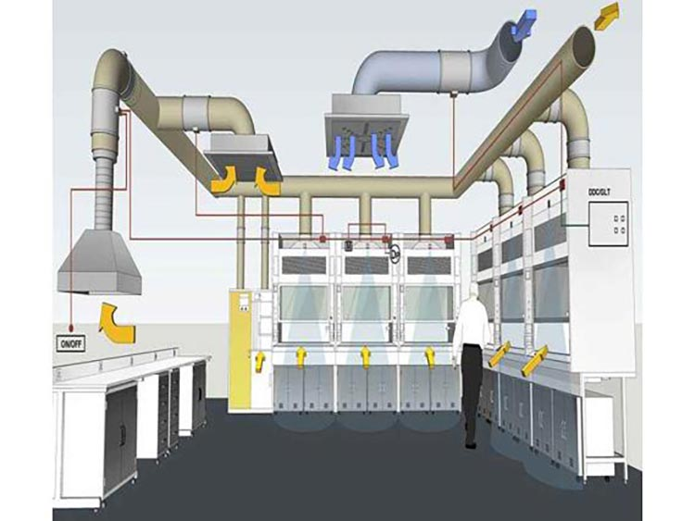
Basic Science Skills
Basic skills in science
1. Observing
This is the most basic skill in science. Observations are made by using the 5 senses. Good observations are essential in learning the other science process skills.
Examples:
The learner will be blind folded and make observations using the sense of touch.
The learner will create observations about a coin using the 5 senses.
The learner will mix primary colors to create more colors.

2. Communicating
It is important to be able to share our experiences. This can be done with graphs, diagrams, maps, and spoken word.
Examples:
The learner will create a line graph showing the relationship between speed and the mass of a marble.
The learner will discuss possible errors with other classmates.
3. Classifying
After making observations it is important to notice similarities, differences, and group objects according to a purpose. It is important to create order to help comprehend the number of objects, events, and living things in the world.
Examples:
The learner will use a magnet to classify objects as magnetic or nonmagnetic.
The learner will use a balance and sort objects according to mass.
The learner will combine different liquids with water to determine which is more or less dense.
4. Inferring
An inference is an explanation based on an observation. It is a link between what is observed and what is already known.
Examples:
The learner will write a conclusion at the end of each investigation.
The learner will create inferences about observations they made about a mystery object. I infer it is solid rather than hollow.
5. Measuring
Measuring is important in collecting, comparing, and interpreting data. It helps us classify and communicate with others. The metric system should be used to help understand the scientific world.
Examples:
The learner will find the mass of different liquids that have the same volume.
The learner will use technology to find the speed of a toy truck.
The learner will measure the distance a marble travels.

6. Predicting
What do you think will happen? It is an educated guess based on good observations and inferences about an observed event or prior knowledge.
Examples:
The learner will predict what is a box based on observations using the sense of touch.
The learner will write a hypothesis about the effect of increasing the salt on the buoyancy of an egg.
7. Manipulative skill
In science, manipulative skills emphasize the use and handling of scientific apparatus and chemical substances during scientific investigation in the laboratory.
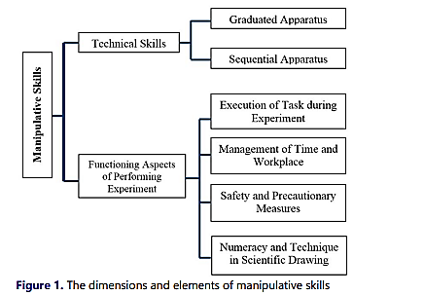
Importance of reading packing labels on products/quantities
- It helps in knowing the quantity of the product
- It helps in knowing the product specifications like:
- Conditions for storage
- Date of expiry
- How to use the product
- Possible side effects
- What to do in case of emergencies
- How to dispose the product among others
SI Units
The International System Of Units (SI) is the metric system that is used universally as a standard for measurements. SI units play a vital role in scientific and technological research and development.

SI unit is an international system of measurements that are used universally in technical and scientific research to avoid the confusion with the units. Having a standard unit system is important because it helps the entire world to understand the measurements in one set of unit systems. Following is the table with base SI units:
Sl. No. | Name of the Quantity | SI Unit | SI Unit Symbol
1. | Length (l) | Meter | m
2. | Mass (M) | Kilogram | kg
3. | Time (T) | Second | s
4. | Electric current (I) | Ampere | A
5. | Thermodynamic temperature (Θ) | Kelvin | K
6. | Amount of substance (N) | Mole | mol
7. | Luminous intensity (J) | Candela | cd
There are 7 SI base units. The seven units along with their SI unit and symbol are given below:
- Unit of length, meter (m): Meter is the SI unit of length and is defined by taking the fixed value of the speed of light in vacuum. It is expressed as m.s⁻¹.
- Unit of mass, kilogram (kg): Kilogram is the SI unit of mass and is defined by taking the fixed value of the Planck constant. It is expressed as kg
- Unit of time, second (s): Second is the SI unit of time and is defined by taking the fixed value of Cesium frequency.
- Unit of electric current, ampere (A): Ampere is the SI unit of electric current and is defined by taking the fixed value of the elementary charge.
- Unit of thermodynamic temperature, Kelvin (K): Kelvin is the SI unit of thermodynamic temperature
- Unit of the amount of substance, mole (mol): Mole is the SI unit of the amount of substance and is defined by the fixed value of Avogadro constant N_{A}.
- Unit of luminous intensity, candela (cd): Candela is the SI unit of luminous intensity and is defined by the fixed value of the luminous efficacy.

Laboratory apparatus
An apparator /apparatus are scientific tools/equipment used in performing scientific experiments. The conventional apparator used in performing scientific experiments is called standard apparator/apparatus. If the conventional standard apparator/apparatus is not available, an improvised apparator/apparatus may be used in performing scientific experiments. An improvised apparator/apparatus is one used in performing a scientific experiment for a standard apparator/apparatus. Most standard apparatus in a school chemistry laboratory are made of glass because:
(i)Glass is transparent and thus reactions /interactions inside are clearly visible from outside
(ii) Glass is comparatively cheaper which reduces cost of equipping the school chemistry laboratory
(iii) Glass is comparatively easy to clean/wash after use.
(iv) Glass is comparatively unreactive to many chemicals.
Apparatus are designed for the purpose they are intended in a school chemistry laboratory:
- Apparatus for measuring volume
1. Measuring cylinder
Measuring cylinders are apparatus used to measure volume of liquid/ solutions. They are calibrated/ graduated to measure any volume required to the maximum. Measuring cylinders are named according to the maximum calibrated/graduated volume e.g.
“10ml” measuring cylinder is can hold maximum calibrated/graduated volume of “10mililitres” /“10 cubic centimetres”
“50ml” measuring cylinder is can hold maximum calibrated/graduated volume of “50mililitres” /“50 cubic centimetres”
“250ml” measuring cylinder is can hold maximum calibrated/graduated volume of “250mililitres” /“250 cubic centimetres”
“1000ml” measuring cylinder is can hold maximum calibrated/graduated volume of “1000mililitres” /“1000 cubic centimetres”
2. Burette
Burette is a long and narrow/thin apparatus used to measure small accurate and exact volumes of a liquid solution. It must be clamped first on a stand before being used. It has a tap to run out the required amount out. They are calibrated/ graduated to run out small volume required to the maximum 50ml/50cm3.
The maximum 50ml/50cm3 calibration/ graduation reading is at the bottom .This ensure the amount run out from a tap below can be determined directly from burette reading before and after during volumetric analysis.
Burettes are expensive and care should be taken when using them.
3. (i) Pipette
Pipette is a long and narrow/thin apparatus that widens at the middle used to measure and transfer small very accurate/exact volumes of a liquid solution.
It is open on either ends.
The maximum 25ml/25cm3 calibration/ graduation mark is a visible ring on one thin end.
To fill a pipette to this mark, the user must suck up a liquid solution upto a level above the mark then adjust to the mark using a finger.
This requires practice.
(ii) Pipette filler
Pipette filler is used to suck in a liquid solution into a pipette instead of using the mouth. It has a suck, adjust and eject button for ensuring the exact volume is attained. This requires practice.
4. Volumetric flask.
A volumetric flask is thin /narrow but widens at the base/bottom. It is used to measure very accurate/exact volumes of a liquid solution.
The maximum calibration / graduation mark is a visible ring.
Volumetric flasks are named according to the maximum calibrated/graduated volume e.g.
“250ml” volumetric flask has a calibrated/graduated mark at exact volume of “250mililitres” /“250centimetres”
“1l” volumetric flask has a calibrated/graduated mark at exact volume of “one litre” /“1000 cubic centimeters”
“2l” volumetric flask has a calibrated/graduated mark at exact volume of “two litres” /“2000 cubic centimeters”
5. Dropper/teat pipette
A dropper/teat pipette is a long thin/narrow glass/rubber apparatus that has a flexible rubber head.
A dropper/teat pipette is used to measure very small amount/ drops of liquid solution by pressing the flexible rubber head. The numbers of drops needed are counted by pressing the rubber gently at a time
(b)Apparatus for measuring mass
1. Beam balance
A beam balance has a pan where a substance of unknown mass is placed. The scales on the opposite end are adjusted to “balance” with the mass of the unknown substance. The mass from a beam balance is in grams.
2. Electronic/electric balance.
An electronic/electric balance has a pan where a substance of unknown mass is placed. The mass of the unknown substance in grams is available immediately on the screen.

(c)Apparatus for measuring temperature
A thermometer has alcohol or mercury trapped in a bulb with a thin enclosed outlet for the alcohol/mercury in the bulb.
If temperature rises in the bulb, the alcohol /mercury expand along the thin narrow enclosed outlet.
The higher the temperature, the more the expansion
Outside, a calibration /graduation correspond to this expansion and thus changes in temperature.
A thermometer therefore determines the temperature when the bulb is fully dipped in to the substance being tested. To determine the temperature of solid is thus very difficult.
(d)Apparatus for measuring time
The stop watch/clock is the standard apparatus for measuring time. Time is measured using hours, minutes and second.
Common school stop watch/clock has start, stop and reset button for determining time for a chemical reaction. This requires practice.
(e) Apparatus for scooping
1. Spatula
A spatula is used to scoop solids which do not require accurate measurement. Both ends of the spatula can be used at a time.
A solid scooped to the brim is “one spatula end full” A solid scooped to half brim is “half spatula end full”.
2. Deflagrating spoon
A deflagrating spoon is used to scoop solids which do not require accurate measurement mainly for heating. Unlike a spatula, a deflagrating spoon is longer.
(f) Apparatus for putting liquids/solid for heating.
1. Test tube.
A test tube is a narrow/thin glass apparatus open on one side. The end of the opening is commonly called the “the mouth of the test tube”.
2. Boiling/ignition tube.
A boiling/ignition tube is a wide glass apparatus than a test tube open on one side. The end of the opening is commonly called the “the mouth of the boiling/ignition tube”.
3. Beaker.
Beaker is a wide calibrated/graduated lipped glass/plastic apparatus used for transferring liquid solution which do not normally require very accurate measurements
Beakers are named according to the maximum calibrated/graduated volume they can hold e.g.
“250ml” beaker has a maximum calibrated/graduated volume of “250mililitres” /“250 cubic centimeters”
“1l” beaker has a maximum calibrated/graduated volume of “one litre” /“1000 cubic centimeters”
“5 l” beaker has a maximum calibrated/graduated volume of “two litres” /“2000 cubic centimeters”
4. Conical flask.
A conical flask is a moderately narrow glass apparatus with a wide base and no calibration/graduation. Conical flasks thus carry/hold exact volumes of liquids that have been measured using other apparatus. It can also be put some solids. The narrow mouth ensures no spillage.
Conical flasks are named according to the maximum volume they can hold e.g. “250ml” Conical flasks hold a maximum volume of “250mililitres” /“250 cubic centimeters”
“500ml” Conical flasks hold a maximum volume of “500ml” /“1000 cubic centimeters”
5. Round bottomed flask
A round bottomed flask is a moderately narrow glass apparatus with a wide round base and no calibration/graduation. Round bottomed flask thus carry/hold exact volumes of liquids that have been measured using other apparatus. The narrow/thin mouth prevents spillage. The flask can also hold (weighed) solids. A round bottomed flask must be held/ clamped when in use because of its wide narrow base.
6. Flat bottomed flask
A flat bottomed flask is a moderately narrow glass apparatus with a wide round base with a small flat bottom. It has no calibration/graduation.
Flat bottomed flasks thus carry/hold exact volumes of liquids that have been measured using other apparatus. The narrow/thin mouth prevents spirage. They can also hold (weighed) solids. A flat bottomed flask must be held/ clamped when in use because it’s flat narrow base is not stable.
(g) Apparatus for holding unstable apparatus (during heating).
1. Tripod stand
A tripod stand is a three legged metallic apparatus which unstable apparatus are placed on (during heating).Beakers. Conical flasks, round bottomed flask and flat bottomed flasks are placed on top of tripod stand (during heating).
2. Wire gauze/mesh
Wire gauze/mesh is a metallic/iron plate of wires crossings. It is placed on top of a tripod stand:
(i) Ensure even distribution of heat to prevent cracking glass apparatus
(ii) Hold smaller apparatus that cannot reach the edges of tripod stand
3 Clamp stand
A clamp stand is a metallic apparatus which tightly hold apparatus at their “neck” firmly.
A clamp stand has a wide metallic base that ensures maximum stability. The height and position of clamping is variable. This require practice
4. Test tube holder
A test tube holder is a hand held metallic apparatus which tightly hold test/boiling/ignition tube at their “neck” firmly on the other end.
Some test tube holders have wooden handle that prevent heat conduction to the hand during heating.
5. Pair of tong.
A pair of tong is a scissor-like hand held metallic apparatus which tightly hold firmly a small solid sample on the other end.
6. Gas jar
A gas jar is a long wide glass apparatus with a wide base.
It is open on one end. It is used to collect/put gases.
This requires practice.
(h) Apparatus for holding/directing liquid solutions/funnels (to avoid spillage).
1. Filter funnel
A filter funnel is a wide mouthed (mainly plastic) apparatus that narrow drastically at the bottom to a long extension.
When the long extension is placed on top of another apparatus, a liquid solution can safely be directed through the wide mouth of the filter funnel into the apparatus without spirage.
Filter funnel is also used to place a filter paper during filtration.
2. Thistle funnel
A thistle funnel is a wide mouthed glass apparatus that narrow drastically at the bottom to a very long extension.
The long extension is usually drilled through a stopper/cork.
A liquid solution can thus be directed into a stoppered container without spillage
3. Dropping funnel
A dropping funnel is a wide mouthed glass apparatus with a tap that narrow drastically at the bottom to a very long extension.
The long extension is usually drilled through a stopper/cork.
A liquid solution can thus be directed into a stoppered container without spillage at the rate determined by adjusting the tap.
4. Separating funnel
A separating funnel is a wide mouthed glass apparatus with a tap at the bottom narrow extension.
A liquid solution can thus be directed into a separating funnel without spillage. It can also safely be removed from the funnel by opening the tap.
It is used to separate two or more liquid solution mixtures that form layers/immiscible. This requires practice.

(h) Apparatus for heating/Burners
1. Candle, spirit burner, kerosene stove, charcoal burner/jiko are some apparatus that can be used for heating.
Any flammable fuel when put in a container and ignited can produce some heat.
2. Bunsen burner
The Bunsen burner is the standard apparatus for heating in a Chemistry school laboratory.
It was discovered by the German Scientist Robert Wilhelm Bunsen in1854.
(a)Diagram of a Bunsen burner
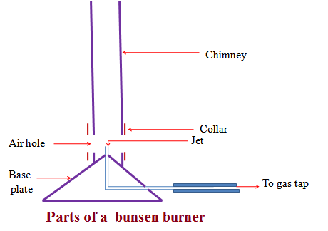
A Bunsen burner uses butane/laboratory gas as the fuel. The butane/laboratory gas is highly flammable and thus usually stored safely in a secure chamber outside Chemistry school laboratory. It is tapped and distributed into the laboratory through gas pipes.
The gas pipes end at the gas tap on a chemistry laboratory bench .If opened the gas tap releases butane/laboratory gas. Butane/laboratory gas has a characteristic odor/smell that alerts leakages/open gas tap.
The Bunsen burner is fixed to the gas tap using a strong rubber tube.
The Bunsen burner is made up of the following parts:
(i) Base plate –to ensure the burner can stand on its own
(ii)Jet-a hole through which laboratory gas enters the burner
(iii)Collar/sleeve-adjustable circular metal attached to the main chimney/burell with a side hole/entry. It controls the amount of air entering used during burning.
(iv)Air hole- a hole/entry formed when the collar side hole is in line with chimney side hole. If the collar side hole is not in line with chimney side hole, the air hole is said to be “closed” If the collar side hole is in line with chimney side hole, the air hole is said to be “open”
(v)Chimney- tall round metallic rod attached to the base plate.
(b)Procedure for lighting/igniting a Bunsen burner
1. Adjust the collar to ensure the air holes are closed.
2. Connect the burner to the gas tap using a rubber tubing. Ensure the rubber tubing has no side leaks.
3. Turn on the gas tap.
4. Ignite the top of the chimney using a lighted match stick/gas lighter/wooden splint.
5. Do not delay excessively procedure (iv) from (iii) to prevent highly flammable laboratory gas from escaping/leaking.
Parts and functions of a microscope
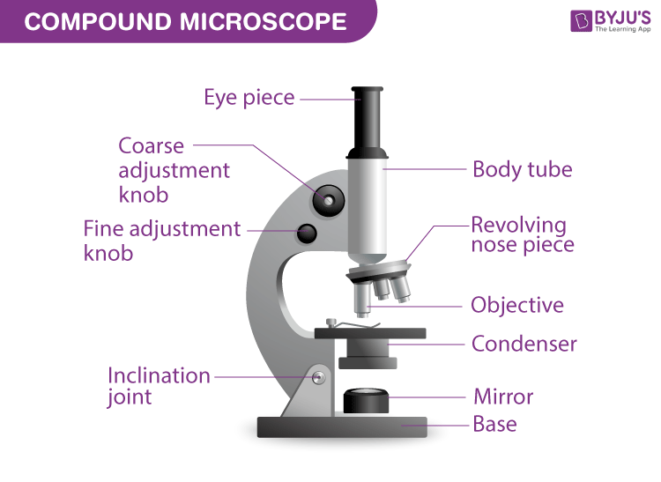
A compound microscope is a high-power microscope that has higher magnification levels than a low-power or dissection microscope. It is used to examine tiny specimens like cell structures that cannot be viewed at lower magnification levels. A compound microscope is made up of both structural and optical components. The 3 basic structural components are – the head, arm and base.
The body or head comprises the optical parts present in the upper part of the microscope
The arm connects and supports the base and head of the microscope. Also, it is used to carry the microscope.
Base of the microscope supports the microscope and comprises the illuminator
The optical part of the microscope includes:
- Eyepiece
- Eye tube
- Objective lenses
- Nosepiece
- Adjustment knobs
- Stage
- Illuminator
- Condenser and condenser focus knob
Diaphragm
The ocular or eyepiece is what an observer looks through and is present in the upper portion of the microscope. The eyepiece tube clasps the eyepieces which are positioned above the objective lens. The objective lenses are the main optical lenses. They range in various magnifications from 4x to 100x and generally include 3 to 5 lenses on a single microscope. Nosepiece houses the objective lenses.
The fine and coarse focus knobs are the adjustment knobs that are often used to focus the microscope. They are coaxial knobs. This means the focusing system of both fine and coarse focus are mounted on the same axis. There is also a condenser focus knob which moves the condenser up or down to control the lighting
The stage is where the specimen to be viewed is placed. A mechanical stage is often used when working on a specimen at a higher magnification. This is when delicate movement of the specimen is required. Stage clips are operated to hold the slide in place. To see different areas of the specimen, the observer must physically move the slide. A separate knob is present to move the slide in the mechanical stage. The aperture is a tiny hole in the stage via which the transmitted light enters the stage.
An illuminator acts as the light source and is typically located at the microscope’s base. Most light microscopes operate on halogen bulbs with low voltage and also have variable and continuous lighting control within the base. A condenser is typically used to gather and focus the illuminator’s light onto the specimen. It is found beneath the stage and is often observed in conjunction with a diaphragm or iris. Iris or Diaphragm regulates the amount of light that reaches the specimen. It is situated above the condenser but beneath the stage.
Functions of Microscope
The primary function of a microscope is to study biological specimens. A microscope solely functions on two concepts – magnification and resolution. Magnification is simply the ability of the microscope to enlarge the image. Whereas the ability to analyse minute details depends on the resolution.
Compound and dissection microscopes are the two types of microscopes that are mostly used in schools for educational purposes.
Functions of compound microscope
It simplifies the study of viruses and bacteria.
They are used in pathology labs to make an easy diagnosis of diseases.
They are also used in forensic laboratories to identify human fingerprints.

Common school laboratory safety rules
The following safety guideline rules should be followed by chemistry laboratory users:
(i) Enter the laboratory with permission in an orderly manner without rushing/pushing/scrabbling.
(ii) Do not try unauthorized experiments. They may produce flammable, explosive or toxic substances that affect your health.
(iii) Do not taste any chemical in the laboratory. They may be poisonous.
(iv) Waft gas fumes to your nose with your palm. Do not inhale/smell gases directly. They may be highly poisonous/toxic.
(v) Boil substances with mouth of the test tube facing away from others and yourself. Boiling liquids spurt out portions of the hot liquid. Products of heating solids may be a highly poisonous/toxic gas.
(vi) Wash with lots of water any skin contact with chemicals immediately. Report immediately to teacher/laboratory technician any irritation, cut, burn, bruise or feelings arising from laboratory work.
(vii) Read and follow safety instruction. All experiments that evolve/produce poisonous gases should be done in the open or in a fume chamber.
(viii )Clean your laboratory work station after use. Wash your hand before leaving the chemistry laboratory.
(ix) In case of fire, remain calm, switch of the source of fuel-gas tap. Leave the laboratory through the emergency door. Use fire extinguishers near the chemistry laboratory to put of medium fires. Leave strong fires wholly to professional fire fighters.
(x) Do not carry unauthorized item from a laboratory.

MIXTURES, ELEMENTS AND COMPOUNDS
- Mixtures
A mixture is a combination of two or more pure substances which can be separated by physical means. There are two types of mixtures:
General Properties of Mixtures
Mixtures are made up of two or more substances that are not chemically combined with each other. The properties of mixtures are listed below.
- The components of a mixture each keep their original properties.
- The separation of components can be easily done.
- The proportion of the components is variable.

Examples of Mixtures
- Crude oil: A mixture of organic compounds (mainly hydrocarbons)
- Seawater: A mixture of various salt and water.
- Air: a mixture of various gases like oxygen, carbon dioxide, nitrogen, argon, neon, etc.
- Ink: A mixture of coloured dyes.
- Gunpowder: A mixture of sulfur, potassium nitrate and carbon.
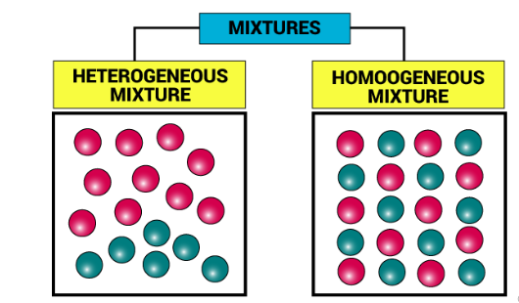
There are two main types of mixtures: homogeneous mixtures and heterogeneous mixtures. The types of mixtures are discussed below.
- Heterogeneous Mixture
What is a Heterogeneous Mixture?
A mixture of sand mixed with salt is an example of a heterogeneous mixture. Heterogeneous mixtures possess different properties and compositions in various parts i.e. the properties are not uniform throughout the mixture.
Examples of Heterogeneous mixtures – air, oil, water, etc.
- Homogeneous Mixture
What is a Homogeneous Mixture?
Sugar mixed with water is the most common example of a homogeneous mixture. Homogeneous mixtures can be defined as the mixtures which possess the same properties and combination throughout their mass.
Examples of Homogeneous mixtures – alloys, salt, and water, alcohol in water, Cup of Coffee, Mouthwash, Detergent
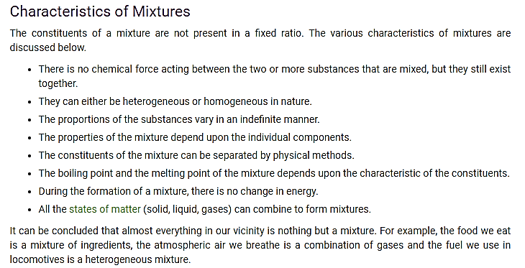
Pure And Impure Substances
a substance is said to be pure if it is made up of only one kind of molecule or particle. Pure substances normally cannot be separated by simple physical methods and are largely classified as elements and compounds.
Substances are either pure or impure. A pure substance is one which contains only one substance. An impure substance is one which contains two or more substances. A pure substance is made up of a pure solid, pure liquid or pure gas.

Characteristics of Pure Substance
- They are perfectly homogenous in nature.
- They are made up of only one kind of atoms or molecules.
- They have a fixed composition.
- It has fixed density, melting point and boiling point etc.

Characteristics of Impure Substance
- It does not have any specific properties; the properties of the mixture are a result of the average properties of all the constituents.
- It is formed as a result of a physical change.
- They have a variable composition.
- The mixtures are either heterogeneous or homogenous mixture in nature.
Melting Point and boiling Point
The melting point is usually defined as the point at which materials changes from a solid to a liquid.
The boiling point of a liquid is the temperature at which the vapour pressure of the liquid becomes equal to the atmospheric pressure of the liquid’s environment. At this temperature, the liquid is converted into a vapour.
The boiling point of the liquid depends upon the pressure of the surrounding. When the liquid is at high pressure, it has a higher boiling point than the boiling point at normal atmospheric pressure. The boiling point of different liquids is different for a given pressure
The boiling point for any material is the temperature point at which the material transforms into the gas phase in the liquid phase. This happens at 100 degrees centigrade for water. The Celsius scale was in fact created on the basis of the ice/water melting point and the liquid water/vapor boiling point. Each substance carries its own boiling point.
The boiling point of a substance is dependent on the pressure of its surroundings. In mountainous terrains (where the altitude is high), the pressure of the atmosphere is relatively lower than the atmospheric pressure at sea level. This is the reason why food cooks at a slower pace in mountainous areas (the lower atmospheric pressure causes water to boil at temperatures below 100oC).

When all the particles in the liquid phase have been transformed into the gas phase, the temperature begins to rise again, as long as heat is still being applied to the surrounding system. As the temperature starts to increase, so does the particle’s kinetic energy.
Boiling Point of Water
Water can boil, raise temperature or decrease air pressure, in two ways. At sea level, it is the pressure of air that causes water to boil at 100oC. Water can boil at a much lower temperature in vacuum, where there’s no air. That is, if not for the skin that keeps the blood pressurized, body temperature would be sufficient to cause the blood to boil with water. At low air pressure the water boils significantly below 100oC at temperatures.
The boiling point of water is the temperature at which the liquid water vapor pressure is equal to the pressure surrounding the body, and the body transforms into a vapour. The boiling point is the temperature for a particular liquid to boil at. For example, the boiling point for water, at a pressure of 1 atm, is 100 degrees Celsius. A liquid’s boiling point depends upon the liquid ‘s temperature, atmospheric pressure, and vapor pressure.
Melting point of ice
For ice, the melting point is 0°C or 273K. The chemical element with the highest melting point is tungsten (3410°C), which is used for making filaments in light bulbs.
During the melting process, till all the ice melts, the temperature of the system does not increase until after the melting point is reached. The whole of the supplied heat energy is consumed in increasing the potential energy of the ice molecules. The kinetic energy of the molecule does not increase further, and the temperature does not increase, so long as the melting continues.
The quantity of heat required to completely change 1 kg of ice into water at atmospheric pressure at its melting point is called latent heat of fusion.
METHODS OF SEPARATING MIXTURES
Mixtures can be separated from applying the following methods:
(a) Decantation
Sediments can be separated from a liquid by pouring out the liquid. This process is called decantation.
Experiment
Put some sand in a beaker. Add about 200cm3 of water. Allow sand to settle. Pour off water carefully into another beaker.
Observation
Sand settles at the bottom as sediments.
Less clean water is poured out.
Explanation
Sand does not dissolve in water. Sand is denser than water and thus settles at the bottom as sediment. When poured out, the less dense water flows out.
(b)Filtration
Decantation leaves suspended particles in the liquid after separation. Filtration is thus improved decantation. Filtration is the method of separating insoluble mixtures/particles/solids from a liquid.
Experiment: To separate soil and water using filtration
Fold a filter paper to fit well into a filter funnel. Place the funnel in an empty 250 cm3 beaker.
Put one spatula end full of soil into 50cm3 of water. Stir. Put the soil/water mixture into the filter funnel.
Observations
Clean water is collected below the filter funnel.
Soil remains above the filter paper.
Explanation
A filter paper is porous which act like a fine sieve with very small holes. The holes allow smaller water particles to pass through but do not allow bigger soil particles. The liquid which passes through is called filtrate. The solid which do not pass through is called residue.
Set up of apparatus
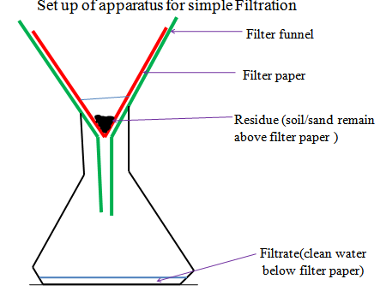
In industries, filtration is used in engine filters to clean up air.
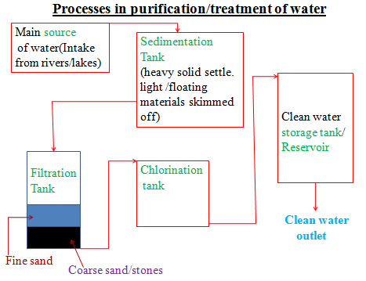
(c)Evaporation
Evaporation is a method of separating a solute/solid from its solution. This involves heating a solution (solvent and solute)to vapourize the solvent out of the solution mixture leaving pure solute/solid. If a mixture contain insoluble solid, they are filtered out.
Experiment: To separate a mixture of soil and salt (sodium chloride).

Procedure:
Put one spatula end full of soil on a filter paper.
Put one spatula full of common salt/sodium chloride into the same filter paper. Mix well using the spatula,.
Place about 200cm3 of water into a beaker.
Put the contents of the filter paper into the water. Stir thoroughly using a glass/stirring rod for about one minute.
Fold a filter paper into a filter funnel.
Pour half portion of the contents in the beaker into the filter funnel.
Put the filtrate into an evaporating dish. Heat on a water bath.
Observation
(i)On mixing
Colourless crystals and brown soil particles appear on the filter paper.
(ii)On adding water
Common soil dissolves in water. Soil particles do not dissolve in water.
(iii)On filtration
Colourless liquid collected as filtrate below the filter funnel/paper.
Brown residue collected above the filter funnel/paper.
(iv)On evaporation
Colourless crystals collected after evaporation
Explanation
Solid mixture of sand and common salt take the colors of the two.
On adding water, common salt dissolves to form a solution.
Soil does not because it is insoluble in water and thus forms a suspension.
On filtration, a residue of insoluble soil does not pass through the filter paper.
It is collected as residue.
Common salt solution is collected as filtrate.
On heating the filtrate, the solvent/water evaporate/vaporize out of the evaporating dish leaving common salt crystals.
Vapourization/evaporation can take place even without heating.
This is the principle/process of drying wet clothes on the hanging line.

Set up of apparatus
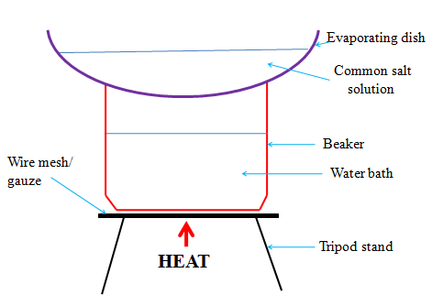
(d) Distillation
Distillation is an improved evaporation where both the solute and the solvent in the solution are separated /collected. Distillation therefore is the process of separating a solution into constituent solid solute and the solvent. It involves heating the solution to evaporate/vaporize the solvent out. The solvent vapour is then condensed back to a liquid.
Salty sea water can be made pure through simple distillation.
Any mixture with a large difference /40ºC in boiling point can be separated using simple distillation.
e)Fractional distillation
Fractional distillation is an improved simple distillation used specifically to separate miscible mixtures with very close /near boiling points.
Fractional distillation involves:
(i) Heating the mixture in a conical/round bottomed /flat bottomed flask.
The pure substance with a lower boiling point and thus more volatile evaporates/boils/vaporize first.e.g. Pure ethanol has a boiling point of 78ºC.Pure water has a boiling point of 100 ºC at sea level/one atmosphere pressure.
When a miscible mixture of ethanol and water is heated, ethanol vaporizes /boils/ evaporates first because it is more volatile.
(ii)The conical/round bottomed /flat bottomed flask is connected to a long glass tube called fractionating column.
The purpose of the fractionating column is to offer areas of condensation for the less volatile pure mixture.
The fractionating column is packed with glass beads/broken glass/ porcelain/ shelves to increase the surface area of condensation of the less volatile pure mixture.
(iii)When the vapors rise they condense on the glass beads/broken glass /porcelain / shelves which become hot.
When the temperature of the glass beads/broken glass/porcelain/shelves is beyond the boiling point of the less volatile pure substance, the pure substance rise and condensation take place on the glass beads/broken glass/porcelain/shelves at a higher level on the fractionating column.
The less volatile pure substance trickles/drips back down the fractionating column or back into the conical/round bottomed /flat bottomed flask to be heated again. e.g.
If the temperature on glass beads/broken glass/porcelain/shelves is beyond 78ºC, the more volatile pure ethanol rise to condense on the glass beads/broken glass /porcelain/shelves higher in the fractionating column.
Water condenses and then drip/trickle to the glass beads/broken glass /porcelain /shelves lower in the fractionating column because it is less volatile.
(iv) The fractionating column is connected to a Liebig condenser. The Liebig condenser has a cold water inlet and outlet circulation.
The more volatile mixture that reach the top of the fractionating column is condenses by the Liebig condenser into a receiver. It is collected as the first fraction.
(v)At the top of the fractionating column, a thermometer is placed to note/monitor the temperature of the boiling mixtures.
Pure substances have constant/fixed boiling point. When one mixture is completely separated, the thermometer reading rises.
E.g. the thermometer reading remains at78ºC when ethanol is being separated. When no more ethanol is being separated, the mercury/alcohol level in the thermometer rises.
(vi)The second /subsequent fractions are collected in the receiver after noting a rise the mercury/alcohol level in the thermometer.
E.g. the thermometer reading rises to 100ºC when water is being separated. It is passed through the Liebig condenser with the cold water inlet and outlet circulation. It is collected different receiver as the second/subsequent fraction.
(vii)Each fraction collected should be confirmed from known physical/chemical properties/characteristic.
Example
Ethanol
Ethanol is a colourless liquid that has a characteristic smell .When it is put in a watch glass then ignited, it catches fire and burn with a blue flame.
Water
Water is a colourless liquid that has no smell/odour .When it is put in a watch glass then ignited, it does not catch fire.
Set up of apparatus
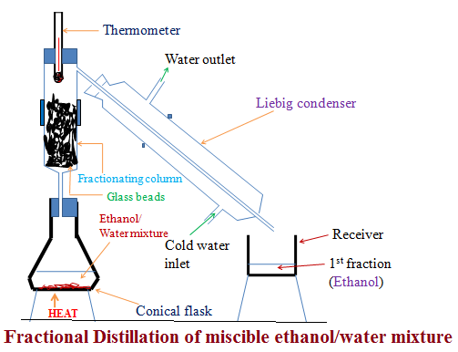
Industrial application of Fractional distillation
On a large scale,fractional distillation is used:
(i)In fractional distillation of crude oil in an oil refinery.
Crude oil is a mixture of many fractions. When heated in a furnace, the different fractions separate out according to their boiling point. In Kenya,fractional distillation takes place at Changamwe in Mombasa.
(ii)In fractional distillation of air.
Air contain a mixture of three main useful gases which are condensed by cooling to very low temperature (-200ºC) to form a liquid. The liquid is then heated. Nitrogen is the most volatile (-196 ºC) and thus comes out as the first fraction. Argon (at -186 ºC) is the second fraction. Oxygen ( at -183 ºC) is the last fraction. The three gases are very useful industrial gases.
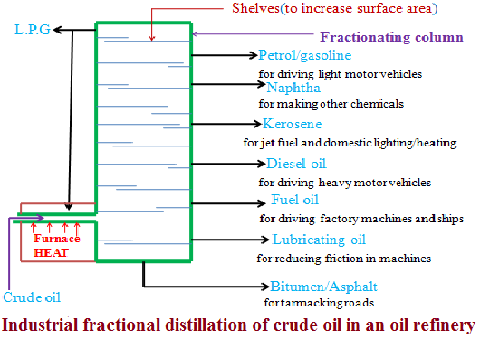

Sublimation/deposition
Some solids on heating do not melt to a liquid but change directly to a gas. The process by which a solid changes to a gas is called sublimation. The gas cools back and changes directly to a solid. The process by which a gas changes to a solid is called deposition. Sublimation and deposition therefore are the same but opposite processes.
Some common substances that undergo sublimation/ deposition include:
(i)Iodine (ii)Carbon(IV)oxide (iii)Camphor (iv) ammonium chloride (v)Iron(III)chloride (vi)Aluminum(III)chloride
(vii) benzoic acid
If a mixture has any of the above as a component, then on heating it will change to a gas and be deposited away from the source of heating.
Procedure
Place about one spatula full of ammonium chloride crystals into a clean dry 100cm3 beaker. Add equal amount of sodium chloride crystals into the beaker. Swirl to mix.
Place the beaker on a tripod stand.
Put about 100cm3 of water into another beaker. Place carefully the beaker containing water on top of the beaker containing the solid mixture. Light/ignite a burner and heat the solid.
Set up of apparatus:
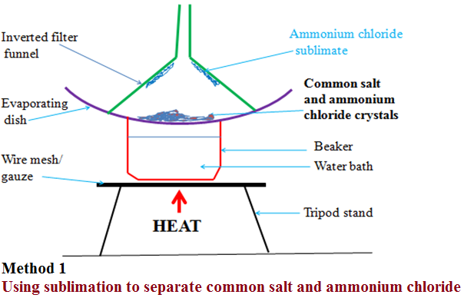
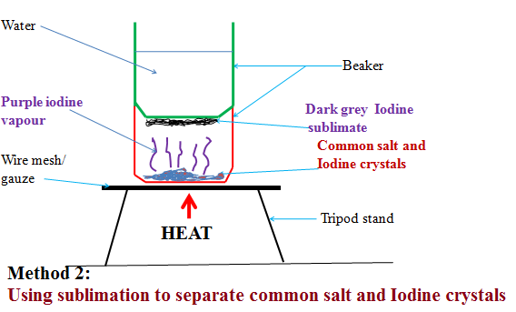
Observation
(i)With ammonium chloride/common salt mixture
White fumes produced.
White sublimate deposited
Colourless residue left
(ii)With Iodine/common salt mixture
Purple fumes produced.
Dark grey sublimate deposited
Colourless residue left
Explanation
(i)On heating a mixture of ammonium chloride and common salt, a white fume of ammonium chloride is produced. The white fumes solidify as white sublimate on the cooler parts. Common salt remains as residue.
Chemical equation:
Ammonium chloride solid Ammonium chloride gas
(ii)On heating a mixture of Iodine and common salt, a purple fume of Iodine vapour is produced. The purple fumes solidify as dark grey sublimate on the cooler parts. Common salt remains as residue.
Chemical equation:
Iodine solid Iodine gas
Chromatography
Chromatography is a method of separating components of a solution mixture by passing it through a medium where the different components move at different rates. The medium through which the solution mixture is passed is called absorbent material.
Paper chromatography is a method of separating colored dyes by using paper as the absorbent material.
Since dyes are insoluble/do not dissolve in water, ethanol and propanone are used as suitable solvents for dissolving the dye.
Practically, a simple paper chromatography involve placing a dye/material on the absorbent material, adding slowly a suitable soluble solvent on the dye/material using a dropper, the solvent spread out on the absorbent material carrying the soluble dye away from the origin.
The spot on which the dye is initially/originally placed is called baseline. The farthest point the solvent spread is called solvent front.
The farthest a dye can be spread by the solvent depend on:
(i) Density of the dye-the denser the dye, the less it spread from the basely ne by the solvent.
(ii) Stickiness of the dye-some dyes sticks on the absorbent material more than other thus do not spread far from baseline.
Experiment: To investigate the colors in ink
Procedure

Method 1
Place a filter paper on an empty beaker. Put a drop of black/blue ink in the centre of the filter paper. Wait for about one minute for the ink drop to spread. Using a clean teat pipette/dropper add one drop of ethanol/propanone. Wait for about one minute for the ink drop to spread further. Add about twenty other drops of ethanol waiting for about one minute before each addition. Allow the filter paper to dry.
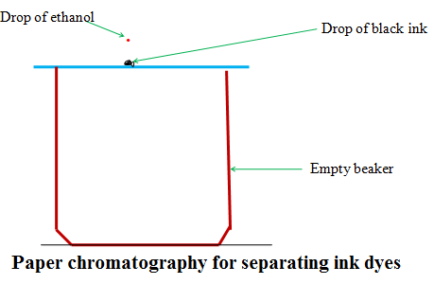
Experiment: To investigate the colors in ink
Procedure
Method 2
Cut an 8 centimeter thin strip of a filter paper. At about 3cm on the strip, place a drop of ink. Place the filter paper in a 10cm length boiling tube containing 5cm3 of ethanol. Ensure the cut strip of the filter paper just dips into the ethanol towards the ink mark. Cover the boiling tube. Wait for about twenty minutes. Remove the boiling tube and allow the filter paper to dry.
Set up of apparatus
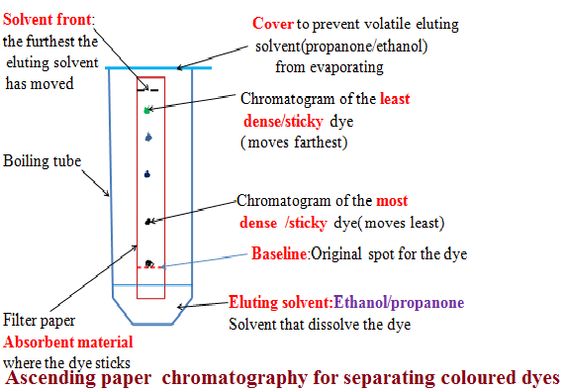

Explanation
When a drop of ink is placed on an absorbent material it sticks. On adding an eluting solvent, it dissolves the dye spread out with it. The denser and sticky pure dye move least. The least dense/sticky pure dye move farthest. A pure dye will produce the same chromatogram/spot if the same eluting solvent is used on the same absorbent material. Comparing the distance moved by a pure dye with a mixture, the coloured dyes in a mixture can be deduced as below:
Example 1
The chromatogram of pure dyes A, B ,C and a dye mixture D is shown below Determine the pure dyes present in D. On the diagram show:
(i)the solvent front
(ii) Baseline
(Iii) the most soluble pure dye
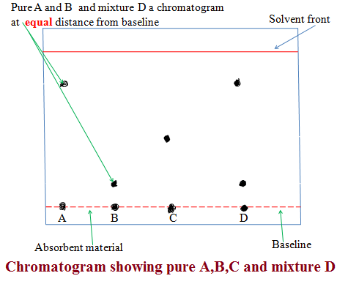
(i) Solvent extraction
Solvent extraction is a method of separating oil from nuts/seeds. Most nuts contain oil. First the nuts are crushed to reduce their size and increase the surface area. A suitable volatile solvent is added. The mixture is filtered. The filtrate solvent is then allowed to crystallize leaving the oil/fat. If a filter paper is rubbed/smeared with the oil/fat, it becomes translucent. This is the test for the presence of oil/fat.
Experiment: To extract oil from Macadamia nut seeds
Procedure
Crush Macadamia nut seeds form the hard outer cover .Place the inner soft seed into a mortar. Crush (add a little sand to assist in crushing).
Add a little propanone and continue crushing. Continue crushing and adding a little propanone until there is more liquid mixture than the solid. Decant/filter. Put the filtrate into an evaporating dish. Vapourize the solvent using solar energy /sunlight. Smear/rub a portion of the residue left after evaporation on a clean dry filter paper.
Observation /Explanation
Propanone dissolve fat/oil in the macadamia nuts. Propanone is more volatile (lower boiling point) than oil/fat. In sunlight/solar energy, propanone evaporate/vaporize leaving oil/fat(has a higher boiling point).Any seed like corn, wheat , rice, soya bean may be used instead of macadamia seed. When oil/fat is rubbed/ smeared on an opaque paper, it becomes translucent.
Crystallization
Crystallization is the process of using solubility of a solute/solid to obtain the solute/solid crystals from a saturated solution by cooling or heating the solution.
A crystal is the smallest regular shaped particle of a solute. Every solute has unique shape of its crystals.
Some solutions form crystals when heated. This is because less solute dissolves at higher temperature. Some other solutions form crystals when cooled. This is because less solute dissolves at lower temperature.
Experiment; To crystallize copper (II) sulphate (VI) solution
Procedure:
Place about one spatula full of hydrated copper sulphate (VI) crystals into 200cm3 of distilled water in a beaker. Stir. Continue adding a little more of the hydrated copper sulphate (VI) crystals and stirring until no more dissolve. Decant/filter. Cover the filtrate with a filter paper. Pierce and make small holes on the filter paper cover. Preserve the experiment for about seven days.
Observation/Explanation
Large blue crystals formed
When hydrated copper (II) sulphate crystals are placed in water, they dissolve to form copper (II) sulphate solution. After some days water slowly evaporate leaving large crystals of copper (II) sulphate. If the mixture is heated to dryness, small crystals are formed.

Using Magnets
Mixtures containing substances that are attracted by magnets can be separated using a magnet. We can separate iron from a mixture of sand and iron, as only the iron is attracted to the magnet.

ACIDS, BASES AND INDICATORS
In a school laboratory:
(i)An acid may be defined as a substance that turns litmus red.
(ii)A base may be defined as a substance that turns litmus blue.
Litmus is lichen found mainly in West Africa. It changes its colour depending on whether the solution it is in, is basic/alkaline or acidic. It is thus able to identify/show whether another substance is an acid, base or neutral.
(iii)An indicator is a substance that shows whether another substance is a base/alkaline,acid or neutral

Common naturally occurring acids include:
Name of acid | Occurrence
1.Citric acid | Found in ripe citrus fruits like passion fruit/oranges/lemon
2.Tartaric acid | Found in grapes/baking powder/health salts
3.Lactic acid | Found in sour milk
4.Ethanoic acid | Found in vinegar
5.Methanoic acid | Present in ants, bees stings
6.Carbonic acid | Used in preservation of fizzy drinks like coke, Lemonade, Fanta
7.Butanoic acid | Present in cheese
8.Tannic acid | Present in tea

Most commonly used acids found in a school laboratory are not naturally occurring. They are manufactured. They are called mineral acids.
Common mineral acids include:
Name of mineral acid | Common use
Hydrochloric acid (HCl) | Used to clean/pickling surface of metals  Is found in the stomach of mammals/human beings
Sulphuric(VI) acid (H₂SO₄) | Used as acid in car battery, making battery, making fertilizers
Nitric(V)acid (HNO₃) | Used in making fertilizers and explosives

Mineral acids are manufactured to very high concentration. They are corrosive (causes painful wounds on contact with the skin) and attack/reacts with garments/clothes/metals.
In a school laboratory, they are mainly used when added a lot of water. This is called diluting. Diluting ensures the concentration of the acid is safely low.
Bases are opposite of acids. Most bases do not dissolve in water.
Bases which dissolve in water are called alkalis.
Common alkalis include:
Name of alkali | Common uses
Sodium hydroxide (NaOH) | Making soaps and detergents
Potassium hydroxide(KOH) | Making soaps and detergents
Ammonia solution(NH₄OH) | Making fertilizers, softening hard water

Common bases (which are not alkali) include:
Name of base | Common name
Magnesium oxide/hydroxide | Anti acid to treat indigestion
Calcium oxide | Making cement and neutralizing soil acidity

Indicators are useful in identifying substances which look-alike.
An acid-base indicator is a substance used to identify whether another substance is alkaline or acidic.
An acid-base indicator works by changing to different colors in neutral, acidic and alkaline solutions/dissolved in water.
Experiment: To prepare simple acid-base indicator
Procedure
(a)Place some flowers petals in a mortar. Crush them using a pestle. Add a little sand to assist in crushing.
Add about 5cm3 of propanone/ethanol and carefully continue grinding.
Add more 5cm3 of propanone/ethanol and continue until there is enough extract in the mortar.
Filter the extract into a clean 100cm3 beaker.
(b)Place 5cm3 of filtered wood ash, soap solution, ammonia solution, sodium hydroxide, hydrochloric acid, distilled water, sulphuric (VI) acid, sour milk, sodium chloride, toothpaste and calcium hydroxide into separate test tubes.
(c)Put about three drops of the extract in (a)to each test tube in (b). Record the observations made in each case.
Sample observations
Solution mixture | Colour on adding indicator extract | Nature of solution
wood ash | green | Base/alkaline
soap solution | green | Basic/alkaline
ammonia solution | green | Basic/alkaline
sodium hydroxide | green | Basic/alkaline
hydrochloric acid | Red | Acidic
distilled water | orange | Neutral
sulphuric(VI)acid | Red | Acidic
sour milk | green | Basic/alkaline
sodium chloride | orange | Neutral
Toothpaste | green | Basic/alkaline
calcium hydroxide | green | Basic/alkaline
Lemon juice | Red | Acidic

The plant extract is able to differentiate between solutions by their nature. It is changing to a similar colour for similar solutions.
(i)Since lemon juice is a known acid, then sulphuric (VI) and hydrochloric acids are similar in nature with lemon juice because the indicator shows similar colors. They are acidic in nature.
(ii)Since sodium hydroxide is a known base/alkali, then the green colour of indicator shows an alkaline/basic solution.
(iii) Since pure water is neutral, then the orange colour of indicator shows neutral solutions.
In a school laboratory, commercial indicators are used. A commercial indicator is cheap, readily available and easy to store. Common indicators include: Litmus, phenolphthalein, methyl orange, screened methyl orange, bromothymol blue.
Experiment:
Using commercial indicators to determine acidic, basic/alkaline and neutral solutions
Procedure
Place 5cm3 of the solutions in the table below. Add three drops of litmus solution to each solution.
Repeat with phenolphthalein indicator, methyl orange, screened methyl orange and bromothymol blue.
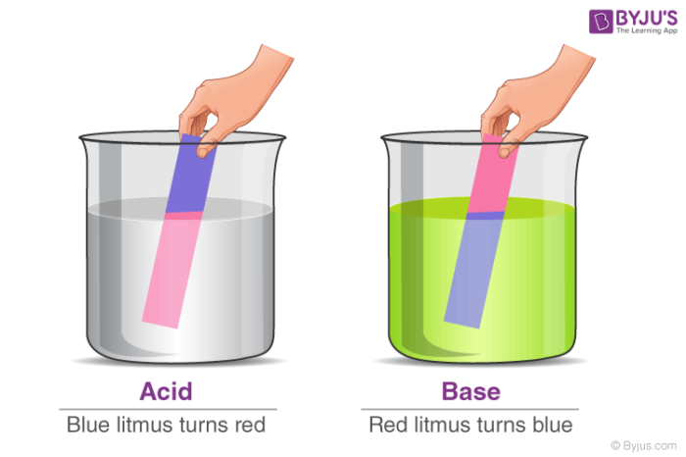

Sample results
Substance/  Solution | Indicator used
 | Litmus | Phenolphthalein | Methyl orange | Screened methyl orange | Bromothymol  blue
wood ash | Blue | Pink | Yellow | Orange | Blue
soap solution | Blue | Pink | Yellow | Orange | Blue
ammonia solution | Blue | Pink | Yellow | Orange | Blue
sodium hydroxide | Blue | Pink | Yellow | Orange | Blue
hydrochloric acid | Red | Colourless | Red | Purple | Orange
distilled water | Colourless | Colourless | Red | Orange | Orange
sulphuric(VI)acid | Red | Colourless | Red | Purple | Orange
sour milk | Blue | Pink | Yellow | Orange | Blue
sodium chloride | Colourless | Colourless | Red | Orange | Orange
Toothpaste | Blue | Pink | Yellow | Orange | Blue
calcium hydroxide | Blue | Pink | Yellow | Orange | Blue
Lemon juice | Red | Colourless | Red | Purple | Orange

The universal indicator
The universal indicator is a mixture of other indicator dyes. The indicator uses the pH scale. The pH scale shows the strength of bases and acids. The pH scale ranges from 1-14.These numbers are called pH values:
(i) pH values 1, 2, 3 shows a substance is strongly acid
(ii) pH values 4, 5, 6 shows a substance is a weakly acid
(iii) pH value 7 shows a substance is a neutral
(iv) pH values 8, 9, 10, 11 shows a substance is a weak base/alkali.
(v) pH values 12, 13, 14 shows a substance is a strong base/alkali
The pH values are determined from a pH chart. The pH chart is a multicolored paper with each colour corresponding to a pH value.i.e
(i) red correspond to pH 1, 2, 3 showing strongly acidic solutions.
(ii)Orange/ yellow correspond to pH 4, 5, 6 showing weakly acidic solutions.
(iii)Green correspond to pH 7 showing neutral solutions.
(iv)Blue correspond to pH 8, 9, 10, 11 showing weakly alkaline solutions.
(v)Purple/dark blue correspond to pH 12,13,14 showing strong alkalis.
The universal indicator is available as:
(i) Universal indicator paper/pH paper
(ii) Universal indicator solution.
When determining the pH of a unknown solution using
(i) pH paper then the pH paper is dipped into the unknown solution. It changes/turn to a certain colour. The new colour is marched/compared to its corresponding one on the pH chart to get the pH value.
(ii) universal indicator solution then about 3 drops of the universal indicator solution is added into about 5cm3 of the unknown solution in a test tube. It changes/turn to a certain colour. The new colour is marched/compared to its corresponding one on the pH chart to get the pH value.
Experiment: To determine the pH value of some solutions
(a)Place 5cm3 of filtered wood ash, soap solution, ammonia solution, sodium hydroxide, hydrochloric acid, distilled water, sulphuric (VI) acid, sour milk, sodium chloride, toothpaste and calcium hydroxide into separate test tubes.
(b)Put about three drops of universal indicator solution or dip a portion of a piece of pH paper into each. Record the observations made in each case.
(c)Compare the colour in each solution with the colors on the pH chart provided. Determine the pH value of each solution.

Sample observations
Solution mixture | Colour on the pH paper/adding universal indicator | pH value | Nature of solution
wood ash | Blue | 8 | Weakly alkaline
soap solution | Blue | 8 | Weakly alkaline
ammonia solution | green | 8 | Weakly alkaline
sodium hydroxide | Purple | 14 | Strongly alkaline
hydrochloric acid | red | 1 | Strongly acidic
distilled water | green | 7 | Neutral
sulphuric(VI)acid | red | 1 | Strongly acidic
sour milk | blue | 9 | Weakly alkaline
sodium chloride | green | 7 | Neutral
toothpaste | Blue | 10 | Weakly alkaline
calcium hydroxide | Blue | 11 | Weakly alkaline
Lemon juice | Orange | 5 | Weakly acidic

Note
1. All the mineral acids Hydrochloric, sulphuric (VI) and nitric (V) acids are strong acids
2. Two alkalis/soluble bases, sodium hydroxide and potassium hydroxide are strong bases/alkali. Ammonia solution is a weak base/alkali. All other bases are weakly alkaline.
3. Pure/deionized water is a neutral solution.
4. Common salt/sodium chloride is a neutral salt.
5. When an acid and an alkali/base are mixed, the final product has pH 7 and is neutral.

Uses of Acids and Bases
The various uses of acids and bases are listed in this subsection.

1. Uses of Acids
- Vinegar, a diluted solution of acetic acid, has various household applications. It is primarily used as a food preservative.
- Citric acid is an integral part of lemon juice and orange juice. It can also be used in the preservation of food.
- Sulphuric acid acid is widely used in batteries. The batteries used to start the engines of automobiles commonly contain this acid.
- The industrial production of explosives, dyes, paints, and fertilizers involves the use of sulphuric acid acid and nitric acid.
- Phosphoric acid is a key ingredient in many soft drinks.

2. Uses of Bases
- The manufacturing of soap and paper involves the use of sodium hydroxide. NaOH is also used in the manufacture of rayon.
- Ca(OH)₂, also known as slaked lime or calcium hydroxide, is used to manufacture bleaching powder.
- Dry mixes used in painting or decoration are made with the help of calcium hydroxide.
- Magnesium hydroxide, also known as milk of magnesia, is commonly used as a laxative. It also reduces any excess acidity in the human stomach and is, therefore, used as an antacid.
- Ammonium hydroxide is a very important reagent used in laboratories.
- Any excess acidity in soils can be neutralized by employing slaked lime.

LIVING THINGS AND THEIR ENVIRONMENT
Reproduction in human beings
What is ovulation?
When a young woman reaches puberty, she starts to ovulate. This is when a mature egg or ovum is released from one of the ovaries. The ovaries are the two female reproductive organs found in the pelvis. If the egg is fertilized by a sperm as it travels down the fallopian tube, then pregnancy occurs. The fertilized egg attaches to the lining of the uterus. The placenta then develops. The placenta transfers nutrition and oxygen to the fetus from mother. If the egg does not become fertilized, the lining of the uterus (endometrium) is shed during menstruation.
The average menstrual cycle lasts 28 days. The cycle starts with the first day of one period and ends with the first day of the next period. The average woman ovulates on day 14. At this time, some women have minor discomfort in their lower abdomen, spotting, or bleeding, while others do not have any symptoms at all.
A woman is generally most likely to get pregnant (fertile) if she has sex a few days before, and during ovulation.
Menstrual Cycle
Each month during the years between puberty and menopause, a woman’s body goes through a number of changes to get it ready for a possible pregnancy. This series of hormone-driven events is called the menstrual cycle.
During each menstrual cycle, an egg develops and is released from the ovaries. The lining of the uterus builds up. If a pregnancy doesn’t happen, the uterine lining sheds during a menstrual period. Then the cycle starts again.
Menstrual phase
The menstrual phase is the first stage of the menstrual cycle. It’s also when you get your period.
This phase starts when an egg from the previous cycle isn’t fertilized. Because pregnancy hasn’t taken place, levels of the hormones estrogen and progesterone drop.
The thickened lining of your uterus, which would support a pregnancy, is no longer needed, so it sheds through your vagina. During your period, you release a combination of blood, mucus, and tissue from your uterus.
You may have period symptoms like these:
- cramps
- tender breasts
- bloating
- mood swings
- irritability
- headaches
- tiredness
- low back pain
On average, women are in the menstrual phase of their cycle for 3 to 7 days. Some women have longer periods than others.
Identifying common issues related to Menstrual cycle
Every woman’s menstrual cycle is different. Some women get their period at the same time each month. Others are more irregular. Some women bleed more heavily or for a longer number of days than others.
Your menstrual cycle can also change during certain times of your life. For example, it can get more irregular as you get close to menopause.
One way to find out if you’re having any issues with your menstrual cycle is to track your periods. Write down when they start and end. Also record any changes to the amount or number of days you bleed, and whether you have spotting between periods.
Any of these things can alter your menstrual cycle:
- Birth control. The birth control pill may make your periods shorter and lighter. While on some pills, you won’t get a period at all.
- Pregnancy. Your periods should stop during pregnancy. Missed periods are one of the most obvious first signs that you’re pregnant.
- Uterine fibroids. These noncancerous growths in your uterus can make your periods longer and heavier than usual.
- Eating disorders. Anorexia, bulimia, and other eating disorders can disrupt your menstrual cycle and make your periods stop.
Here are a few signs of a problem with your menstrual cycle:
- You’ve skipped periods, or your periods have stopped entirely.
- Your periods are irregular.
- You bleed for more than seven days.
- Your periods are less than 21 days or more than 35 days apart.
- You bleed between periods (heavier than spotting).
If you have these or other problems with your menstrual cycle or periods, talk to your healthcare provider.
Managing issues related to the menstrual cycle
- stopping smoking
- using heating pads, hot water bottles, or warm baths to ease pain
- trying gentle forms of exercise, such as walking
- managing stress and making time for relaxation
- avoiding caffeine, alcohol, and refined sugar in the 2 weeks before a period
- getting enough sleep each night
Fertilization and implantation in human beings
“Fertilization in humans refers to the fusion of male and female gametes that facilitates the development of a new organism.”
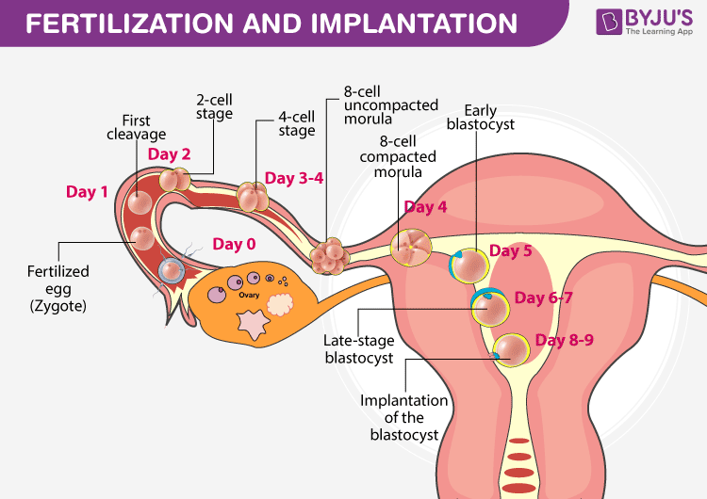
Fertilization is the natural life process, which is carried out by the fusion of both male and female gametes, which results in the formation of a zygote. In humans, the process of fertilization takes place in the fallopian tube.
During this process, semen comprising thousands of sperms are inseminated into the female vagina during coitus. The sperms move towards the uterus and reach the opening of the fallopian tube. only a few sperms will succeed in reaching the opening of the fallopian tube.
Both sperm and egg can show their vitality only to a limited period. Sperm is alive for 48-72 hours in a female reproductive system, whereas the egg can be fertilized for 24 hours before it is released.
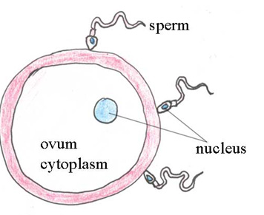
Only one sperm will succeed in fertilising the ovum, by penetrating its cell membrane and depositing the male genetic material into the female cell, where the two nuclei fuse. The fertilised ovum (zygote) immediately becomes resistant to penetration by any other sperm arriving later. After fertilisation occurs, the zygote remains in the fallopian tube for about 72 hours, and during this time it develops rapidly, as you will see in the next section.
Early development of the embryo
From the moment of fertilisation until the eighth week of pregnancy, the developing human is called an embryo.
While these changes are taking place in the early embryo, it is moving along the fallopian tube towards the uterus. This takes five to seven days.
Between five to seven days after fertilisation, the blastocyst reaches the uterus and embeds itself in the thickened endometrium (lining of the uterus). This process is called implantation, and if the embryo survives it is the beginning of a pregnancy. However, the embryo may not implant, or it may not survive for more than a few days. In this case, it is shed from the uterus as the endometrium breaks down, and it passes out of the vagina in the menstrual fluid. The loss of a very early pregnancy in this way is very common, and the woman does not even know that she was momentarily pregnant.
Human Excretory system
  - Skin
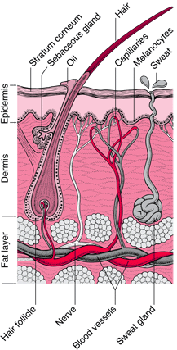
The skin is the largest organ of the body, with a total area of about 20 square feet. The skin protects us from microbes and the elements, helps regulate body temperature, and permits the sensations of touch, heat, and cold.
Skin has three layers:
- The epidermis, the outermost layer of skin, provides a waterproof barrier and creates our skin tone.
- Acts as a protective barrier: The epidermis keeps bacteria and germs from entering your body and bloodstream and causing infections. It also protects against rain, sun and other elements.
- Makes new skin: The epidermis continually makes new skin cells. These new cells replace the approximately 40,000 old skin cells that your body sheds every day. You have new skin every 30 days.
- Protects your body: Langerhans cells in the epidermis are part of the body’s immune system. They help fight off germs and infections.
- Provides skin color: The epidermis contains melanin, the pigment that gives skin its color. The amount of melanin you have determines the color of your skin, hair and eyes. People who make more melanin have darker skin and may tan more quickly.
- The dermis, beneath the epidermis, contains tough connective tissue, hair follicles, and sweat glands.
- Has collagen and elastin: Collagen is a protein that makes skin cells strong and resilient. Another protein found in the dermis, elastin, keeps skin flexible. It also helps stretched skin regain its shape.
- Grows hair: The roots of hair follicles attach to the dermis.
- Keeps you in touch: Nerves in the dermis tell you when something is too hot to touch, itchy or super soft. These nerve receptors also help you feel pain.
- Makes oil: Oil glands in the dermis help keep the skin soft and smooth. Oil also prevents your skin from absorbing too much water when you swim or get caught in a rainstorm.
- Produces sweat: Sweat glands in the dermis release sweat through skin pores. Sweat helps regulate your body temperature.
- Supplies blood: Blood vessels in the dermis provide nutrients to the epidermis, keeping the skin layers healthy.
- The deeper subcutaneous tissue (hypodermis) is made of fat and connective tissue.
- Cushions muscles and bones: Fat in the hypodermis protects muscles and bones from injuries when you fall or are in an accident.
- Has connective tissue: This tissue connects layers of skin to muscles and bones.
- Helps the nerves and blood vessels: Nerves and blood vessels in the dermis (middle layer) get larger in the hypodermis. These nerves and blood vessels branch out to connect the hypodermis to the rest of the body.
- Regulates body temperature: Fat in the hypodermis keeps you from getting too cold or hot.
The skin’s color is created by special cells called melanocytes, which produce the pigment melanin. Melanocytes are located in the epidermis.

  - The Urinary system
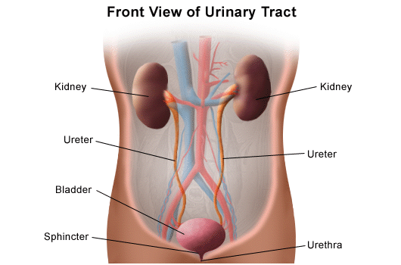
The body takes nutrients from food and converts them to energy. After the body has taken the food components that it needs, waste products are left behind in the bowel and in the blood.
The kidney and urinary systems help the body to eliminate liquid waste called urea, and to keep chemicals, such as potassium and sodium, and water in balance. Urea is produced when foods containing protein, such as meat, poultry, and certain vegetables, are broken down in the body. Urea is carried in the bloodstream to the kidneys, where it is removed along with water and other wastes in the form of urine.
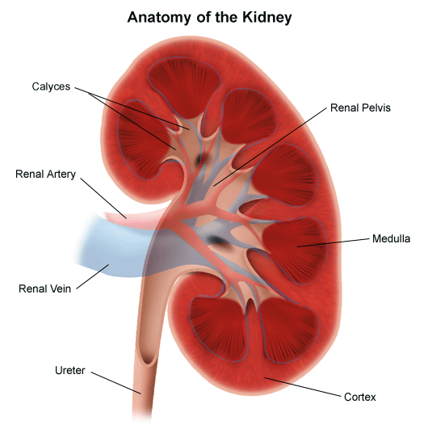

- Two kidneys. This pair of purplish-brown organs is located below the ribs toward the middle of the back. Their function is to:
  - Remove waste products and drugs from the body
  - Balance the body's fluids
  - Release hormones to regulate blood pressure
  - Control production of red blood cells
Two ureters. These narrow tubes carry urine from the kidneys to the bladder. Muscles in the ureter walls continually tighten and relax forcing urine downward, away from the kidneys.
Bladder. This triangle-shaped, hollow organ is located in the lower abdomen. It is held in place by ligaments that are attached to other organs and the pelvic bones. The bladder's walls relax and expand to store urine, and contract and flatten to empty urine through the urethra. The typical healthy adult bladder can store up to two cups of urine for two to five hours.
Urethra. This tube allows urine to pass outside the body. The brain signals the bladder muscles to tighten, which squeezes urine out of the bladder. At the same time, the brain signals the sphincter muscles to relax to let urine exit the bladder through the urethra. When all the signals occur in the correct order, normal urination occurs.
Facts about urine
- Normal, healthy urine is a pale straw or transparent yellow color.
- Darker yellow or honey colored urine means you need more water.
- A darker, brownish color may indicate a liver problem or severe dehydration.
- Pinkish or red urine may mean blood in the urine.
Diseases and conditions that cause chronic kidney disease include:
- Type 1 or type 2 diabetes
- High blood pressure
- an inflammation of the kidney's filtering units (glomeruli)
- an inflammation of the kidney's tubules and surrounding structures
- other inherited kidney diseases
- Prolonged obstruction of the urinary tract, from conditions such as enlarged prostate, kidney stones and some cancers
- Recurrent kidney infection, also called pyelonephritis
- Heart (cardiovascular) disease
- Smoking
- Obesity
- Being Black, Native American or Asian American
- Family history of kidney disease
- Abnormal kidney structure
- Older age
- Frequent use of medications that can damage the kidneys
Signs and symptoms of Kidney Diseases
Signs and symptoms of chronic kidney disease develop over time if kidney damage progresses slowly. Loss of kidney function can cause a buildup of fluid or body waste or electrolyte problems. Depending on how severe it is, loss of kidney function can cause:
- Nausea
- Vomiting
- Loss of appetite
- Fatigue and weakness
- Sleep problems
- Urinating more or less
- Decreased mental sharpness
- Muscle cramps
- Swelling of feet and ankles
- Dry, itchy skin
- High blood pressure (hypertension) that's difficult to control
- Shortness of breath, if fluid builds up in the lungs
- Chest pain, if fluid builds up around the lining of the heart
To reduce your risk of developing kidney disease:
- Follow instructions on over-the-counter medications. When using nonprescription pain relievers, such as aspirin, ibuprofen (Advil, Motrin IB, others) and acetaminophen (Tylenol, others), follow the instructions on the package. Taking too many pain relievers for a long time could lead to kidney damage.
- Maintain a healthy weight. If you're at a healthy weight, maintain it by being physically active most days of the week. If you need to lose weight, talk with your doctor about strategies for healthy weight loss.
- Don't smoke. Cigarette smoking can damage your kidneys and make existing kidney damage worse. If you're a smoker, talk to your doctor about strategies for quitting. Support groups, counseling and medications can all help you to stop.
- Manage your medical conditions with your doctor's help. If you have diseases or conditions that increase your risk of kidney disease, work with your doctor to control them. Ask your doctor about tests to look for signs of kidney damage.

How can I protect my skin?
You lose collagen and elastin as you age. This causes the skin’s middle layer (dermis) to get thinner. As a result, the skin may sag and develop wrinkles.
While you can’t stop the aging process, these actions can help maintain healthier skin:
- Apply sunscreen every day (even if you’re mostly indoors). Choose a sunscreen with a broad-spectrum sun protection factor (SPF) of at least 30.
- Don’t tan indoors or outdoors. Tanning causes skin damage. It ages skin and can cause skin cancer.
- Find healthy ways to manage stress. Stress can make certain skin conditions worse.
- Perform regular skin and mole checks to look for changes that may be signs of skin cancer.
- Quit smoking and using tobacco products. Nicotine and other chemicals in cigarettes and electronic cigarettes age skin faster.
- Use gentle cleansers to wash your face in the morning and at night.
- Shower regularly and apply moisturizing lotion to prevent dry skin.

Effects of cosmetics on health
- Headaches
- Hair problems- Extensive use of chemical based hair products could lead to dandruff, scalp redness, thinning of hair, and even loss of hair. Long term use of hair color could also lead to hair discoloration.
- Acne - Some types of makeup which are in the form of liquids and creams clog the pores in your skin. This leads to the formation of blackheads, which when not cleaned regularly can form acne.
- Skin allergies - hemicals known as Parabens which include ethyl-paraben, butyl-paraben, and isopropyl-paraben are used as preservatives to prevent bacterial growth in cosmetics. Parabens can cause various allergic reactions like skin irritation, blotches, and blemishes on the skin.
- Eye infections - Layers of eye makeup can be damaging to your eyes as it also slips into your eyes through the corners causing irritation.
- Premature aging - When you use skin products for a longer period of time, the chemicals present tend to permanently damage your skin. With time, you could begin to see skin ageing signs likes wrinkles or patchiness on your face and body. While makeup does help you hide or cover flaws in your skin, the long term effects could be counterproductive. Also, considering how big the anti-ageing products market is, cosmetic companies have no incentive to reduce the ageing effects of makeup.
- Cancer - Many of the chemical based cosmetics available in the stores today contain toxic ingredients that could cause cancer. With regulations in place, there is testing being done on the ingredients before the products can be sold. ry and avoid products with the following ingredients.
- Formaldehyde and formaldehyde-releasing preservatives
- Phenacetin
- Coal tar
- Benzene
- Untreated or mildly treated mineral oils
- Ethylene oxide
- Chromium
- Cadmium and its compounds
- Arsenic
- Crystalline silica (or quartz)
- Skin discoloration- Skin products like sunscreens, moisturizers, toners, and creams contain agents that bleach or darken the skin. Cosmetic products that use poor quality ingredients which have not been regulated can lead to skin discoloration. The effect could be patches, pigmentation, uneven skin tone, redness, and freckles.

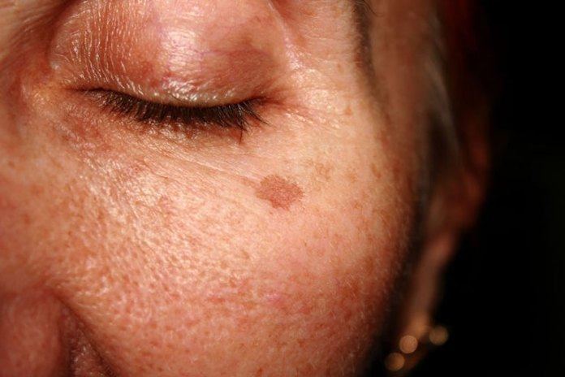

FORCE AND ENERGY
Static electricity
Static electricity is an imbalance of electric charges within or on the surface of a material or between materials.
A static electric charge can be created whenever two surfaces contact and have worn and separated, and at least one of the surfaces has a high resistance to electric current.
The effects of static electricity are familiar to most people because people can feel, hear, and even see the spark as the excess charge is neutralized when brought close to a large electrical conductor (for example, a path to ground), or a region with an excess charge of the opposite polarity (positive or negative)
Contact-induced charge
In high-school science demonstrations involving rubbing different materials together (e.g., fur against an acrylic rod). Contact-induced charge separation causes your hair to stand up and causes "static cling" (for example, a balloon rubbed against the hair becomes negatively charged; when near a wall, the charged balloon is attracted to positively charged particles in the wall, and can "cling" to it, appearing to be suspended against gravity).
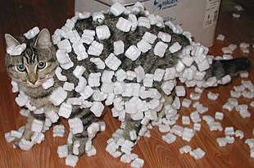
There are two ways of charging objects
  - rubbing
By using the method of friction, positive charge is developed on one of the bodies and negative charge on the other. When these two bodies are brought close, they attract.
Some objects have tendency to gain positive charge (example glass and ebonite rod) while some objects have the tendency to gain negative charge(example silk).
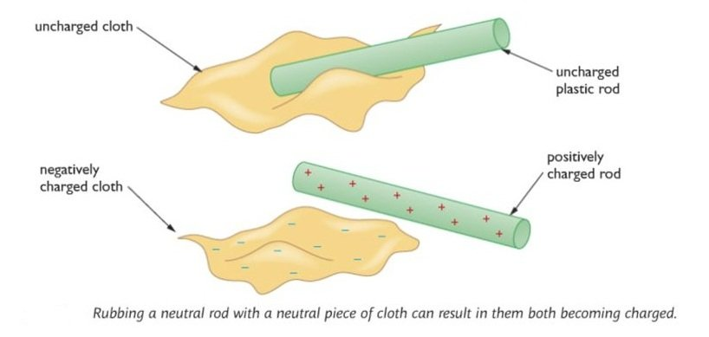

  - Induction
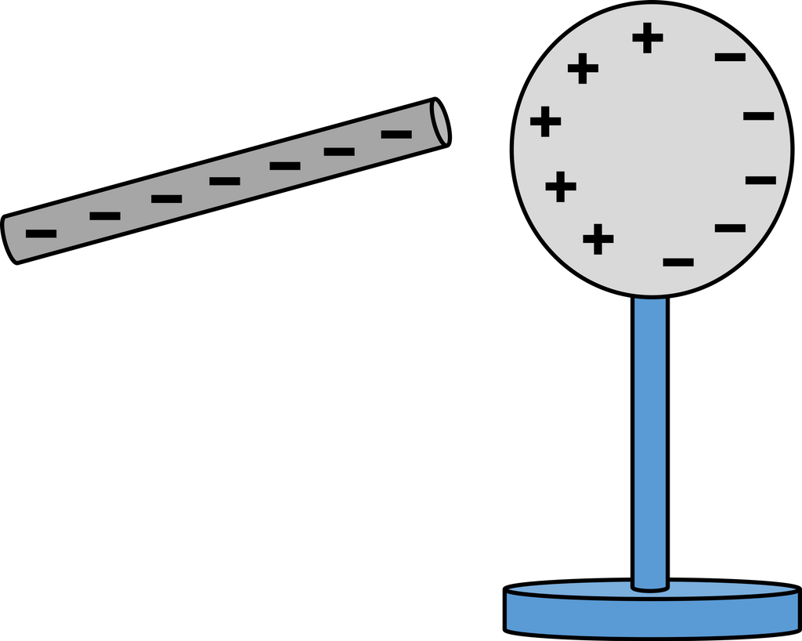
When an uncharged object is placed very close to a charged conductor without touching, the nearer end acquires a charge opposite to the charge on the charged conductors and the two bodies attract. This is called charging by induction. The net charge on the bodies remains the same and body is charged until they are kept close or brought in contact.
Effects of force between charged objects
- Like charges repel each other; unlike charges attract. Thus, two negative charges repel one another, while a positive charge attracts a negative charge.
- The attraction or repulsion acts along the line between the two charges.
- Forces are exerted by charged objects. Two electrically charged objects can exert a force on each other without directly touching. This force is an example of a non-contact force.
- Forces can attract and repel. Two objects with the same type of charge will repel, whilst two oppositely charged objects attract. The force between unlike charges is called electrostatic attraction. The force between like charges is called electrostatic repulsion.
- Electrostatic forces can cause movement. Similar to other forces, electrostatic forces can cause movement. Electrostatic attraction causes objects to move closer together, whilst electrostatic repulsion causes objects to move further away from each other. If we think back to our example with the rod and the cloth, the positive rod will attract the negative cloth, so they will move closer together.
Uses of static charges
Although static electricity can be a nuisance—like getting shock when you touch a doorknob or having static cling on your clothes—it has a number of beneficial uses.
The forces of attraction between charged particles caused by static electricity are used in air pollution control, xerography and automobile painting.
Questions you may have include:
- How is static electricity used in air pollution control?
- How does a Xerox machine work?
- How is static electricity used to paint cars?

Pollution control
Static electricity is used in pollution control by applying a static charge to dirt particles in the air and then collecting those charged particles on a plate or collector of the opposite electrical charge. Such devices are often called electrostatic precipitators.

Smokestacks
Factories use static electricity to reduce pollution coming from their smokestacks. They give the smoke an electric charge. When it passes by electrodes of the opposite charge, most of the smoke particles cling to the electrodes. This keeps the pollution from going out into the atmosphere.
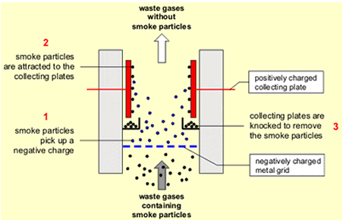

Air fresheners
Some people purchase what are called air ionizers to freshen and purify the air in their homes. They work on a similar principle as the smokestack pollution control. These devices strip electrons from smoke molecules, dust particles, and pollen in the air, just as what happens in creating static electricity.
These charged dust and smoke particles are then attracted to and stick to a plate on the device with the opposite charge. After a while, much of the pollution is drawn from the air.
Since charged particles will also stick to neutral surfaces, some of them can stick to the wall near the ionizer, making it very dirty and difficult to clean.

Xerography
Your photocopier or Xerox machine uses static electricity to copy print to a page. This is done through the science of xerography.
One version of this device electrically charges ink so that it will stick to the paper in the designated areas. Another version of a photocopier uses charges to stick the ink to a drum, which then transfers it to the paper.

Painting cars
Some automobile manufacturers use static electricity to help them paint the cars they make. The way this works is that they first prepare the car's surface and then put it in a paint booth. Next, they give the paint an electrical charge and then spray a fine mist of paint into the booth. The charged paint particles are attracted to the car and stick to the body, just like a charged balloon sticks to a wall. Once the paint dries, it sticks much better to the car and is smoother because it is evenly distributed.

Safety measures when dealing with static charges
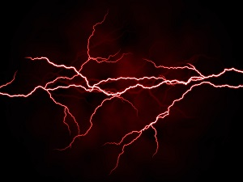
Use of the following in the workplace may be necessary to prevent charge accumulation that can lead to static electricity:
- nonmetal handrails
- insulated doorknobs
- nonconductive shields
- antistatic wrist straps
- static dissipating boots
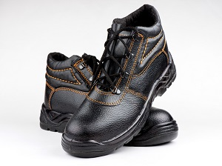
- antistatic or conductive clothing
Electrical Energy
Sources of electricity
Electricity cannot be mined from the ground like coal. So it is called a secondary source of energy, meaning that it is derived from primary sources, including coal, natural gas, nuclear fission reactions, sunlight, wind, and hydropower. Most direct uses of primary energy are limited to generating heat and motion.

Electric circuit
When there are two or more electrical devices in a circuit with an energy source, there are a couple of basic ways by which we connect them. They can either be connected in series or in parallel combinations. A series circuit is a circuit in which two components share a common node and the same current flows through them. However, in a parallel circuit, components share two common nodes.
Series
A circuit is said to be connected in series when the same current flows through all the components in the circuit. In such circuits, the current has only one path. Let us consider the household decorative string lights as an example of a series circuit. This is nothing but a series of multiple tiny bulbs connected in series. If one bulb fuses, all the bulbs in the series do not light up.
Parrallel
A circuit is said to be parallel when the electric current has multiple paths to flow through. The components that are a part of the parallel circuits will have a constant voltage across all ends.
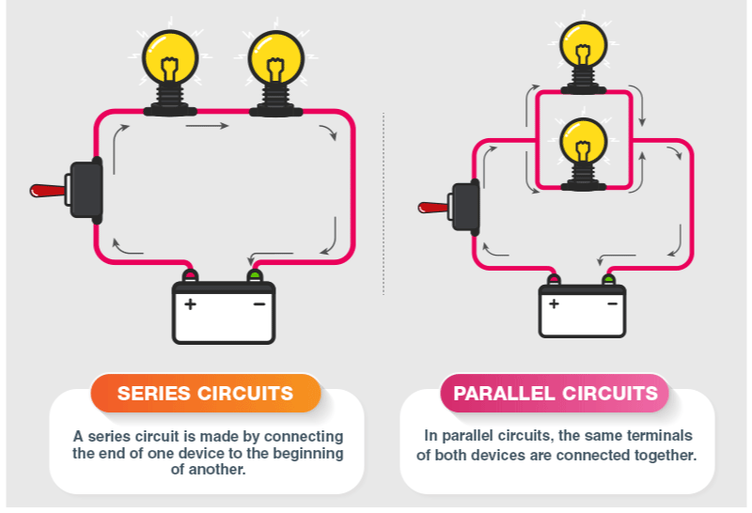

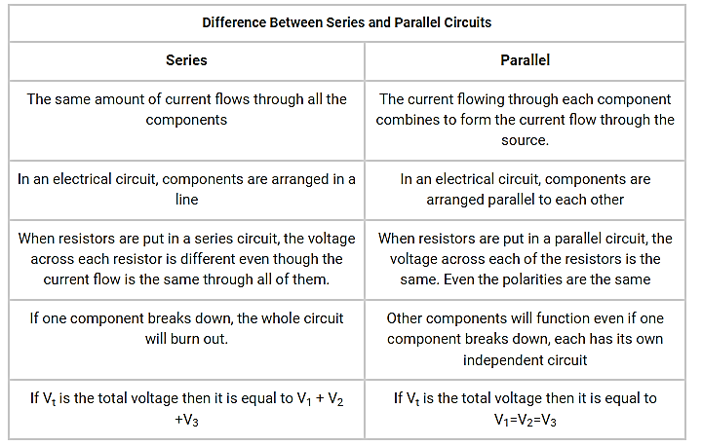
Electric conductors
The are two types
  - conductors
  - non-conductors
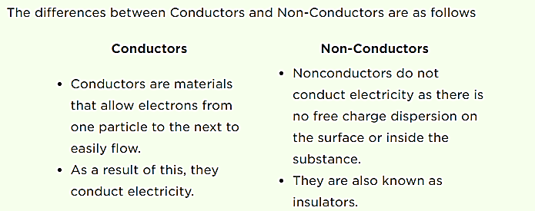

Applications of Conductors
Conductors are quite useful in many ways. They find use in many real-life applications. For example,
- Mercury is a common material in thermometer to check the temperature of the body.
- Aluminium finds its use in making foils to store food. It is also used in the production of fry pans to store heat quickly.
- Iron is a common material used in vehicle engine manufacturing to conduct heat.
- The plate of iron is made up of steel to absorb heat briskly.
- Conductors find their use in car radiators to eradicate heat away from the engine.

Applications of Insulators
As insulators resist the flow of electron, they find worldwide applications. Some of the common uses include:
- Thermal insulators, disallow heat to move from one place to another. Hence, we use them in making thermoplastic bottles. They are also used in fireproofing ceilings and walls.
- Sound insulators help in controlling noise level, as they are good in absorbance of sound. Thus, we use them in buildings and conference halls to make them noise-free.
- Electrical insulators hinder the flow of electron or passage of current through them. So, we use them extensively in circuit boards and high-voltage systems. They are also used in coating electric wire and cables.
Electrical appliances
The term appliance can be defined as, "a device or apparatus or equipment designed to perform an application or task, other than industrial, benefited in our personal life that uses some kind of technology".

USE OF APPLIANCES
When we consider the demands of our work schedules, whether be it in our house or office or in the exterior work place, appliances lower the stress levels almost everywhere. An appliance is designed to cater a function in our personal life, and use the following five main functional categories: Lighting, Heating, Cooling, Mechanical Work, and Information & Knowledge Processing.
For example, a light bulb does lighting, an oven does heating, a refrigerator does cooling, a hand mixer does mechanical work, and a smart phone does information & knowledge processing.
Home Appliances or Domestic Appliances or Household Appliances are devices or equipment that assists in household functions such as cooking, cleaning, food preservation, lighting, and entertainment
An Electric Appliance is a device or apparatus that uses to perform a function in our personal life, other than industrial, with the help of electrical energy.
Some of the major appliances are:
- Air conditioner Room: 750-1500 watts
- Audio System: 10-100 watts
- Blender: 300 watts
- Blow dryer: 1000 watts
- Ceiling fan: 10-70 watts
- Clothes dryer: 4000 watts
- Coffee Maker: 800 watts
- Coffee Pot: 200 watts
- Cooking Range: 1250-3200 watts
- Compact Fluorescent Lamp: 18 watts
- Computer: 50-250 watts
- Food Blender: 390 watts
- Frying Pan: 1200 watts
- Garage door opener: 350 watts
- Hand Drill: 250-1000 watts
- Heater: 1500 watts
- Hot Plate: 1200 watts
- Iron: 1000 watts
- Laptop: 80-150 watts
- Television: 70-250 watts
- Toaster: 800-1500 watts
- Washing machine Automatic: 500 watts
SAFETY MEASURES WHEN HANDLING ELECTRICAL APPLIANCES
- Never overload a power socket. Too many plugs in a socket will draw a large current and generate heat in the wires which can result in overloading.
- Never touch an electrical socket. You can receive an electric shock by doing so.
- Do not wet electrical appliances, plugs, or sockets.
- Disconnect the appliance while cleaning it.
- Do not touch electric poles, high voltage wires, etc., with your hands or any metal.
Uses of Electricity
- Entertainment
- Healthcare
- Engineering
- Transport and Communication
- Outdoors
- Household
- Commercial
- Office
- Fuel
- Space

Uses of Electricity in Entertainment
- Listening to music on MP3 players.
- Watching Television.
- Playing movies on DVDs, VCDs or VCRs runs on electricity.

Uses of Electricity in Healthcare
- Surgical operations
- Doctors need a powerful light during an operation on a patient
  - Without electricity, the operation can prove fatal.

Uses of Electricity in Engineering
Constructions of buildings and structures for the convenience of people require electricity in every step. Building houses, installing gates and windows, welding of materials require current electricity to operate the machines.

Uses of Electricity in Transport and Communication
Reaching places or communicating from a different corner of the world is only possible because of electricity. A power cut during airline travel can be dangerous.

Uses of Electricity outdoors
The street lights on the road use electricity to function, even the pool requires electricity to heat the water in colder regions. The lawnmower, which is used to cut grass uses electricity to operate. The water sprinkler for the grass on the lawn uses electricity as well.

Uses of Electricity in Household
Starting from toaster to refrigerator, microwave, washing machine, dishwasher, electrical chimney, and many more appliances which are simple to use and made for the convenience of day-to-day activities use electricity to function.

Uses of Electricity in commercial places
For the production of various materials, the factory uses heavy machinery which always runs on electricity. Even the magnets which are of a giant like structures require electricity to keep it charged for lifting heavy metals.

Uses of Electricity in Office
We go to work in offices in which most things run on electricity. The lights, lifts, AC, coffee machine, ID card reader, biometric scanners and everything else requires electricity.

Uses of Electricity as fuel
Electrical energy comes under renewable energy, and we can produce it using most of the natural resources available to us. Today, things which were running on fossil fuels, such as cars and bikes, are now made in such a way that it runs on electricity (like solar-powered), which will be more convenient in the future.

Uses of Electricity in Space
The satellites and probes which are sent from the earth for space expeditions run on electricity. The electricity is generated with the help of a generator or is battery powered.

Magnetism
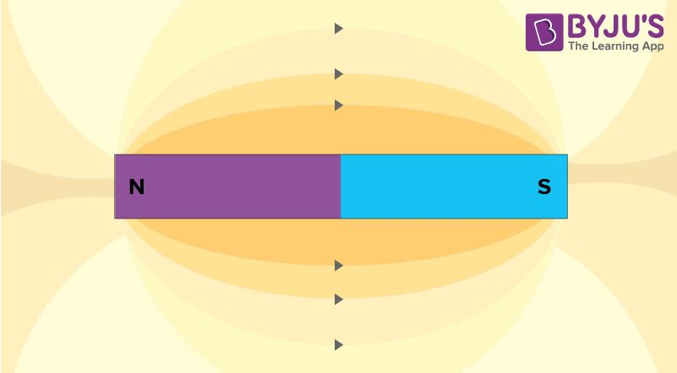
A magnet is an object that produces a magnetic field around itself
Magnets are classified into two groups natural and artificial magnets based on how they achieved their magnetism and for how long they retain their magnetic abilities and on their magnetic field. Natural magnets occur in nature and are much weaker than artificial magnets.
Natural magnets – Natural magnets occur in nature and have a weak magnetic field. Lodestones are a common example of natural magnets.
Artificial magnets – Artificial magnets can be produced by man-made means and have a stronger magnetic field. They can also be shaped as required. When an artificial magnet is shaped in the form of a bar, it is called a bar magnet.
Properties of Bar Magnet
A bar magnet has properties similar to any permanent magnet.
It has a north pole and a south pole at two ends. Even if you break a bar magnet from the middle, both the pieces will still have a north pole and a south pole, no matter how many pieces you break it in.
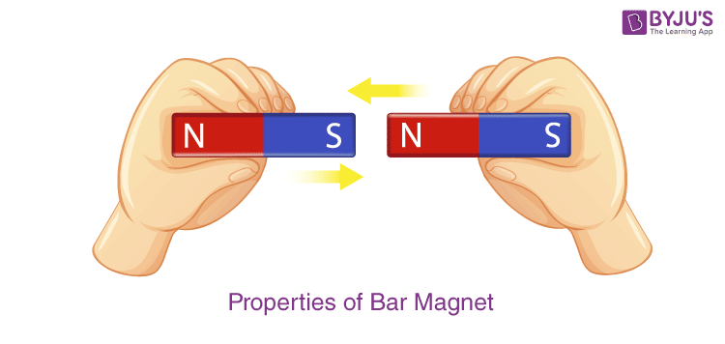
- Its magnetic force of it is the strongest at the poles.
- If this magnet is suspended freely in the air with a thread, it will not come to rest until the poles are aligned in a north-south position. A Mariner’s Compass uses this property to determine direction.
- If two bar magnets are placed close to each other, their unlike poles will attract and like poles will repel each other.
- A bar magnet will attract all ferromagnetic materials such as iron, nickel and cobalt.
The magnetic force between two moving charges may be described as the effect exerted upon either charge by a magnetic field created by the other.
Magnetic and non-magnetic materials
Substances that are attracted by a magnet are called magnetic substances. Example: Iron, cobalt, nickel, etc.
Substances that are not attracted by a magnet are called non-magnetic materials. Example: Aluminium, copper, wood, etc.
Force between like and unlike poles of a magnet
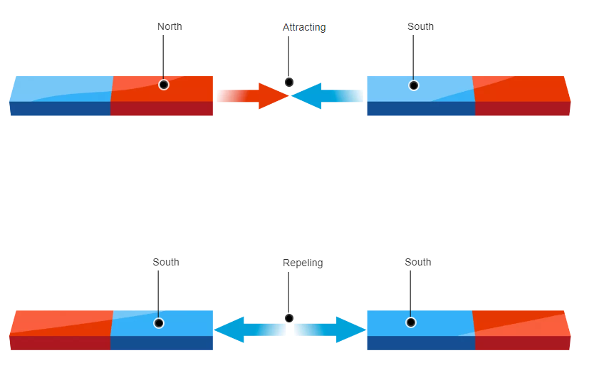
Uses of a magnet

Various Applications and Uses of Magnets
- We might be using computers in our day-to-day lives but never wondered about the presence of a magnet inside it. Magnetic elements on a hard disk help to represent computer data, which is later ‘read’ by the computer to extract information.
- Magnets are used inside TVs, sound speakers and radios. The small coil of wire and a magnet inside a speaker transforms the electronic signal to sound vibrations.
- Magnets are used inside a generator to transform mechanical energy into electrical energy. In contrast, other kinds of motors use magnets to change electrical energy to mechanical energy.
- Electrically charged magnets can help cranes to move large metal pieces.
- Magnets are used in filtering machines that separate metallic ores from crushed rocks.
- It is also used in food processing industries for separating small metallic pieces from grains etc.
- Magnets are used in MRI machines which are used to create an image of the bone structure, organs, and tissues. Even magnets are used to cure cancer.
- At home, you use magnets when you stick a paper on the refrigerator in order to remember something. Attaching a magnetic bottle opener to the fridge can come in handy.
- We often use pocket a compass to find out directions when we are on a trek. The pocket compass uses a magnetic needle to point north.
- The dark strip on the back of debit and credit cards is magnetic and is used to store data like computers’ hard drives.
- Magnets can help collect all the nails which are scattered on the ground after a repair job.

