Grade 8

VISUAL ARTS

NAME……………………………………………………………………………………………………………..
SCHOOL ………………………………………………………………………………………………………….
TIME 1hr

The table below shows differences between ornaments and jewellery considering their functions, materials and tools. Fill it appropriately.
 | Ornaments | Jewellery.
Function
Materials
Tools

- Name the following jewellery and ornaments

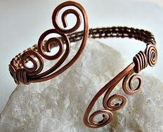
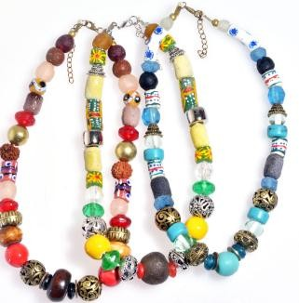
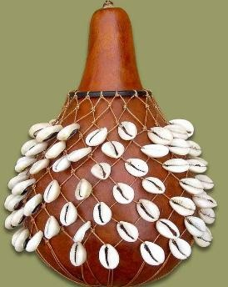

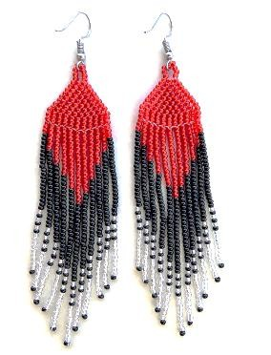

Name the Materials and tools for making a wire armlet.

- ………………………………………………
- ………………………………………………
- ……………………………………………….

Name the following Materials and tools for making a wire armlet.

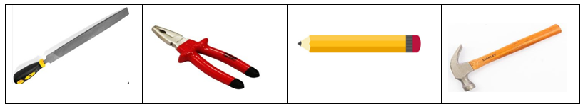

- List down various way of displaying armlet
- …………………………………………
- ………………………………………..
- State examples of natural materials used to make earrings:
- ……………………………………………….
- ……………………………………………
- …………………………………………..

- State the Steps followed when making earrings from natural materials.

Step 1
- ………………………………………………………………………………………………………………………….

Step 2.
- …………………………………………………………………………………………………………………..

Step 3
- ………………………………………………………………………………………………………………….

Step 4.
- ………………………………………………………………………………………………………………………..

- Identify the types of weave structures below

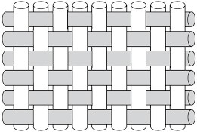

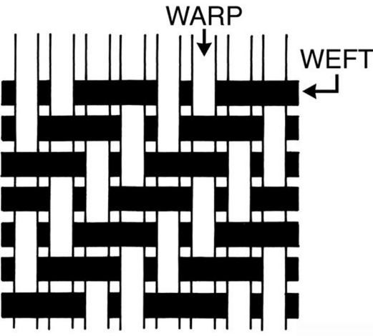
…………………………………………………..

…………………………………………………….

- What is a loom?
……………………………………………………………………………………………………………..

- Which materials are required to make a frame loom?
- ……………………………………………………………….
- ……………………………………………………………….
- ……………………………………………………………….

- Some of the main tools required in weaving are?
- ……………………………………………….
- ………………………………………………

- What is a shuttle?
……………………………………………………………………………………………………………….

- A shuttle can be made from the following tools, namely?
- ……………………………………..
- ……………………………………….
- ……………………………………….

- State the Precautions to observe when weaving using a Framed loom.
- …………………………………………………………………………………………….
- …………………………………………………………………………………………….
- ……………………………………………………………………………………………

- Identify the Finishing techniques of the woven scarf



 

