Grade 8

VISUAL ARTS MARKING SCHEME

The table below shows differences between ornaments and jewellery considering their functions, materials and tools. Fill it appropriately.
 | Ornaments | Jewellery.
Function | - Ornament is a collective name used to describe anything that is used to  adorn objects and the human body. | - Jewellery are specific ornaments used for personal adornment and include earrings, bangles, armlets, necklaces, anklets and rings.
Materials | - Ornaments are made from various materials such as  - Beads.  - Glass.  - Metals.  - These materials can be in form of beads or items of different size, shape and designs. | - In jewellery, safety is the main factor to consider when selecting materials.  - Since jewellery are worn on the body, material used should not cause any injury or an allergic reaction to the person wearing.  - Materials should also not be toxic or change colour when it comes into contact with water or sweat.  - Some jewellery are also made from precious stones and metals such as gold, diamond and emerald.
Tools | - A wide range of tools can be used to make ornaments and jewellery.  - Tools used depend on  the design, types and material used. | - Some jewellery require precision and specialized tools to make them since they may have small detailed parts.

- Name the following jewellery and ornaments

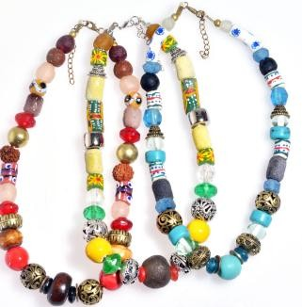
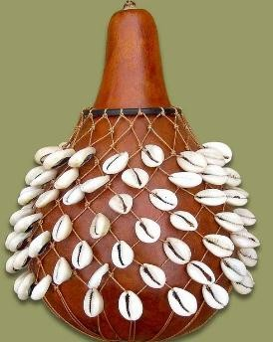
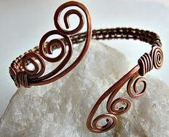

Armlet. Bangles beads

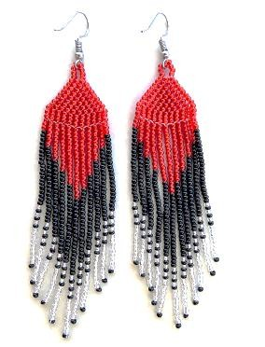

Earings

Name the Materials and tools for making a wire armlet.

- Pair of scissors
- Flat nose pliers
- Wire cutter
- Pliable wire
- Item with cylindrical shape
- Ball pein hammer.
- Round nose pliers
- Tin snip
- File
- Pliers
- Pencil.
- Hammer

Name the following Materials and tools for making a wire armlet.

Tin snip  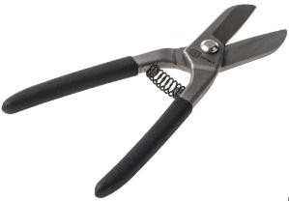 | Pliable wire.  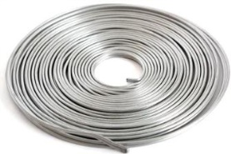  . | Pair of scissors.  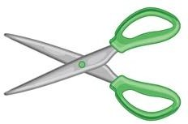 | Item with cylindrical shape.  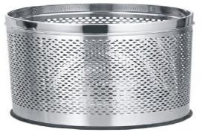
File  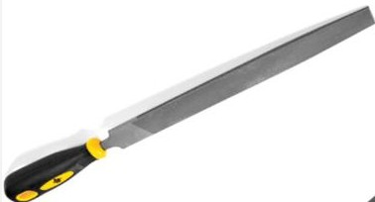 | Pliers.  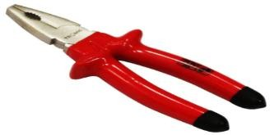 | Pencil. | Hammer.  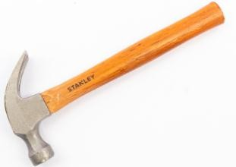

- List down various way of displaying armlet
- Hanging them on a stand.
- Tying around a rolled paper.
- Hanging on a string.
- Placing them on a contrasting background.
- State examples of natural materials used to make earrings:
- Inedible seeds.
- Bones.
- Shells.
- Thorns.
- Sticks or twigs.
- Porcupine quills.
- Reeds.
- Wood.

- State the Steps followed when making earrings from natural materials.

Step 1
- Select natural materials for making the earring such as inedible seed, twigs, cowrie shells and horn.

Step 2.
- Design the earring into a unique design.

Step 3
- Prepare the materials for making the earrings.
- Cleaning-depending on the materials used for making the earrings cleaning can be done by dry wiping, soap cleaning with water.
- Drilling holes-can be done using various methods depending on the type of materials used. It can be done using nails, a thorn, sharp wire, needle or handheld drilling machine.
- Twisting-the materials can be twisted using hand or tools such as pliers, flat nosed and round nosed pliers.
- Sanding-it is done to smoothen the surface of the material being used.
- It can be done by using sand, stones or any other rough surface.
- Folding-can be done to shape the material for making the earrings such as wire.
- Cutting-it is important in shaping the material and reducing the materials to the required size. Cutting can be done using tools such as blade, knife or scissors.

Step 4.
- Decorating-it is done using methods such as painting, cutting patterns, burning, varnishing or staining.
- Cut pliable wire and use pliers to fold one end using round shaped pliers.
- String the beads already made from natural materials on the wire as you arrange to form a pattern.
- Add spaces in between or at the end of the beads. Spacers are used to create gasps between the beads to enhance the appearance of the earrings.
- Fold the wire at the end to form a loop.
- Make the earing hook.
- File the earring hook and the hoop to make the safe for use.
- Fix the earring hook to the loop having beads.
- Design and make a stopper from rubber and attach it to the earring.

- Identify the types of weave structures below

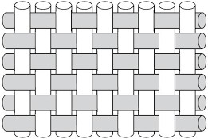

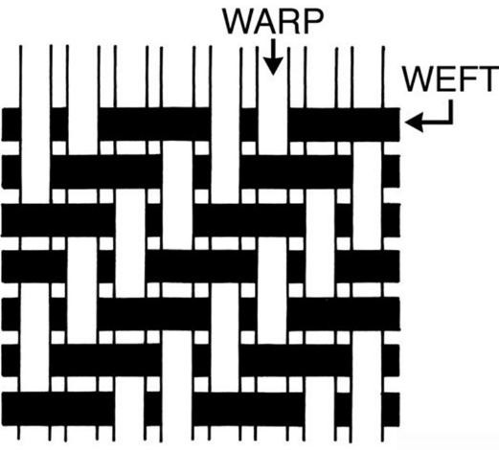
Plain weave structure.

Twill weave structure

- What is a loom?
A loom is a device used for weaving,

- Which materials are required to make a frame loom?
- Nails.
- Four pieces of timber.
- Hammer.
- Saw.
- Sand paper.
- Wood glue.
- Ruler or meter rule.
- Pencil.
- Tri square or protractor.

- Some of the main tools required in weaving are?
- Shuttle.
- Beater.
- Cutting tools.

- What is a shuttle?
A shuttle is a tool used to assist in interlacing the weft over and under the warp.

- A shuttle can be made from the following tools, namely?
- A wood.
- Stiff paper.
- Plastics.
- A stick.

- State the Precautions to observe when weaving using a Framed loom.
- Do not pull the weft too tightly when weaving. It is recommended you leave an allowance on the weft when interlacing the threads before beating each line as indicated below.

- If the weft threads are pulled too tightly during weaving, it will cause a defect on the woven item at the length that weft were pulled as shown below.

- Ensure that the warp threads are tight and have uniform tension. If the warp threads are loose with uneven tension, it will cause a defect on the woven work

- Identify the Finishing techniques of the woven scarf
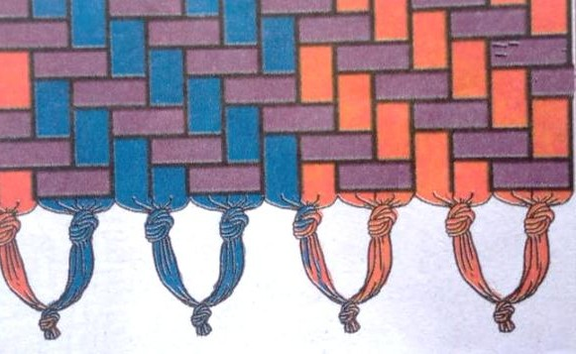
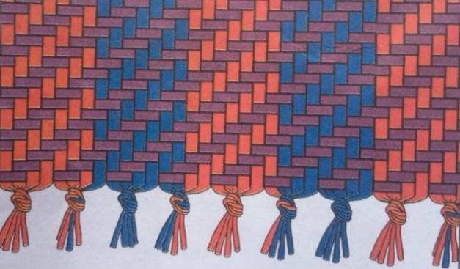

Knotting technique after weaving. Tasseling technique.

