GRADE 8 PRE-TECHNICAL STUDIES NOTES- TERM 2
STRAND 2-COMMUNICATION.
§
2.1-Business Communication.
- Communication is the process of sharing information through a channel from the sender to
the receiver.
- Business communication is the exchange of information between a business organization and its customers or between people within and outside a company.
- When business communication is done correctly, everyone can do their job, all of which increases productivity and even creativity.
- A communication channel is a medium or method that is used to deliver a message to an intended audience.

Forms of communication channels used in Business.
- Oral/verbal communication channels.
- Written communication channels.
- Audio-visual communication channels.

Oral/verbal communication channels.
✰ It involves speaking and listening by both the sender and the receiver.
✰ Examples of oral communication channels include:
∼ Face to face conversations.
∼ Group presentations.
∼ Telephone calls.
∼ Speeches.
∼ Lectures.

Advantages and disadvantages of oral communication channels.
 | Advantages | Disadvantages.
1 | Sharing of information is quicker especially through phone call or one on one conversation. | Not possible to tell if everybody is listening to you especially when dealing with a large group.
2 | Feedback is shared immediately. | Sometimes there is no record kept for future reference.
3 | Oral communication channels are suitable where persuasion is required. | Misinterpretation of the message may occur  due to tone variation and mispronunciation of word.
4 | They are cheap. | Misunderstanding may occur when the message is misinterpreted.
5 | The sender can reinforce the message by using body language. | They could results in boredom and disengagement when a lot of information is being shared.

Written communication channels.
✰ They involve use of text to pass information.
✰ The text can be handwritten, printed or shared using digital communication devices.
✰ Examples of written channels of communication in businesses are:
∼ Emails.
∼ Letters.
∼ Memos.
∼ Reports.
∼ Circulars.
∼ Short message services (SMS)
∼ Newsletters.
 | Written  communication channel | Description.
1 | Letter | A written or printed message that is addressed to a person or organization. It can be formal or informal and is usually delivered by hand or mail.
2 | Memo | A short official note that is sent by one person to another or to a group of people within the same business organization.
3 | Circular | An official letter addressed to many people outside the business organization.
4 | Notice | Communication used to tell or warn about something that is going to happen.
5 | Minutes | Written record of what happened in an official meeting.
6 | Report. | An account or statement giving details of an event or a situation, usually as a result of observation or inquiry.
7 | Email. | A formal method of exchanging messages or communication from one person to another or more recipients through the internet.

Advantages and disadvantages of written communication channels.
 | Advantages | Disadvantages.
1 | Suitable for sending detailed information such as business reports. | There is no immediate feedback from the receiver of information.
2 | Easy to keep records of information in physical files or digital devices e.g., emails and typed documents. | Some such as letters and reports are costly in some circumstances.
3 | It ensures clarity of information as a person can read the information several times. E.g. a letter and minutes. | The receiver of a letter or circular may not get a chance to seek clarification on the information.
4 | They are ideal for passing confidential information o stakeholders in business e.g.,  memos and letters | They are not suitable for people who cannot read and write.

5 | They ensure there is no distortion of information because it is received as the sender intended. | Body language in all written communication channel cannot be used to enhance understanding of the message.

Audio-visual communication channels.
✰ It involves a combination of different content forms such as text, audio, images, video and animation.
✰ Examples are:
∼ social media platforms.
∼ Blogs.
∼ Televisions.
∼ Video-conferencing.
∼ Websites.

Advantages and disadvantages of audio-visual communication channels.

 | Advantages | Disadvantages.
1 | Business information can be sent and  received instantly, anywhere in the world through internet or television. | Information overload-exposes users to a lot  of content flow in addition to the intended information.
2 | They allow for information to be changed and to be updated, for example blogs and social media. | It can lead to time wastage for example one can spend a lot of time scrolling through other content on smartphone or computer even after receiving the intended message.
3 | They are flexible-one can send or receive information from anywhere in the world. | Not all people have the gadgets that support multimedia communication channels.
4 | Makes it easier for the sender and receiver of information to interact and share  feedback in real time. For example, emails and social media. | They can be costly because they involve getting specialized equipment and skilled  people to compile and package information before it is sent to the target audience.
5 | Due to their easy integrated nature, they allow for easy understanding of the information shared. | They may be subject to cyber security threats such as hacking, which threaten the policy of the information.
6 | They can be used to reach many people and  to engage them all at once, for example television and radio.
7 | They are exciting to use due to their interactive nature, for example social  media.

Factors considered when selecting channels of communication.
- Cost of the channel.
- Urgency of the message.
- Number of people receiving the message.
- Confidentiality of the message.
- Reliability of communication.
- Nature of the message: whether it is urgent, private or confidential.
- Need for immediate feedback.
- Supporting technology: both the sender and the receiver should have supporting tools to ensure the message is delivered successfully, for example mobile phones and internet connectivity.

2.2-Plain Scale Drawing.
- Plain scale drawing involves drawing a line that has been divided into a specific number of
equal parts.
- The first part of the line is subdivided into equal smaller portions or units.
- It can be used to represent two units, a unit or a fraction of a unit.
- Plain scale is used in engineering drawings to measure up to two units such as metre and decimeters or feet and inches.
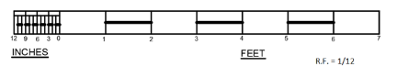

Interpreting a plain scale used in drawing.
- A representative fraction (R.F) is the ration od the size of a feature on a drawing to its true size on the object.
- It is expressed in fraction form as R/F
- A plain scale can be constructed using the example below.
Example 1.:
On a drawing, 1 cm represents 1,5m on the ground.
Draw a plain scale to measure up to 30m in 5m interval. Show the length of 27m on the scale.

Steps to follow.
Step 1

  - Determine the scale to use.
  - In our case 1cm represents 1.5m or 150cm.
  - In this example, it is appropriate to use Centimetres.

Step 2.
  - Calculate the Representative fraction, R.F
  - R.F = measurement on the map divided by measurement on the ground.
  - R.F =1cm/1.5m
  - R.F =1/150.
  - R.F =1:150.

Step 3.
  - Calculate the maximum length of the scale to read 30 metres length.
  - Measurement on map =R. F x measurement on the ground.
  - Measurement on map =1/150 x3000
  - Measurement on map =20.

Step 4
  - Draw a straight line 20cm long and divide it into 6 equal parts.
  - Divide again first part into 5 equal parts.

  - Indicate the number on the points on the line as shown.

▪
  - To show length 27m, draw a line AB above the scale with and B at 25 m mark on the
main scale. Extend the line for point A to be at point 2m on the smaller scale. Complete the drawing with all details.
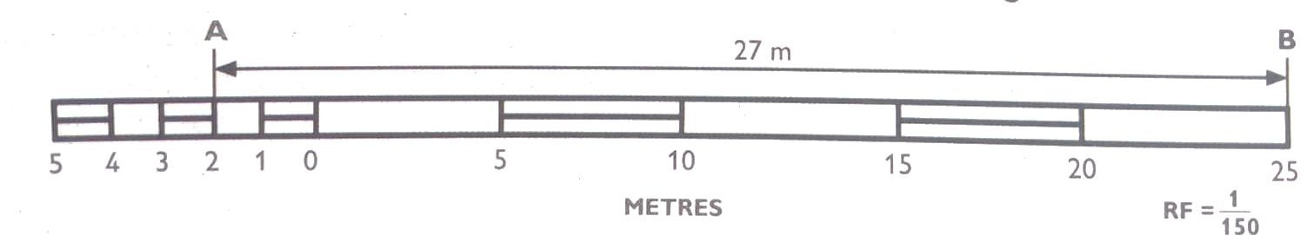
Example 2:
On a scale 1:150, determine the length of line PQ as shown in the figure. Give your answer in metres.
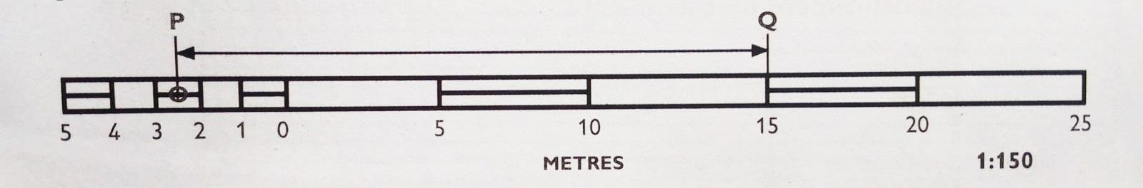

Steps to follow.
- Determine where line begins on the main scale. In this example, point Q is at the 15m mark.
- Determine the point on the smaller scale where the line reaches. From the diagram above, point P is between 2 and 3 on the smaller scale. Therefore, this point represents 2.5m from 0.
- Combine the two values such that 15 is the value on main scale, while 2.5 is the value from smaller scale.
- Therefore, length of the line PQ is 15 + 2.5= 17.5 m.

Example 3
- On a drawing of scale 1.5, the length of a line is a s shown in the diagram. The unit of the

scale is decimeters. Determine the length of the line in centimetres.
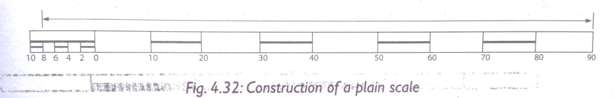
- Determine where the line begins on the main scale. In this came point is at 9cm mark.
- Determine the point on the smaller scale where the line reaches. From this case it is 8 mark representing a length of 8cm.
- Combine the two values such that: 90cm (9dm) is the value rom main scale and 8cm is the value from smaller scale, 90 cm + 8cm =98cm.
- Hence the length of the line = 98cm.
2.3 Visual Programming.

Introduction.
🢝 Visual programming is developing applications using graphical components and figures.
🢝 These graphical components and figures mostly include images and video clips.

- Types of visual programming applications.
🢝 Visual programming is also called block-based programming.
🢝 It is a way of creating applications using graphical components and figures. This is mostly done through the use of code blocks and drag-and drop processes.
🢝 The most common examples of visual programming applications are:

Microsoft MakeCode.
- Scratch.

Code.org.
- Sprite box.

Microsoft Visual Studio.
- Roblox.

Minecraft.
🢝 Visual programming applications are used because they are easy and interesting to use.
They also help in creating stories, animations and videos that entertain users.

Launching a visual programming application.
⭢ Type the word Scratch in the search box. The Scratch application will appear.
⭢ Click on the Scratch application to launch it.
⭢ Alternatively, click Start.
⭢ Scroll down to category S then click on Scratch App. The application will launch.

Visual Programming Features.
- Features of Scratch.
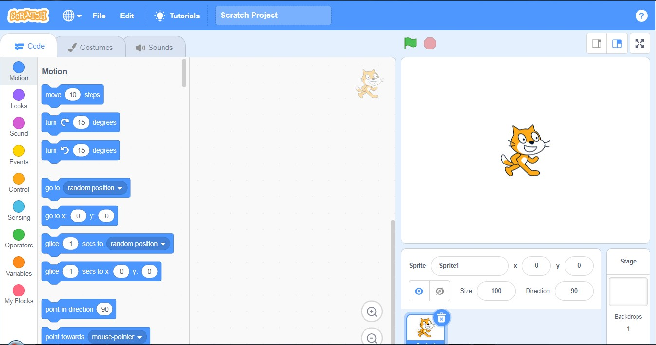
⭢ Scratch is a visual programming language that can be used to create interactive stories, games and animations.

Features of scratch include:
- The menu bar-it contains the fie menu used to save and load projects and the view menu which displays rulers, grid lines, status, zoom in and out options.
- The black palette-it contains a coloured set of code blocks that are used to program and give instructions to the sprite.
- The stage-it is the main working area where the sprite moves and performs according to the given code of instruction.
- Backdrops pane-it is the part used to add a back ground to the project.

Functions of the features of Scratch.

Feature | Function
Sprite | It is also called the coding area. it is where codes (scripts) area created for a sprite to do a specific action.
Sprite area | Are blocks shaped differently and are used to create codes in Scratch.
Code blocks | A small graphic character that performs actions such as moving around the stage.
Sprite pane | Shows information about the size of each sprite.
Sprite info | Displays all the sprites in a project
- A sprite is a small graphic character that performs actions such as moving around the stage.
- The script area is also called the coding area; it is where codes (scripts) are created for a sprite to do a specific action. Codes are dragged and dropped here then snapped together to create a program.
- Code blocks are blocks shaped differently and are used to create codes in Scratch. The codes connect to each other vertically like a jigsaw.
- The sprite info shows information about the size of each sprite.
- The sprite pane displays all the sprites in a project. A selected sprite has a blue border around it.

NB
🢖 To move the sprite, add a move block from the motion category.
🢖 To add sound, click on sound category and choose a sound block.
🢖 To move the sprite back, use a negative value on the move back block. The block can be repeatedly severally to generate the desired animation.

Terminologies used in visual programming applications.
- The start option commands the sprite to perform moves, it is represented by a green flag . When you click stop the sprite ends its moves.
- Reserved words are also known as key words. These are words with a special meaning to the programming application. In scratch they are words that we cannot edit on the blocks. They include when, by and change.
- The rules that should be followed when writing a program using an application are called

syntax.
- Input statement are blocks that are used to create animations.
- Output statements are outcomes of the processed instructions that are programmed using clocks. These are the actions viewed on the stage when the blocks are executing.
- Control structures are the blocks that allow selecting or repeating execution of certain blocks or instructions.

- A backdrop is the background for the stage. Backdrops can be changed from the gallery or photo in the computer.

- The sensing category helps one to enable input from the mouse, keyboard and other input devices. ’IF’ is used to choose between two output. For example, it can be used to perform mathematical calculations and state whether the answer given is correct or not

STRAND 3-MATERIALS FOR PRODUCTION.
3.1 – Composite Materials.

Identification of Composite materials.
- A composite material is formed by combining two or more materials of different characteristics.
- Some of the composite materials found in the locality include:

∼ Mud.
∼ Stone.
∼ Sand paper.
∼ Chip board and ply wood.
∼ Concrete.
∼ Mortar.

Composition of composite materials.
∼ Bituminous felt.
∼ Fiberglass.
∼ Papier mache.
∼ Putty.
∼ Rubber.

Different composite materials are made of different materials as described in the table below.
 | Material | Composition
1 | Fibre glass | Fine glass particles or plastic fibre and resins.
2 | Mud | Soil and water.
3 | Papier mache | Paper pieces or pulp and adhesive (glue, starch or wallpaper paste)
4 | Stone | Different natural materials.
5 | Manufactured boards | Wood waste like saw dust or wood shavings and glue.
6 | Concrete | Cement, sand, water and coarse aggregates.
7 | Mortar | Cement, sand and water.
8 | Rubber | Natural latex, fibres and other additives.
9 | Bituminous felt | Petroleum by -products and sand particles.
10 | Window putty | Limestone and oil.
11 | Sand paper | Piece of cloth or paper, glue and sand particles.

Uses of Composite materials.
Some of the uses of composite materials are explained as follows:
- In sports industry, composite materials are used to make various games and sports items.
- Composite materials are used to make body parts of vehicles and bicycles.
- Composites materials are used to make customer goods and electronics such as mobile phones, television sets, radios and calculators.
- At home, composite materials are used to make hand tools and furniture.
- In construction industry, composites like concrete are used to build houses and to construct roads and bridges among other structures.
- In medical engineering, composite materials are used to make artificial body parts and implants.

- In transport industry, composite materials are used to make the body parts of vehicles, aeroplane, ships and boats among others. It is also used to make travelling bags and briefcases.

NOTE:
  - Artificial body parts are also called prosthetics.
  - Prosthetics limbs are given to substitute missing body parts.
  - These body parts may have been lost in an accident or through amputation.
  - The prosthetic body parts help people with missing limbs to function properly and with ease despite the missing body parts

Careers in use of Composite materials.
- Masonry-involves use of mortar, stones and concrete to construct structures.
- Pottery- involves use of mud to make pots, dishes, mugs, vases and other types of artworks.
- Interior design – involves use of papier mache and manufactured boards to decorate interior of houses and motor vehicles.
- Sculpting -involves uses of clay, fiberglass, stone or concrete to make sculptures.
- Boat construction -involves use of fiberglass to construct boats that are light and resistant to corrosion.
- Carpentry – involves use of manufactured boards to make furniture, construct ceilings and other finishes in a building.

Importance of composite materials used in the locality.
🢖 Promote recreation that improves health.
🢖 Providing employment.
🢖 Use of manufactures boards such as blockboards, softboards or chipboards to reduce deforestation through recycling of waste.
🢖 Improves the appearance in landscaping of compounds
3.2 -Ceramic materials.
- A ceramic material is made by mixing clay, earthen elements like silica, kaolin, alumina and
feldspar, and water.
- The material is thoroughly kneaded, shaped into desired forms and baked before being covered in decorative, waterproof, paint-like substances called glazes.
- Some ceramic materials like sea shells occur naturally.
- The common type of ceramic materials are:
  - Earthenware- clay heated at temperatures of between 1000⁰C and 1150⁰C. An example is clay used to make pot.
  - Stoneware – clay heated at an average temperature of 1200⁰C until it appears like glass. An example is material used to make a stoneware mug.
  - Porcelain -clay mixed with glass and heated at high temperature of between 1200⁰C and 1450⁰C. Example is material used to make a porcelain cup.

Most common ceramics materials found in the locality.
∼ Ceramic tiles.
∼ Glass.
∼ Backed clay bricks.
∼ Clay tiles.

Physical properties of Ceramic materials.
- Ceramic materials break easily when crushed.
- Ceramic materials are poor conductors of electricity.
- Ceramic materials have a hard surface which is difficult to scratch.
- Ceramic materials are resistant to corrosion.
- Ceramic materials do not absorb water.
- Ceramic materials do not bend.
- Ceramic materials do not burn.

Uses of ceramic materials.
- In electrical and electronic engineering, ceramics are used to make items like resistors, semiconductors and inductors etc.
- Ceramic materials are used to make a variety of pottery items like pots and utensils.
- In the manufacturing industry, ceramics are used to make a variety of household utensils.
- Ceramics are used in plumbing works to make drainage installations and sanitary fittings such as toilets and wash basins,
- In construction, ceramics like bricks and tiles are used in building construction for walling, roofing and finishing materials.
- In beautification, ceramics are used to produce items like flower vase, lamp stand and souvenirs.

