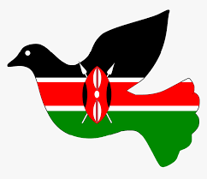
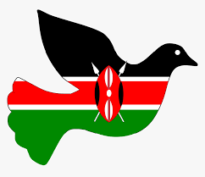

Grade 8

SOCIAL STUDIES

NAME……………………………………………………………………………………………………………..
SCHOOL ………………………………………………………………………………………………………….
TIME 1hr

- Draw the map of Africa and shade the countries that were colonized by;
    - Belgian
    - British
    - French
    - German
    - Italians

- State the Importance of the Constitution.
- ……………………………………………………………………………………………
- ……………………………………………………………………………………………
- The National Values provided in the Constitution of Kenya.
- ………………………………………….……………..
- ………………………………………….………………
- ………………………………………………………….

Name two types of democracy.
- ……………………………………………….
- ……………………………………………….

Importance of Democracy in the society
- …………………………………………………………………………………………
- …………………………………………………………………………………………

- Role of Citizens in democracy representation.

- ……………………………………………………………………………………………….
- ………………………………………………………………………………………………
- ……………………………………………………………………………………………….
- Give Examples of human rights
  - …………………………………………………………
  - ………………………………………………………..
  - ……………………………………………………….

- Human rights can be classified as?
- …………………………………….
- ……………………………………
- ……………………………………

- Describe the Characteristics of Human rights in the society.
- …………………………………………………………………………………………..
- …………………………………………………………………………………………..

- The following ways can be used to promote equity and non-discrimination in the society.
- …………………………………………………………………………………………
- …………………………………………………………………………………………

Describe the Factors that contributed to the presence of African Diasporas across the World.
- ………………………………………………………………………………….
- ………………………………………………………………………………….

- Africans in diaspora play an important role in the political development in Africa. Mention at least three roles
- ……………………………………………………………………
- …………………………………………………………………..
- ………………………………………………………………….

What were the Reasons for interconnectedness and interdependence among countries in the world?

- ………………………………………………
- ………………………………………………
- ……………………………………………..
- State the Positive effects of globalization
- …………………………………………………………….
- …………………………………………………………….
- …………………………………………………………….

State the Negative effects of globalization include;
- ………………………………………………………….
- ………………………………………………………….
- Mention the Qualities of a global citizen in the modern society.

- ………………………………………………….
- ……………………………………………………

- Match the logo to the organization.

AFRICAN UNION
COMMONWEALTH
UNITED NATIONS

- Who were the founders of OAU?

- ………………………………….
- ………………………………….
- ………………………………….
- ………………………………….
- …………………………………

- Why was OAU formed?

- …………………………………………………………………………………….
- ……………………………………………………………………………………..

- What were the Achievements of the Organization of African Unity (OAU) and African Union (AU)?

- …………………………………………………………………………………………………………………………………………………………………………….
- ………………………………………………………………………………………………………………………………………………………………………………..
- ………………………………………………………………………………………………………………………………………………………………………….

- The union is divided into various organs that include;
- …………………………………………….
- …………………………………………….
- Mention the Challenges of the OF Organization of African Unity (OAU) and African Union (AU

- ……………………………………………..
- ……………………………………………..

Mention the Principles of Leadership and integrity.

- …………………………………………..
- …………………………………………..
- State the Factors which promote Continental Interconnectedness and Interdependence
- ………………….………………………………………
- ………………………………………………………
- …………………………………………………………..

