COMPETENCE BASED CURRICULUM
JUNIOR SCHOOL
GRADE 8
FORMATIVE ASSESSMENT
SOCIAL STUDIES

2 HOURS
SCHOOL: ……………………………………………………………………………..……
NAME: ……………………………………………………..……………………..………..
ASSESSMENT NO: ……………….………. SIGN: …....DATE: ………..….
RUBRICS (for official use)
Mark Score Range | Below 40 | 40-59 | 60-79 | 80-100
PERFORMANCE LEVEL | Below expectation | Approaching expectations | Meeting expectations | Exceeding expectations
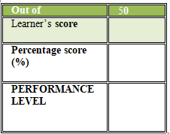
FOR EXAMINERS
INSTRUCTIONS TO CANDIDATES
- Answer all the questions in the spaces provided.
- Ensure your work is neat.

QUESTIONS

- Identify the following maps. (3 mks)

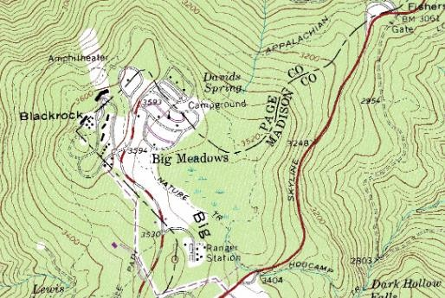
…………………………………………..

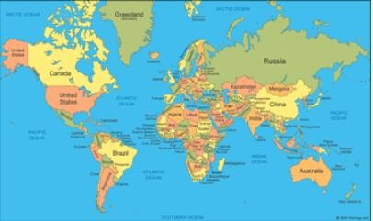

…………………………………………..

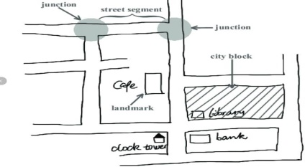

🢒

……………………………………………

- Discuss the origin of the solar system under the following theories
  - The passing star theory (4mks)
- ………………………………………………………………………………..
- ………………………………………………………………………………..
- …………………………………………………………………………………
- …………………………………………………………………………………

  - The nebula cloud theory. (4mks)
- …………………………………………………………………………………..
- …………………………………………………………………………………..
- …………………………………………………………………………………..
- ………………………………………………………………………………….

- State the names that describes the shape of the earth . (3mks)
- ………………………………..
- ……………………………….
- ………………………………..

- What are the Effects of Rotation of the Earth . (3mks)
- ……………………………………………………………………………….
- ……………………………………………………………………………….
- ……………………………………………………………………………….
- What are the effects of Revolution of the earth? (3mks)
- ………………………………………………………………………………….
- …………………………………………………………………………………..
- …………………………………………………………………………………..

- If the time in Monrovia , Liberia ,12⁰W is 8:00am,what is the time at Addis Ababa, Ethiopia, 38 ⁰E?(4mks)

- List down four proofs that the earth is spherical (4mks)
- ………………………………..…………………………………………………
- …………………………………………………………………………………..
- ………………………………………………………………………………….
- …………………………………………………………………………………
- Identify the following parts of internal structure of the earth (4mks)

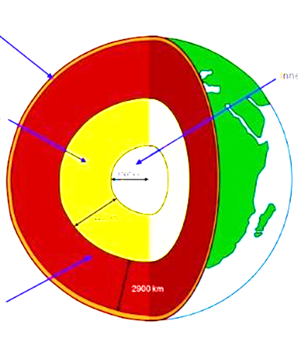

State the characteristics of the earth’s Core(3mks)
- …………………………………………………………………….
- …………………………………………………………………….
- …………………………………………………………………….

State the Composition of the Atmosphere(3mks)
- ……………………………………………
- …………………………………………..
- …………………………………………..

- a) Name the four main zones of the atmosphere (4mks)
- ………………………………
- ……………………………….
- ……………………………….
- …………………………………

- The table below shows rain fall and temperature in town x use it to answer the questions that follow
Months | JA | FE | MA | AP | MA | JUN | JUL | AU | SE | OC | NO | DE
Temp °C | 23 | 24 | 26 | 28 | 29 | 28 | 26 | 26 | 26 | 30 | 28 | 25
Rainfall mm | 3 | 0 | 3 | 1 | 18 | 500 | 720 | 408 | 300 | 70 | 15 | 0

- Calculate (2mks)
- The total annual rainfall

- The mean monthly rainfall (2mks)

- The annual range of temperature (2mks)

- The mean annual temperature (2mks)

- Using the table indicate the following (3mks)
- The wettest month …………………………………

- The hottest month …………………………………………

- The coolest month …………………………………………
- What are the factors to be taken into account when sitting a weather station (3mks)
- ……………………………………………………………………………….
- ……………………………………………………………………………….
- ……………………………………………………………………………….

Write what element of weather they measure(3mks)
- Thermometer- ……………………………………..
- Hygrometer- …………………………………….
- Rain gauge-………………..……………………..

- State the Factors influencing population distribution in Africa.(3mks)
- …………………………………………………………………………..
- ……………………………………………………………………………
- ……………………………………………………………………………

- A Grade 8 learner in a certain school obtained the following data showing monthly temperatures recorded in the nearby weather station. Create a simple bar graph using the information given(5mks)
Month | Jan | Feb | Mar | Apr | May | Jun | Jul | Aug | Sep | Oct | Nov | Dec
Temp  0 C | 29 | 24 | 33 | 27 | 27 | 29 | 29 | 28 | 33 | 28 | 30 | 29

- Name one way of making peace with oneself under different circumstances.(1m k)
…………………………………………………………………………………………………………
- Name one situation require assertiveness in our lives.(1 mk)
…………………………………………………………………………………………………………Name one situation that require creative thinking.(1mk)
…………………………………………………………………………………………………………

This is the last printed page

