JUNIOR SCHOOL

2024 ANSWERS

G8 SOCIAL STUDIES

Answer all questions

- Identify the following maps

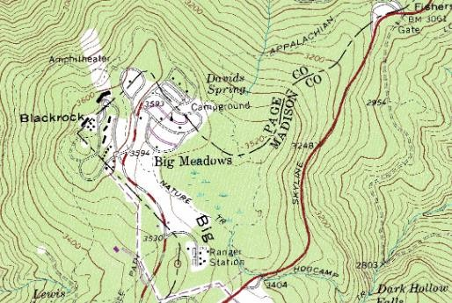
Topographical map

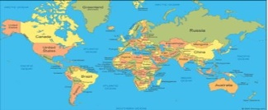

Atlas map

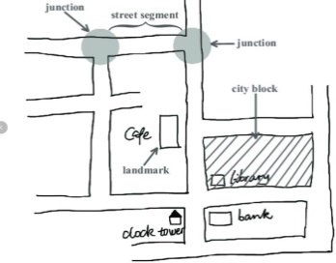

🢒

A sketch map.

- Discuss the origin of the solar system under the following theories
  - The passing star theory
- A star with a greater gravitational pull passed near the sun
- It attracted large quantities of gaseous materials from the sun
- The materials split, cooled and condensed to form planets
- The planets were set in orbit by the passing star

  - The nebula cloud theory
- There was a slowly rotating cloud of dust and gas called Nebula. This caused high concentration of materials at the centre that formed the sun.
- Rotation speed increased and successive rings of gaseous materials were formed.
- The rings condensed to form planets.
- The materials grew in size enough to exert their own gravitational pull.
- The central gaseous material remained as the sun

- State the names that describes the shape of the earth
- Geoid
- Ovoid
- Oblate-spheroid

- What are the Effects of Rotation of the Earth
- Creates day and night because at any one time one side of the earth faces the sun (day) and the other remains in darkness (night).
- Causes deflection of winds and ocean currents in the N hemisphere to the left and in the S hemisphere to the right.
- It causes rising and falling of ocean tides.
- Causes time difference between longitudes.
- What are the effects of Revolution of the earth?
- Causes the four seasons summer, autumn, winter and spring due to the movement of overhead sun causing changes in the heat belt.
- Causes variation of day and night’s lengths due to the earth’s axis being inclined to the path of revolution at an angle of 60◦.
- Equinoxes have equal lengths of day and night.
- Summers have longer days and shorter nights.
- Winters have longer nights and shorter days.
- Causes changes in the altitude of the midday sun due to the earth’s orbit being elliptical.
- Highest altitude during equinox.
- Lowest altitude during solstices.
- Causes lunar eclipse due to revolution bringing the earth in line with the sun and the moon.
- If the time in Monrovia , Liberia ,12⁰W is 8:00am,what is the time at Addis Ababa, Ethiopia, 38 ⁰E?
Longitudinal Difference= 38⁰+12º=50º
1⁰ =4 Min Or 15⁰ =1hour
If 1⁰=4mins
What About 50o?= 50×4= 200 Mins
Change Minutes To Hours= $\left(\frac{200mins}{60mins}\right)×Ihr$
=$3hours 20 Mins$
Since Addis Ababa Is Ahead Of Monrovia, Add Time
$$=8:00am+3hr 30 Min=11:20am$$
- List down four proofs that the earth is spherical
- circumnavigation
- Approaching ship
- earth rotates from west to East
- Eclipse of the moon
- Earth curved horizon
- All other planets are round
- Identify the following parts of internal structure of the earth

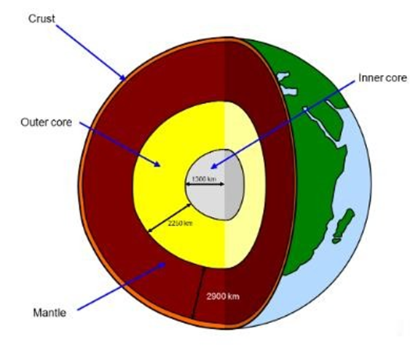

State the characteristics of the earth’s Core
- The innermost/central layer of the earth.
- Has 2 layers
- Outer Core
- Composed of very dense rocks
- Made up of nickel and iron
- Temperatures are up to 3700◦c.
- Inner Core
- A solid mass of mainly iron
- Temperatures are estimated to be 4500◦c to 5000◦c.

State the Composition of the Atmosphere
- Gases-exist as a mixture
- Smoke particles
- Dust particles
- Water vapour.

- a) Name the four main zones of the atmosphere
- Troposphere
- Stratosphere
- Mesosphere
- Thermosphere/ionosphere
- The table below shows rain fall and temperature in town x use it to answer the questions that follow
Months | JA | FE | MA | AP | MA | JUN | JUL | AU | SE | OC | NO | DE
Temp °C | 23 | 24 | 26 | 28 | 29 | 28 | 26 | 26 | 26 | 30 | 28 | 25
Rainfall mm | 3 | 0 | 3 | 1 | 18 | 500 | 720 | 408 | 300 | 70 | 15 | 0

- Calculate
- The total annual rainfall
Add all values for rainfall in all the months
Rainfall mm | 3+ | 0+ | 3+ | 1+ | 18+ | 500+ | 720+ | 408+ | 300+ | 70+ | 15+ | 0+

2038
- The mean monthly rainfall
Add all values for rainfall in all the months, then, divide by the number of months
Rainfall mm | 3+ | 0+ | 3+ | 1+ | 18+ | 500+ | 720+ | 408+ | 300+ | 70+ | 15+ | 0+

=$\frac{2038}{12}$

169.83
- The annual range of temperature
Differences between highest and lowest mean monthly temperature in year
30-23 = 7°C
- The mean annual temperature (2mks)
Mean annual temp = sum mean monthly temperature =319
12 12

=26.58°C
- Using the table indicate the following
- The wettest month
July
- The hottest month
October
- The coolest month
January
- What are the factors to be taken into account when sitting a weather station
- Open space-An open place where there is little obstruction of weather elements.
- Accessible place-Accessible place so that recording can be done easily.
- Gently sloping land-A fairly level or gently sloping ground (5◦) so that it’s easy to position weather instruments.
- Security-The place should have security.
- The place should provide a wide view of the surrounding landscape and the sky.
- The site should be free from flooding.

Write what element of weather they measure
- Thermometer- measures temperature
- Hygrometer- measures humidity
- Rain gauge-measures rainfall

- State the Factors influencing population distribution in Africa.
- Climate.
- Security.
- Soil.
- Presence of water.
- Transport and communication.
- Historical events.
- Conflicts.
- Growth of towns among others.

- A Grade 7 learners in a certain school obtained the following data showing monthly temperatures recorded in the nearby weather station. Create a simple bar graph using the information given
Month | Jan | Feb | Mar | Apr | May | Jun | Jul | Aug | Sep | Oct | Nov | Dec
Temp  0 C | 29 | 24 | 33 | 27 | 27 | 29 | 29 | 28 | 33 | 28 | 30 | 29
