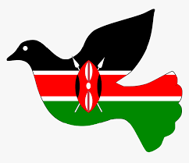
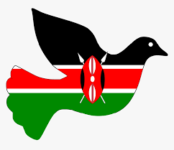

Grade 8
SOCIAL STUDIES

- Draw the map of Africa and shade the countries that were colonized by;
    - Belgian
    - British
    - French
    - German
    - Italians

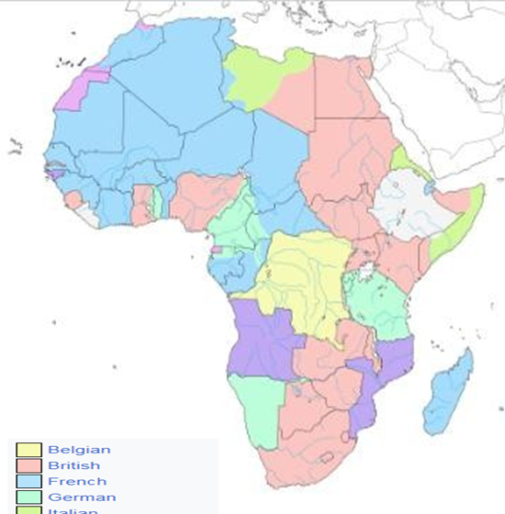

- State the Importance of the Constitution.
- Allows representation of the people in the parliament.
- Ensures justice is followed.
- It gives privilege of dual citizenship.
- It clearly states the rights and responsibilities of individuals.
- It outlines the structure and how resources should be shared equally.
- It spells out responsibilities of those in power hence promoting good governance.
- The National Values provided in the Constitution of Kenya.
- Patriotism.
- National unity.
- Rule of law.
- Equity.
- Inclusiveness-
- Social justice
- Equality-
- Integrity
- Human rights

Name two types of democracy.

Direct democracy
- His is a type of democracy that involves inclusion of citizens in the formulation of laws and government policies. The citizens have a strong influence on operations of government institutions.

  - Representative or indirect democracy.
- Citizens take part in governance of their own country indirectly through elected representatives. The representatives make decisions that reflect the will of the people.

Importance of Democracy in the society
- It allows us to elect leaders of our choice.
- It promotes freedom of speech, expression and association.
- It protects us from bad governance and leadership.
- Allows us to enjoy human rights in our society.
- It promotes rule of law in our society.

- Role of Citizens in democracy representation.

- Take part in vetting process of our leaders before allowing then to vie for elective seats or positions.
- Respect leaders elected through democratic process.
- Participate in voting. Ensure elected leaders have integrity, vision and a reputable development record.
- Citizens must put their elected leaders into account on what they do with public funds.
- Respect rule of law that given points to our electoral system and democratic process.
- Public participation in projects, policies and plans at various electoral representation levels.

Give Examples of human rights

- ✗ | - Rights to education. | - Right to vie for any political office.
- ✗ | - Right to proper housing. | - Right to join trade unions.
- ✗ | - Right to marry and have family. | - Right to clean water.
- ✗ | - Right to fair trial. | - Right to basic needs.
- ✗ | - Right to own property. | - Right to security.
- ✗ | - Right to employment. | - Right to vote.
- ✗ | - Right to access information and fair | - Right to medical care.
 | - application f law. | - Right to life.
- ✗ | - Right to participate in cultural life of
 | - choice.
- Human rights can be classified as?
- Social rights.
- Economic rights.
- Civil rights.
- Cultural rights.

- Describe the Characteristics of Human rights in the society.
- Non-discrimination- human beings should not be discriminated on the basis of colour, ethnicity, gender, race, age, religion, nationality or language.
- They are universal-human rights are the same in all member states of the United Nations.
- They are enforceable-human rights must be anchored in constitution f member states and be protected by the court of law.
- Immutable-human rights should not be taken away or changed by anyone.
- Equal -human rights are equal in status.

- The following ways can be used to promote equity and non-discrimination in the society.
- Providing food, shelter and caring for the orphans.
- Donating wheelchairs to physically challenged people.
- Ensuring laws that protect the women, disabled and other minorities are respected.
- Creating public awareness to support equity and non-discrimination through schools, media, support groups among others.

Describe the Factors that contributed to the presence of African Diasporas across the World.
- Trans-Atlantic trade.
- Refugees.
- Search for education opportunities.
- African seeking asylum due to political instability and community hostility.
- Search for employment opportunities.

- Africans in diaspora play an important role in the political development in Africa. Mention at least three roles
- They help formulate policies that improve the political environment in their home countries.
- They also help in voting during general elections.
- They help in funding political parties during elections.
- They protect political asylum in the diaspora.
- They help in pushing for political changes in countries that have leaders who abuse power.
- They provide funds to organizations that help in civic education

What were the Reasons for interconnectedness and interdependence among countries in the world?

- Trading.
- Technology.
- Tourism.
- Better medical care.
- Investments.
- Education.
- Employment.
- Peacekeeping missions.
- Sports reasons.
- State the Positive effects of globalization
- Improvement of the economy.
- Led to poverty reduction and general development of some countries.
- Creation of employment opportunities or jobs.
- There is greater access to technology due to sharing.
- There is cultural diversity due to ease in movement around the world. .
- Enable easy communication and flow of information around the world.
- Has enables importation of cheap and affordable goods.
- Has led to access to new talents.
- Led to access to new markets.

State the Negative effects of globalization include;
- Loss of cultural identity due to integration.
- Widens the gap between developed countries and the developing countries.
- It has led to collapsing of the local industries.
- Has led to unequal business growth.
- It has also led to job displacement where people involuntarily losses jobs due to closure of firms.
- Mention the Qualities of a global citizen in the modern society.

- Should understand other people and have empathy.
- Should act fairly in his or her choices and decisions.
- Believes that all people are equal.
- Accepts differences among people.
- Cooperatives with others.
- Should be curious and ants to know about others.
- Should be open minded and confident.
- Should be able to respect the universal human rights.
- Should conserve the environment.
- Believes in making positive changes in the world.
- Should advocate for peace in all areas.
- Should be adaptable and flexible to any global challenges

Global Governance.

- Match the logo to the organization.

AFRICAN UNION
COMMONWEALTH
UNITED NATIONS

- Who were the founders of OAU?

- Kwame Nkurumah from Ghana,
- Haille Selassie from Ethiopia,
- Julius Nyerere from Tanzania,
- Gamal Abdel Nasser from Egypt,
- Leopolld Sedar Senghor from Senegal and
- Ahmed Bella Ben from Algeria.

- Why was OAU formed?

- The OAU was formed to foster unity among African states. The aim was to identify ways of achieving political, economic and social freedoms from the colonialists.

- What were the Achievements of the Organization of African Unity (OAU) and African Union (AU)?

- It liberated countries such as Mozambique, Angola, South Africa, Namibia, Zimbabwe and Guinea Bissau from colonial rule.
- It has created Continental African Free Trade Area. (AFCFTA) which was endorsed at the AU summit in Niamey in 2021. The AFCFTA will be the world’s largest free trade area.
- It helped to secure over 1 billion Covid-19 doses from manufactures abroad to vaccinate the African population.
- It has promoted the use of African languages like Swahili in its official meeting.
- It assisted member states like Somali, Ethiopia and Eritrea resolve their border disputes.

- The union is divided into various organs that include;
- Assembly.
- Executive council.
- Commission.
- Permanent Representatives’ Committee.
- Peace and Security Council.
- Pan-African Parliament.
- Economic, Social and Cultural Council.
- Court of Justice.
- Specialized Technical Committee.
- Financial Institutions
- Mention the Challenges of the OF Organization of African Unity (OAU) and African Union (AU

- Terror groups inhibiting tourism.
- Diseases-related deaths.
- Ungovernable states due to political instability.
- Border disputes leading to deaths.
- Infrastructure challenges.

Mention the Principles of Leadership and integrity.

- Integrity.
- Honesty.
- Openness and Transparent.
- Accountability.
- Impartial.
- Selfless.
- Public participation.
- Competence and sustainability.
- Commitment.
- Participation and representation.
- Rule of law.
- Objectivity.
- State the Factors which promote Continental Interconnectedness and Interdependence
- Transport and network.
- Common infrastructure network such as roads, dams and sports.
- Health.
- Continental free trade area.
- Education.
- Agricultural programs.
- Music and art.

