COMPETENCE BASED CURRICULUM

JUNIOR SCHOOL

FORMATIVE ASSESSMENT

TERM ONE 2024

GRADE 8

Name……………………………………………………………….………………………………………………

Centre ………………………………………………………………………………….......................................

Assessment No. ……………………………………………………………… Stream………………………

Learner’s Sign……………………………………………………..… Date: ………………..…………………..

**SOCIAL STUDIES**

FOR EXAMINERS

ASSESSMENT RUBRICS (for official use)

|  |  |  |  |  |
| --- | --- | --- | --- | --- |
| %SCORE RANGE | Below 40 | 40-59 | 60-79 | 80-100 |
| PERFORMANCE LEVEL | Below expectation | Approaching expectations | Meeting expectations | Exceeding expectations |
|  | 1 | 2 | 3 | 4 |

#### Name the following ancient Egypt invention

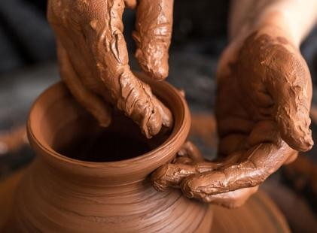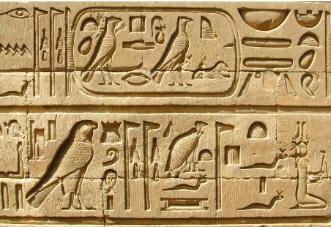

#### State three factors led to the growth of the Great Zimbabwe civilization. (3 mks)

1. …………………………………………………………………………………………
2. ………………………………………………………………………………………….
3. …………………………………………………………………………………………

##### Mention four contributions of early civilization to modern world.

1. ……………………………………………………………………………………
2. 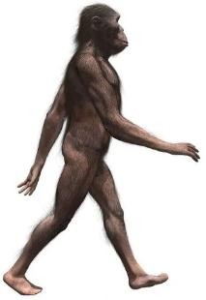…………………………………………………………………………………….
3. …………………………………………………………………………………….
4. …………………………………………………………………………………….

#### State three characteristics of Australopithecus. (3 mks)

* + 1. ……………………………………………………………………
    2. …………………………………………………………………..
    3. ……………………………………………………………………

#### State three characteristics of Homo sapiens.(3 mks)

1. ………………………………………………………………………….
2. ………………………………………………………………………….
3. ………………………………………………………………………….

#### Name four factors that led to the growth of kingdom of Kongo. (4 mks)

1. ………………………………………………………………………………
2. ……………………………………………………………………………….
3. ……………………………………………………………………………….
4. ………………………………………………………………………………..
5. Name the following person and item used by the Ogiek people. In the 19th century . (3 mks)



1. Describe the Social organization of the Zulu community up to 1900. (10mks)
2. …………………………………………………………………….…………………………
3. ………………………………………………………………………….…………………….
4. ………………………………………………………………………….…………………….
5. ………………………………………………………………………….…………………….
6. ………………………………………………………………………………………………..
7. Highlight the Social organization of the Asante community up to 1900 . (5 mks)
8. ………………………………………………………………………………………………
9. ………………………………………………………………………………………………
10. ………………………………………………………………………………………………
11. ………………………………………………………………………………………………
12. ……………………………………………………………………………………………..

# State three Personal characteristics that express a state of peace for mutual social well-being . (3 mks)

1. ………………………………..……………………………………….
2. …………………………………………..…………………………….
3. …………………………………………………………………………
4. There are different approaches that can promote inner peace for harmonious living. Name three. (3 mks)
5. …………………………………………………………………………………………
6. …………………………………………………………………………………………
7. …………………………………………………………………………………………
8. State four factors that led to development of the Indian Ocean Trade 15th Century
9. …………………………………………………………………………………………..
10. …………………………………………………………………………………………..
11. …………………………………………………………………………………………..
12. …………………………………………………………………………………………..
13. What are the Social Injustices committed on the Africans during the Indian Ocean Slave Trade in the 15th Century. (5 mks)
    * 1. …………………………………………………………………………………….
      2. …………………………………………………………………………………….
      3. …………………………………………………………………………………….
      4. …………………………………………………………………………………….
      5. …………………………………………………………………………………….
14. State five Factors influencing population distribution in Africa.(5 mks)
15. …………………………………………………………………………………
16. …………………………………………………………………………………
17. …………………………………………………………………………………
18. ………………………………………………………………………………….
19. ………………………………………………………………………………….
20. Data in the field can be collected in the following ways: namely?(4 mks)
    * + 1. …………………………………………….…………………………………..….
        2. ………………………………………………………………………………..…..
        3. ………………………………………………………………………………..……
        4. ………………………………………………………………………………….….
21. State three methods of recording data. (3 mks)
22. ……………………………………………………………………………………………
23. ……………………………………………………………………………………………
24. ……………………………………………………………………………………………
25. A Grade 8 learners in a certain school obtained the following data showing monthly temperatures recorded in the nearby weather station. Create a simple bar graph using the information given

|  |  |  |  |  |  |  |  |  |  |  |  |  |
| --- | --- | --- | --- | --- | --- | --- | --- | --- | --- | --- | --- | --- |
| Month | Jan | Feb | Mar | Apr | May | Jun | Jul | Aug | Sep | Oct | Nov | Dec |
| Temp  0 C | 29 | 24 | 33 | 27 | 27 | 29 | 29 | 28 | 33 | 28 | 30 | 29 |

1. What are the Challenges in carrying out Field study?(3 mks)
2. ………………………………………………………………………………………….
3. …………………………………………………………………………………………..
4. …………………………………………………………………………………………..

### What are the solutions to problems experience when carrying out Field study?(3 mks)

1. ……………………………………………………………………………………………
2. ……………………………………………………………………………………………
3. …………………………………………………………………………………………..
4. Name the Crops that were grown in the rift valley of East Africa, Egypt and Nubia(5 mks)
   1. ……………………………………………………………………….
   2. ………………………………………………………………………..
   3. ………………………………………………………………………..
   4. ………………………………………………………………………
   5. ………………………………………………………………………..
5. Name some Animals that were domesticated in the rift valley of East Africa, Egypt and Nubia:(5 mks)
6. …………………………………………………………………………………………………
7. …………………………………………………………………………………………………
8. …………………………………………………………………………………………………
9. …………………………………………………………………………………………………
10. …………………………………………………………………………………………………
11. Which Methods of irrigation used in ancient Egypt have been described below?( 2 mks)
12. The farmer collects water using a bucket or a vessel tied with a rope to one end of a long stick.
13. The stick was operated like a see-saw balancing with the weight on the other end.
14. The vessel was lowered into the river to collect water which was then poured onto the nearby farms.

#### …………………………………………………………………

1. When river Nile started flooding it brought silt along with it.
2. As the flood retreated, some water and silt was deposited in the surface.
3. The land was then tilled and cultivated.

……………………………………………………………………………….

1. Match the Methods of irrigation used in ancient Egypt. (3 mks)

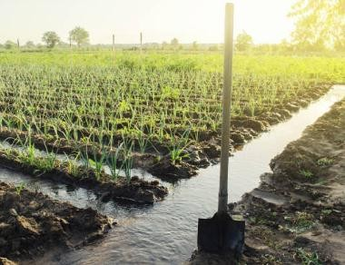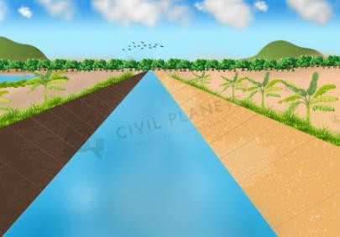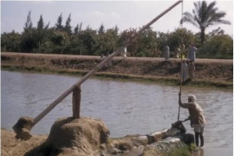

#### Canal irrigation Shadouf irrigation. Basin flooding irrigation

#### What are the uses of Money?(4 mks)

1. ………………………………………………………………………………….
2. ………………………………………………………………………………….
3. ………………………………………………………………………………….
4. ………………………………………………………………………………….
5. List some of the Sustainable ways of using resources available in the community.(4 mks)
6. …………………………………………………………………………
7. ………………………………………………………………………….
8. …………………………………………………………………………
9. …………………………………………………………………………
10. State five ways we can apply sustainable use of resources in our community. (5 mks)
11. ……………………………………………………………………………………………
12. ……………………………………………………………………………………………
13. ……………………………………………………………………………………………
14. ……………………………………………………………………………………………
15. …………………………………………………………………………………………….

THE END