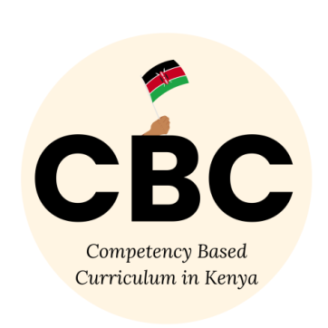

COMPETENCE BASED CURRICULUM

JUNIOR SCHOOL

FORMATIVE ASSESSMENT

TERM ONE 2024

GRADE 8

Name……………………………………………………………….………………………………………………

Centre ………………………………………………………………………………….......................................

Assessment No. ……………………………………………………………… Stream………………………

Learner’s Sign……………………………………………………..… Date: ………………..…………………..

**SOCIAL STUDIES**

1. State three Factors that led to the presence of Europeans in Africa. (3 mks)
2. To spread Christianity.
3. In search of raw materials for their industries in Europe.
4. Search for markets for their finished goods.
5. National pride and prestige.
6. For exploitation.
7. To spread European civilization.
8. State the countries colonized by the following colonial masters. (7 mks)

|  |  |
| --- | --- |
| Colonial  masters | Countries they colonized. |
| Britain | South Africa, Kenya, Nigeria, Ghana, Zimbabwe. |
| Belgium | Congo, Rwanda. |
| Portugal | Angola, Mozambique. |
| Germany | Namibia, Tanzania. |
| Italy. | Libya, |
| Spain. | Western Sahara, Equatorial Guinea, |
| France | Mauritania, Mali, Niger, Chad, Central African Republic, Ivory coast, Guinea Bissau, Algeria, Morocco, Burkina Faso, Tunisia, Madagascar.  Senegal, Burundi |

1. State four terms of the Berlin Conference of 1884-1885 on partitioning of Africa.(4 mks)
2. Congo, Niger and Zambezi rivers are free for navigation and commerce.
3. Declare the spheres of influence and colonies.
4. Solve any boundaries dispute through negotiations.
5. Ensure security of all Europeans in our colonies.
6. Name the countries marked UVWX

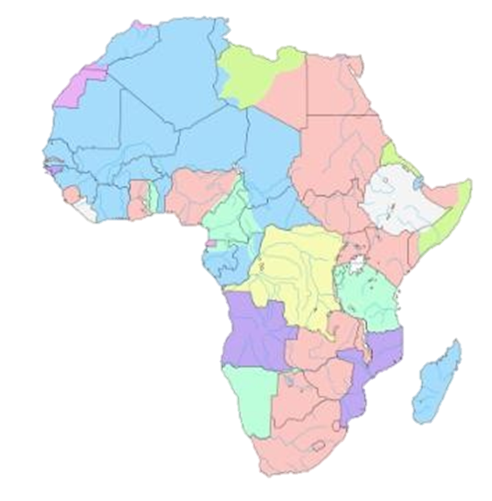

W

X

Z

Y

W-Egypt

X-Ethiopia

Y-South Africa

Z-Madagascar

1. State three Importance of the Constitution.(3 mks)
2. Allows representation of the people in the parliament.
3. Ensures justice is followed.
4. It gives privilege of dual citizenship.
5. It clearly states the rights and responsibilities of individuals.
6. It outlines the structure and how resources should be shared equally.
7. It spells out responsibilities of those in power hence promoting good governance.
8. State three National Values provided in the Constitution of Kenya.(3 mks)
9. Patriotism.
10. National unity.
11. Rule of law.
12. Equity.
13. Inclusiveness-
14. Social justice
15. Equality-
16. Integrity
17. Human rights

#### Name two types of democracy.(2 mks)

#### Direct democracy

* His is a type of democracy that involves inclusion of citizens in the formulation of laws and government policies. The citizens have a strong influence on operations of government institutions.
  + Representative or indirect democracy.
* Citizens take part in governance of their own country indirectly through elected representatives. The representatives make decisions that reflect the will of the people.

#### State three importance of Democracy in the society. (3 mks)

1. It allows us to elect leaders of our choice.
2. It promotes freedom of speech, expression and association.
3. It protects us from bad governance and leadership.
4. Allows us to enjoy human rights in our society.
5. It promotes rule of law in our society.
6. What is the Role of Citizens in democracy representation.(3 mks)
7. Take part in vetting process of our leaders before allowing then to vie for elective seats or positions.
8. Respect leaders elected through democratic process.
9. Participate in voting. Ensure elected leaders have integrity, vision and a reputable development record.
10. Citizens must put their elected leaders into account on what they do with public funds.
11. Respect rule of law that given points to our electoral system and democratic process.
12. Public participation in projects, policies and plans at various electoral representation levels.
13. List down four proofs that the earth is spherical
14. circumnavigation
15. Approaching ship
16. earth rotates from west to East
17. Eclipse of the moon
18. Earth curved horizon
19. All other planets are round
20. Identify the following parts of internal structure of the earth

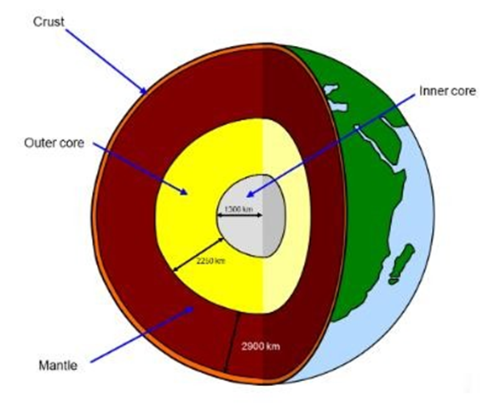

#### Give four Examples of human rights . (4 mks)

|  |  |  |
| --- | --- | --- |
| 1. ✗ | 1. Rights to education. | 1. Right to vie for any political office. |
| 1. ✗ | 1. Right to proper housing. | 1. Right to join trade unions. |
| 1. ✗ | 1. Right to marry and have family. | 1. Right to clean water. |
| 1. ✗ | 1. Right to fair trial. | 1. Right to basic needs. |
| 1. ✗ | 1. Right to own property. | 1. Right to security. |
| 1. ✗ | 1. Right to employment. | 1. Right to vote. |
| 1. ✗ | 1. Right to access information and fair application f law. | 1. Right to medical care. |
|  |  | 1. Right to life. |
| 1. ✗ | 1. Right to participate in cultural life of choice. |  |
|  |  |  |

1. Human rights can be classified as?(4 mks)
2. Social rights.
3. Economic rights.
4. Civil rights.
5. Cultural rights.
6. The following ways can be used to promote equity and non-discrimination in the society. Namely. (4 mks)
7. Providing food, shelter and caring for the orphans.
8. Donating wheelchairs to physically challenged people.
9. Ensuring laws that protect the women, disabled and other minorities are respected.
10. Creating public awareness to support equity and non-discrimination through schools, media, support groups among others.

#### Describe three factors that contributed to the presence of African Diasporas across the World. (3 mks)

1. Trans-Atlantic trade.
2. Refugees.
3. Search for education opportunities.
4. African seeking asylum due to political instability and community hostility.
5. Search for employment opportunities.
6. Africans in diaspora play an important role in the political development in Africa. Mention at least three roles. (3 mks)
7. They help formulate policies that improve the political environment in their home countries.
8. They also help in voting during general elections.
9. They help in funding political parties during elections.
10. They protect political asylum in the diaspora.
11. They help in pushing for political changes in countries that have leaders who abuse power.
12. They provide funds to organizations that help in civic education

#### What were the Reasons for interconnectedness and interdependence among countries in the world? (3 mks)

1. Trading.
2. Technology.
3. Tourism.
4. Better medical care.
5. Investments.
6. Education.
7. Employment.
8. Peacekeeping missions.
9. Sports reasons.
10. State three Positive effects of globalization. (3 mks)
11. Improvement of the economy.
12. Led to poverty reduction and general development of some countries.
13. Creation of employment opportunities or jobs.
14. There is greater access to technology due to sharing.
15. There is cultural diversity due to ease in movement around the world. .
16. Enable easy communication and flow of information around the world.
17. Has enables importation of cheap and affordable goods.
18. Has led to access to new talents.
19. Led to access to new markets.

##### State the Negative effects of globalization include;(4 mks)

1. Loss of cultural identity due to integration.
2. Widens the gap between developed countries and the developing countries.
3. It has led to collapsing of the local industries.
4. Has led to unequal business growth.
5. It has also led to job displacement where people involuntarily losses jobs due to closure of firms.
6. Mention three Qualities of a global citizen in the modern society.(3 mks)
7. Should understand other people and have empathy.
8. Should act fairly in his or her choices and decisions.
9. Believes that all people are equal.
10. Accepts differences among people.
11. Cooperatives with others.
12. Should be curious and ants to know about others.
13. Should be open minded and confident.
14. Should be able to respect the universal human rights.
15. Should conserve the environment.
16. Believes in making positive changes in the world.
17. Should advocate for peace in all areas.
18. Should be adaptable and flexible to any global challenges
19. Match the logo to the organization.(3 mks)

**AFRICAN UNION**

**COMMONWEALTH**

**UNITED NATIONS**

1. Who were the founders of OAU?(6 mks)
2. Kwame Nkurumah from Ghana,
3. Haille Selassie from Ethiopia,
4. Julius Nyerere from Tanzania,
5. Gamal Abdel Nasser from Egypt,
6. Leopolld Sedar Senghor from Senegal and
7. Ahmed Bella Ben from Algeria.

### Mention three Principles of Leadership and integrity.(3 mks)

1. Integrity.
2. Honesty.
3. Openness and Transparent.
4. Accountability.
5. Impartial.
6. Selfless.
7. Public participation.
8. Competence and sustainability.
9. Commitment.
10. Participation and representation.
11. What is?

Evolution is a natural process of gradual and continuous change of living organisms from a lower (simpler) state to a better-adapted (complex) and superior one.

#### Archaeological site or prehistoric site

* Is a place where human remains were found.

#### Archaeologists

* Are scientists who excavated the human remains for study

#### Fossils

* Refers to human remains.

#### 

1. What were characteristics of Ramapithecus. (3 mks)
2. also called kenyapithecus
3. He was manlike.
4. He had small canines.
5. He was quadrupedal (he moved on his four limbs), though he occasionally walked on two legs
6. Match the following stages of man correctly



RAMAPITHECUS

 HOMOHABILIS



ZINJENTHROPUS