COMPETENCE BASED CURRICULUM

JUNIOR SCHOOL

FORMATIVE ASSESSMENT

TERM ONE 2024

GRADE 8

MARKING SCHEME

**SOCIAL STUDIES**

#### Name the following ancient Egypt invention

Calendars

Pyramids

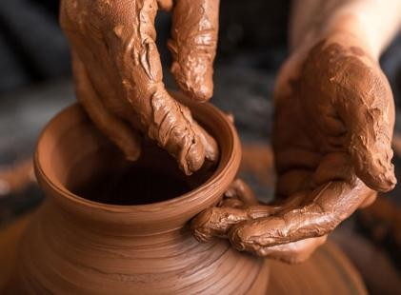

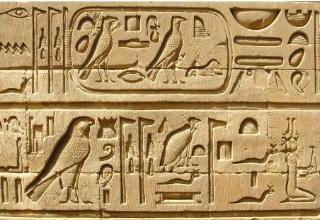

Hierographics

Potters wheel

#### State three factors led to the growth of the Great Zimbabwe civilization. (3 mks)

1. Agriculture-this ensured steady supply of food for the kingdom.
2. Trade- acquisition of firearms in exchange of goods boosted their strong army.
3. Existence of several minerals deposits.-presence of large deposits of minerals such as gold, copper and iron was good for the economy.
4. Centralized government & Strong leadership-the great Zimbabwe had hereditary kings which made it stable.
5. Strong and stable army-this helped protect the kingdom.
6. Fertile soil and good climate- this were favourable factors that promoted agriculture.
7. Religion- Religious beliefs brought them together. The traditional God called Mwari
8. helped unify the kingdom.

##### Mention four contributions of early civilisation to modern world.

1. Religion was practiced in different communities in the past. This has developed over time shaping our spiritual beliefs and worship. Different religions are practiced in different countries.
2. Writing- the Egyptians hieroglyphics inventions resulted in the modern writing paper industries also developed and were used to keep records developed into the modern writing and education.
3. Ancient Egypt was the beginning of building designs and construction of permanent buildings we have today.
4. The knowledge of planning and prediction of seasons based on calendar started in the early civilisation. Today it has been developed further to include weather forecasting in predicting accurate changes.
5. The industrial development in the ancient kingdoms was based on simple skill. Copper and tin were used in ancient Egypt to make items. Today most of the industries use metals and alloys to make construction and infrastructural equipment.
6. The modern irrigation technology borrows a lot from the ancient irrigation techniques such as shadoof. This has been applied in the agricultural sector
7. Tools such as jembes/hoes used in farming today were developed in the ancient civilization
8. The political structure of modern government resembles the early civilisation government

#### State three characteristics of Australopithecus. (3 mks)

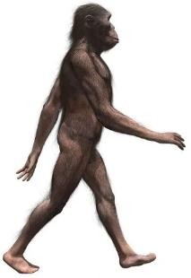

Also called southern ape/zinjathropus

* + 1. He was the earliest most manlike hominid.
    2. He had a pelvis and leg that were similar to modern man’s.
    3. He was bipedal (walked on two limbs).
    4. Could defend themselves.
    5. Could attack their enemies.
    6. Could see or sense impending danger from a distance.
    7. Could grasp objects with ease.
    8. May have been hairy, short and strong.
    9. Had a large face and low forehead.
    10. Had stereoscopic vision.
    11. Had much larger teeth, skull and jaws.
    12. His brain was smaller than modern man’s, but larger than that of the most intelligent ape: the Gorilla.

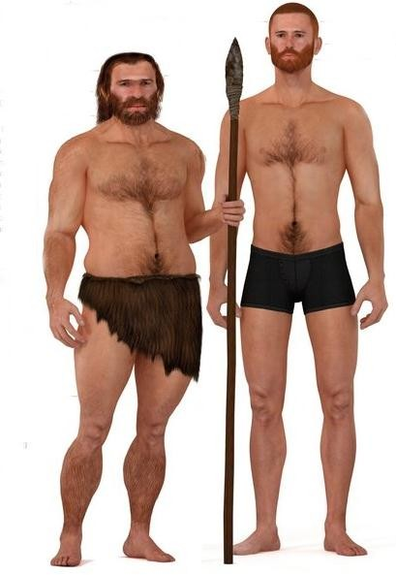

#### State three characteristics of Homo sapiens.(3 mks)

1. He was under six feet tall
2. He had small teeth.
3. He had a steep and well-rounded forehead.
4. He had long straight legs.
5. He made a variety of more refined tools i.e. microliths.
6. He was a fisherman and hunter-gatherer.
7. He domesticated plants and animals.

#### Name four factors that led to the growth of kingdom of Kongo. (4 mks)

1. Strategic location of the kingdom.
2. Economic prosperity of the kingdom.
3. Trading amongst people of Kongo.
4. Presence of traditional industries in Kongo.
5. The political stability of the industries of Kongo.
6. The coming of the Portuguese.
7. The Christianity factor.
8. Favourable climate and the kingdom its closeness to Congo river which supported agriculture throughout the year
9. Name the following person and item used by the Ogiek people. In the 19th century . (3 mks)

  

Ogiek Hunter Ogiek Honey Pot Ogiek Bee Hive

1. Describe the Social organisation of the Zulu community up to 1900. (10mks)
2. Zulu are Nguni people, bantu speaking in south Africa.
3. They occupy Kwazulu natal province in South africa
4. In the Ngumi languages izulu means heaven or weather
5. The zulu clans referred to as the isizwe
6. The zulu society was organised into parilineal sibs. The sibs were further divide into lineages which were composed of descendants of a common ancestor
7. Most households comprised extended families who lived in one household called kraal
8. Men inherited everything. Inheritance was patrilineal
9. The zulu people were polygamous. Men married many wives and lived with them with the extended family in the kraal.
10. Men paid dowry in terms of cows and gifts during the weeding day umabo
11. The zulu community believed in Umhlanga or Reeds dance ceremony
12. Beadwork was a prominent attire that worn at the Umahlanga
13. Beadworks was a sign of communication
14. It also symbolized wealth status of a person
15. Zulu believed in one God called unkulunkulu
16. The controlled day to day human life of the Zulu community
17. The Zulu had traditional medicine men who treated the sick.
18. Highlight the Social organization of the Asante community up to 1900 . (5 mks)
19. Asante are Akan speaking people
20. They live in the central part of the Modern day Ghana
21. Are organized into clans which is headed by a chief
22. Each clan speaks its own dialect of the Aken language
23. They believe in one supreme creator called Nyame
24. Ancestors were believed to connect people to Nyame
25. Asante empire leader was called Asantehene
26. He also acted as a spiritual leader
27. Omamhene and chiefs were all religious leaders who presided over religious ceremonies
28. Golden stool was th symbol of national unity in the Asante empire
29. It symbolized ones and authority from the Asantehene
30. It was based in Kumasi, the capital of Asante empire
31. Odwira festival was an annual ceremony
32. They believed in the spirits of the departed rulers
33. Asante were socially stratified into 5 main divisions
34. 1st division – king and those close to the king
35. Lived in the capital of Kumasi
36. Were wealthy and lived in luxury
37. 2nd division – consisted of the chiefs and top officials who assisted the king in enforcing law and order
38. 3rd division – those who had acquired a lot of wealth hence respect in the society
39. 4th division – comprised of ordinary farmers, traders and fishermen
40. 5th division – the lowest class was for the slaves
41. Asante families were extended and matrilineal – mother’s brother was the legal guardian of her children
42. Asante were experts in form of decoration, logos, arts, sculture and pottery
43. These were known as Adinkra symbols

# State three Personal characteristics that express a state of peace for mutual social well-being . (3 mks)

1. Forgiveness.
2. Self-discipline.
3. Positive attitude.
4. Loving.
5. Calmness.
6. Loyalty and honesty.
7. There are different approaches that can promote inner peace for harmonious living. Name three. (3 mks)
8. Developing your understanding on how to promote your inner peace through minding for example, charging perception about people.
9. Develop your understanding about emotions and conflict. For example, anger and fear.
10. Pay attention to how communication reduces conflict.
11. Get guidance from role models. (Mentors.)
12. Engage in activities such as sports, yoga, reading and meditation.
13. State four factors that led to development of the Indian Ocean Trade 15th Century
14. Availability of slaves- they were commodities for the trade.
15. Long distance traders- they included Akamba and Nyamwezi who helped in ferrying fellow African as slaves.
16. Accessibility of East African coast by sea- this helped in shipping the slaves across the Indian Ocean.
17. Existence of the monsoon winds- it helped in aiding movement of ships carrying slaves.
18. Peace and political stability in the coastal city- it gave the traders peaceful environment to do the slave business.
19. Collaborating of African chiefs- such as Mirambo and Kivoi welcomed Traders in their territories. They exchanged slaves for other goods.
20. Advancement of the ship building industry in Europe and natural harbour
21. What are the Social Injustices committed on the Africans during the Indian Ocean Slave Trade in the 15th Century. (5 mks)
    * 1. Long hours without food.
      2. Death.
      3. Fatigue.
      4. Slaves were ferried in ships for long distances.
      5. Whipping.
      6. Legs and hands chained during the long distances from villages to coastal towns.
      7. Harsh climate.
22. State five Factors influencing population distribution in Africa.(5 mks)
23. Climate.
24. Security.
25. Soil.
26. Presence of water.
27. Transport and communication.
28. Historical events.
29. Conflicts.
30. Growth of towns among others.
31. Data in the field can be collected in the following ways: namely?(4 mks)
    * + 1. Use of questionnaires.
        2. Interviews.
        3. Sampling.
        4. Observation.
        5. Experimentation.
32. State three methods of recording data. (3 mks)
33. Mapping-drawing a map of the area of research.
34. Filling in the questionnaire-filling the blank spaces that have been left in a questionnaire.
35. Tabulating-filling climatic data in already prepared series of columns and rows.
36. Tallying-recording counts to ensure that they are accurate by using vertical strokes.
37. Tape recording-using an audio tape to get the exact words spoken by the respondent.

##### Field sketching-

1. Taking photographs-using a camera to capture what is seen in the field.
2. Note-taking-using a pen and a book to record what you are seeing and hearing.
3. Labelling samples-
4. A Grade 8 learners in a certain school obtained the following data showing monthly temperatures recorded in the nearby weather station. Create a simple bar graph using the information given

|  |  |  |  |  |  |  |  |  |  |  |  |  |
| --- | --- | --- | --- | --- | --- | --- | --- | --- | --- | --- | --- | --- |
| Month | Jan | Feb | Mar | Apr | May | Jun | Jul | Aug | Sep | Oct | Nov | Dec |
| Temp  0 C | 29 | 24 | 33 | 27 | 27 | 29 | 29 | 28 | 33 | 28 | 30 | 29 |

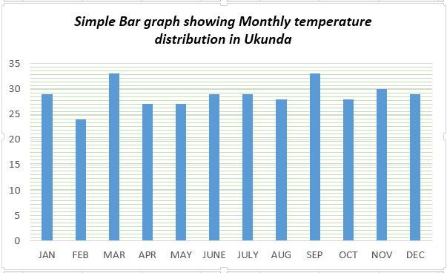

1. What are the Challenges in carrying out Field study?(3 mks)
2. Language barrier.
3. Inaccessibility due to thick vegetation, steep slopes and muddy areas.
4. Poor roads network.
5. Environmental challenges such as weather elements which include heavy rainfall or high temperatures.
6. Attack by wild animals.
7. Uncooperative respondents.
8. Accidents in the field.

### What are the solutions to problems experience when carrying out Field study?(3 mks)

* 1. Carry out a pre-visit to identify the challenges of the field study earlier before the field study.

1. Use of language translators in interviews and questionnaires.
2. Carrying out field study in appropriate climatic periods i.e. during the dry season.
3. Name the Crops that were grown in the rift valley of East Africa, Egypt and Nubia(5 mks)

1. ***Rice.***
2. ***Flax.***
3. ***Barley.***
4. ***Wheat.***
5. ***Cotton.***
6. ***Sorghum.***
7. **Fruits.**
8. **Beans.**
9. **Vegetables.**
10. **Cucumber.**
11. **Onions.**
12. **Lentils.**
13. ***Dates.***
14. ***Figs.***
15. ***Henna.***
16. ***Grapes.***
17. ***Finger millet.***
18. Name some Animals that were domesticated in the rift valley of East Africa, Egypt and Nubia:(5 mks)

##### Caprines.

1. Cattle.
2. Sheep.
3. Goats.
4. Donkey.

##### Poultry.

1. Bees.
2. Which Methods of irrigation used in ancient Egypt have been described below?( 2 mks)
3. The farmer collects water using a bucket or a vessel tied with a rope to one end of a long stick.
4. The stick was operated like a see-saw balancing with the weight on the other end.
5. The vessel was lowered into the river to collect water which was then poured onto the nearby farms.

#### Shadow irrigation.

1. When river Nile started flooding it brought silt along with it.
2. As the flood retreated, some water and silt was deposited in the surface.
3. The land was then tilled and cultivated.

Basin flooding irrigation.

1. Match the Methods of irrigation used in ancient Egypt. (3 mks)

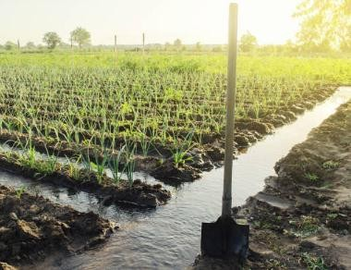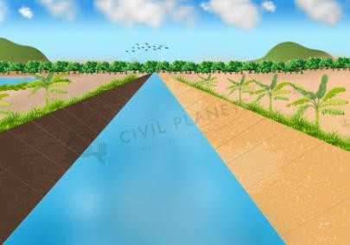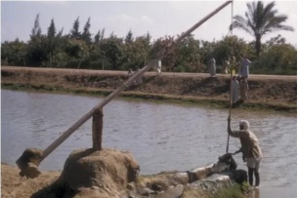

#### Canal irrigation Shadouf irrigation. Basin flooding irrigation

#### What are the uses of Money?(4 mks)

1. Money serves as a medium of exchange and people use money to pay for goods and services.
2. Money serves as a store of value. You do not need to spend it immediately because it will still hold its value the next day or year.
3. Money serves as a unit of account, which means that it is used to measure and record financial transactions or buying and selling of goods and services.
4. Money serves as a means of transfer of immobile properties. One can sell or buy immovable properties such as land by use of money.
5. List some of the Sustainable ways of using resources available in the community.(4 mks)
6. Use of geothermal energy.
7. Use of wind energy.
8. Use of wind energy.
9. Recycling, reducing and reusing waste.
10. Use of solar energy.
11. Planting trees in our environment.
12. Using manure instead of fertiliser and chemicals in farming.
13. Protecting endangered species.
14. State five ways we can apply sustainable use of resources in our community. (5 mks)
15. Collecting plastic bottles and using them to make trashcan bins.
16. Participate in tree planting sessions at home, school.
17. Creating posters that promote sustainable ways of using resources.
18. Sensitizing the community on the importance of sustainable use of resources.
19. Taking part in waste collection around the school and sorting them into recyclable, reusable and reducible.
20. Prepare composts pits where wastes will be disposed.
21. Encourage use of compost manure to enrich soil and reduce or do away with use of fertilisers and chemicals in farming.

The end