AGRICULTURE & NUTRITION GRADE 8 NOTES – TERM 1

STRAND 1-CONSERVING AGRICULTURAL ENVIRONMENT.
1.1-Soil Conservation Measures. Soil conservation measures refers to a combination of practices done or taken to prevent the loss of soil through soil erosion.

Reasons/Importance for Soil conservation.
- To keep top soil in its place.
- To maintain fertility in the soil.
- To maintain soil productivity.
- Helps to increase agricultural production promotes food security.

Methods of soil conservation in agricultural environment.
- Strip cropping.
- Grassed water ways.
- Stone lines.
- Trash lines.
- Soil bunds.

Strip cropping.
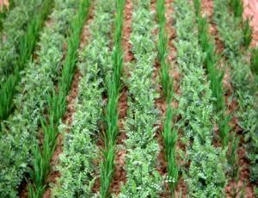

- It is the growing of crops in a way that crops that have little soil cover like maize are grown in alternating strips with those that have good ground cover such as sweet potatoes.
- Permanent vegetations such as grass can also be used as strips.
- The role of strip crop is it prevents loss of soil through surface runoff.

Grassed water ways.
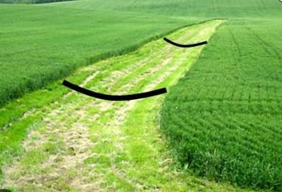
- Grassed waterways are natural or man-made shallow channels in which excess rain water flows.
- Grass and other vegetations are planted to grow in the channels.
- When surface run off is directed in the channels, the vegetation in the channels lower the speed of run off and also traps eroded soil.


Stone lines.
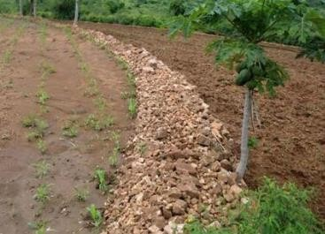
- These are stones (of different sizes) heaped in a line along the contour to prevent loss of soil down the slope through run off.
- Stone lines reduce speed of run off increasing water infiltration especially in semi-arid areas. Water infiltration is the downward entry of water into the soil from the surface.
- Stone lines are suitable in gently slopes.

Trash lines.
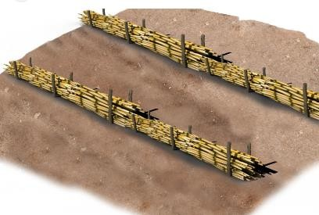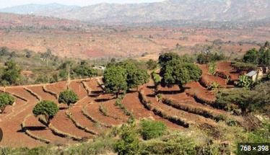

- Trash lines are plant materials or crop residues(remains) arranged along the contour in a cultivated field.
- Trash lines help to reduce runoff hence preventing loss of soil from land.
- They also increase water infiltration into the soil.
- Trash line should be 1 m wide and 0.5 m high.

Soil bunds.
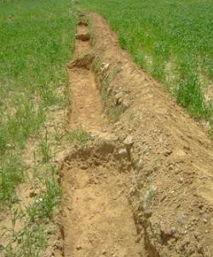
- A bund refers to a heap of compacted soil made along the contours.
- Grasses can be grown on top of the bunds to hold soil together firmly.
- Bunds help to reduce the volume of water flowing downwards in a cultivated field after rain fall.
- Bunds enhance water infiltration.
NOTE:
⭸ Most structures constructed to conserve the soil are made along the contour line.
Therefore, it is very important to establish the contour lines first before construction of the structures.
⭸ Contour lines are established to guide the position of the soil conservation measures.
⭸ Contour farming is the farming carried out across the slope rather than up and down.
Therefore, contour lines run across the slope and not up and down.

A model of the Farm Layout.
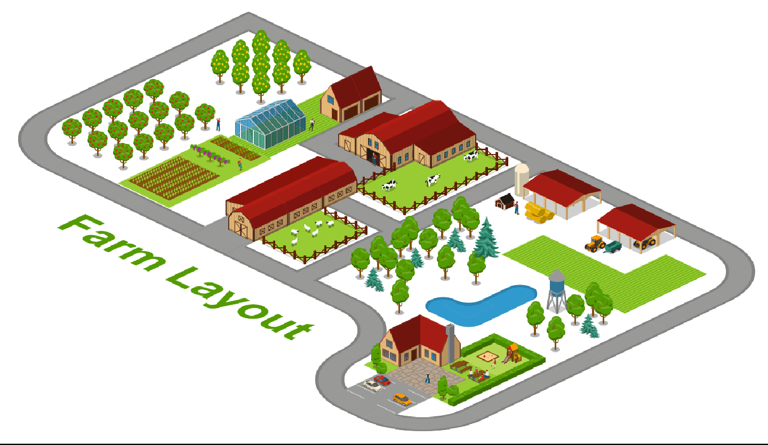
- A farm layout is a drawn plan that shows various farm enterprises and where they are placed in the farm.
- A farm layout is a plan of how various farm components (enterprises) are arranged and set up on the farm.
- A farm model guides the farmer to locate various farm activities and structures for convenience.

What is the importance of Farm layout?
- It helps in maximum utilization (use) of land.
- Farm enterprise are orderly arranged.

Local available material that can be used to make a farm model in school include:
- Cartons.
- Cardboards.
- Soil.
- Papier mache.
1.2-Water Harvesting and Storage
- In rainy season, a lot of water goes in waste.
- This water can be harvested and stored then used for farming purposes.

Methods of harvesting and storing water for farming purposes.
- There are various methods used to harvest and store water for farming purposes.
  - Use of rooftops.
  - Use of diversion channels. (Directs water into water ponds and water tanks.)
  - Water ponds.
  - Shallow water pans.
  - Tanks.

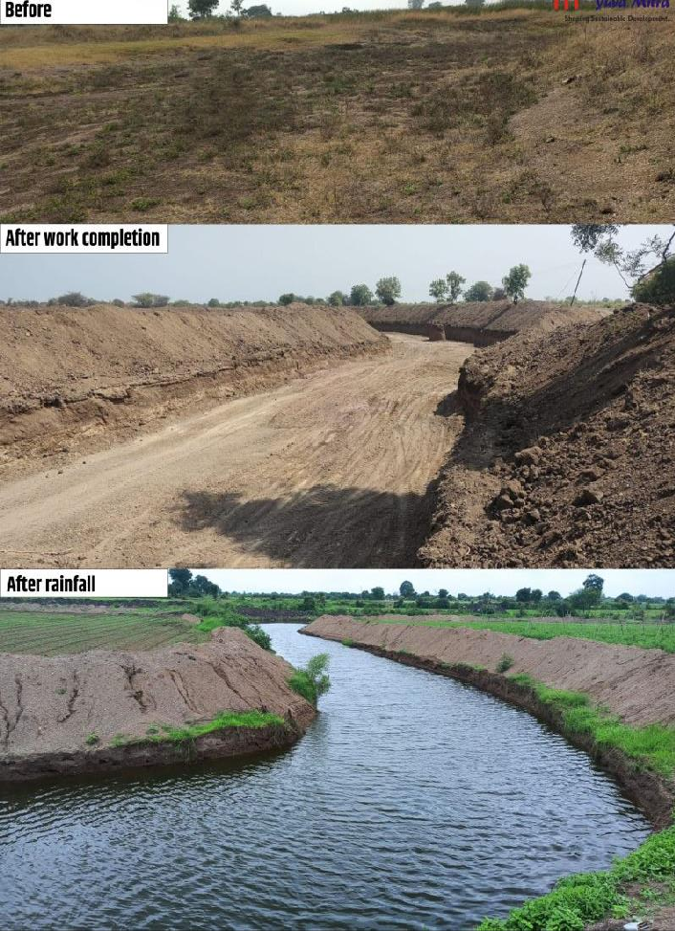
roof

Diversion channel constructed to direct water to storage areas

Shallow water pans
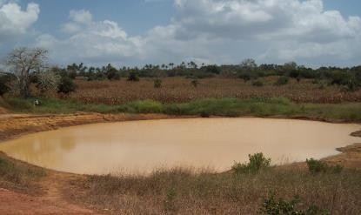

Water pond

Grass should be planted around the shallow water pan to:
- Control soil erosion.
- Control sedimentation.

Constructing Shallow water pan.
- Measure desired size of the structure.
- Dig out soil to the desired length and width with depth between 1 to 3 metres.
- Make conveyor or small channels that directs surface runoff to the structure.

Construction of a water pond.
  - Mark desired measurements on ground.
  - Dig out the soil.
  - Place a polythene liner evenly covering the sides and the base.
  - Reinforce the liner by placing soil in the upper part around the pond.
  - Plant grass around the pond to control erosion and sedimentation.
  - Make channels to transfer surface runoff.

Water tanks.
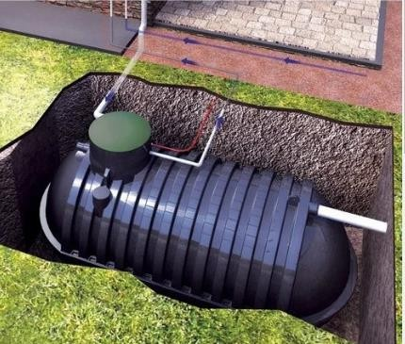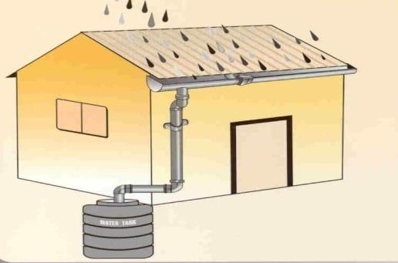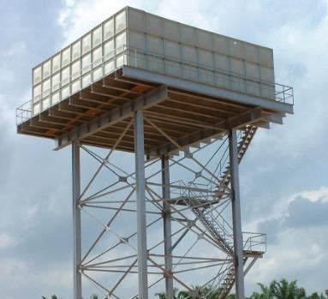
Gutter
Underground water tank Elevated water tank
  - Water tanks can be used to collect surface runoff or water from the rooftops.
  - Ensure water flow into the tank by removing any materials such as gravel, sediments from the sieve entrance of the tank.

  - Gutters should be fixed around the house to collect water when it rains and direct it to the tank through pipes for storage.

Factors to consider when setting up a water harvesting and storage unit at home or at school.
  - Location.
  - Accessibility.
  - Type of crop to be irrigated using water.
  - Size of the farm.
  - Dimension of the storage unit.
  - The slope of the land.
  - The cost of the work.

Importance of harvesting and storing water.
- Harvesting and storing water helps to supplement other sources of water.
- It provides water during shortage and in dry seasons.
- Water is available through out.
- Reduces cost of farming.
- Excess water from the rain is utilized.
- Helps to prevent destruction of infrastructures such as buildings and roads by surface runoff.

Maintenance of water harvesting and storage structures.
  - Plant grass around the water pans and water ponds to control soil erosion and sedimentation and to stabilize the embankments.
  - Remove foreign material in water found in water pans, ponds and tanks.
  - Structures such as water pans and water pons should be fenced.
  - Water tanks should be cleaned and foreign materials such as gravel, twigs, leaves sieved out during water entry.
  - Clean the gutters to remove accumulated materials.

Uses of water harvested and stored on the farm.
Watering/irrigating crops. Watering animals.
Domestic uses such as washing, cleaning items etc.

Types of water storage tanks.
- Water tanks can be:
  - Plastic.
  - Metallic.
  - Concrete.
- They can also be elevated (placed on top of the ground) or underground.

STRAND 2- FOOD PRODUCTION PROCESSES
2.1 Kitchen and Backyard Gardening.
✰ Food security is an important aspect of a healthy society.
✰ To promote food security, household should embrace kitchen gardens.
✰ A kitchen garden ensures regular and ready supply of fresh vegetables, fruits and herbs.
✰ Food security exists only when all people at all times have access to sufficient, safe and nutritious food that meets their dietary needs and food preference for healthy living.
✰ Kitchen garden is any convenient size of a plot, space or structure located in a home where a variety of crops are grown mainly for family consumption.

The role of a kitchen garden in food and nutrition security.
⮑ To produce safe, fresh food that is accessible to the family.
⮑ It is a reliable source of green leafy vegetables, herbs, fruits, legumes and cereals for home consumption.
⮑ Growing of both seasonal and off-season crops that ensures steady supply of nutritious food.
⮑ Help family to meet their nutritional needs and promotes healthier lifestyles.
⮑ Generates income from sale of surplus (excess) produce.
⮑ Helps to save family income direct towards purchase of vegetables, fruits and others.
⮑ Provide alternative when staple foods are not in stock.
⮑ Helps to increase food production.
⮑ Some form of kitchen gardening use recycled materials like plastics hence contributes to environmental conservation.

Innovative technologies for kitchen garden.
- Increase in population and urbanization has led to limited space that can be used to establish large gardens.
- Innovative technologies ensure proper use of the small available space for maximum production.
- The main aim of innovative gardening is to maximize the small available space with proper water conservation, measures in crop production.

Examples of innovative kitchen gardens include:
✰ Container.
✰ Wick.
✰ Hanging pots.
✰ Tyre.
✰ Multistore gardens.
✰ Simple drip.
✰ Organic sack garden.
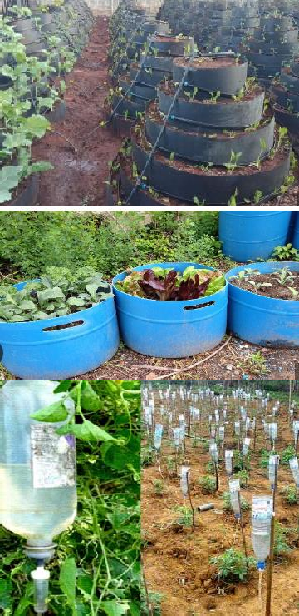
- Most of the kitchen gardens focus on vertical gardens which keeps the crops off the ground as compared to horizontal gardening.
Multi-storey garden | Involves filling a bag, sack or container with soil and manure the planting vegetables on the top or sides, it requires little space.
Container garden. | Done by planting crops in a container such as earthen pots, wooden boxes and plastic containers. The garden is not appropriate for deep rooted crops.
Simple drip garden | An innovative technology which involves use of plastic bottles and jerricans. It involves use of two containers, one filled with soil and manure in which crops are planted while the other is placed directly above the first container and filled with water, tiny holes are made at the bottom to allow water to drip.
Wick garden | A modern technology of using underground irrigation system. Crops are planted in a container which is placed on another container filled with water.  A wick connecting the bottom container with top container draws water up feeding the crops at the top. This technology is suitable for areas with little space | 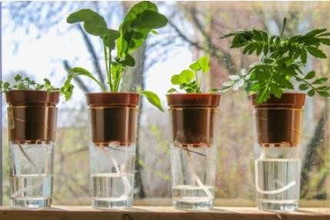

Benefits of innovative gardens.
 Use locally available materials.
 Requires little amount of water.
 Easy to manage because less labour is required.
 Makes good use of little space.
 Some are portable-can be moved from one area to another.
 High productivity or yields.
 Aesthetic value around the compound.
 Ideal for urban areas and congested homesteads.
2.2 Poultry Rearing in a Fold.
Poultry rearing is the keeping of domesticated birds such as chicken, ducks, turkeys, geese,
pigeons, guinea fowls and ostriches.
Poultry are kept for production of meat, eggs and other products.

Poultry folds. Structural appearance of a poultry fold.
A fold is a portable structure used for rearing poultry in an open piece of land where they can access sunlight, vegetation to supplement their feeds and can also exercise.
Feed and water troughs are placed inside the folds.
The fold can be moved from one place to another for the birds to eat fresh vegetation. Poultry folds are portable triangular shaped structures.
A fold has two sections, one is roofed and the other is left open but fitted wih wire mesh to secure the birds.
The fold has a door fitted on one side.
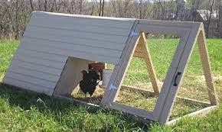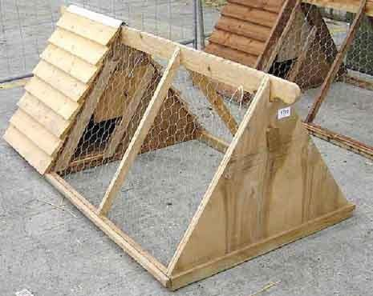

Materials used in the Construction of a poultry fold.
Poultry folds are constructed using locally available materials. This makes it cheap and easy to construct them.
Materials for constructing a poultry fold include:

⭸ Wire mesh.
⭸ Fencing staples
⭸ Reused and recycled wires.
⭸ Plastic materials.
⭸ Wood materials.
⭸ Nails.
⭸ Claw hammer.

NOTE:
Smaller folds have rollers and wheels that helps to move them from place to place.
Some folds structures have wire mesh at the base to allow droppings to pass through to the ground.
Fencing staples can be used instead of nails.
The size of the fold depends on the number and type of poultry reared.

Rearing practices of poultry in a fold.
There are various practices which are carried out when rearing poultry in a fold.

These rearing practices includes:
∼ Moving the fold to new sites regularly for the birds to feed on fresh vegetation.
∼ Ensure birds are provided with clean water.
∼ Ensure hygiene is maintained in the poultry fold.
∼ The fold should be strong enough to secure birds and kept in a safe place.
∼ The fold should be sheltered from the rain to avoid wetness. It should be placed in such a way that the open side is away from direct winds to avoid drought.

How to rear Poultry in a fold.
✗ Sitting. (where to place your fold) Ensure the fold is placed in an area:
∼ Protected from rain and direct wind.
∼ With enough security.
∼ That can be easily accessible.
∼ With enough vegetation.

✗ Stocking the folds.
∼ Place chicks into the fold carefully in the early hours of the day for them to familiarize with the environment.
∼ Place the right number of birds in the fold to avoid overcrowding which encourages diseases.

✗ Feeding.
∼ Provide enough feed depending on the stages of growth.
∼ Place feed in the feeding troughs.
∼ Move fold unit from one place to another to enable birds to eat fresh vegetation.

✗ Watering.
∼ Provide clean water in waterers.

✗ Sanitation.
∼ Maintain high standards of hygiene in the folds by cleaning the waterer, feed troughs and poultry folds.

✗ Vaccination.
∼ Provide poultry vaccinations to prevent poultry diseases. Ensure vaccines are provided at the correct time using the right means.
2.3 Crop Pests and Disease Control.

Vegetables crops attacked by pest and diseases.
Vegetables are usually attacked by various pests and diseases that eventually affects their growth and productivity.

Identification of vegetables crops attacked by pests.
We can identify various vegetables attacked by crop pests through the following:
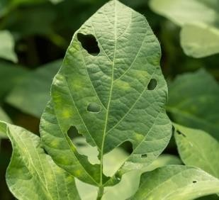
⭸ Punctured leaves – vegetables have leaves that are
damaged and have holes in them. This indicates the vegetables are attacked by pests.

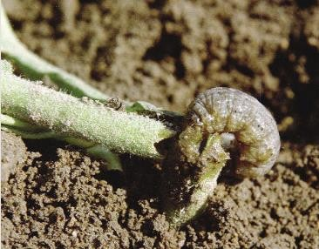
⭸ Cut-off seedlings – vegetables damaged by pests also have seedling that are cut off and fall.

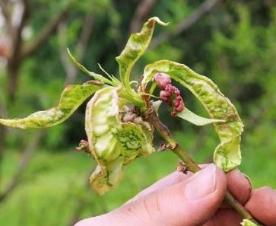
⭸ Curling leaves – leaves shrink and reduce in size because of pests sucking.
⭸ Holes made in vegetable fruits – pests bore holes in vegetable fruits such as tomatoes. This reduce quality and yields.
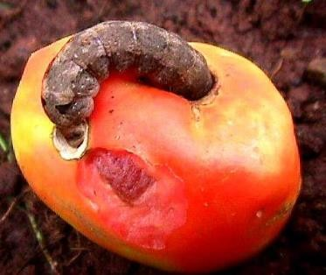

⭸ Fruits appear rotten and fall prematurely – vegetables attacked by pests also indicate rottenness in some areas such as fruits.
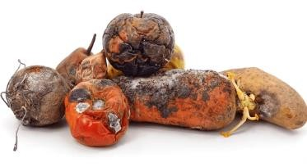
⭸ Presence of pests on vegetable parts- vegetables that are attacked by pest show presence of the pests on them
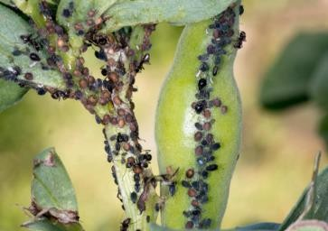

Identification of vegetables crops attacked by diseases.
We can identify various vegetables attacked by diseases through the following:
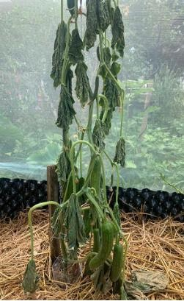
⭸ Wilting plants-plants appear to have lost water even in times of wet season.

Wilted plant- leaves appear to have lost water and droops down.

⭸ Presence of black and brown spots.
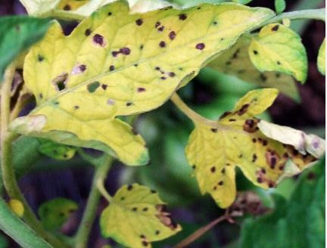

⭸ Rotting of plant parts
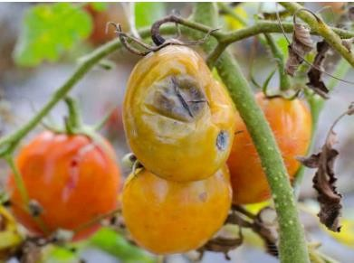

Control of pests and diseases on vegetables crops
The following can help to control pests in vegetable crops.
- Handpicking-pests are removed by hands.
- Removing affected plants parts-affected plant parts should be removed to prevent spread of pests to other plant parts.
- Uprooting heavily affected crops-uprooting heavily affected plants stops spread of pests in the farm.
- Applying natural pesticides such as ashes-some natural pesticide such as ashes help to prevent attack of pests.

The following can be done to control diseases in vegetable crops.
- Removing affected plant parts.
- Uproot heavily affected crops.

