COMPETENCE BASED CURRICULUM
JUNIOR SCHOOL
FORMATIVE ASSESSMENT
TERM ONE 2024
GRADE 8

Name…………………………………………….………………………………………………
Centre ………………………………………………………………….......................................
Assessment No. ……………………………………………… Stream………………………
Learner’s Sign…………………………………..… Date: ………………..…………………..
PRETECHNICAL STUDIES
FOR EXAMINERS

ASSESSMENT RUBRICS (for official use)
%SCORE RANGE | Below 40 | 40-59 | 60-79 | 80-100
PERFORMANCE LEVEL | Below expectation | Approaching expectations | Meeting expectations | Exceeding expectations
 | 1 | 2 | 3 | 4

- Name the following input devices. (4 mks)
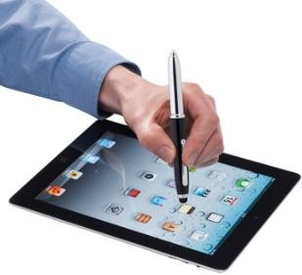
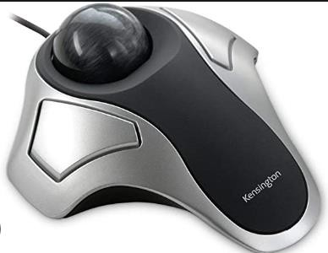

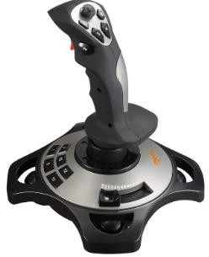

Name two components of pre-technical studies. (2 mks)

……………………………………………………….

……………………………………………………….

State four Importance of safety in a work environment. (4 mks)
- …………………………………………………………………………
- …………………………………………………………………………
- …………………………………………………………………………
- …………………………………………………………………………
- Name the following storage devices. (2 mks)
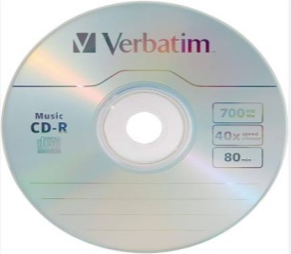
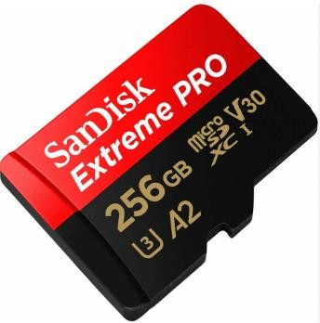

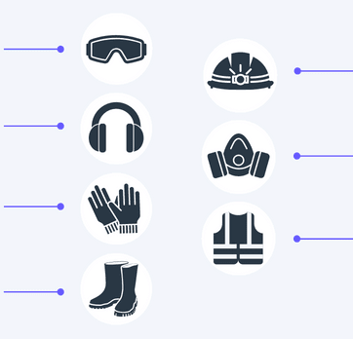

- Name the following safety wears. (7 mks)

State five Causes of fire in a work environment. (5 mks)
- ……………………………………………………………………..
- ………………………………………………………………………
- ………………………………………………………………………
- ………………………………………………………………………
- ………………………………………………………………………

Name four injuries caused by fire at work places. (4 mks)
- ……..………………………………………………………………….…..
- ………………………………………………………………………..…..
- ……………………………………………………………………………..
- ……………………………………………………………………………

Outline four Prevention methods of fire outbreaks in a work environment. (4 mks)
  - ……………………………………………………………………….
  - ……………………………………………………………………….
  - ……………………………………………………………………….
  - ………………………………………………………………………
- Identify the following computer drives.(3 mks)

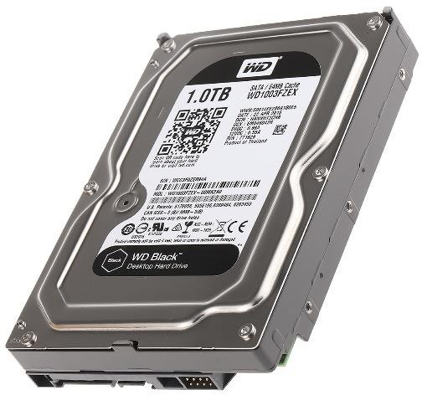 | 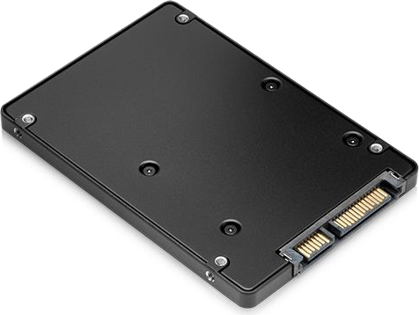 | 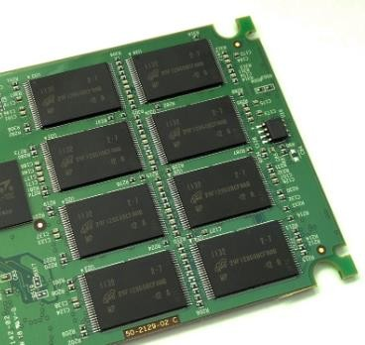

- State three Categories of the computer hardware.(3 mks)
  - ………………………………………………………………….
  - …………………………………………………………………
  - ………………………………………………………………….
- State three ways of reusing input devices to minimize wastage.(3 mks)
  - …………………………………………………………………..……….
  - …………………………………………………………………..……….
  - ……………………………………………………………………………
- State the function of the following output device. (8 mks

Monitor ……………………………………………………………………………………………………………………………………………………………………………..

Speakers

………………………………………………………………………………………………………………………………………………………………………………

Headphones/earphones

…………………………………………………………..………………………………………………………………………………………………………………….

Printers. ……………………………………………………………………………………………………………………………………………………………………………..

Projectors. ……………………………………………………………………………………………………………………………………………………………………………..

Plotters. ……………………………………………………………………………………………………………………………………………………………………………..

Actuators

…………………………………………………………………..………………………………………………………………………………………………………….

Braille embosser. ……………………………………………………………………………………………………………………………………………………………………………..

- State three Advantages and disadvantages of Hardcopy output

Advantages of hardcopy | Disadvantages of hardcopy

THE END

