

COMPETENCE BASED CURRICULUM

JUNIOR SCHOOL

FORMATIVE ASSESSMENT

TERM ONE 2024

GRADE 8

Name……………………………………………………………….………………………………………………

Centre ………………………………………………………………………………….......................................

Assessment No. ……………………………………………………………… Stream………………………

Learner’s Sign……………………………………………………..… Date: ………………..…………………..

**PRETECHNICAL STUDIES**

FOR EXAMINERS

ASSESSMENT RUBRICS (for official use)

|  |  |  |  |  |
| --- | --- | --- | --- | --- |
| %SCORE RANGE | Below 40 | 40-59 | 60-79 | 80-100 |
| PERFORMANCE LEVEL | Below expectation | Approaching expectations | Meeting expectations | Exceeding expectations |
|  | 1 | 2 | 3 | 4 |

### Name four types of removable storage devices.(4 mks)

1. ……………………………………………………
2. ……………………………………………………
3. ……………………………………………………
4. …………………………………………………….
5. Name the following storage devices. (5 mks)

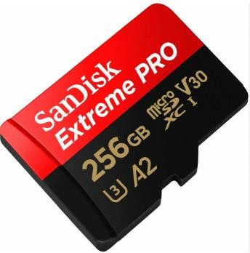 ……………………………………………

 ………………………………………………

 ………………………………….…………..

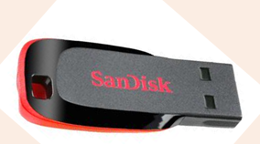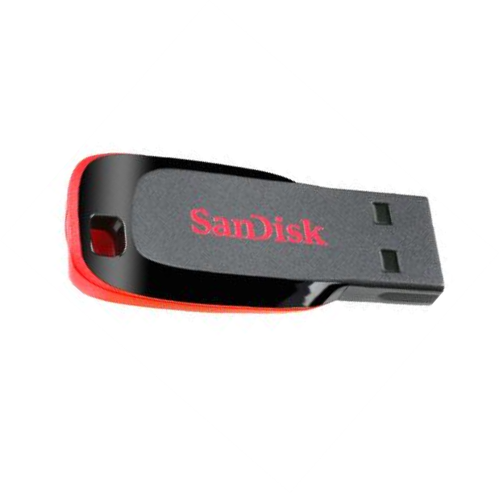 ………………………………………………

1. State five factors to consider when selecting a removable storage device for use. (5 mks)
2. ………………………………………………………………………………………….
3. ………………………………………………………………………………………….
4. ………………………………………………………………………………………….
5. ………………………………………………………………………………………….
6. ………………………………………………………………………………………….
7. State three importance of consumer protection.(3 mks)
8. …………………………………………………………………………………………..
9. …………………………………………………………………………………………
10. ………………………………………………………………………………………….

### State three ways in which the government protects consumers and investors.(3 mks)

1. ……………………………………………………………………………………….
2. ……………………………………………………………………………………….
3. ……………………………………………………………………………………….
4. Identify the scanners name below. (4 mks)

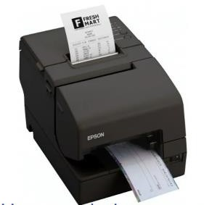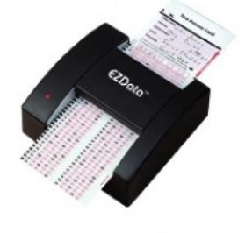

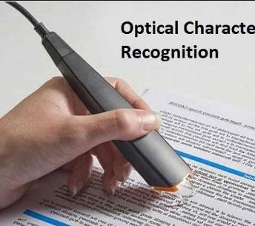

### State four factors to consider when selecting input devices.(4 mks)

1. …………………………………………………………………………………………..
2. ………………………………………………………………………………………….
3. …………………………………………………………………………………………..
4. ………………………………………………………………………………………….
5. Define the following business term.(2 mks)

Communication ……………………………………………………………………………………………………………………………………………………………………………………………………

### State three advantages and three disadvantages of oral communication channels.(6 mks)

|  |  |  |
| --- | --- | --- |
|  | Advantages | Disadvantages. |
| 1 |  |  |
| 2 |  |  |
| 3 |  |  |

1. State three examples of written communication channels. (3 mks)
   1. ……………………………………………………………….
   2. ……………………………………………………………….
   3. ………………………………………………………………..

## State four Factors considered when selecting channels of communication.(4 mks)

1. ……………………………………………………………………..
2. ……………………………………………………………………..
3. …………………………………………………………………….
4. …………………………………………………………………….
5. On a drawing of scale 1.5, the length of a line is as shown in the diagram. The unit of the

Scale is decimeters. Determine the length of the line in centimetres.

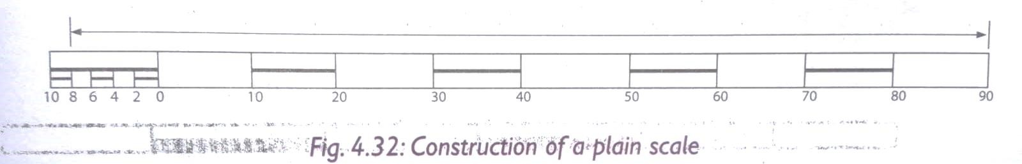

1. Identify three common examples of visual programming applications. (3 mks)
2. …………………………………………………………
3. …………………………………………………………
4. …………………………………………………………
5. Match the following picture to its hardware category. (8 mks)



**Keying devices**

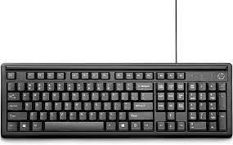

**Pointing devices**



**Voice input devices**

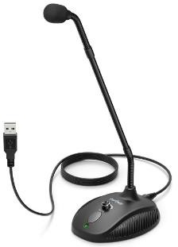

**Scanning devices**

1. Name the following gadgets

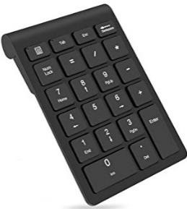

**Television remote**

**Voice input devices**