COMPETENCE BASED CURRICULUM
JUNIOR SCHOOL
FORMATIVE ASSESSMENT
TERM ONE 2024
GRADE 8

MARKING SCHEME
PRETECHNICAL STUDIES

- Name the following input devices. (4 mks)
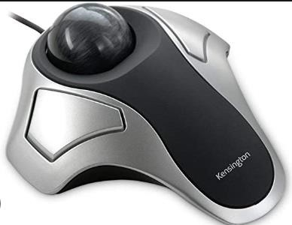

Trackball
Light pen

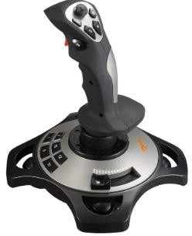

Touch pad
Joystick

Name two components of pre-technical studies. (2 mks)

Business education

Technical education

Computer education

Career studies

State four Importance of safety in a work environment. (4 mks)
- Reduces financial losses needed to repair damaged property.
- Increases business rating because of customer and worker satisfaction.
- Reduces job losses that comes from permanent injuries.
- Reduces financial losses needed for medical expenses.
- Reduces damage to property because of lower number of accidents at workplaces.
- Reduces cases of injury because of lower number of accidents at workplaces.
- It improves productivity.
- Name the following storage devices. (2 mks)
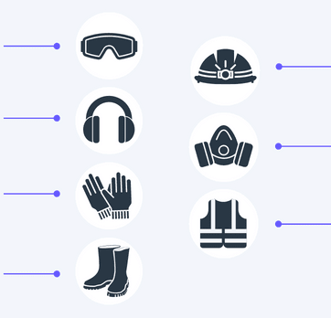
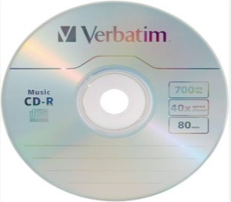
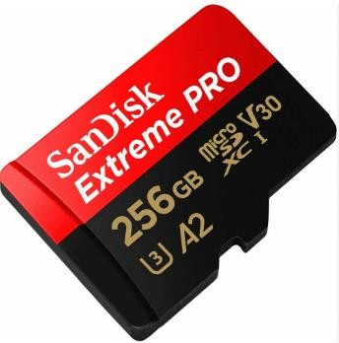 Memory card Compact disc.
- Name the following safety wears. (7 mks)

Safety Goggles
Helmet

Head phones/ear muffs

Gas mask

Gloves

Safety jacket

Gumboots

State five Causes of fire in a work environment. (5 mks)
- Faulty equipment such as extension cables in places such as kitchens, offices, workshop or warehouses.
- Fires when performing tasks such as welding, flame-cutting or grinding. This work generates heat, sparks or flames to cause fire.
- Improper storage of flammable and combustible materials such as flammable liquids or charcoal in workplace.
- Human errors such as using equipment such as electric cooker incorrectly, not reporting faulty machinery as well as leaving cooking food unattended may lead to fire accidents.

Name four injuries caused by fire at work places. (4 mks)
- Burns-where fire raises temperature of the skin and tissues causing the tissues and cells to die.
- Smoke chocking- where the victim suffers obstructed breathing, seizures and comas.
- Chemical poisoning from inhaling poisonous fumes such as carbon monoxide.
- Shock where a victim develops abnormal heart rhythm and becomes unconscious.

Outline four Prevention methods of fire outbreaks in a work environment. (4 mks)
  - Providing enough safety and security at work premises.
  - Keeping a work environment clean and orderly.
  - Being cautious when performing activities using open fire.
  - Having all equipment well services and maintained.
  - Allowing for easy access to electrical switches and fire alarm equipment.
  - Storing and handling flammable materials and liquids with care.

- Identify the following computer drives.(3 mks)

Hard disk drive HDD | Solid state drive SSD | Internal flash drive
 | 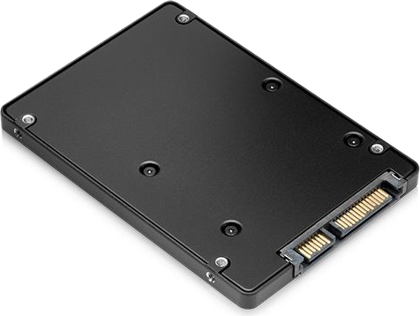 | 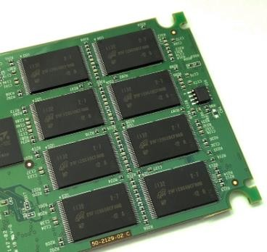

- State three Categories of the computer hardware.(3 mks)
  - Input devices.
  - Output devices.
  - Storage devices.
  - Central processing unit. (CPU)

- State three ways of Reusing Input devices to minimize wastage.(3 mks)

  - Input devices that are in good condition can be reused to minimize waste.
  - Computers keyboards can be used to make: book covers, pencil holders, key holders, rings and fridge notes.
  - A computer mouse can be used to make toys, soap dishes, toothbrush holders and Christmas tree decorations.
  - Obsolete and dysfunctional input devices can be sent to recycling facility where they will be recycled to make new products.

- State the function of the following output device. (8 mks

Monitor It displays data in text and graphics.

Speakers.Gives information in form of sound or audio.

Headphones/earphones.Produce audio information.

Printers.Produce text or picture on paper.

Projectors.Gives visual information by projecting it on a flat smooth like wall or a white board.

Plotters.Produces digital created graphics and drawings. A plotter uses a pen to draw lines on paper.

Actuators.A part of a device or machine that helps to create physical movement using signals from a computer.

Braille embosser.A device that presses dots onto paper for people with visual impairment to read using their fingers.

- State three Advantages and disadvantages of Hardcopy output

Advantages of hardcopy | Disadvantages of hardcopy
It is considered permanent data as editing and changing is not easy. | It is expensive to produce as it requires paper, ink and printer.
It does not need electricity, special devices or software to display/show | It is not easy to move from one place to another.
When properly stored it is not easily lost | It requires a lot of physical storage space.
it is not subjected to data stealing and cyber attacks | it can be stolen or destroyed through wear and tear or be subjected to factors such as fire and water.

THE END

