COMPETENCE BASED CURRICULUM
JUNIOR SCHOOL
FORMATIVE ASSEESMENT
GRADE 8
COMPUTER STUDIES
2 HOURS
SCHOOL: ……………………………………………………………………………..……
NAME: ……………………………………………………..……………………..………..
ASSESSMENT NO: ……………….………. SIGN: …....DATE: ………..….
RUBRICS (for official use)
Mark Score Range | Below 40 | 40-59 | 60-79 | 80-100
PERFORMANCE LEVEL | Below expectation | Approaching expectations | Meeting expectations | Exceeding expectations
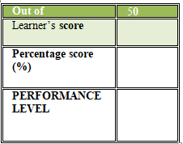
FOR EXAMINERS
INSTRUCTIONS TO CANDIDATES
- Answer all the questions in the spaces provided.
- Ensure your work is neat.

QUESTIONS

Clearly define a computer. (2 mks)

…………………………………………………………………………………………………………………………………………………………………………………………….

Give one reason why a computer is referred to as an electronic device (1 mk)

……………………………………………………………………………………………………………………………………………………………………………………

Explain the following terms as used in computer science. (4 mks)

(i) Data

……………………………………………………………………………………………………

(ii) Program

…………………………………………………………………………………………………..

(iii) Data processing

………………………………………………………………………………………………..

(iv) Information

………………………………………………………………………………………………..

Identify the following computer components. (3 mks)
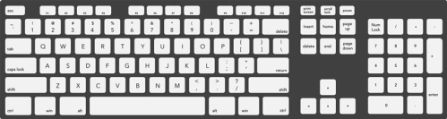

Identify the following components contained in a computer case. ( 6mks)

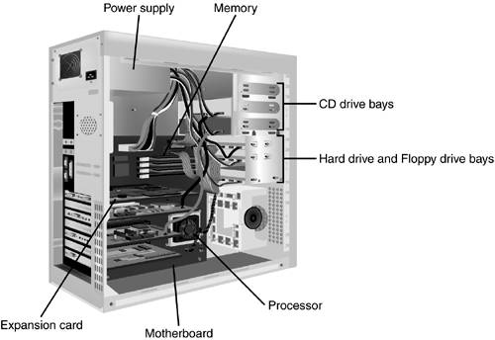

`

What are the functions of the motherboard. (3 mks)

……………………………………………………………………………………

………………………………………………..………………………………….

…………………………………………………………..…………………..…

Name three buses of computer system. (3 mks)

………………………………………………………

………………………………………………………

……………………………………………………..

State any three functions of a computer. (3 mks)

………………………………………………………………………………….

…………………………………………………………………………………..

…………………………………………………………………………………..

Explain the following input/ output terms as used in computer systems. Give an example for each. (2mks)

(a) Read - ……………………………………………..………………………………..

(b) Write - ……………………………………………………………………………….

State four different parts that make up a computer (2 mks)

………………………………………….…….

…………………………………………………

………………………………….……………

………..……………………………………….

(a) Explain the term system Unit. (2 mks)

…………………………………………………………………………………………

(b) List four devices located under the cover of the system unit. (4 mks)

………………………………………………………

………………………………………………………

………………………………………………………

……………………………………………………..

Give two differences between tower – style and desktop system units. (4 mks)

…………………………………………………………………………………………………………………………………………………………………………………………………….

…………………………………………………………………………………………………………………………………………………………………………………………………..

Computers have evolved through a number of generations. List any 4 characteristics of the first generation of computers.(4 mks)

……………………………………………………………..……………………..

…………………………………………………………………………………….

…………………………………………………………………………………….

…………………………………………………………………………………….

Briefly explain the classification of computer according to historical development (generations)(4 mks)

First generation computers

………………………………………………………….

…………………………………………………………

…………………………………………………………

………………………………………………………………

Second generation computers. (4 mks)

………………………………………………………………………..

.............................................................................................................

………………………………………………………………………

State four factors used to classify computers. (4 mks)

………………………………………………………………….

………………………………………………………………….

…………………………………………………………………

…………………………………………………………………..

State the differences between desktop computers and laptop computers. (3 mks)

……………………………………………………………………………………………..

………………………………………………………………………………………………

……………………………………………………………………………..………………..

(a) Explain the emerging trends in microcomputer technology in relation to size. (1 mk)

…………………………………………………………………………………………………

(b) Give two reasons why smaller computers like Laptops tend to be more expensive than Desktop computers. (3 mks)

…………………………………………………………………………..

…………………………………………………………………………….

…………………………………………………………………………..

Which category of computers would you place an N- series Nokia phone. (1mk)

……………………………………………………..

Give three reasons why a mobile phone is regarded to be a computer. (3 mks)

…………………………………………………………………

…………………………………………………………………

…………………………………………………………………

    - What are some of the most significant consequences of fire?(3mks)
- …………………………………………………………………………………………..
- ……………………………………………………………………………………………
- …………………………………………………………………………………………..
    - Identify good management practice when dealing with electricity(3mks)
- …………………………………………………………………………………………….
- …………………………………………………………………………………………….
- ……………………………………………………………………………………………
    - State what not to do with electricity to ensure safety(3mks)
- ……………………………………………………………………………………………...
- ………………………………………………………………………………………………
- ………………………………………………………………………………………………

    - Identify the following tools used when working(3mks)
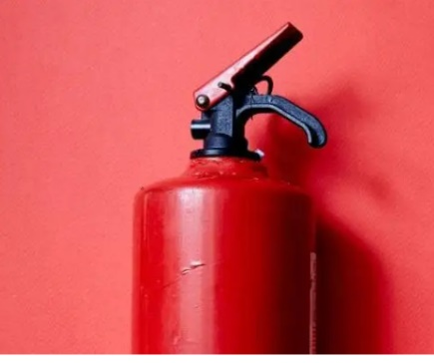

    - Name examples of Hazards to personal safety. (3mks)
- ………………………………………………………………………………………
- ……………………………………………………………………………………….
- ……………………………………………………………………………………….

    - What are Some of the ways used to handle tools and equipment safely while performing tasks in the locality?(3mks)
- ……………………………………………………………………………………………………………………….
- ……………………………………………………………………………………………………………………….
- ……………………………………………………………………………………………………………………….

    - What are Some of the common types of injuries that occurs in the locality ?(3mks)
- ………………………………………
- ……………………………………….
- ………………………………………

    - What are the Causes of injuries in the locality?3 mks)
- ……………………………………………………………………………………………………………….
- ………………………………………………………………………………………………………………..
- ………………………………………………………………………………………………………………..

Devices can be used when setting up personal goals easily.
- ……………………………………………………
- …………………………………………………..
- ……………………………………………………

State three differences between talent and ability.

TALENT | ABILITY

What are the Differences between Needs and Wants?

NEEDS | WANTS

    - Define the following terms
  - Scarcity
……………………………………………………………………………………………………………………………………………………………………………………………………………………………………………..

Opportunity cost.
………………………………………………………………………………………………………………………………………………………………………………………………………...

Choice.
………………………………………………………………………………………………………………………………………………………………………………………………………..

Scale of preference.
………………………………………………………………………………………………………………………………………………………………………………………………………………………………………..

State and explain three Categories of Business Activities.
………………………………………………………………………………………………………………………………………………………………………………………………………………………………………..
………………………………………………………………………………………………………………………………………………………………………………………………………………………………………..
………………………………………………………………………………………………………………………………………………………………………………………………………………………………………..

    - Outline four Types of large-scale retail outlets
- …………………………………………………..
- …………………………………………………..
- ………………………………………………….
- ………………………………………………….
    - State the Importance of Studying Business studies in schools

- ………………………………………………………………………………………………….
- …………………………………………………………………………………………………..
- …………………………………………………………………………………………………..

State the meaning of the Components of Business

 | Component of Business | Meaning.
A | Economics
B | Commerce
C | Accounting
D | Entrepreneurship
E | Financial literacy

What are the uses of Money?
- ………………………………………………………………………………
- ………………………………………………………………………………
- ………………………………………………………………………………

What are the security features of Kenyan denominations below?
KEY SECURITY FEATURES;
- ………………………………………………………
- …………………………………………………….
- …………………………………………………….
- …………………………………………………….

Distinguish the following goods

Free goods and economic goods.
Free goods ………………………………………………………………………………….
Economic goods ……………………………………………………………………………

Producer goods and consumer goods.
Producer goods …………………………………………………………………………….
Consumer …………………………………………………………………………………..

Perishable goods and durable goods.
Perishable goods ……………………………………………………………………………..
Durable goods …………………………………………………………………….....

Public goods and private goods.
Public goods …………………………………………………………………………….
Private goods …………………………………………………………………………..

Which devices can be used when setting up personal goals easily.
- ……………………………………………………
- …………………………………………………..
- ……………………………………………………

State three differences between talent and ability.

TALENT | ABILITY

What are the Differences between Needs and Wants?

NEEDS | WANTS

    - Define the following terms
  - Scarcity
……………………………………………………………………………………………………………………………………………………………………………………………………………………………………………..

Opportunity cost.
………………………………………………………………………………………………………………………………………………………………………………………………………...

Choice.
………………………………………………………………………………………………………………………………………………………………………………………………………..

Scale of preference.
………………………………………………………………………………………………………………………………………………………………………………………………………………………………………..

State and explain three Categories of Business Activities.
………………………………………………………………………………………………………………………………………………………………………………………………………………………………………..
………………………………………………………………………………………………………………………………………………………………………………………………………………………………………..
………………………………………………………………………………………………………………………………………………………………………………………………………………………………………..

    - Outline four Types of large-scale retail outlets
- …………………………………………………..
- …………………………………………………..
- ………………………………………………….
- ………………………………………………….
    - Distinguish between goods and services.
GOODS | SERVICES

    - What is
  - Resources ……………………………………………………………………………………………………………………………………………………………………………………
  - Economic resources …………………………………………………………………………………………………………………………………………………………………………………………………….

    - There are four factors of production namely:
  - …………………………………
  - …………………………………
  - …………………………………
  - …………………………………
    - State the Legal requirements for Starting and Operating a simple business in Kenya
- ……………………………………………………………………………..
- …………………………………………………………………………….
- ……………………………………………………………………………..

This is the last printed page

