JUNIOR SCHOOL

2024 QUESTIONS

G8 PRETECHNICAL

Answer all questions

ANSWER ALL QUESTIONS
- What are some of the most significant consequences of fire?
- …………………………………………………………………………………………..
- ……………………………………………………………………………………………
- …………………………………………………………………………………………..
- Identify good management practice when dealing with electricity
- …………………………………………………………………………………………….
- …………………………………………………………………………………………….
- …………………………………………………………………………………………….

- State what not to do with electricity to ensure safety
- ……………………………………………………………………………………………...
- ………………………………………………………………………………………………
- ………………………………………………………………………………………………

- Identify the following tools used when working


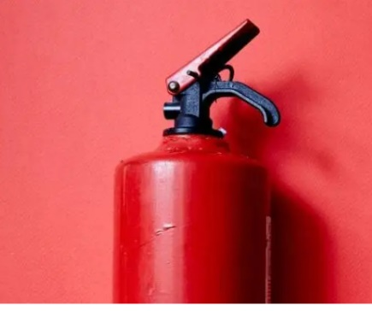
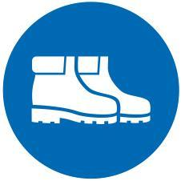

- Name examples of Hazards to personal safety.
- ………………………………………………………………………………………
- ……………………………………………………………………………………….
- ……………………………………………………………………………………….

- What are Some of the ways used to handle tools and equipment safely while performing tasks in the locality?
- ……………………………………………………………………………………………………………………….
- ……………………………………………………………………………………………………………………….
- ……………………………………………………………………………………………………………………….

- What are Some of the common types of injuries that occurs in the locality ?
- ………………………………………
- ……………………………………….
- ………………………………………

- What are the Causes of injuries in the locality?
- ……………………………………………………………………………………………………………….
- ………………………………………………………………………………………………………………..

- State the Items Contained in A First Aid Kit.
- …………………………………….……………….
- ……………………………………………………..

- Describe the Procedure of Administering First Aid for Fracture.
- …………………………………………………………………………………………………………………..
- ………………………………………………………………………………………………………………….
- …………………………………………………………………………………………………………………..
- ………………………………………………………………………………………………………………….
- ……………………………………………………………………………………………………………………

- What is the Importance of Safety in everyday Life?
- ………………………………………………………………………………
- ………………………………………………………………………………

- Distinguish between synthetic and natural non-metallic materials

 | Natural non-metallic materials | Synthetic non-metallic materials
1
2
3
4
5

- What are the Uses of artistic and technical drawings.

 | Uses of artistic drawings | Uses of technical drawings
a | To remember something important in the  culture or personal life. | To communicate ideas in the technical and  manufacturing workplaces.
b | To illustrate events and communicate  ideas or information. | To convey information about how an object  functions or it is constructed.
c | For self-expression of the artist’s personal, internal emotions and feelings. | Used as guide for engineers and technicians  when constructing or repairing objects and buildings.
d | To beautify objects that we use in  everyday life.
e | To promote ideas and products
- Mention some Drawing instruments and equipments used in technical drawing

- ……………………………………………
- ……………………………………………..
- ……………………………………………..
- State types of lines used in technical drawing
- ……………………………………..
- ……………………………………..
- Mention the Forms of energy.
- ……………………………………………………….
- ……………………………………………………

