JUNIOR SCHOOL

2024 ANSWERS

G8 PRETECHNICAL

Answer all questions

ANSWER ALL QUESTIONS
- What are some of the most significant consequences of fire?
- Property Damage
- Business Interruption
- Injuries And Fatalities
- Emotional Trauma
- Litigation
- Loss Of Productivity
- Increased Insurance Premiums
- Damage To Brand Reputation
- Occupational Health And Safety Issues
- Financial Loss
- Regulatory Fines And Penalties
- Identify good management practice when dealing with electricity
- Ensure the power supply is regularly tested by a competent person and taken out of service if unsafe.
- Keep isolators and other electrical systems clear at all times and clearly identify them with signs.
- Ensure anyone working with electricity is trained and competent. The level required will depend on the task, e.g. maintenance of electrical equipment will require a higher level of training and competence.
- Use portable electrical equipment safely, e.g. not misusing it, using it for its intended purpose and storing it properly after use.
- Fully pull out electrical extension reels when in use to prevent overheating.
- When defrosting raw foods, keep them away from other foods to prevent cross-contamination.
- Complete a pre-use check of electrical equipment to ensure it is safe.
- Switch off and unplug electrical equipment during maintenance, cleaning, repairing or adjusting.
- Switch off all non-essential electrical equipment at the end of the working day. Not only is this safer, but it also saves energy.

- State what not to do with electricity to ensure safety
- Do not overload sockets, as this can cause overheating and fire.
- Do not force a plug into a socket if it does not fit.
- Do not route electrical cables where they could be damaged or where someone could trip. Use cable protectors if they cannot be re-routed.
- Do not use electrical equipment with wet hands or near water.
- Do not keep liquids by electrical equipment, e.g. open drinks next to computers.
- Do not plug multiple extension leads together (daisy-chaining).
- Do not pull electrical equipment out of a socket by its lead. Always grip the plug.

- Identify the following tools used when working

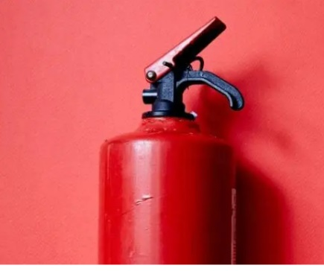
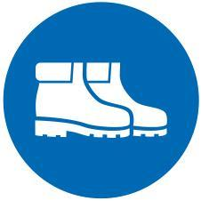
Safety shoes

Fire extinguisher
Helmet

- Examples of Hazards to personal safety.
- Sharp edged tools and objects that can easily cut or poke someone.
- Disarranged rooms where one can easily tumble and fall.
- Naked electric wires that can easily cause electric shock.
- Poorly lit rooms where one can easily know oneself against objects.
- Poorly stored items on the shelves where they can easily fall off and hit someone.
- Working without protective gear where one can easily be hurt or injured.
- Rooms with wet slippery floors where one can easily slip and fall.

- What are Some of the ways used to handle tools and equipment safely while performing tasks in the locality?
a.) Wearing personal protective equipment like safety goggles, helmet and others.
b.) Picking the right tool for the task at hand.
c.) Avoid throwing or tossing a tool in the direction of or directly to a co-worker.
d.) Never put sharp tools in the pocket.
e.) Keeping safe distance from each other when working with tool. This gives enough space to safely operate without coming into contact with co-workers.
f.) Picking up all hand tools after the job. Idle tools lying around the workplace can lead to tripping.
g.) Unplugging and disconnecting electric power tools when not in use, when making adjustments such as replacing blades and bits or loading fasteners.
h.) Sharpening cutting tools before and after use.

- What are Some of the common types of injuries that occurs in the locality ?
- A burn is an injury caused by a flame.
- A scald is an injury caused by hot liquid or team.
- A cut is a tear or opening in the skin by a sharp object.
- Fracture is a partial or complete break of a bone.
- Sprains
- Pricks
- Bruises

- What are the Causes of injuries in the locality?
- Cuts which are caused by sharp objects or tools and equipment like knives. Also can be caused by sharp furniture corners or rough edges.
- Burns which are caused by fire or hot objects or touching open flames.
- Scalds which are caused by hot liquids or steam.
- A fracture which is caused by twisting of an arm or leg resulting from during falls or slips.

- State the Items Contained in A First Aid Kit.
- Bandages.
- Adhesive tape.
- Gauze roll and pads.
- First Aid manual.
- Safety pins.
- Tweezers.
- Scissors.
- Antiseptic wipes.
- Emergency blanket.
- Gloves.
- Thermometer.
- Instant cold pack.
- Elastic bandages.
- Triangular bandages.

- Describe the Procedure of Administering First Aid for Fracture.
- A fracture is a broken bone. Call for any assistance in case of the following:
- The broken bone is the result of major trauma or injury.
- The person is not breathing or is not moving.
- There is heavy bleeding.
- Gentle pressure or movement cause pain.
- The limb or joint appears deformed.
- The bone has pierced the skin.
- The extreme end of the injured arm or leg such as a toe or finger is numb.
- You suspect a bone is broken in the neck, head or back.
- What is the Importance of Safety in everyday Life?
- It saves life.
- It guards against pain and suffering.
- It assures one of continued income and financial well-being.
- It gives one piece of mind.
- It enables one to continue his or her job or career.
- It saves one medical cost.
- It gives one self-confidence.
- It reduces one’s reliance om others for support.
- One does not become a burden to other people.

- Distinguish between synthetic and natural non-metallic materials

 | Natural non-metallic materials | Synthetic non-metallic materials
1 | Natural materials like skin or bark depends on the length and size of the  animal or plant form which it is taken. | The length or size of synthetic material can be adjusted according to the needs.
2 | The shape of a natural material is similar to the shape of the source from  which it is got. | The shape of synthetic material can be adjusted to the needs.
3 | Items made from natural fiber such as  wool and cotton are soft and very comfortable to wear. | Items made from synthetic fibre are less comfortable.
4 | Natural materials are in their original  colour and they do not fade easily. | Synthetic materials are dyed to change their  colours as desired and they easily fade.
5 | Most of materials are not easily  damaged by water. | Most synthetic materials are easily damaged  by water.

- Mention some Drawing instruments and equipments used in technical drawing

- Pencils
- Tee squares
- Drawing boards
- Drawing pens
- Rulers
- Sharpeners
- Drawing templates
- Erasers
- Pair of compass

- State types of lines used in technical drawing
- Construction line
- Centre line
- Hidden line
- Phantom line
- Break line
- Drawing line
- Break line
- Dimension line
- Leader line
- Cutting line
- Mention the Forms of energy.
- Wind energy from wind.
- Solar energy from the sun.
- Chemical energy from biomass and petroleum products.
- Electrical energy comes from electric cells or batteries, hydropower, wind power. Solar power and geothermal.
- Thermal or heat energy from hot objects.
- Mechanical energy from moving objects.

