COMPETENCE BASED CURRICULUM

JUNIOR SCHOOL

FORMATIVE ASSESSMENT

TERM ONE 2024

GRADE 8

NAME: …………………………………………………………………………………………..

SCHOOL: ………………………………………………………………………………………..

ASSESSMENT NUMBER ………………………………………….STREAM …………….

SIGN ………………………………………DATE …………………….

**INTEGRATED SCIENCE**

FOR EXAMINERS

ASSESSMENT RUBRICS (for official use)

|  |  |  |  |  |
| --- | --- | --- | --- | --- |
| %SCORE RANGE | Below 40 | 40-59 | 60-79 | 80-100 |
| PERFORMANCE LEVEL | Below expectation | Approaching expectations | Meeting expectations | Exceeding expectations |
|  | 1 | 2 | 3 | 4 |

1. Name the following parts of the light microscope.( 5 mks)

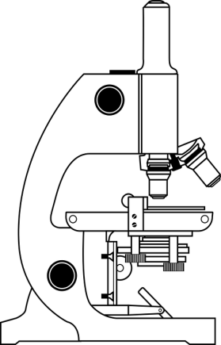

1. Grade 8 students had their practical lesson in the laboratory.Name two common accidents their Integrated Science teacher taught them. (2 mks)
2. ……………………………………………
3. ……………………………………………
4. Name the following heating apparatus

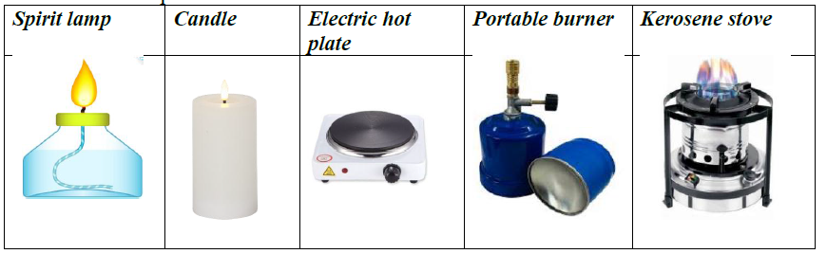

1. Name three protective wear for safety in the laboratory.( 3 mks)
2. …………………………………………..
3. ………………………………………….
4. ………………………………………….
5. Calculate the area of the Circle whose diameter is 14cm. (2 mks)

14cm

1. Name the compound formed by reacting sodium and chorine. (1 mk)

…………………………………………………….

1. The property of gases demonstrated is that? (1 mk)



…………………………………………………………………………

### Define the following terms. (6 mks)

1. Matter.

……………………………………………………………………………………………………………………………………………………………………

1. An element …………………………………………………………………………………………………………………………………………………………
2. A compound ………………………………………………………………………………………………………………………………………………
3. Name three careers that are related to the knowledge and skills gained in integrated science.( 3 mks)
4. …………………………………………..
5. ………………………………………….
6. ………………………………………….
7. Name two common accidents in the laboratory.(2 mks)
8. ……………………………….
9. ………………………………….

#### Name three e examples of food nutrients. (3 mks)

1. ………………………………………….
2. ………………………………………….
3. …………………………………………

### Relate the following common elements to their symbols.(8 mks)

1. H - ………………………………..
2. O - ……………………………….
3. K - ………………………………..
4. C - ……………………………….
5. Ca-……………………………….
6. Cl-……………………………….
7. Cu-……………………………….
8. Fe-………………………………..
9. Name the apparatus below. (1mk)



1. Name the parts R, T and P. (3mks)

R-…………………………………………

T-…………………………………………

P-………………………………………….

1. Name three examples of compounds used at home. (3 mks)
2. ……………………………………………..
3. ……………………………………………..
4. ……………………………………………...

###### Outline two uses of bases. (2 mks)

1. ……………………………………………………………………………..
2. ……………………………………………………………………………..
3. Name two apparatus used for measuring length.(2 mks)
4. …………………………………………….
5. ……………………………………………

### Fill the following table on the various food sources that contain various elements. (10 mks)

|  |  |
| --- | --- |
| Mineral element of  compound | Examples of food sources |
| Carbon |  |
| Nitrogen |  |
| Flouride |  |
| Calcium |  |
| Copper |  |
| Iron |  |
| Magnesium |  |
| Phosphorus |  |
| Potassium |  |
| Sodium chloride |  |

THE END