

COMPETENCE BASED CURRICULUM

JUNIOR SCHOOL

FORMATIVE ASSESSMENT

TERM ONE 2024

GRADE 8

Name……………………………………………….………………………………………………

Centre ………………………………………………………………….......................................

Assessment No. …………………………………………… Stream………………………

Learner’s Sign…………………………………..… Date: ………………..…………………..

**INTEGRATED SCIENCE**

FOR EXAMINERS

ASSESSMENT RUBRICS (for official use)

|  |  |  |  |  |
| --- | --- | --- | --- | --- |
| %SCORE RANGE | Below 40 | 40-59 | 60-79 | 80-100 |
| PERFORMANCE LEVEL | Below expectation | Approaching expectations | Meeting expectations | Exceeding expectations |
|  | 1 | 2 | 3 | 4 |

1. The following table represents basic quantities. Write their SI units and their symbols.(5 mks)

|  |  |  |  |
| --- | --- | --- | --- |
|  | quantity | SI Unit | Symbol |
| 1 | Length |  |  |
| 2 | Mass |  |  |
| 3 | Time |  |  |
| 4 | Electric current |  |  |
| 5 | Temperature |  |  |
| 6 | Amount of substance |  |  |
| 7 | Luminous intensity |  |  |

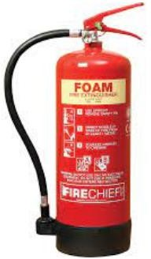

1. Name the fire gadget below. ( 1 mk)

### What is the importance of various elements and compounds? (4 mks)

* 1. Gold:

1. ………………………………………………………………………………
2. ………………………………………………………………………………
   1. Silver:
3. ………………………………………………………………………………
4. ………………………………………………………………………………
5. State the meaning of the following Fire safety posters in the environment. (3mks)

|  |  |  |
| --- | --- | --- |
|  | . |  |

1. What are the three components of integrated science? ( 3 mks)
2. ……………………………………………..
3. ……………………………………………..
4. …………………………………………….
5. Give two differences between luminous and non-luminous flame.( 4 mks)

|  |  |
| --- | --- |
| Luminous flame | Non-luminous flame |
|  |  |
|  |  |
|  |  |
|  |  |

1. State three characteristics of liquids. (3 mks)
2. ……………………………………………………………………...
3. ………………………………………………………………………
4. Change of state of matter has many applications in day-to-day life. Some of these changes are?(3 mks)
   1. …………………………………………………………………………………..
   2. ………………………………………………………………………………….
5. ………………………………………………………………………………….. Mention six classes of fire. (6 mks)
   * + - 1. …………………………………………..
         2. …………………………………………..
         3. …………………………………………..

### State three components of fire. (3 mks)

### …………………………………………..

### …………………………………………..

### ……………………………………………

### State three fire control measures.(3 mks)

### ………………………………………………………………………….

### ………………………………………………………………………….

### ………………………………………………………………………….

1. 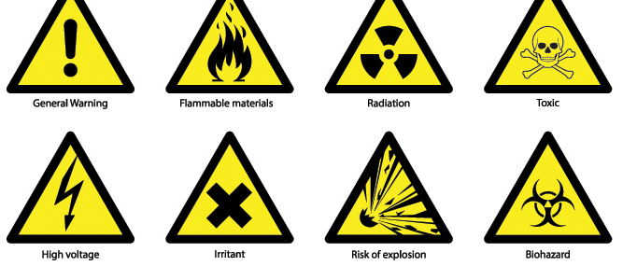Identify the following lab hazards.(2 mks)
2. Indicate their colour in the given solutions. (6 mks)

|  |  |  |  |
| --- | --- | --- | --- |
| Indicator | Acidic solution | Neutral solution | Basic solution |
| Methyl Orange |  |  |  |
| Phenolphthalein |  |  |  |

###### State two uses of acids (2 mks)

1. ……………………….……………………………………………………
2. …………………………………………………………………………….
3. Identify three basic science skills one gains in science practical.(3 mks)
4. ……………………………………………………….
5. ………………………………………………………..
6. ………………………………………………………..

### State four safety precautions to undertake to avoid fire outbreak in school.(4 mks)

1. ………………………………………………………………………………..
2. …………………………………………………………………………………
3. …………………………………………………………………………………
4. Access to information on flammable substances is important for the following reasons. Namely?(3 mks)
5. ………………………………………………………………………....
6. ………………………………………………………………………....
7. ………………………………………………………………………….
8. Name the lab apparatus below. (2 mks)

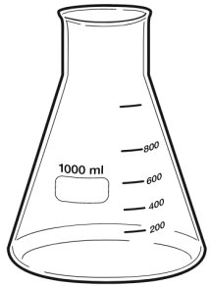

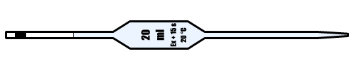

##### Outline two safe ways of handling of the Bunsen burner. (2 mks)

1. ………………………………………………………………………
2. ……………………………………………………………………….

THIS IS THE LAST PRINTED PAGE

……………….Every learner counts …………