GRADE 8 INTEGRATED SCIENCE NOTES – TERM 2

Strand 2 LIVING THINGS & THEIR ENVIRONMENT.
§
2.1 The Cell.
- Cells make up the structure of living organisms and carry out various biological processes.
- Organisms such as amoeba are composed of a single cell hence are said to be unicellular.
- Organisms such as plants and animals are composed of many cells hence are said to be multicellular.

Therefore, a cell is defined as the basic unit of structure and functions in organisms.
- To observe the cell, a powerful magnifying instrument called a microscope is used.
- A microscope enlarges the image of objects when observed and improves the resolution of the image.
Plant and animal cell structures as seen under a light microscope.
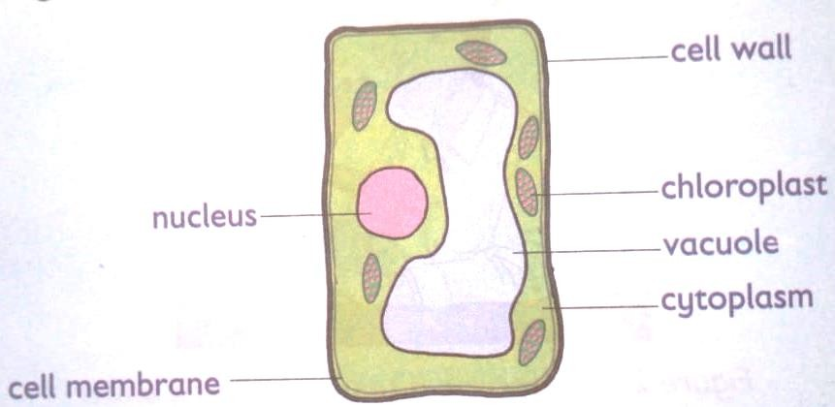
- The following diagram shows the components of a plant cell as seen under a light microscope.

Components of a plant cell.

- The following diagram shows different components of the animal cell as seen under a light microscope.

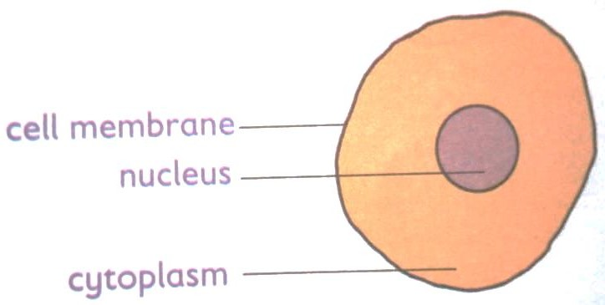
Components of an animal cell.

Comparing plant and animal cells.
🢒 Plant and animal cells have slight differences in their internal structures while sone features are common in both.

🢒 The figures below show the components of both plant and animal cells as seen under a light microscope.
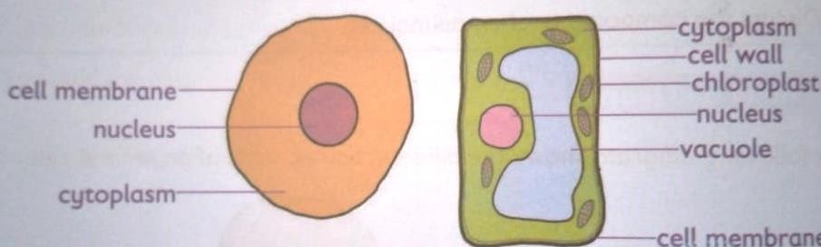

Plant cells | Animal cells.
They are large in size. | They are small compared to plant cells.
It has a cell wall. | It does not have a cell wall.
Some plant cells have chloroplast that give the plant its green colour. | It lacks chloroplast.
Plant cells have a permanent vacuole that occupies a large part of the cell. | Animal cells usually do not have vacuoles,  however, small temporary vacuoles may occur

Similarities between a plant cell and an animal cell.
They both have the cell membrane. Both have nucleus within them

Functions of the cell structures found in plants and animals’ cells.
Part/structure | Function | Found in
Vacuole | It is the space that has a watery fluid (cell sap) that contains dissolved water, mineral salts and waste products. | Both plant and animal cells.
Cell membrane | Cell membrane is a thin layer around the cell that holds the cell together.  It acts like a fence and controls what goes in and out of the cell.  Therefore, the cell can take in substances it needs and get rid of waste products. | Both plant and animal cells.
Cytoplasm. | It is a jelly-like liquid that fills inside the cell. The cytoplasm is where chemical reactions of the cell take place.  It also contains small structures called organelles which have special functions | Both plant and animal cells.
Nucleus | The nucleus carries genetic information and  controls what happens or all the activities of the cell. | Both plant and animal cells.
Cell wall | It is a thick, tough layer made from cellulose found on the outside of the cell. It covers the cell membrane in plants cells.  Cell wall helps the cell to keep its shape.  It protects the cell form mechanical damages. | Plant cells.
Chloroplast | It is an organelle in the cytoplasm of plant cells. Chloroplast contain green pigment called chlorophyll.  Chlorophyll absorbs light that is used by plants to make their own food through photosynthesis. | Plant cells.

Magnification of Cells.
🢖 Magnification of a specimen is the measure of how much bigger a specimen is when it is viewed through a hand lens or microscope compared to its original size.
🢖 Magnification is usually expressed using “X” before the digits, for example, X2, X10 and
X20. The X stands for ‘times.’
🢖 It is a measure of how much bigger an object appears when viewed through a hand lens or microscope, for example X2 means the object has been magnified or enlarged two times or the image is twice bigger than the actual object.
🢖 For alight microscope, the final magnified image of an object as seen by the observer is the
product of the magnifying power of the lenses that are used. These lenses include eyepiece
lens and the objective lens.
🢖 The magnifying power of each of these lenses is marked on the sides of the objective and eye piece lens holder.
🢖 In a light microscope, the revolving nosepiece holds three different objective lenses, each with a specific magnifying power of X4, X10 and X40. The eyepiece lens further magnifies the image formed by the objective lens.

Calculating the Total magnification.
- Finding total magnification of an image you are viewing in alight macroscope is done by:
- Take the power od the objective lens you are using e.g., X4, or X10 or X40 and multiply it by the power of the eyepiece lens, which is usually X10.

Total magnification =magnification of eyepiece lens x magnification of objective len.
Example.
Fill the table below with the correct magnification.
Objective lens magnification. | Eyepiece lens magnification | Total magnification.
X4 | 10 | X40
X10 | 10
 | X10

2.2 Movement of Material in and Out of the Cell.
Diffusion and Osmosis. Meaning of Terms.
a.) Solutes and solvent.
When a solid is dissolved in a liquid, we get a solution formed. The solid that dissolves in this solution is called the solute.
The liquid that dissolves the solid is known as the solvent. For example,
Sugar and salt are examples of substances (solutes) that are soluble in water (solvent)

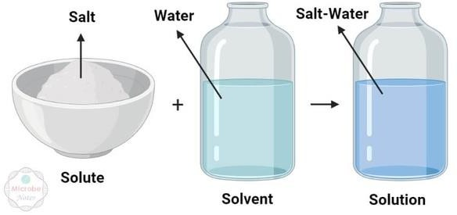

b.) Concentration.
- When there are more solute molecules compared to solvent molecules, a solution is said to be concentrated.
- When there are more solvent molecules compared to solute molecules, then the solution is said to be dilute.

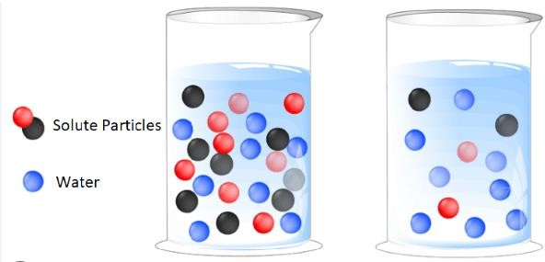
DIFFUSION.

An experiment to demonstrate diffusion in liquids.

Requirements:
🢝 A beaker.
🢝 Water.
🢝 Dye or ink.
🢝 A dropper.
🢝 writing materials.

Procedure:
 pour some water in a beaker.
 Put a drop of the dye or ink in the water.
 What observations do you make after a few minutes?

Observation, explanation and conclusion.
🢒 After a few minutes, the ink or dye spread throughout the water in the beaker.
🢒 The ink pr dye spread from the region where it was highly concentrated to region in water where it was in low concentration.
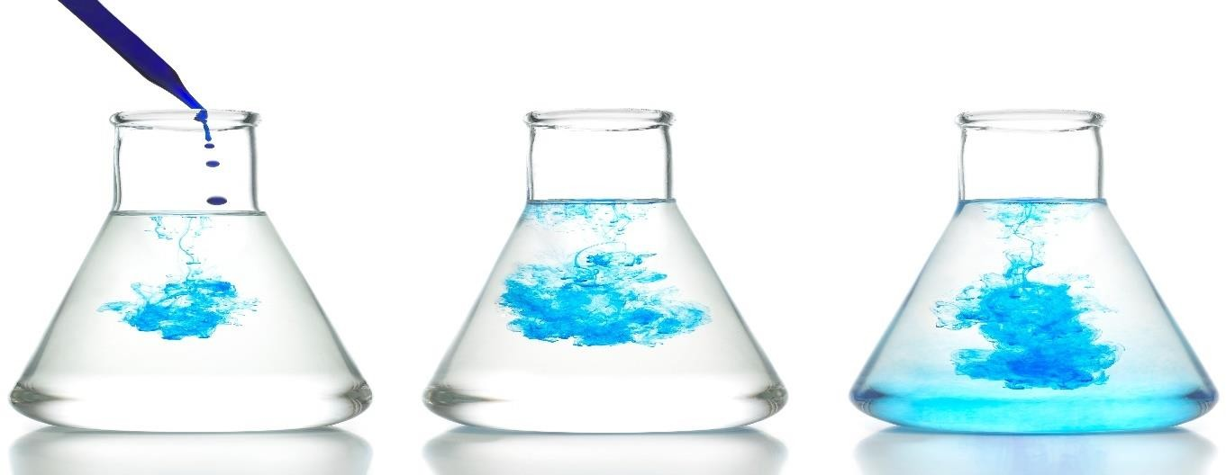
Diffusion is defined as the movement of molecules from a region of high concentration to a region of low concentration.

Experiment demonstrating diffusion in gases.

Requirements:
- A bottle of perfume of scented flowers.

Procedure:
- Place the scented flower in a corner of the classroom.
- Remove the stopper of the perfume, hold it a few centimetres away from your friend’s nose.
Observation, explanation and conclusion.
🢖 After a few seconds, you and your classmates will be able to smell the scent of the flower or perfume. This is due to diffusion. The scent of the flower and perfume molecules diffuse the air to their nose.
🢖 Molecules in the scent of flower or perfume moved from the region of high concentration
and spread evenly towards the region of low concentration.
🢖 Diffusion in gases also makes it possible for us to smell things, for example, flower, food being cooked and also foul smells.

Roles of diffusion in Living things.
🢖 Plants absorb minerals salts from soil through diffusion.
🢖 Nutrients such as glucose and amino acids move from the small intestines into bloodstream of animals by diffusion.
🢖 Cells and unicellular organisms such as amoeba get rid of waste substance through diffusion.
🢖 Gaseous exchange is the process through which gases are transferred across cell membrane to either enter or leave the blood. This process is done by diffusion in human beings in the alveoli in lungs. Oxygen gas moves from alveoli where is it is highly concentrated to the blood capillaries where it is lowly concentrated.
🢖 On the other hand, carbon (IV) oxide moves from the capillaries where it is highly
concentrated into the alveoli where it is lowly concentrated to be exhaled out.
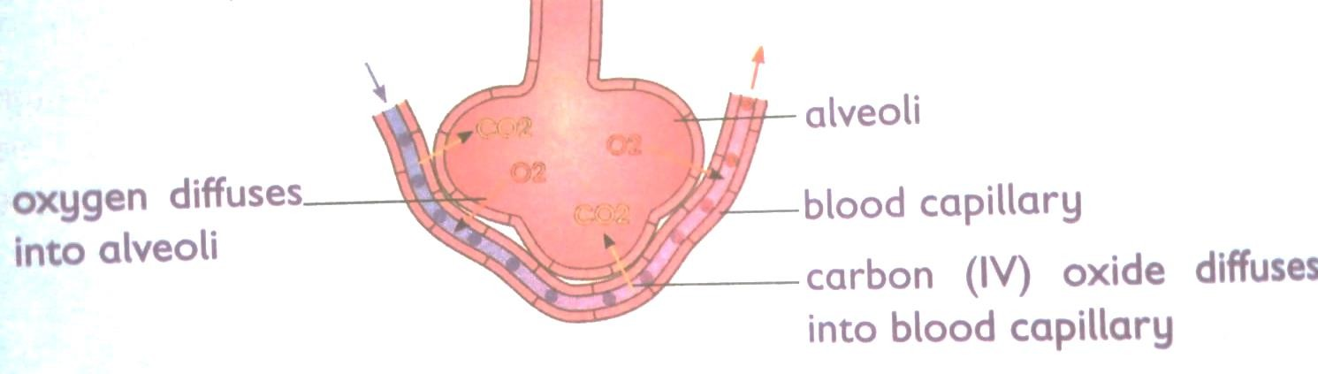

Factors that affect the rate of diffusion.
- Concentration gradient-molecules move from region of high concentration to that of low concentration. The greater the difference in concentration between high and low regions, the faster the rate of diffusion.

- Temperature-high temperature increases energy and therefore faster movement of molecules. This increases the rate of diffusion.

- Mass of particles- heavy particles move slowly hence slower rate of diffusion. Light particles on the other hand move fast hence faster rate of diffusion.
•
- Diffusion distance- rate of diffusion depends on distance that particles have to travel in order to be evenly distributed within available space.

- Medium of diffusion- particles diffuse faster through gases than liquids.
- Surface area to volume ration- diffusion occurs faster in smaller organisms as compared to larger organisms. This is because small organisms have a large surface area to volume ratio.

OSMOSIS.

Experiment to demonstrate osmosis process.

Requirements:
🢖 Capillary tube.
🢖 A thread.
🢖 A clamp.
🢖 Distilled water.

🢖 Visking tubing.
🢖 Dyed concentrated sugar solution.
🢖 A measuring cylinder.
🢖 Writing material.

Procedures:
- Moisten a piece of visking tube and rubber between your fingers to open it.
- Tie one end of the visking tubing tightly with a thread.
- Put the dye concentrated sugar solution in the Visking tubing using a measuring cylinder.
- Insert one end of capillary tube to the open end of the visking tubing and tie that end.

- Slowly lower it into a beaker containing distilled water and hold the capillary tube with a clamp.
- Mark the level of dyed concentrated sugar solution in the capillary tube at the beginning of the experiment.
- Leave the experiment for about 20 minutes. Observe and record your results
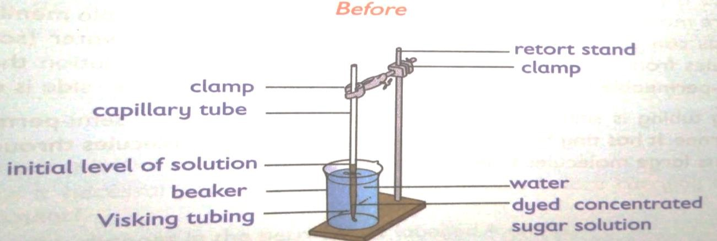
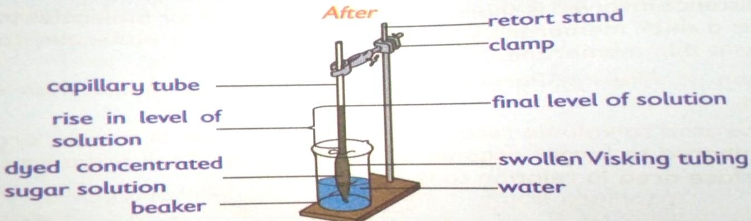
Questions to answer.

What happens to the level of the dye concentrated sugar solution in the capillary tube after 20 minutes?
The level of the dye concentrated sugar solution increases in the capillary tube.

Why did the above change take place?
Water is highly concentrated in the beaker than in the visking tubing. Water moves from where is it more into the visking tubing across the visking tubing where it is less hence making the visking tubing to swell.

Explain the biological process taking place in the experiment.
Osmosis takes place since water moves from the beaker where it is highly concentrated to the visking tube where is lowly concentrated.

What is the role of the visking tubing in the experiment?
The visking tubing acts as a semipermeable membrane.

What can we compare the visking tubing with in living cells? The cell membrane.

Observation and explanation.
🢖 The concentration of water outside the visking tubing is higher than the concentration of water inside the visking tubing.
🢖 Water moves in through the pores in the semi-permeable membrane of the Visking tubing by osmosis because of the differences in concentration inside and outside the visking tubing.

🢖 Osmosis is the random movement of water (solvent) molecules from there they are more to where they are less through a semi-permeable membrane.
🢖 Osmosis can also be defined as the random movement of water (solvent) molecules from a
dilute solution to a more concentrated solution through a semi-permeable membrane until the concentration on each side is equal.
🢖 Visking tubing is similar to the cell membrane. It is also a semi-permeable membrane, it has
tiny holes (pores) that allows small molecules through but prevents large molecules from passing through.

Investigating the process of Osmosis using plant materials.
🢖 Requirements:

- Raw potato tuber.
- Table salt.
- Boiled potato.
- Labels.
- Petru dishes.
- Clock or wrist watch.
🢖 Procedure:
- Label two petri dish A and B.
- Distilled water.
- A measuring cylinder.
- A scalpel.
- A spatula.
- Writing material.

- Half fill each petri dish with equal volume of distilled water.
- Using a scalpel, peel a raw potato tuber and trim both if its ends.
- Make a scoop (cavity) in one of the ends.
- Using a scapula, place a given amount of salt in the cavity.
- Carefully place the set-up in petri dish labelled A and note the time.
- Repeat step 3 and 5, this time using a previously boiled potato. Place it in a petri dish and label it B.
- Leave the set up for 40 minutes.
- Observe and record.

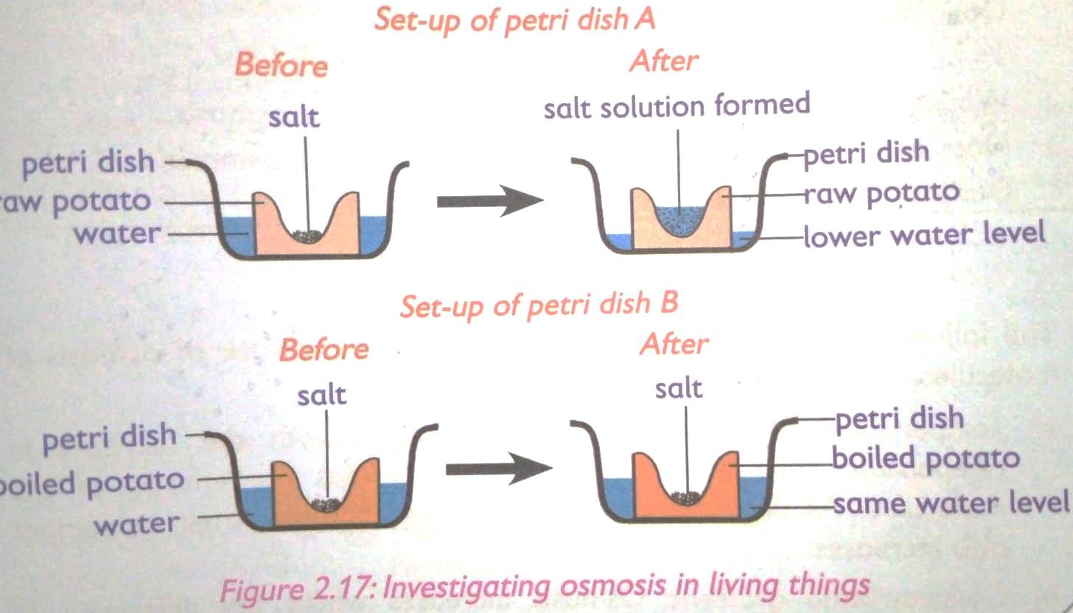

Questions to answer.
Why is it necessary to peel off the potato tuber before carrying out this experiment? Explain the changes in the petri dish A and B.

What biological process is being investigated?

Observation and explanation.
🢖 It is necessary to peel off potato tubers so as to expose large surface area and expose the inner cells that are permeable for osmosis.
🢖 Petri dish A-water moves up by osmosis through the potato cells then dissolves the table salt in the cavity.

🢖 Petri dish B-the slat did not dissolve because no water moved by osmosis in to the cavity. This is because the boiled potatoes have destroyed semi-permeable cells membranes that cannot carry out osmosis.
🢖 The process being investigated is osmosis in living cells.

Factors affecting the rate of osmosis.
  - Temperatures -rate of osmosis increases with increase in temperature. This is because increase in temperature increases energy of the molecules.
  - Concentration gradient- osmosis increases where the difference in concentration of water molecules is higher.
  - Type of semi-permeable membrane- larger number of pores, the faster the rate of osmosis.

Role of osmosis in living things.

🢖 In plants Osmosis plays the following roles:
 Absorption of water from the soil-roots absorb water from the soil by osmosis.
 Support-some plants have cells that absorb water, become turgid hence providing support to the plants.
 Feeding in insectivorous plants-insectivorous plants such as pitcher plant prey on insects. They trap insects when there is a sudden change in their stiffness when disturbed by the insect. Trapped insects are digested to provide the plant with nitrogen.

🢖 In animals, Osmosis plays the following roles:
 Absorption of water in the human body.
 Excretion-this is the removal of waste products from the body. Urine is the main product through which excess water is excreted from the body. Kidneys filter urine to control the amount of water lost. This happens through osmosis.
Similarities and difference between osmosis and diffusion.

Similarities.
Both are mean to equalize concentration of two solutions.
Both are passive transport processes, i.e., they do not require any energy to occur.
In both, particles move from an area of higher concentration to an area of low concentration.

Differences.
- Osmosis happens in liquid medium while diffusion happens in liquids, gases and even solids.
- Semi-permeable membrane is required in osmosis while in diffusion no membrane is needed.
- Osmosis requires water for movement of particles while diffusion does not require water.
- In osmosis there is only one way for particles to flow while in diffusion particles can flow in any direction.
2.3 Reproduction in Human Beings.

Menstrual cycle.
- Menstrual cycle consists of natural changes that occur to the body of a female human being every month in preparation to pregnancy.
- A menstrual cycle lasts between 28-35 days. However, this can vary between female and from one cycle to the next. The cycle depends on hormones.
- Hormones are chemical messengers in the body.
- They direct the body on what to do and when to do it.
- The menstrual cycle is a process controlled by hormones in the female body.
- The menstrual cycle is divided in to the following phases:
Approximate day(s) | Event(s)
1-5 day | - Bleeding from the vagina begins. This is caused by the loss of the lining of the uterus.  - This is called menstruation or monthly periods
6-14 days | - Blood loss stops.  - The lining of the uterus begins to regrow and an ovum starts to mature in one of the ovaries.
14-25 days | - Ovulation occurs.  - The ovum travels through the oviduct towards the uterus.
25-28 days | - If the egg becomes fertilized by a sperm and attaches itself to the uterus wall, the woman becomes pregnant.  - If pregnancy does not occur, the uterus lining begins to break down again, repeating the cycle.

Challenges related to the Human menstrual cycle.
  - Irregular periods.
- This can be determined by finding out how long your menstrual cycles are.
- You can determine your personal menstrual length by counting from day 1 of your period to day 1 of your next period.
- Day 1 means the first day of the actual flow.
- It is normal to have menstrual cycles that are between 21 and 35 says.
- Your periods are irregular if it tends to come more frequently than every 21 days or less often than 35 days.
- If the circle length falls in the normal range but varies by 7 to 9 days from the cycle to cycle that is a sign of an irregular period too.
- For example, if one is 25 days and the next is 33 days, your cycles would be considered irregular.

Absent periods.
- In some cases, some females may fail to get periods.
- Others might not get their first period by the age of 16 years.
- Other cases when some females stop getting their regular periods for 6 months or more.

Irregular bleeding.
- Bleeding very little or no bleeding at all with each menstrual cycle is another challenge related to the menstrual cycle.
- Light or lack of bleeding can result from being extremely underweight or overweight.
- If you are overweight, losing weight might help to make your periods regular.
- If you are underweight, slow and steady weight gain may help to regulate your menstrual circle.
- Excessive bleeding is another challenge related to the menstrual cycle.
- Bleeding is considered heavy if it interferes with normal activities.
- However, though common, you should see a doctor.
- Heavy periods can be a sign of a health problem.

Painful periods.
- Most women experience menstrual cramps before or during their period at some point in their lives.
- For some of them it is part of the regular monthly routine.
- However, if the cramps are painful and persistent, you should see a doctor.
Management of Menstrual challenges.
- A doctor can prescribe hormonal medication that can help control heavy bleeding.
- If one experiences heavy bleeding, an iron supplement might help to prevent anaemia.
- Mild to moderate pain or cramps can be lessened (reduced) by taking an appropriate pain reliever.
- Taking a warm bath might also help to relieve cramps.
- Surgery can also be performed.
- If symptoms persist, always visit a doctor.

Fertilization and Implantation.
- Fertilization is the fusion of a sperm with an ovum in the oviduct (also called the
fallopian tube.)
- During sexual intercourse, thousands of sperms are released into the vagina by the penis.
- Sperms swim through the cervix into the uterus up to the oviduct.
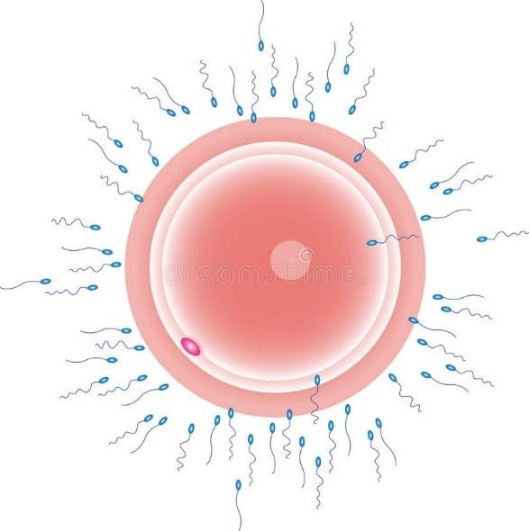
·
Sperm
Ovum

- Few sperms that reach the ovum try to penetrate it.
- Only one sperm penetrates the ovum.
- When the sperm penetrates the ovum, the surface of the sperm fuses with the nucleus of the ovum to form a zygote.
- The zygote moves from the oviduct and enters the uterus, attaching itself to the uterus walls.
- This process is called implantation.
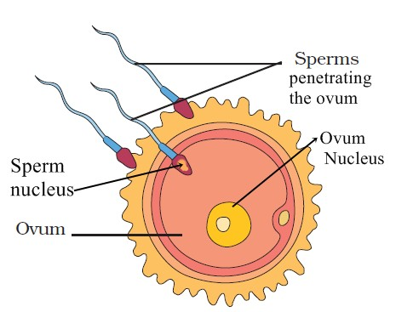
- Once implantation has taken place, the zygote is now referred to as an embryo.

Symptoms and prevention of common STIs. HIV & aid.

Symptoms.
🢖 Chronic diarrhea.
🢖 High fever and night sweating.
🢖 Weight loss.
🢖 Patient becomes very thin and weak.

Prevention.
- Abstain from unnecessary sex.
- Self control in drinking.
- Carry out blood transfusion only in extreme need and consider safety.

Gonorrhea.

Symptoms.
Vaginal discharge with bad odours. Penis becomes sore at the tip.
Urination is difficult and painful.
If untreated it spreads to rest of the organs blocking passages.

Prevention.
Avoid unnecessary sexual behaviours. Abstain from sexual intercourse.
Faithfulness in marriage is encouraged.

Syphilis.

Symptoms.
Sore resembling blisters appear at site of infection. Rashes appear on the skin.
Patient feels feverish, suffers body pains and loses hair. Can be prevented by using same measures as in gonorrhea.

Herpes

Symptoms.
Painful sores on the genitals. Blisters may disappear.
Can be prevented by;
Not indulging in promiscuous sexual behavior. Being faithful in marriage.
Avoiding sexual contact with an HSV-II infected person

