COMPETENCE BASED CURRICULUM

JUNIOR SCHOOL

FORMATIVE ASSESSMENT

TERM ONE 2024

GRADE 8

**MARKING SCHEME**

**INTEGRATED SCIENCE**

1. Name the following parts of the light microscope.( 5 mks)

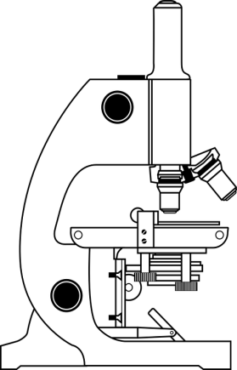

Eye-piece lens

Body tube

Stage

Mirror

Base

1. Grade 8 students had their practical lesson in the laboratory.name two common accidents their Integrated Science teacher taught them. (2 mks)
2. Burns, corrosion
3. Falls and fractures
4. Fires and explosions
5. Cuts and scalds
6. Name the following heating apparatus

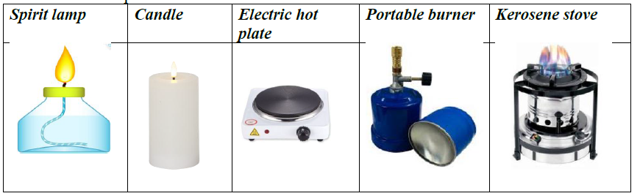

1. Name three protective wear for safety in the laboratory.( 3 mks)
2. Gloves
3. Overall
4. Safety goggles
5. Facemask
6. Headgear
7. Calculate the area of the Circle whose diameter is 14cm. (2 mks)

14cm

Area = 𝜋𝑟2

Area= $\frac{22}{7}$*7cm*7cm

Area=154cm2

1. Name the compound formed by reacting sodium and chorine. (1 mk)

Sodium chloride

1. The property of gases demonstrated is that? (1 mk)

Gases occupy space



### Define the following terms. (6 mks)

1. Matter.

Matter is anything that occupies space and has mass.

1. An element is a substance that cannot be decomposed into simpler substances by chemical or physical means.
2. A compound is pure substance that consists of atoms of two or more elements that are chemically joined together.
3. Name three careers that are related to the knowledge and skills gained in integrated science.( 3 mks)
4. Doctors,
5. teachers,
6. engineers,
7. architects,
8. nurses, etc
9. Name two common accidents in the laboratory.(2 mks)
10. Cuts
11. burns
12. Fractures
13. scalds

#### Name three e examples of food nutrients. (3 mks)

1. Proteins.
2. Fats.
3. Carbohydrates.
4. Vitamins.
5. Mineral salts.

### Relate the following common elements to their symbols.(8 mks)

1. H - Hydrogen.
2. O - Oxygen.
3. K - Potassium.
4. C - Carbon.
5. Ca-Calcium.
6. Cl-Chlorine
7. Cu-Copper
8. Fe-Iron
9. Name the apparatus below. (1mk)



Bunsen burner

1. Name the parts R, T and P. (3mks)

R-gas horse/gas pipe

T-air hole/air inlet

P-chimney

1. Name three examples of compounds used at home. (3 mks)
2. Salt
3. Water
4. Toothpaste
5. Mouthwash
6. Sugar
7. Aspirin
8. Baking powder
9. Body lotion

###### Outline two uses of bases. (2 mks)

1. Manufacturing of soaps and paper involves the use of sodium hydroxide.
2. Calcium hydroxide is used to manufacture bleaching powder.
3. Magnesium hydroxide is commonly used as a laxative. It also reduces excess acidity in the human stomach and is therefore, used as an antacid.
4. Slaked lime can neutralize any excess acidity in soils.
5. Name two apparatus used for measuring length.(2 mks)
6. Metre rule,
7. Rulers,
8. Tape measure,
9. Vernier calipers

### Fill the following table on the various food sources that contain various elements. (10 mks)

|  |  |
| --- | --- |
| Mineral element of  compound | Examples of food sources |
| Carbon | present in all foods |
| Nitrogen | Meat, chicken, fish, milk and eggs. |
| Flouride | Fish, potatoes, spinach and black tea. |
| Calcium | Milk, cheese, green leafy vegetables, soya beans, bread and fish |
| Copper | Nuts and shellfish. |
| Iron | Liver, meat, beans, nuts and whole grain. |
| Magnesium | Spinach, bread, fish, meat and dairy foods. |
| Phosphorus | Read meat, dairy foods, fish, bread and rice. |
| Potassium | Banana, vegetables, milk, fish, beef, chicken and bread. |
| Sodium chloride | Salt is found naturally at low levels in all foods.  Some salt is added to processed foods and meat products. |

THE END