

COMPETENCE BASED CURRICULUM

JUNIOR SCHOOL

FORMATIVE ASSESSMENT

TERM ONE 2024

GRADE 8

Name……………………………………………….………………………………………………

Centre …………………………………………………………………….......................................

Assessment No. …………………………………………… Stream………………………

Learner’s Sign…………………………………..… Date: ………………..…………………..

**INTEGRATED SCIENCE**

1. The following table represents basic quantities. Write their SI units and their symbols.(5 mks)

|  |  |  |  |
| --- | --- | --- | --- |
|  | quantity | SI Unit | Symbol |
| 1 | Length | Metres | M |
| 2 | Mass | Grammes | g |
| 3 | Time | Seconds | s |
| 4 | Electric current | Ampheres | A |
| 5 | Temperature | Kelvin | K |
| 6 | Amount of substance | Mole | mol |
| 7 | Luminous intensity | Candela | Cd |

1. Name the fire gadget below. ( 1 mk)

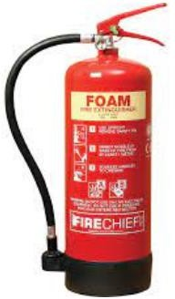

Fire extinguisher

### What is the importance of various elements and compounds? (4 mks)

* 1. Gold:

1. It is widely used to make jewellery as it is fairly soft and easy to work with.
2. It is attractive in appearance and neither rust or discolours.
   1. Silver:
3. It is used in making jewellery but it tends to discolour.
4. It is also used in making cutlery, teapots and medals.
5. State the meaning of the following Fire safety posters in the environment. (3mks)

|  |  |  |
| --- | --- | --- |
| In case of fire out break this is the point to assemble. | Show the route to use and exit the affected area in case of fire. | Used to alert the users of the premises to exit the area due to fire outbreak |

1. What are the three components of integrated science? ( 3 mks)
2. Biology
3. Chemistry
4. Physics
5. Health education
6. Astronomy
7. Give two differences between luminous and non-luminous flame.( 4 mks)

|  |  |
| --- | --- |
| Luminous flame | Non-luminous flame |
| Yellow/orange in colour | Blue in colours |
| Used for lighting | Used for heating |
| Has 4 regions and burns quietly | Has 3 regions and noisy |
| Produced when air hole is closed | Produced when air hole is open |
| Produces soot | Does not produce soot |
| Its wavy and large | Its straight |

1. State three characteristics of liquids. (3 mks)
2. A liquid has no definite shape.

That means a liquid changes its shape to take the shape of the container or vessel in which it is put.

1. A liquid also changes its shape when spilled on the floor.

For example, when a liquid is poured in two different containers, the liquid will display two different shapes that resemble or are similar to the container they are placed in. this means liquids lack a definite shape

1. Has no definite volume etc
2. Change of state of matter has many applications in day-to-day life. Some of these changes are?(3 mks)
3. Refrigerators. Liquids evaporate and absorbs heat in the process. A refrigerator works by using a liquid to remove heat from the food items inside and transfer it to the surrounding. The liquid is first heated and then cooled at the back of the fridge where the heat is removed. The process of changing liquid to gas cools the food. Ice cream vendor.
4. Ice cream vendors place ice inside their ice cream carts. The ice absorbs heat from the container surrounds and change to a gas. This leaves the inside of the ice cream cart cold, thus maintaining the ice cream in frozen state.
5. Melting metals. Metals are heated to a molten state making it possible to shape and form them into desired objects or structures.
6. Generating electricity. Water can be converted to steam, which can in turn be used to drive turbines to generate electricity.
7. Fog formation.Fog forms when water vapour (gaseous state) condenses. During condensation, molecule of water of water vapour combine to make tiny liquid water droplets that are suspended in the air. Fog reduces visibility. Some animals such as insects, depend on fog as a source

of water, especially in desert climate.

1. Mention six classes of fire. (6 mks)

|  |  |  |
| --- | --- | --- |
| Class | Type | Involves |
| Class A | Ordinary fires. | Fires that burn materials such as wood, cloth, paper and  plastics. |
| Class B | Flammable liquids. | Fires that involve liquids such as grease, oils, paraffin,  petrol, diesel and alcohol. |
| Class C | Flammable gases. | Fires that involve gases such as propane, butane and  methane. |
| Class D | Metallic fires. | Fires that are ignited by combustible metals such as  potassium, sodium, aluminium and magnesium. |
| Class E | Electrical fires. | Fores that are caused by electricity or involve electrical  equipment and appliances, for example mobile phone and computer chargers. |
| Class F | Cooking fires | These fires are ignited by cooking oil and animal fats. |

### State three components of fire. (3 mks)

### Fuel,

### Heat and

### Oxygen.

### State three fire control measures.(3 mks)

### Removing fuel: Use fire-resistant materials where possible. This will help to prevent the fire from starting and spreading.

### Removing heat: Water is mostly used to remove the heat from fire. A water fire extinguisher would be the safest way of doing this. However, these extinguishers cannot be used on all types of fire.

### Removing oxygen: It is important to remove oxygen gas from fore triangle to prevent spread of a fire. This can be achieved by using either a carbon (IV) oxide or a form fire extinguisher.

1. 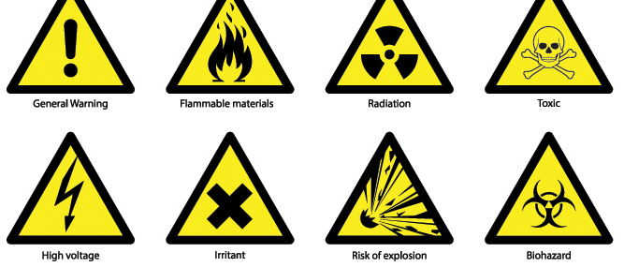Identify the following lab hazards.(2 mks)



1. Indicate their colour in the given solutions. (6 mks)

|  |  |  |  |
| --- | --- | --- | --- |
| Indicator | Acidic solution | Neutral solution | Basic solution |
| Methyl Orange | Red | Yellow | Yellow |
| Phenolphthalein | Colourless. | Colourless | Pink |

###### State two uses of acids. (2 mks)

1. Vinegar has various household uses such as preservation.
2. Citric acid is important part of lemon juice and orange juice; it can also be used in food preservation.
3. Sulphuric acid is widely used in batteries that are used to start the engines of automobiles.
4. Industrial production of dyes, paints and fertilizers involve the use of Sulphuric acids and nitric acid.
5. Phosphoric acid is a key ingredient in many soft drinks.
6. Identify three basic science skills one gains in science practical.(3 mks)
7. Manipulation
8. Observation
9. Calculation
10. Prediction
11. Measurement etc

### State four safety precautions to undertake to avoid fire outbreak in school.(4 mks)

1. Avoid build up of rubbish that can fuel fire.
2. Put measures in place to detect fires and warn people quickly in case fires start. This can be done successfully by installing smoke detectors and fire alarms or bells.
3. Have correct fire fighting equipment to put out a fire quickly.
4. Keep fire exits and escape routes clearly marked and unobstructed at all times.
5. Give proper training on emergency procedures to follow, including fire drills.
6. Access to information on flammable substances is important for the following reasons. Namely?(3 mks)
7. It makes us aware of all hazards (fire and explosion) of the materials we are handling.
8. Helps us to know which of the materials or products we are working with are flammable.
9. Helps us to remove sources of ignition (sparks, smoking, flames or hot surfaces) when working with flammable and combustible products.
10. Helps to use approved equipment, including labelled safety containers, for flammable liquids.
11. Helps to know the proper personal protective equipment to use when handling hazardous liquids.
12. Helps us to know how to handle emergencies (fires, spills, personal injury) involving the hazardous materials we work with.
13. Name the lab apparatus below. (2 mks)

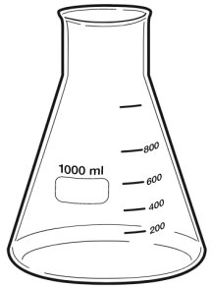

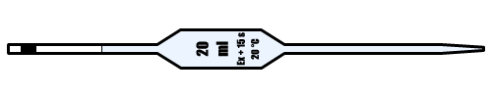

**Pipette**

**Conical flask**

##### Outline two safe ways of handling of the Bunsen burner. (2 mks)

1. Always turn off the Bunsen burner after use.
2. Always make sure that flammable liquids and combustible materials are not near the Bunsen burner to avoid the risk of unwanted fires and explosions.
3. When lighting the gas, have your strikers ready to avoid excess gas leakage that might lead to an explosion.
4. Once you are done with the Bunsen burner, it is critical to turn off the main gas valve to avoid leakages.
5. The burner should cool completely after use before any further handling.

THIS IS THE LAST PRINTED PAGE

……………….Every learner counts …………