Grade 8

INTEGRATED SCIENCE

NAME……………………………………………………………………………………………………………..
SCHOOL ………………………………………………………………………………………………………….
TIME 1hr

- Identify one quality of each matter
- Solid
……………………………………………………………………………………..
- Liquid
……………………………………………………………………………………..
- Gases
……………………………………………………………………………………..
- Identify some of the ways that help to keep the kidney healthy.
- ……………………………………………………………………………….
- ……………………………………………………………………………….
- ……………………………………………………………………………….
- ………………………………………………………………………………

- Name the following components of a circuit
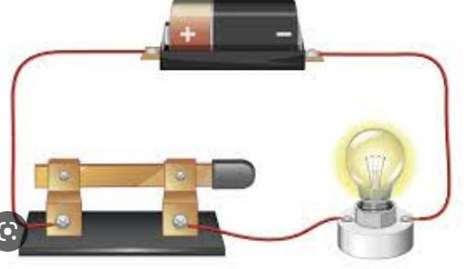

Bulb
Switch
- Name the following components of a simple circuit
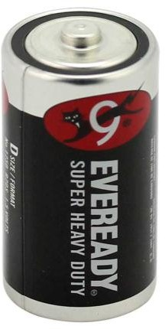
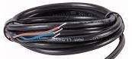
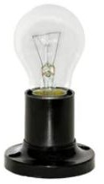

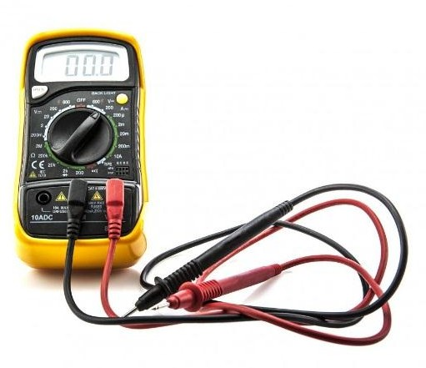
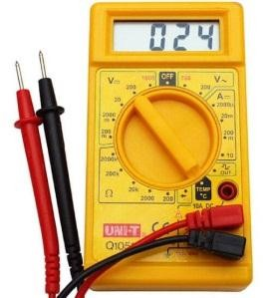

- Name two forms of electric energy.
- …………………………………………………………..
- ………………………………………………………………

- Examples of conductors of electricity are:

…………………………….………..
  - ………………………………………..
- Examples of insulators include:

…………………………………………..

…………………………………………

…………………………………………….

- State the uses of electricity :
- …………………………………
- ………………………………..
- ………………………………

- Name four electric appliances:

………………………………………
………………………………………..
………………………………………..

- Safety measures are put in place when handling electrical appliances to prevent any dangers brought about by electricity. Discuss
Possible danger of electricity. | Safety measure to apply
- State Safety measures to observe when using electrical appliances.
- ……………………………………………………………………………………………………………..
- …………………………………………………………………………………………………………….
- ………………………………………………………………………………………………………………
- State the Uses of Magnets in day to day life
- ………………………………………………………………………………………………………………
- …………………………………………………………………………………………………………….
- ……………………………………………………………………………………………………………..

