**COMPETENCE BASED CURRICULUM**

**JUNIOR SCHOOL**

**GRADE 8**

**FORMATIVE ASSESSMENT**

**INTEGRATED SCIENCE**

**2 HOURS**

***SCHOOL:*** *……………………………………………………………………………..……*

***NAME:*** *……………………………………………………..……………………..………..*

***ASSESSMENT NO:*** *……………….……….* ***SIGN:*** *…....****DATE:*** *………..….*

*RUBRICS (for official use)*

|  |  |  |  |  |
| --- | --- | --- | --- | --- |
| *Mark Score Range* | *Below 40* | *40-59* | *60-79* | *80-100* |
| PERFORMANCE LEVEL | *Below expectation* | *Approaching expectations* | *Meeting expectations* | *Exceeding expectations* |

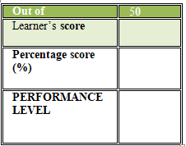

**FOR EXAMINERS**

**INSTRUCTIONS TO CANDIDATES**

1. Answer all the questions in the spaces provided.
2. Ensure your work is neat.
3. Name the following parts of a Bunsen burner. (5MKS)



1. Name two apparatus used for measuring length.(2MKS)
2. ………………………………………
3. ………………………………………
4. Name three protective wear for safety in the laboratory.(3MKS)
5. ………………………………………
6. ………………………………………
7. ………………………………………
8. What are the names of the following laboratory apparatus?(3 MKS)

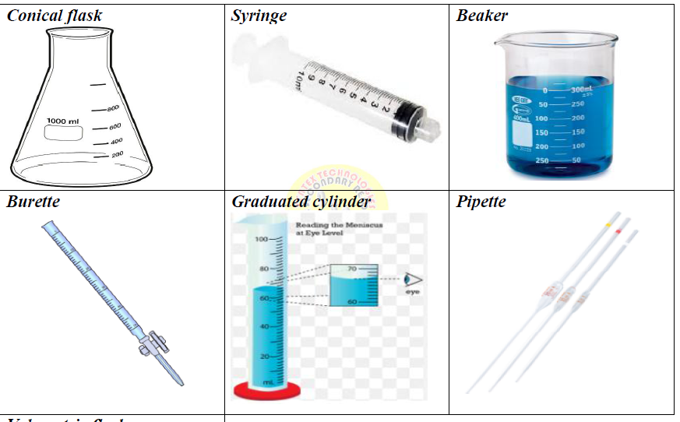

1. Identify two properties of gases:(2 MKS)
2. ………………………………………………………………………………….
3. ………………………………………………………………………………….
4. Name two heat instruments used in the lab for heating purposes.(2MKS)
5. …………………………………………
6. …………………………………………
7. In an experiment to demonstrate a certain aspect in liquids, Mwangi put potassium Manganate (vii) in water and observed the process

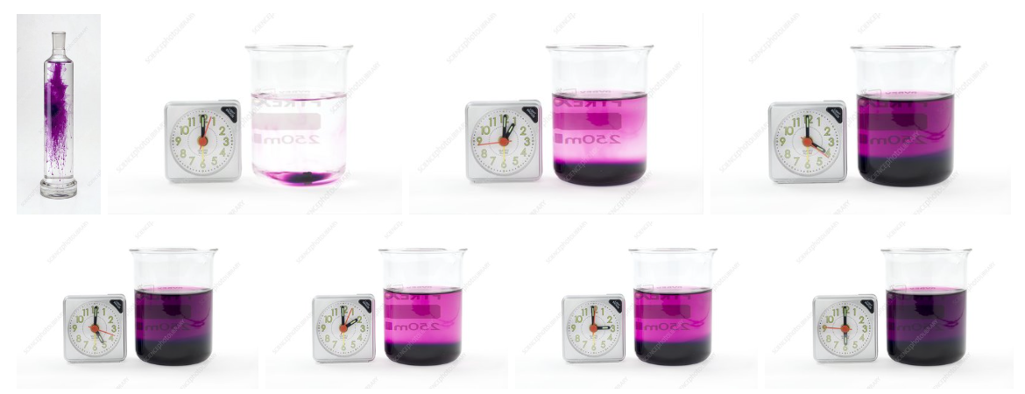

When the crystals of potassium permanganate were kept in water, the purple-coloured crystals of potassium permanganate broke further into smaller particles and occupied the space between the molecules of water imparting a purple colour to the water.

1. So this experiment was to show (1MK)

………………………………………………………………….

1. What was the use of the clock in the experiment?(1MK)

……………………………………………………………………………………………………………………………………………………………………………….

1. What is the chemical symbol of potassium permanganate?(1MK)

…………………………………………………………………………………….

1. What is the colour of potassium permanganate?(1MK)

…………………………………..

1. Identify one basic science skills one gains in science practical.(1MK)
2. …………………………………….
3. Name the following changes of state of matter(2mks)

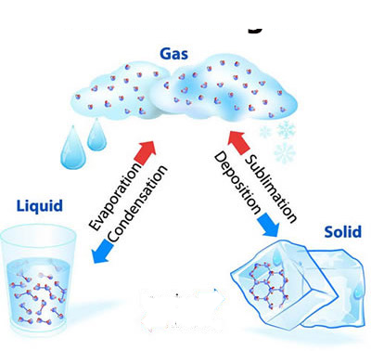

1. List two common examples of changes of state of matter that occur in everyday life:(2mks)
2. ……………………………………………………………………………………
3. ……………………………………………………………………………………
4. …………………………………………………………………………………..
5. Name two laboratory apparatus used for measuring mass of substances.(2mks)
6. ……………………………………………………………………..
7. …………………………………………………………………….
8. Give two differences between luminous and non-luminous flame.(2mks)

|  |  |
| --- | --- |
| Luminous flame | Non-luminous flame |
|  |  |
|  |  |

## **State two causes of changing states of matter (2mks)**

1. **……………………………………………………………………………………………**
2. **…………………………………………………………………………………………..**

#### State the safety precautions to prevent burns and scalds. (2mks)

1. ………………………………………………………………………………………….
2. …………………………………………………………………………………………
3. What is the area of the Trapezium? (2 mks)

20cm

10cm

30cm

1. What are the names and functions of the following first aid items?(2mks)

|  |  |  |  |
| --- | --- | --- | --- |
|  | ITEM | PHOTOGRAPH | FUNCTION |
| 1 | Bandages. |  |  |
| 2 | Cotton wool. |  |  |

#### First aid for burns and scalds.(2mks)

1. ……………………………………………………………………………………….
2. ……………………………………………………………………………………….

#### Outline the Causes of a sprain in the following body parts. (2mks)

|  |  |
| --- | --- |
| Body part | Cause of sprain |
| Ankle. |  |
| Knee |  |
| Wrist |  |
| thumb |  |

1. State the Factors that contribute to road accidents.(3 mks)
   1. …………………………….…………………………………………………….
   2. …………………………………………………………………………………..
   3. ………………………………………………………………………………….
2. Explain the Measures pedestrians can observe to be safe when using roads to avoid accidents.(2mks)
3. ……………………………………………………………………………………………….
4. ………………………………………………………………………………………………..
5. A dentist was driving home from hospital when he saw the following signs. What is the meaning of the following road sign?(5mks)

|  |  |
| --- | --- |
|  |  |
|  |  |
|  |  |
|  |  |
|  |  |

1. State the physical changes that adolescents undergo during the period of adolescence.(2mks)

|  |  |  |  |
| --- | --- | --- | --- |
|  | Physical changes in Boys |  | Physical changes in girls. |
| 1 |  |  |  |
| 2 |  |  |  |

1. Identify the names of the following items used by adolescent girls. (4 mks)

|  |  |  |  |
| --- | --- | --- | --- |
|  |  |  |  |
|  |  |  |  |

#### State measures of management of menstrual hygiene.( 2 mks)

1. ………………………………………………………………………………………
2. ……………………………………………………………………………………….
3. ………………………………………………………………………………………..

**This is the last printed page**