**JUNIOR SCHOOL**

**INTEGRATED SCIENCE**

**2024 Marking scheme**

1. **Name the following parts of a Bunsen burner.**

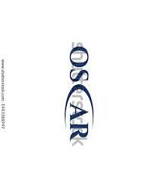****

1. Name two apparatus used for measuring length.
2. **Metre rule,**
3. **rulers,**
4. **tape measure,**
5. **Vernier callipers**
6. Name three protective wear for safety in the laboratory.
7. **Gloves**
8. **Overall**
9. **Safety goggles**
10. **Facemask**
11. **Headgear**
12. **What are the names of the following laboratory apparatus?**

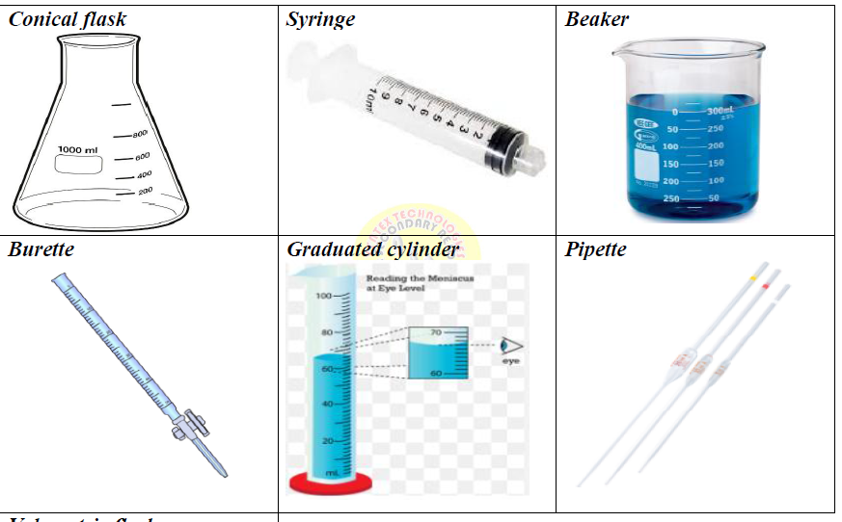

**Pipette Graduated Cylinder Burette**

1. Identify three properties of gases:
2. **Gases have neither a fixed shape nor a fixed volume.**
3. **Gases can be compressed easily.**
4. **Gases have the least density among the three.**
5. **Intermolecular forces of attraction are weakest.**
6. **The space between the gas particles is large.**
7. Name three heat instruments used in the lab for heating purposes.
8. **Portable burner**
9. **Bunsen burner**
10. **Candle**
11. **Spirit lamp**
12. In an experiment to demonstrate a certain aspect in liquids, Mwangi put potassium Manganate (vii) in water and observed the process

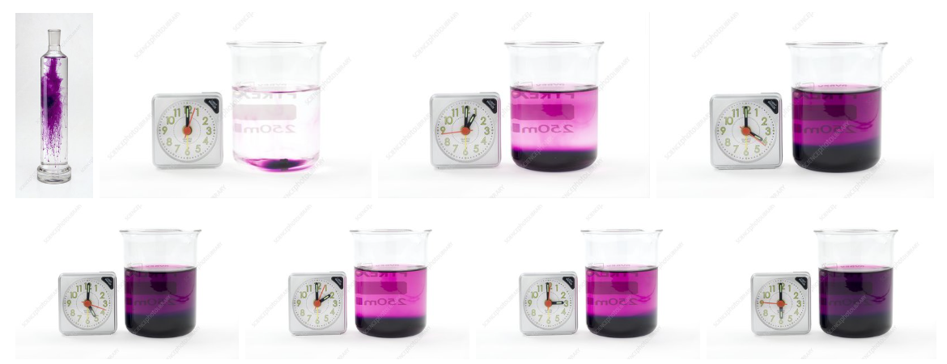

When the crystals of potassium permanganate were kept in water, the purple-coloured crystals of potassium permanganate broke further into smaller particles and occupied the space between the molecules of water imparting a purple colour to the water.

1. So this experiment was to show

**Diffusion in liquids.**

1. What was the use of the clock in the experiment?

**A clock being used to time how long it takes for the purple colour to spread through the water as the potassium permanganate dissolves**

1. What is the chemical symbol of potassium permanganate?

**Kmo4**

1. What is the colour of potassium permanganate?

**Purple**

1. Name the following states of matter
2. Identify four basic science skills one gains in science practical.
3. **Manipulation**
4. **Observation**
5. **Calculation**
6. **Prediction**
7. **Measurement etc**
8. Name the following changes of state of matter

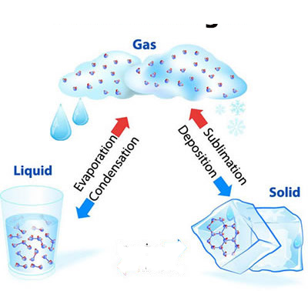

1. List three common examples of changes of state of matter that occur in everyday life:
2. **Ice melting: When ice at 0°C is heated, it changes from solid state to liquid state and starts melting.**
3. **Frost formation: When the temperature drops below 0°C, water vapour in the air condenses directly into solid ice crystals.**
4. **Water boiling: When water is heated, it changes from liquid state to gas state (steam).**
5. **Condensation of water vapour: When water vapour in the air cools below 100°C, it changes from gas state to liquid state and condenses to form liquid water droplets.**
6. **Sublimation: An example of sublimation is when solid dry ice (frozen carbon dioxide) changes into carbon dioxide gas without melting.**
7. Name two laboratory apparatus used for measuring mass of substances.
8. **Electric balance**
9. **Double beam balance**
10. **Triple beam balance**
11. Give two differences between luminous and non-luminous flame.

|  |  |
| --- | --- |
| Luminous flame | Non-luminous flame |
| Yellow/orange in colour | **Blue in colours** |
| Used for lighting | **Used for heating** |
| Has 4 regions and burns quietly | **Has 3 regions and noisy** |
| Produced when air hole is closed | **Produced when air hole is open** |
| Produces soot | **Does not produce soot** |
| Its wavy and large | **Its straight** |

## ****State two causes of changing states of matter****

1. **Change in Temperature:**The temperature change occurs in states of a matter when it undergoes heat transfer to its surroundings.
2. **Change in Pressure:**The change in [pressure](https://testbook.com/physics/pressure) occurs in states of a matter only when it undergoes liquefaction.

#### Safety precautions to prevent burns and scalds.

1. ⬄ Wear kitchen gloves or use a piece of cloth to hold hot kitchen utensils.
2. ⬄ Keep hot liquids out of reach of children.
3. ⬄ Do not leave children unattended around fires or near hot surfaces.
4. ⬄ Avoid wearing loosely hanging clothes near fires.
5. ⬄ Always direct steam away from your body when opening lids while cooking food.
6. **What is the area of the Trapezium**

**20cm**

**10cm**

**30cm**

Area =**1/2** (sum of parallel side) x perpendicular distance between the lines

= **1/2 (a+b)h**

**= $\frac{1}{2}$*(20cm+30cm)*10cm**

**=250cm2**

1. What are the names and functions of the following first aid items?

|  |  |  |  |
| --- | --- | --- | --- |
|  | **ITEM** | **PHOTOGRAPH** | **FUNCTION** |
| **1** | **Bandages.** |  | Hold dressing in place to help control bleeding and protect against infection. |
| **2** | **Cotton wool.** |  | It is used for cleaning and protecting the wound. |
| **3** | **Surgical gloves.** |  | Cover our hands and prevent transmission of diseases. |
| **4** | **Safety pins.** |  | Are used to secure wraps and bandages |

#### First aid for burns and scalds.

1. Wash your hands.
2. Wear gloves.
3. Move the injured person from the source of heat.
4. Cool the burn or scald by pouring cold water on it for about 10 minutes.
5. Remove jewellery or clothing around the wound. Do not try to remove the clothing it is is stuck to the skin.
6. Cover the wound with a loosely hanging piece of cloth.
7. Seek further medical assistance for serious burns and scalds

#### Outline the Causes of a sprain in the following body parts

|  |  |
| --- | --- |
| **Body part** | **Cause of sprain** |
| Ankle. | * Walking, running or exercising on an uneven surface. * Landing unsteadily from a jump. |
| Knee | * Overstretching during an athletic activity. |
| Wrist | * Landing on an outstretched hand during a fall. |
| thumb | * Hitting your thumb on a hard surface. |

1. **State the Factors that contribute to road accidents.**
   1. Failure to observe road safety signs and signals by drivers, passengers and pedestrians.
   2. Speeding of vehicles and motorbikes.
   3. Failure of pedestrians to use designated crossing areas like foot bridges and pedestrian’s crossing.
   4. Use of mobile phones, earphones and other electronic gadgets while driving or crossing the road.
   5. Driving under the influence of alcohol and drugs.
   6. Use of medicines that may cause drowsiness.
   7. Overtaking carelessly.
   8. Driving too close behind another vehicle.
   9. Being distracted while using the road. For example, reading billboards, talking or being in deep thoughts.
   10. Unroadworthy vehicles.
   11. Driving at night with poor eyesight.
   12. Bad weather which affects visibility.
2. **Explain the Measures pedestrians can observe to be safe when using roads to avoid accidents.**
3. Use a footpath while walking along the road.
4. Wear reflective jackets at night.
5. Children should walk in the company of an adult.
6. Walk in organized groups when crossing a road.
7. Cross only when the road is safe and clear.
8. Do not run while crossing the road.
9. Use the pedestrian crossing or footbridges where the pedestrian’s crossing light is on.
10. Walk on the right hand of the road to see oncoming vehicles.
11. **What is the meaning of the following road sign?**

|  |  |
| --- | --- |
|  | **Danger ahead** |
|  | **Animal crossing** |
|  | **Cyclist only** |
|  | **Pedestrian crossing.** |
|  | **Children crossing.** |

1. State the physical changes that adolescents undergo during the period of adolescence.

|  |  |  |  |
| --- | --- | --- | --- |
|  | **Physical changes in Boys** |  | **Physical changes in girls.** |
| 1 | Increase in weight and height | 1 | Increase in weight and height. |
| 2 | Chest and shoulders broaden. | 2 | The hip region broadens. |
| 3 | Growth of hair on the face or chin(beards) | 3 | Breasts enlarge. |
| 4 | They experience wet dreams. | 4 | Hair grows under the armpits and around the pubic area. |
| 5 | Growth of hair on the chest, under the armpits and around the pubic area. | 5 | Pimples may appear on the face. |
| 6 | Pimples may appear on the face. | 6 | Menstruation begins. |
| 7 | Breaking of voice. The voice becomes deeper. | 7 |  |

1. Identify the names of the following items used by adolescent girls

|  |  |  |  |
| --- | --- | --- | --- |
| **Reusable pads** | **Disposable pads.** | **Tampons** | **Menstrual cup** |
|  |  |  |  |

#### State measures of management of menstrual hygiene.

1. On the onset (start) of menstruation, girls are advised to bathe properly and regularly to avoid infections in the reproductive system.
2. Pack enough sanitary towels in your bag if you are leaving the house.
3. Change sanitary towels frequently to avoid infections and soaking of the towel which may stain clothes.
4. Wrap disposable sanitary towels properly after use. Dispose them correctly in pit latrines or in sanitary pad bins.
5. Reusable sanitary towels must be washed properly and dried in the sunlight. The sun’s heat dries the towels and naturally sterilizes them. The materials should be stored in a clean and dry place to avoid contamination.

